***HINDUISM:***

1. ***Holi Celebrations:***

Holi is not just a celebration of colors; it is also a time to forgive and mend relationships. The festival encourages people to forget past conflicts and embrace joy. It is a social festival where caste, creed, and status differences are put aside, and everyone is seen as equal. People often visit friends and family to exchange sweets and warm wishes, further strengthening social bonds.In addition to the fun and festivity, Holi has spiritual significance. It is considered a time for spiritual renewal, where people cleanse themselves from past wrongdoings and start anew. The colors represent the different aspects of life, such as prosperity, happiness, and hope. Holi is not only celebrated in India but also by the Indian diaspora around the world.

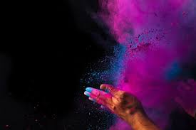

***About Holi:***

Holi, often called the "festival of colors," is a vibrant and joyful Hindu celebration that marks spring’s arrival, the triumph of good over evil, and the legendary love between Radha and Krishna.This festival, mainly observed in South Asia but also recognized globally, typically spans two days and is rooted in ancient traditions, mythology and community gatherings. Its date changes, as it is based on the full moon in the month of Phalguna, part of the Hindu lunar calendar, usually falling in late February or March. In 2024, Holi falls on Monday, March 25.Holi, dating back to the 4th century, stands alongside Diwali, the festival of lights, as one of the most prominent Hindu celebrations and is famous for the playful tossing of colored powders and water.

