***HINDUISM:***

***3.Janmashtami:***

**Janmashtami is more than a celebration of Lord Krishna's birth; it is a reminder of his teachings and divine presence. Devotees celebrate by visiting temples, offering prayers, and chanting mantras. The night of Janmashtami is especially significant, as it is believed that Krishna was born at midnight. In many regions, people observe a fast, sing devotional songs (bhajans), and participate in community prayers. The playful and mischievous nature of Lord Krishna is also celebrated with dance and festivities.**

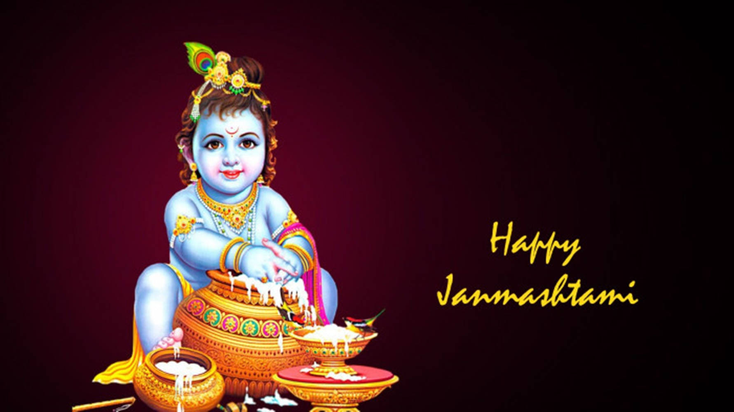

***About Janmashtami:***

**Janmashtami is a significant Hindu festival that celebrates the birth of Lord Krishna, the eighth incarnation of Lord Vishnu. It is observed with immense devotion and enthusiasm, particularly in India and by the Hindu diaspora worldwide. The festival typically falls in the month of August or September, on the eighth day (Ashtami) of the dark fortnight of the month of Shravana. Devotees celebrate by fasting, singing devotional songs, and reenacting episodes from Krishna’s childhood. The day culminates with the midnight celebration of Krishna’s birth.**

