***TAOISM RELIGION:***

1. ***Lantern Festival:***

**The Lantern Festival is renowned for its stunning lantern displays, where families and communities come together to create and exhibit beautiful lanterns in various shapes and sizes. The lanterns are often inscribed with riddles, and people take part in the tradition of solving these riddles for fun and good fortune. Another prominent feature of the festival is the **Lion Dance**, a traditional performance meant to bring good luck and scare away evil spirits. The festival also involves the preparation and sharing of **tangyuan** (sweet rice dumplings), which are eaten to symbolize family unity and the fulfillment of wishes.**

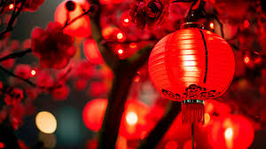

***About Lantern Festival:***

**The Lantern Festival, also known as **Yuanxiao Festival**, is celebrated on the 15th day of the first lunar month, marking the final day of the Chinese New Year festivities. The festival is a time for family reunions and a celebration of light, symbolizing the arrival of spring and the hope for a bright, prosperous year ahead. Traditionally, people hang colorful lanterns in the streets, create intricate lantern displays, and enjoy a variety of cultural performances, including traditional dances and fireworks. The Lantern Festival is also known for its delicious food, particularly **tangyuan** (sweet rice dumplings) that symbolize unity and family harmony.**

