***ZOROASTRIANISM:***

***2. Maghi Festivals:***

**On Maghi, Sikhs observe the occasion by visiting Gurdwaras and offering prayers, remembering the martyrdom of the **Chali Mukte**. The day is also marked by a special **Amrit Sanchar** (baptism ceremony) in some Gurdwaras, where new initiates are blessed into the Khalsa. Sikhs participate in **Langar**, a community meal that symbolizes equality, sharing, and service to others.**

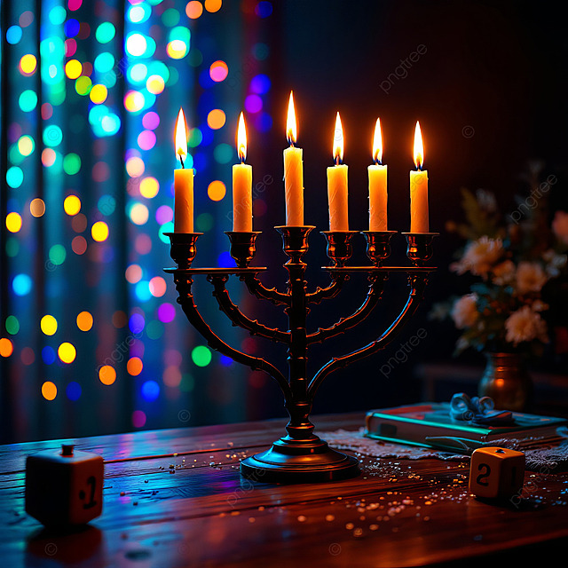

***About Maghi:***

**Maghi is an important festival in Sikhism, observed on the first day of the month of Maghar (which typically falls in January). It commemorates the historic event of the martyrdom of the forty Sikh soldiers, known as the **Chali Mukte**, who sacrificed their lives in the battle of Muktsar in 1705. Their bravery and sacrifice are remembered as a symbol of courage, loyalty, and commitment to faith. Maghi is a day of reflection, remembrance, and spiritual renewal for Sikhs, where they gather at Gurdwaras to honor the memory of these martyrs and partake in prayers and community service.**

