***HINDUISM:***

***2.*** ***Navratri:***

**Navratri is a time for spiritual renewal and worship, where devotees fast, sing bhajans (devotional songs), and pray to Goddess Durga. Each of the nine nights is dedicated to a different form of Durga, and specific rituals are followed to invoke the goddess's blessings. The festival is marked by high-energy Garba and Dandiya dances, which are a major part of the celebrations in Gujarat and other regions. These dances are performed to honor the goddess, promote community spirit, and seek divine protection. On the tenth day, Dussehra is celebrated with the burning of effigies of Ravana, symbolizing the victory of good over evil. Navratri not only provides a time for religious reflection but also for bonding with family and friends through joyful dances and social gatherings.**

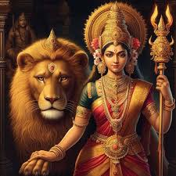

***About Navratri***

**Navratri is a major Hindu festival celebrated over nine nights, dedicated to honoring the divine feminine energy of Goddess Durga. The festival symbolizes the victory of good over evil and celebrates the power of the goddess in her nine forms. Occurring annually in the months of September or October, Navratri involves fasting, prayer, devotional singing, and dancing. The festival culminates in Dussehra, marking the triumph of Lord Rama over the demon king Ravana. Each night of Navratri is associated with a specific form of Durga, and the celebrations include the traditional dances of Garba and Dandiya, particularly popular in Gujarat and Maharashtra.**

