***TAOISM:***

***4.Nine Emperor Gods Festival:***

**During the Nine Emperor Gods Festival, one of the main traditions is the **offering of prayers and food** to the Nine Emperor Gods in Taoist temples. Devotees engage in **purification rituals**, such as fasting and avoiding meat, to cleanse their bodies and minds. The **vibrant street processions** are a highlight, with participants dressed in white, often carrying lanterns, incense, and offerings to show reverence. In some regions, the festival also features **spiritual mediums** who enter trances to communicate with the Emperor Gods.**

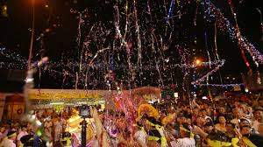

***About Nine Emperor Gods Festival:***

**The **Nine Emperor Gods Festival** is a significant Taoist festival celebrated primarily by the Chinese communities in Southeast Asia, including Malaysia, Singapore, and Thailand. It takes place during the ninth lunar month, usually lasting nine days, and is dedicated to the worship of the Nine Emperor Gods, believed to bring blessings of health, prosperity, and protection from evil spirits. The festival involves various rituals, including processions, prayers, and offerings to honor the Nine Emperor Gods. Devotees also participate in purification practices, fasting, and performing acts of devotion to purify their bodies and souls.**

