***ZOROASTRIANISM:***

***3.*** ***Nowruz Festivals:***

**Nowruz is rich in customs and rituals that symbolize renewal, purity, and the hope for a prosperous new year. One of the central traditions is the preparation of the **Haft-Seen** table, a symbolic arrangement of seven items starting with the Persian letter "S" that represent various aspects of life, such as **health**, **wealth**, **prosperity**, and **rebirth**. The table often includes items like **sprouts (sabzeh)** symbolizing rebirth, **apples (seeb)** for health, and **garlic (seer)** for medicine. People also clean their homes thoroughly before Nowruz, a tradition known as **Khaneh Tekani**, to welcome positive energy.**

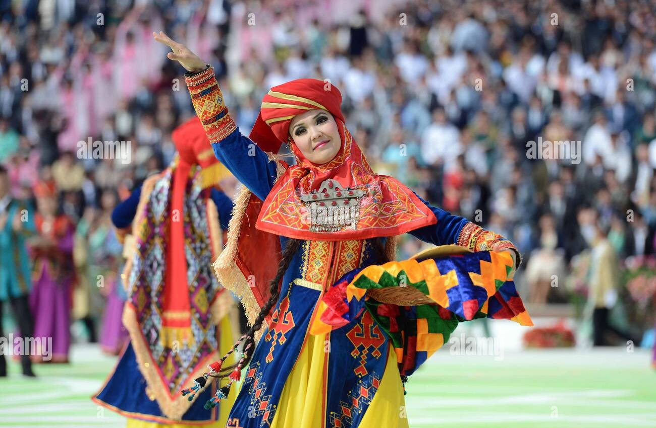

***About Nowruz:***

**\*\*Nowruz**, meaning "new day" in Persian, is the celebration of the Persian New Year, marking the first day of spring and the beginning of the year in the Iranian calendar. Nowruz has been celebrated for over 3,000 years and is observed by millions of people across the globe, particularly in Iran, Afghanistan, Azerbaijan, Central Asia, and parts of the Caucasus. The festival signifies renewal, rejuvenation, and the triumph of light over darkness. It is rooted in Zoroastrian traditions but has evolved into a multicultural celebration of nature, family, and community.**

