***VOODOO:***

***2.Ouidah Voodoo Festival:***

***Gahambar:***

**Throughout the year, Zoroastrians celebrate six Gahambars, each associated with a different creation phase. These festivals include rituals and feasts to honor the divine spirits of **Ahura Mazda**, as well as the seasonal changes that bring prosperity to the earth. The Gahambars are a time to reflect on the interconnectedness of all beings, the earth's fertility, and the role humans play in maintaining balance in the natural world.**

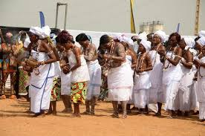

***About Gahambars:***

**\*\*Gahambars** are a series of six seasonal festivals in the Zoroastrian calendar, dedicated to the divine spirits of creation and the natural forces of the universe. Each Gahambar corresponds to a different aspect of creation, celebrating the harmony between the divine and the natural world. The Gahambars serve as a time for **thanksgiving**, **community gatherings**, and **rituals** that honor the gifts of nature, particularly focusing on **harvests**, **fertility**, and **spiritual prosperity**.**

