**JUDAISM**

**The Meaning of Passover**

Passover (Pesach) commemorates the Israelites' liberation from slavery in Egypt, as described in the Book of Exodus.

About Passover

The history and spiritual significance of Passover.

Passover (Pesach) is one of the most important Jewish holidays, commemorating the Exodus of the Israelites from slavery in Egypt. The holiday begins on the 15th day of the Hebrew month of Nissan, which typically falls in March or April. In 2024, Passover begins at sunset on Wednesday, April 23, and ends at nightfall on Thursday, May 2. During Passover, Jews observe a week-long festival, during which they eat matzah (unleavened bread) to recall the haste in which their ancestors left Egypt, not allowing their bread to rise. The highlight of the holiday is the Seder meal.

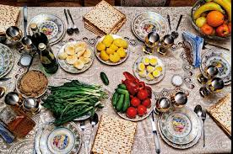

Passover Celebrations

A time for freedom, family, and reflection.

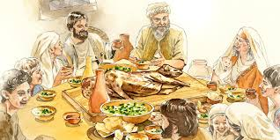

Passover is marked by several key rituals, with the most significant being the Seder meal. During the Seder, families gather around the table to eat traditional foods such as matzah, maror (bitter herbs), and charoset (a sweet paste symbolizing mortar). The story of the Exodus is recounted through the reading of the Haggadah, and the youngest child typically asks the Four Questions to prompt discussion about the holiday's meaning. The Seder plate, containing the symbolic foods, serves as a teaching tool about the hardships of slavery and the joy of freedom. During Passover.

Celebrate Freedom and Renewal this Passover

Passover reminds us of the importance of freedom and the journey from oppression to liberation. It is a time for families to gather, reflect on their history, and renew their commitment to faith and justice. Let this Passover bring peace, renewal, and joy into your home, as you celebrate the blessings of freedom and tradition!