**CHRISTIANITY**

**The Meaning of Pentecost**

Pentecost celebrates the descent of the Holy Spirit upon the apostles, marking the birth of the Christian Church.

About Pentecost

The history and cultural significance of Pentecost.

Pentecost, celebrated fifty days after Easter, is a major Christian feast that commemorates the descent of the Holy Spirit upon the apostles and other followers of Jesus Christ, as described in the Book of Acts, chapter 2. This event is often considered the "birthday" of the Christian Church, as it marks the beginning of the apostles' ministry to spread the teachings of Jesus. Pentecost occurs fifty days after Easter, and in 2024, it will be celebrated on Sunday, May 19. The day is also known as Whitsunday in some traditions, and it is a time of spiritual renewal, prayer, and community gathering. Pentecost is a celebration of the Holy Spirit’s presence in the world, guiding and empowering believers to live out their faith.

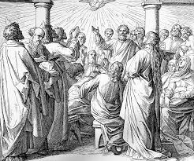

Pentecost Celebrations

A celebration of the Holy Spirit and the birth of the Church.

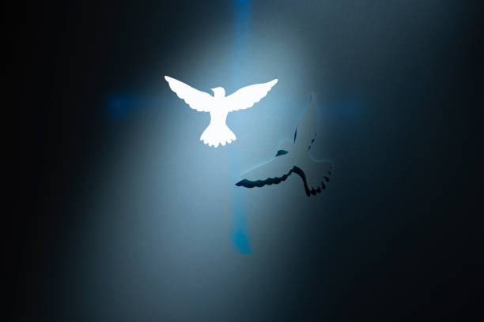

Pentecost is observed with special church services, prayers, and songs, as Christians around the world celebrate the powerful presence of the Holy Spirit. Many churches hold a Pentecost vigil, with the reading of Scripture and a focus on the gifts of the Holy Spirit, including wisdom, understanding, and courage. In some traditions, the church is decorated with symbols of the Holy Spirit, such as doves and flames, and worshipers often wear red to symbolize the fire of the Holy Spirit. Pentecost is a time for renewal of faith, and many congregations engage in acts of service to share God's love with others, reflecting the call of Pentecost to spread the gospel and serve the community.

Celebrate the Power of the Holy Spirit

Pentecost reminds us of the transformative power of the Holy Spirit and the call to live out our faith through service, love, and unity. It’s a time to reflect on the strength and guidance of the Spirit and to be renewed in our commitment to the Christian mission. Let this Pentecost bring spiritual renewal and a deeper connection to God and community!