**JUDAISM**

**The Story of Purim**

Purim commemorates the salvation of the Jewish people from the plot of Haman in ancient Persia, as told in the Book of Esther.

About Purim

The history and cultural significance of Purim.

Purim is a joyous Jewish festival that commemorates the events recorded in the Book of Esther, where Queen Esther and her cousin Mordecai saved the Jewish people from a plot to annihilate them, orchestrated by the wicked Haman. Celebrated on the 14th day of the Hebrew month of Adar (usually falling in February or March), Purim is marked by feasting, giving charity, and festive costumes. In 2024, Purim will be celebrated on Wednesday, March 6. The festival is a time for revelry, as the Jewish community remembers the deliverance of their ancestors, and the themes of courage, faith, and overcoming adversity are emphasized.

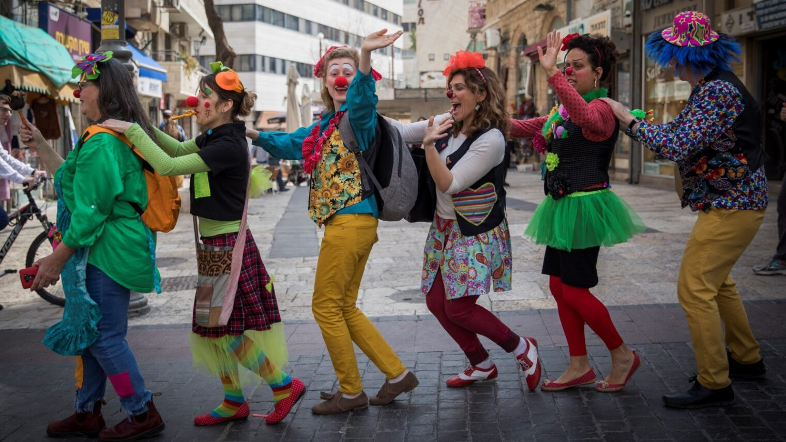

Purim Celebrations

A festive celebration of courage, joy, and unity.

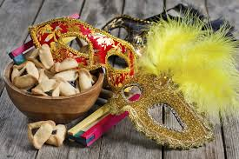

Purim is celebrated with a combination of religious observance and joyous revelry. The holiday begins with the reading of the Megillah (Book of Esther) in synagogues, during which participants use noisemakers called graggers to drown out the name of Haman. This symbolizes the community's rejection of his evil deeds. Purim is also a time for wearing costumes and masks, symbolizing the hidden miracles in the Purim story. People gather for festive meals, enjoy sweet pastries such as hamantaschen (triangular filled cookies), and exchange gifts with family, friends, and the poor. Charity is a key element of the holiday, with donations made to help those in need. Purim is a celebration of life and survival, and it brings together Jewish communities in joyful gatherings.

Celebrate the Joy and Courage of Purim

Purim reminds us of the power of courage, faith, and unity. It’s a time to reflect on the strength of the Jewish people and to celebrate the triumph of good over evil. Let this Purim bring joy,