***TAOISM:***

***2.*** ***Qingming Festival:***

**Qingming Festival is traditionally marked by visits to ancestral graves. Families engage in **tomb sweeping**, cleaning the tombstones, removing weeds, and offering food, incense, and other items as a sign of respect. This practice is an expression of filial piety, honoring the ancestors and maintaining the connection between generations. In addition to these solemn rituals, Qingming is also a time for outdoor activities. People fly kites, a tradition that symbolizes letting go of misfortune and bringing in good luck.**

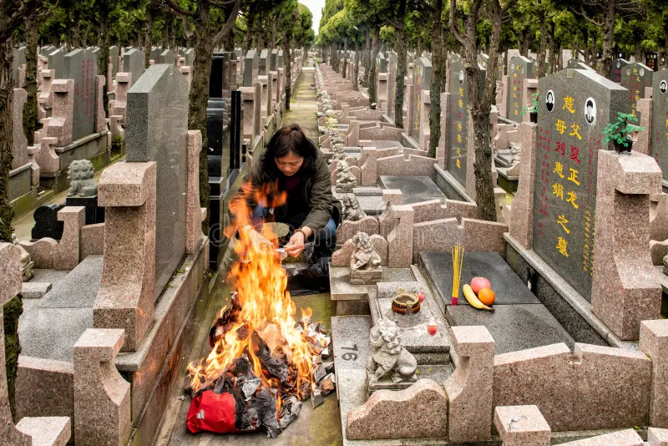

***About Qingming Festival:***

**Qingming Festival, also known as Tomb Sweeping Day, is a traditional Chinese festival that takes place on April 4th or 5th, marking the arrival of spring. The festival is primarily focused on honoring ancestors and celebrating the rebirth of nature. Families visit the graves of their ancestors to clean the tombstones, offer food and other sacrifices, and pay respects to their departed loved ones. Qingming also provides an opportunity for people to enjoy the outdoors, engage in recreational activities such as flying kites, and appreciate the beauty of nature during the spring season.**

