***HINDUISM:***

***4.*** ***Raksha Bandhan:***

**Raksha Bandhan is more than just a celebration of the sibling bond; it is a reminder of the love, care, and protection siblings share. On this day, sisters tie a Rakhi around their brothers' wrists, and in return, brothers give gifts and take an oath to protect their sisters. The festival is celebrated with great enthusiasm in India and among the Indian diaspora. It is not just a family event but also a time for friends to celebrate the love and protection they offer each other. Many people also perform prayers for the well-being and happiness of their loved ones.**

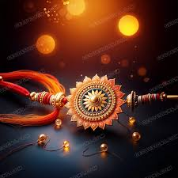

***About Raksha Bandhan:***

**Raksha Bandhan is a traditional Hindu festival celebrating the sacred bond between brothers and sisters. The festival is marked by the sister tying a protective thread, called a "Rakhi," around her brother's wrist, symbolizing love, protection, and a lifelong bond. In return, the brother gives a gift and promises to protect his sister from harm. Celebrated annually in the month of Shravana (usually August), Raksha Bandhan transcends familial ties, extending the celebration of protection and care to all loved ones. The ritual emphasizes the importance of sibling relationships and is observed with joy, gift-giving, and prayers for the well-being of each other.**

