***HINDUISM:***

***5.*** ***Rama Navami:***

**Rama Navami is a time for devotion, prayer, and community celebrations. The day begins with early morning prayers and visits to temples dedicated to Lord Rama, where devotees perform special rituals, including the reading of the Ramayana and the chanting of mantras. In some regions, the procession of Lord Rama's idol is carried out, and devotees sing bhajans (devotional songs) in his praise. Fasting is commonly observed by many as a sign of respect and devotion.**

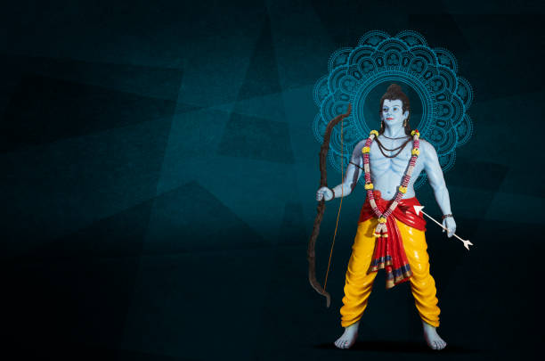

***About Rama Navami:***

**Rama Navami is a significant Hindu festival that marks the birth of Lord Rama, the seventh incarnation of Lord Vishnu. Celebrated on the ninth day of Chaitra month (usually in March or April), Rama Navami honors the divine virtues of Lord Rama, including his righteousness, bravery, and devotion to duty. It is a day of spiritual reflection, where devotees gather in temples to sing hymns, chant mantras, and engage in prayers to seek Lord Rama's blessings. The festival is widely celebrated across India, especially in temples dedicated to Lord Rama, where special rituals are conducted, including the recitation of the Ramayana, the epic that narrates his life and deeds.**

