**JUDAISM**

**The Meaning of Shabbat**

Shabbat is the Jewish day of rest, observed from Friday evening to Saturday evening, honoring the creation of the world.

About Shabbat

The history and spiritual significance of Shabbat.

Shabbat is the Jewish day of rest and spiritual rejuvenation, observed from sunset on Friday evening to the appearance of three stars on Saturday night. It is one of the most important aspects of Jewish life and is considered a gift from God. Shabbat commemorates both the creation of the world, as described in the Book of Genesis, and the Exodus from Egypt. During Shabbat, Jews refrain from work and engage in prayer, family meals, and rest. The lighting of candles, the recitation of prayers, and the sharing of challah bread are key rituals. In 2024, Shabbat will begin on Friday, January 5, at sunset, and end on Saturday, January 6, at nightfall.

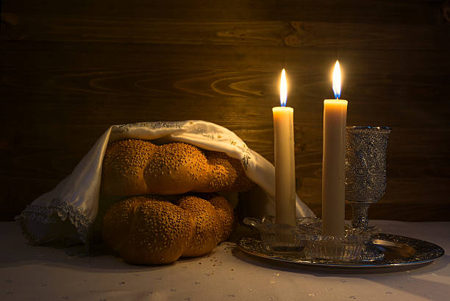

Shabbat Celebrations

A time for rest, reflection, and spiritual renewal.

Shabbat is a weekly celebration of rest, peace, and connection. The observance begins with the lighting of Shabbat candles by the woman of the household, followed by the recitation of blessings. A festive meal is shared, with traditional foods such as challah bread, wine, and a variety of delicious dishes. The prayers and songs sung during Shabbat help bring a sense of peace and sanctity to the home. On Saturday morning, many Jewish communities attend synagogue for prayer services, where they read from the Torah. Shabbat is a time for family bonding, spiritual reflection, and rejuvenation. The day ends with the Havdalah ceremony, marking the separation between the sacred Shabbat and the regular week ahead.

Experience the Peace and Joy of Shabbat

Shabbat is a time to step away from the busyness of daily life, to rest, reflect, and reconnect with loved ones and with God. It offers a weekly opportunity for spiritual renewal and a deeper sense of gratitude for the blessings of life. Let the peace and joy of Shabbat fill your home and your heart!