***TAOISM:***

***3.*** ***Supreme Purity Festival:***

**The Supreme Purity Festival is filled with traditions that focus on honoring the elderly, promoting well-being, and celebrating the seasonal beauty of autumn. One of the central customs is hiking, as it is believed to help strengthen the body and avoid sickness. People also appreciate the blooming of **chrysanthemums**, which are seen as a symbol of longevity and are often used in decorative displays or brewed into teas for health benefits. Additionally, many families prepare and share **double ninth cakes**, which are made with a variety of ingredients to symbolize wealth, health, and long life.**

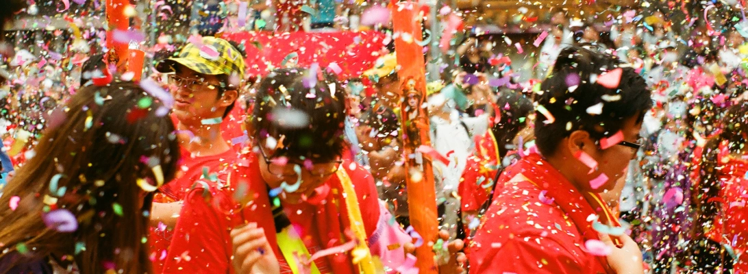

***About Supreme Purity Festival:***

**The Supreme Purity Festival, also known as **Chongyang Festival** or the **Double Ninth Festival**, is celebrated on the ninth day of the ninth lunar month. This festival holds deep cultural significance in China, honoring the elderly and promoting health and longevity. The number "nine" is considered auspicious, symbolizing long life and vitality. Traditionally, the festival is a time to respect and appreciate the older generation, while also celebrating the beauty of nature and the changing seasons.**

