***VOODOO:***

***3.*** ***The Festival Of Yemanjá:***

**The **Festival of Yemanjá** is a vibrant and deeply spiritual celebration, rich in **rituals** and **traditions**. The main event takes place at the beach, where thousands of people gather to offer **flowers**, **fruits**, and **gifts** such as **perfumes** and **jewelry** to Yemanjá. It is believed that by casting these offerings into the sea, devotees can receive blessings, protection, and guidance for the year ahead.**

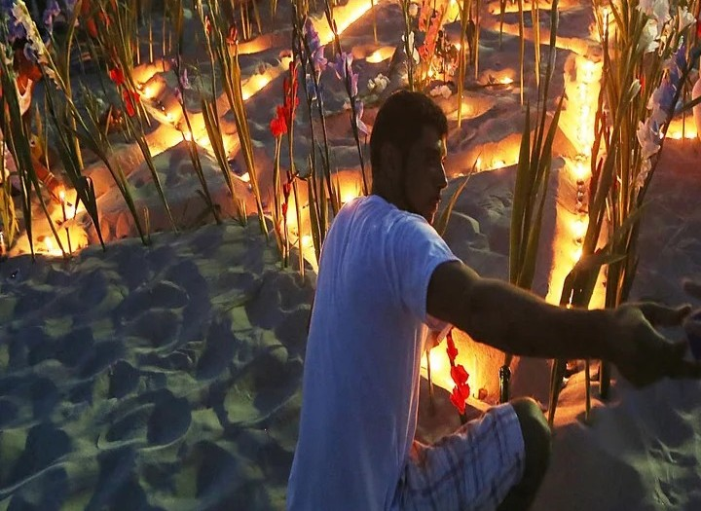

***About the Festival of Yemanjá:***

**The **Festival of Yemanjá** is one of the most important Afro-Brazilian religious celebrations, honoring **Yemanjá**, the goddess of the sea in **Candomblé**, **Umbanda**, and other Afro-Brazilian traditions. This annual festival is celebrated in coastal regions, particularly in **Salvador**, **Rio de Janeiro**, and **Bahia**, with thousands of devotees gathering at the beach to pay tribute to the goddess. Yemanjá is considered the **mother of all orixás** and is revered as the protector of sailors, fishermen, and families.**

