**SIGNIFICANCE OF TORII**

Torii gates mark the entrance to sacred areas, symbolizing the transition from the ordinary to the divine.

About Torii

The history and cultural significance of Torii gates.

The Torii gate is a traditional Japanese structure commonly found at the entrance of Shinto shrines. It symbolizes the transition from the mundane to the sacred, marking the boundary between the human world and the divine. Torii gates have been a part of Japanese culture for centuries and are often associated with Shintoism, the indigenous religion of Japan. They come in various styles and sizes, from simple wooden structures to massive stone gates, with the most famous being the red-painted gates at Fushimi Inari Shrine in Kyoto. Torii gates are a powerful symbol of Japan's spiritual and cultural heritage.

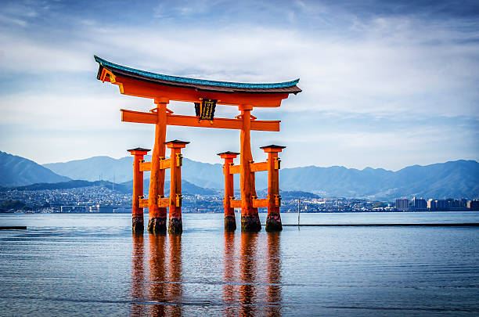

Torii Gate Traditions

A symbol of spirituality, purification, and connection with the divine.

The Torii gate marks the entrance to sacred spaces in Shintoism. The gate is believed to purify those who pass through it, symbolizing the shedding of worldly concerns as one enters a holy site. The color red is often used for Torii gates, as it is thought to ward off evil spirits. Torii gates are commonly found at Shinto shrines, along paths leading to temples, and at important cultural sites in Japan. While some gates are small and simple, others, like those at the Fushimi Inari Shrine, create beautiful, spiritual pathways that stretch for miles. The Torii is a visual and spiritual landmark that holds deep significance in Japanese culture.

Embrace the Spirit of Torii

Torii gates invite us to step into a sacred space and reflect on our connection to the divine. As symbols of purity and spiritual gateways, they inspire reverence, mindfulness, and tranquility. Let the presence of the Torii remind us to embrace the sacredness of life, honor tradition, and seek spiritual growth.

