**Vesak Traditions**

Devotees observe Vesak by visiting temples, offering prayers, and engaging in acts of charity to honor Buddha's teachings.

About Vesak

The history and spiritual significance of Vesak.

Vesak, also known as Buddha Day, is one of the most important festivals in Buddhism, celebrating the birth, enlightenment, and death of the Buddha, Siddhartha Gautama. The date of Vesak varies by country but typically falls on the full moon day in April or May. In 2024, Vesak will be celebrated on Saturday, May 18. Vesak is a time for Buddhists to reflect on the life and teachings of the Buddha, meditate, and engage in acts of charity and kindness. Temples and homes are decorated with lights and flowers, and offerings are made to honor the Buddha. The celebration often includes processions, prayers, and chanting, as well as rituals to commemorate the Buddha’s key life events.

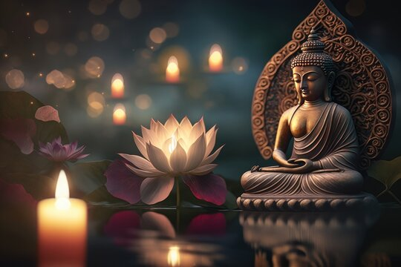

Vesak Celebrations

A time to reflect on the Buddha’s teachings and spread peace.

Vesak is marked by various rituals and celebrations that honor the Buddha. In many Buddhist communities, people visit temples to offer flowers, incense, and candles to the Buddha, as a symbol of their respect and reverence. It is a time for meditation, reflection on the Buddha's teachings, and making vows to live a life of compassion and mindfulness. Many Buddhists also engage in acts of charity, feeding the poor and offering donations to support the less fortunate. In some countries, there are public processions featuring statues of the Buddha, as well as cultural performances and rituals that highlight the Buddha’s path to enlightenment. Vesak is a celebration of peace, harmony, and spiritual growth, focusing on kindness, mindfulness, and the pursuit of wisdom.

Embrace Peace and Enlightenment this Vesak

Vesak is an opportunity to reflect on the teachings of the Buddha, deepen one's understanding of compassion, and commit to the path of mindfulness. It is a time to celebrate peace, kindness, and spiritual growth. Let the teachings of Vesak inspire you to live with greater wisdom, compassion, and tranquility in the coming year!

