***VOODOO:***

1. ***Voodoo Festival:***

**The **Ouidah Voodoo Festival** is rich with **rituals** and **traditions** that reflect the deep spiritual beliefs of the Vodun religion. A central event is the **ritual procession** to the **Temple of Pythons**, where thousands of worshippers gather to honor the sacred **pythons** believed to be the earthly representatives of Voodoo spirits. The festival is marked by performances of **traditional dances**, where devotees enter into trances to communicate with the Loa, the spirits. **Music** is also a key part of the festival, with drums and chants that invoke the presence of divine entities.**

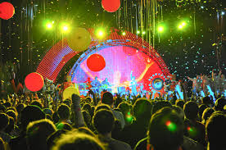

***About Ouidah Voodoo Festival:***

**The **Ouidah Voodoo Festival** is one of the largest and most important celebrations in Benin, held annually in the town of **Ouidah**, the spiritual capital of Voodoo. Celebrating the rich cultural heritage and spiritual traditions of **Vodun**, this festival draws thousands of people from around the world, including devotees, tourists, and cultural enthusiasts. The festival takes place in January and honors the diverse **spirits** (or **Loa**) that are central to the Voodoo religion.**

