**JUDAISM**

**The Meaning of Sukkot**

Sukkot is a Jewish festival celebrating the harvest and the Israelites' journey through the wilderness after their exodus from Egypt.

About Sukkot

The history and spiritual significance of Sukkot.

Sukkot, also known as the Feast of Tabernacles, is a major Jewish festival that celebrates the harvest and commemorates the 40 years the Israelites spent wandering in the desert after the Exodus from Egypt. It begins on the 15th day of the Hebrew month of Tishrei, and in 2024, it will start at sunset on Sunday, September 22, and end at nightfall on Sunday, September 29. Sukkot is a time of joy, as Jews build and dwell in temporary shelters called sukkahs, as a reminder of the fragile dwellings the Israelites lived in during their journey. The holiday also involves the waving of the Four Species: the lulav (palm branch), etrog (citron), hadassim (myrtle branches), and aravot (willow branches), which are shaken in a special ceremony. It is a time for thanksgiving for the harvest and for God's protection and provision.

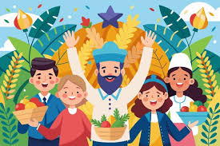

Sukkot Celebrations

A joyful celebration of harvest and faith.

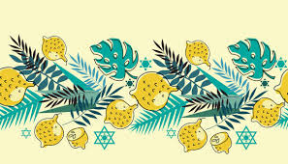

Sukkot is celebrated by building sukkahs—temporary booths or huts that symbolize the shelters the Israelites used during their desert journey. Families decorate their sukkahs with fruits, vegetables, and other items to create a festive atmosphere. Meals are eaten in the sukkah, and it is customary to invite guests into the sukkah as a way of sharing the joy of the holiday. The waving of the Four Species is a central ritual of Sukkot, performed in synagogues and in the sukkah itself. The holiday is also a time for gratitude, as Jews thank God for the harvest and seek His blessings for the coming year. Sukkot is a joyous occasion, marked by music, dancing, and celebrations with family and community.

Celebrate the Joy and Abundance of Sukkot

Sukkot is a time to reflect on God's protection and provision, as well as to celebrate the blessings of the harvest. It is a joyful festival that brings together families and communities to give thanks and share in the beauty of nature. Let the spirit of Sukkot bring happiness, peace, and gratitude to your home and heart!