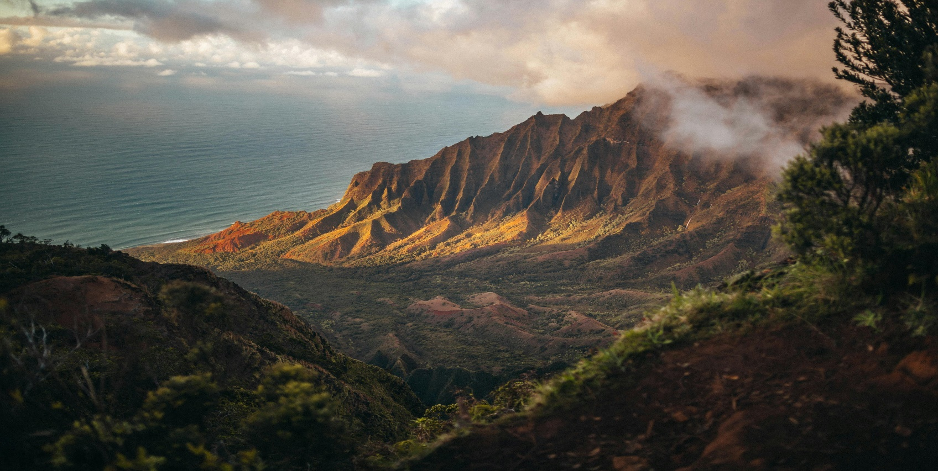

**AYUBIA**

**Ayubia: The Jewel of Nathia Gali, Khyber Pakhtunkhwa**

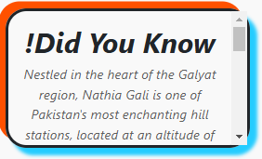Nestled in the captivating hills of Nathia Gali, Ayubia is a true gem of Khyber Pakhtunkhwa that beckons nature lovers and adventure seekers alike. Situated at an elevation of approximately 8,000 feet above sea level, Ayubia boasts a harmonious blend of breathtaking landscapes, rich biodiversity, and cultural heritage. Known for its serene ambiance and lush green surroundings, it has become a favorite destination for travelers looking to escape the hustle and bustle of city life. Whether you’re seeking tranquility, thrilling trekking experiences, or simply a breath of fresh mountain air, Ayubia promises an unforgettable journey.  
  
Ayubia is not just a single location but a collection of four picturesque hill stations – Khanspur, Ghora Dhaka, Changla Gali, and Khairagali – collectively forming the Ayubia National Park. Spanning an impressive area of 3,312 hectares, the park is a haven for wildlife enthusiasts, offering glimpses of rare species like leopards, black bears, and a plethora of colorful birds. The area’s dense pine forests, dotted with deodar and oak trees, create an enchanting canopy that enhances its natural allure. Visitors can wander along meandering trails, take in panoramic views of snow-capped peaks, and relish the soothing sounds of chirping birds and rustling leaves.

**Ayubia: A Gateway to Adventure and Serenity**

Tucked away in the majestic hills of Nathia Gali, Ayubia serves as a gateway to both adventure and serenity. This iconic destination, located in Khyber Pakhtunkhwa, is renowned for its unparalleled natural beauty and cool, refreshing climate. Named after Pakistan’s second President, Ayub Khan, the area has grown into a vibrant tourist hub while still preserving its pristine charm. The cool temperatures during summer and snow-covered landscapes in winter make Ayubia a year-round attraction for visitors from all corners of the globe.  
  
One of Ayubia’s most famous attractions is the Pipeline Track, a scenic 4-kilometer walk that connects Dunga Gali to Ayubia. This easy yet mesmerizing trek is surrounded by thick forests and offers panoramic views of the Himalayan foothills. The track’s well-maintained path makes it suitable for all ages, and it’s a perfect opportunity to connect with nature while enjoying the soothing mountain breeze. For those looking to dive deeper into adventure, Ayubia National Park offers various hiking trails, picnic spots, and the chance to explore its incredible flora and fauna. The area’s diverse wildlife and enchanting landscapes create an experience that lingers in the hearts of travelers long after they leave.

**Discover Ayubia: A Nature Lover’s Paradise**

Located in the heart of Nathia Gali, Ayubia is a nature lover’s paradise that exudes tranquility and charm. This scenic hill station in Khyber Pakhtunkhwa is part of the larger Galyat region, famous for its mesmerizing landscapes, pleasant weather, and vibrant ecosystems. With its rolling hills, dense forests, and panoramic vistas, Ayubia offers a refreshing retreat for those seeking solace in nature.  
  
Ayubia National Park, a cornerstone of the area, is a treasure trove of natural wonders. The park’s rich biodiversity includes an array of indigenous plants and animals, making it a hotspot for ecotourism. Birdwatchers can spot rare species like the golden eagle, while adventure enthusiasts can embark on thrilling treks to explore the park’s hidden gems. The park also plays a vital role in preserving the region’s ecological balance, offering a sanctuary for endangered species and protecting its unique flora and fauna. With its well-maintained walking tracks and picturesque picnic spots, Ayubia is an ideal destination for families, couples, and solo travelers alike.

**Ayubia: Where Nature Meets Adventure**

Ayubia, situated in the serene hills of Nathia Gali in Khyber Pakhtunkhwa, is a destination where nature and adventure seamlessly come together. Known for its breathtaking beauty and tranquil environment, Ayubia has become a sought-after getaway for tourists looking to rejuvenate their spirits. The area’s lush green landscapes, cool climate, and vibrant cultural heritage make it a unique and unforgettable experience.  
  
One of the standout features of Ayubia is its accessibility. Located just a short drive from Abbottabad, the journey to Ayubia is as enchanting as the destination itself, with winding roads that offer stunning views of verdant valleys and majestic mountains. Upon arrival, visitors are greeted by the charming hill station ambiance, complete with quaint cottages, local bazaars, and friendly faces. For thrill-seekers, the surrounding hills offer opportunities for trekking, rock climbing, and even camping under the starlit skies. Meanwhile, those looking for a more relaxed experience can enjoy serene walks along the Pipeline Track, savor local delicacies at roadside eateries, or simply bask in the area’s natural beauty.  
  
Ayubia is more than just a tourist spot; it’s a destination that rejuvenates the soul and rekindles a connection with nature. Whether you’re exploring its scenic trails, spotting wildlife in the national park, or enjoying the hospitality of the local community, Ayubia offers something for everyone. It’s a place that invites you to slow down, take in the beauty of the world around you, and create memories that last a lifetime.

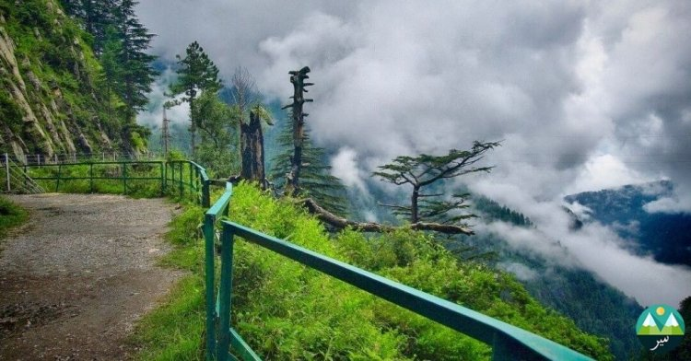***ENJOYABLE ACTIVITIES***

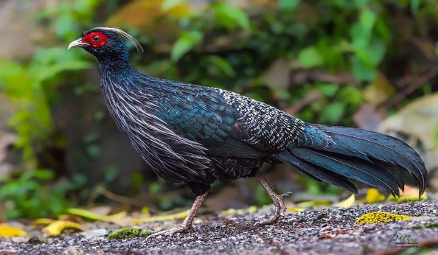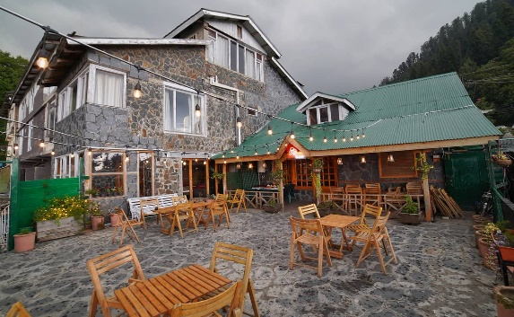

***! Wildlife Spotting – Catch glimpses of leopards, deer, and colorful birds in the lush forests.***

***! Hiking Trails – Explore Mukshpuri and Miranjani trails with stunning views and serene nature.***

***! Picnics & Food – Relax at scenic spots or enjoy local treats like pakoras and karahi.***

**Ayubia National Park: A Natural Paradise in Pakistan**

Ayubia National Park, located in the picturesque Abbottabad district of Khyber Pakhtunkhwa, Pakistan, is an awe-inspiring destination that offers nature enthusiasts an escape into the heart of the majestic Himalayan foothills. Established in 1984, the park spans across 33,000 hectares of lush green forests, steep valleys, and breathtaking mountain vistas. This natural haven is named after the revered former President of Pakistan, Ayub Khan, who was instrumental in the park's creation.  
The park is a sanctuary for a rich diversity of

**Explore the Scenic Beauty of Ayubia National Park: A Gem of Nature’s Wonders**

Nestled in the lush green hills of Abbottabad, Khyber Pakhtunkhwa, Ayubia National Park stands as one of Pakistan's most captivating natural treasures. Spanning over 33,000 hectares, this verdant sanctuary is an exceptional blend of diverse ecosystems, from dense forests to rugged mountain slopes, offering a serene retreat for nature lovers and adventure seekers alike. The park was established in 1984 and is named in honor of Ayub Khan, the former President of Pakistan, reflecting the country’s commitment to preserving its natural heritage.

Ayubia is home to an impressive variety of wildlife, including rare species such as the Himalayan brown bear, leopards, and over 200 species of birds, making it an excellent destination for wildlife enthusiasts. The lush forests of oak, pine, and deodar are not only ecologically significant but also create a spectacular backdrop for those looking to immerse themselves in nature. One of the park's most famous attractions is the Ayubia Chairlift and the famous "Pipeline Track," a historical and scenic hiking trail that offers panoramic views of the surrounding mountains and valleys.

Whether you are hiking through its serene trails, exploring its diverse ecosystems, or simply relaxing amidst its tranquil beauty, Ayubia National Park is an unforgettable experience that allows you to connect with nature in its purest form. This park, with its rich biodiversity and unmatched scenery, remains a must-visit destination for anyone seeking an authentic and unspoiled natural environment in Pakistan.

**LOCATION**

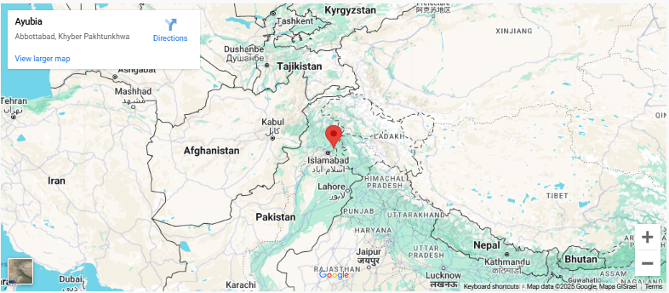

Ayubia is a scenic town in the Abbottabad District of Khyber Pakhtunkhwa, Pakistan. It is located around 70 kilometers (43 miles) from Islamabad and is part of the Galyat range. Known for the famous Ayubia National Park and its famous "Pipeline track," Ayubia offers beautiful views, dense forests, and cool weather, making it a popular destination for nature enthusiasts and trekkers.

**Why Visit AYUBIA?**

**Ayubia National Park is a must-visit for nature lovers, offering stunning landscapes, diverse wildlife, and scenic hiking trails. Enjoy breathtaking views, explore rich ecosystems, and experience tranquility in one of Pakistan's most beautiful regions.**

**FEATURED PRODUCT**

