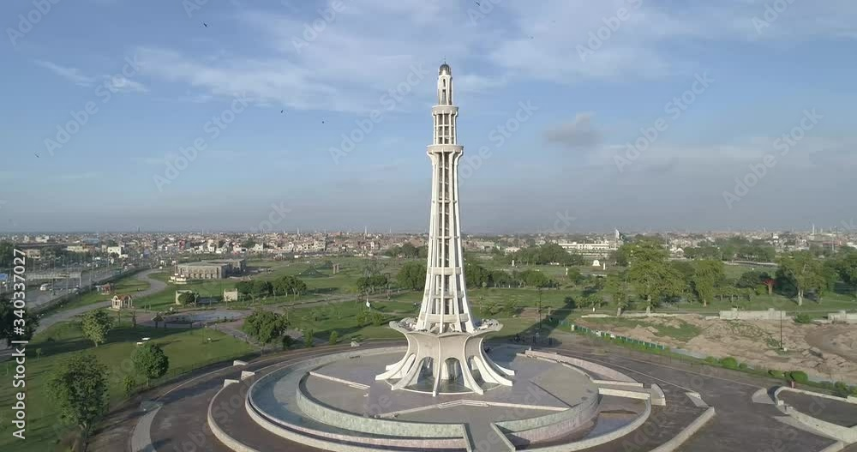

**MINAR-E-PAKISTAN**

**Historical Significance and Symbolism**

Minar-e-Pakistan, located in Lahore, stands as one of Pakistan's most iconic landmarks, symbolizing the country's struggle for independence. Erected in 1968, it marks the historical moment of the Lahore Resolution of 1940, where the demand for an independent Muslim state was officially presented. This monumental structure, with its unique blend of Mughal, modern, and Islamic architectural styles, represents the dreams and aspirations of the Pakistani people. The minaret rises majestically to a height of 70 meters, serving as a reminder of the sacrifices made during the journey to independence. It is not just a monument, but a symbol of Pakistan's unity, resilience, and the relentless pursuit of freedom.

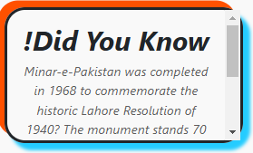

**Architectural Beauty and Design**

The design of Minar-e-Pakistan is an architectural marvel,

combining classical Mughal design elements with contemporary

styles. The structure’s base is made up of four large platforms,

with intricate floral motifs and geometric patterns that evoke the grandeur of Mughal-era craftsmanship. The central tower, which rises high into the sky, is adorned with beautiful marble and granite, offering a stunning visual appeal. The minaret’s top is topped with a large umbrella-shaped dome, adding to its graceful silhouette against the skyline of Lahore. The combination of Islamic calligraphy and artistic decoration makes the Minar-e-Pakistan not just a monument of historical significance, but also a masterpiece of architectural design that continues to attract visitors from around the world.

**A Center for National Pride and Reflection**

Minar-e-Pakistan holds a deep emotional significance for Pakistanis, as it stands as a national symbol of their pride and unity. It serves as a focal point for numerous celebrations, including Independence Day events, rallies, and national commemorations. For many, visiting this monument is an opportunity to reflect on the sacrifices made for the creation of Pakistan and to honor the vision of the leaders who fought for the nation’s independence. The park surrounding the minaret is a popular space for picnics, strolls, and gatherings, making it an ideal place for both contemplation and celebration. Minar-e-Pakistan is more than just a historical structure; it is a place where the nation’s identity is celebrated and its future is envisioned.

**A Beacon of Hope and Unity**

Minar-e-Pakistan represents not only the struggle for independence but also the vision of a united and prosperous Pakistan. The resolution passed at Lahore in 1940 marked the beginning of a new chapter in South Asian history, and the minaret stands as a permanent tribute to that moment. Visitors to Minar-e-Pakistan are often filled with a sense of reverence and pride, as the monument continues to inspire a sense of hope and collective identity. It stands as a beacon of unity, reminding all who see it of the importance of freedom, equality, and justice. Whether you're a local resident or a foreign tourist, Minar-e-Pakistan is a place where history and hope converge.

