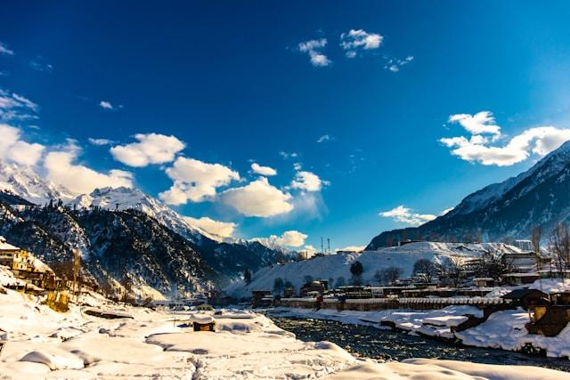

**Murree: The Scenic Mountain Escape of Punjab**

Nestled in the heart of the Punjab province, near Islamabad, Murree stands as a quintessential hill station that draws travelers from all corners of Pakistan and beyond. Known for its charming pine-covered hills, crisp air, and vibrant green landscapes, Murree offers an idyllic retreat away from the hustle and bustle of city life. The hill station is dotted with colonial-era buildings, offering a unique blend of natural beauty and rich history. With its pleasant weather and breathtaking views of the surrounding mountains, Murree is the perfect place for anyone looking to relax, rejuvenate, or explore the wonders of nature. Visitors to Murree can enjoy a variety of activities, from scenic drives along the winding hills to exploring the many trekking trails that lead to panoramic viewpoints. Whether it's the lush greenery of Patriata (New Murree), the snowy charm of Mall Road, or the quaint markets selling local handicrafts, Murree’s charm is undeniable. The area also boasts beautiful parks, serene lakes, and lush valleys, each offering a unique experience to adventurers, photographers, and nature enthusiasts. Murree is not just a destination; it’s an experience that offers something for everyone, making it one of the most beloved spots in Pakistan.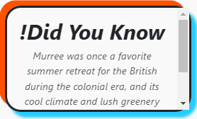

**Murree: A Majestic Hill Station Amidst the Himalayas**

Murree is a scenic hill station situated in the foothills of the majestic

Himalayas, just a short drive from Islamabad. The town is renowned for its

breathtaking natural beauty, consisting of dense forests, lush valleys, and towering peaks that are particularly captivating during the monsoon and winter seasons. The hill station offers panoramic views of the surrounding areas, including the majestic Rawalpindi and Islamabad plains, all of which add to the area’s unique allure. With its cool weather and picturesque landscapes, Murree has long been a favorite vacation spot for families, couples, and solo travelers seeking tranquility in nature.  
The town’s vibrant markets, filled with local souvenirs and handicrafts, blend harmoniously with its serene natural surroundings, providing a delightful experience for those who visit. Additionally, Murree boasts a rich cultural history that can be explored through its colonial-era architecture, local traditions, and festivals that add to the area's charm. Whether you’re admiring the stunning views from Pindi Point, taking a chairlift ride at Patriata, or enjoying a leisurely walk along Mall Road, Murree is the ideal getaway to reconnect with nature and rejuvenate your spirit.

**Murree: A Perfect Blend of Nature and Adventure**

Murree is a picturesque hill station located in Punjab, near the capital city of Islamabad, offering visitors a perfect blend of nature, adventure, and tranquility. Surrounded by pine forests, charming valleys, and cool mountain air, it’s the ultimate destination for those who wish to escape the heat of the plains and immerse themselves in natural beauty. Whether you’re visiting during the summer to enjoy the refreshing weather or in winter to experience the charm of snowfall, Murree is an all-season destination with something to offer everyone.  
  
From hiking in the hills to exploring the rich biodiversity of the surrounding forests, Murree offers countless outdoor activities for adventure enthusiasts. Families can enjoy leisurely walks along the scenic roads or visit the famous Patriata chairlifts to witness panoramic views of the entire region. Murree is not just a retreat into nature but also a place to reconnect with history, as its architecture and local traditions tell the story of a region that has evolved over centuries. For those seeking relaxation, the serene environment of Murree provides the perfect ambiance for a peaceful holiday.

**Murree: The Gateway to Tranquil Mountain Retreats**

Situated in the beautiful Punjab province of Pakistan, Murree is a mountain retreat that offers visitors an unforgettable blend of scenic views, outdoor adventure, and a peaceful environment. Located just an hour’s drive from Islamabad, it serves as an accessible getaway for those seeking a break from city life. Murree is renowned for its cool climate, lush forests, and beautiful hilltop vistas, which make it a favorite destination for tourists, photographers, and nature lovers alike. The area’s proximity to Islamabad also makes it a popular weekend destination for both locals and international visitors who are eager to experience the natural splendor of the region.  
  
The town is famous for its winding roads, beautiful hiking trails, and towering pines, providing ample opportunities for outdoor enthusiasts. From exploring the beautiful hills of Patriata to taking in the panoramic views from the top of Mall Road, Murree promises to deliver both peace and adventure. The serene lakes, green valleys, and scenic parks in Murree offer the ideal spots for relaxation, meditation, and family picnics. With its combination of natural beauty, cool weather, and cultural charm, Murree is a must-visit destination for anyone seeking an escape into the tranquility of the mountains.

***ENJOYABLE ACTIVITIES***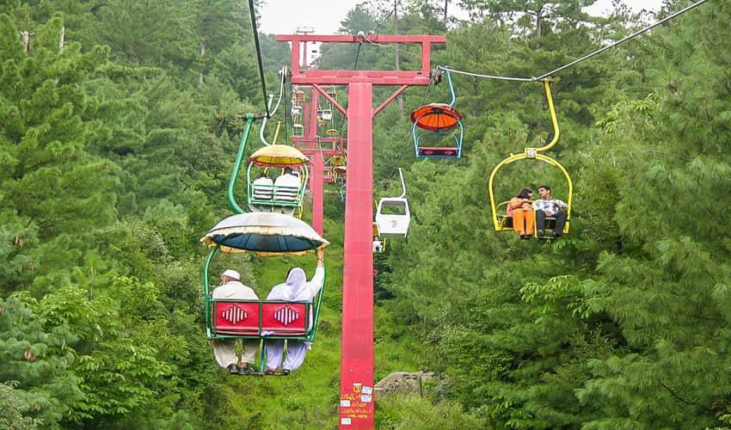

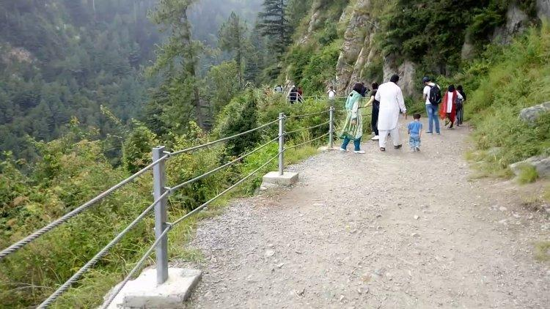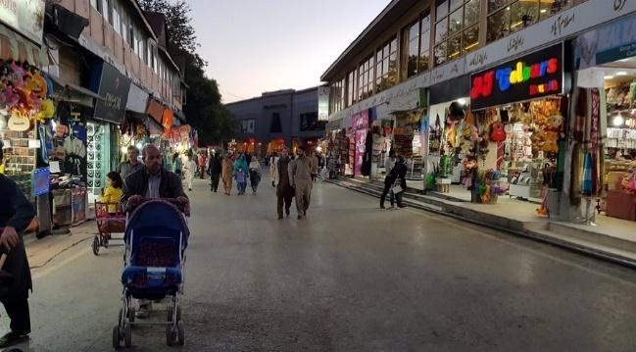





**Murree: A Year-Round Tourist Destination Surrounded by Majestic Mountains**

Murree, often referred to as the "Queen of Hills," is a captivating hill station located in the Punjab province of Pakistan, just a short drive from Islamabad. The town sits amidst the picturesque hilltops of the Pir Panjal Range, offering visitors unparalleled views of lush valleys, dense forests, and snow-capped peaks. Murree is a perfect year-round destination, with its cool summer weather and snow-covered landscapes in the winter, providing a serene escape from the hustle and bustle of city life. The area’s diverse natural beauty and tranquility make it a popular choice for tourists seeking a respite from the stress of daily life, while also catering to adventure seekers with its hiking trails, chairlifts, and scenic spots.  
  
The history and charm of Murree are reflected in its unique colonial-era architecture, blending seamlessly with the surrounding natural beauty. The town boasts a rich cultural heritage, with its lively markets offering local handicrafts, authentic food, and souvenirs, making it a great place to explore and immerse yourself in the local culture. Major attractions include Mall Road, Pindi Point, Patriata, and Kashmir Point, all offering sweeping vistas of the surrounding valleys. Whether you’re visiting for a short weekend getaway or a longer stay, Murree provides a perfect blend of adventure, relaxation, and cultural exploration. Its combination of natural landscapes, cool weather, and vibrant local culture makes Murree an enchanting destination that appeals to visitors of all ages and interests.

**Murree: The Ideal Hill Station for Nature Lovers, Adventurers, and Culture Enthusiasts**

Murree, located in the stunning Punjab province near Islamabad, stands as one of Pakistan’s most beloved hill stations. Nestled in the foothills of the majestic Himalayas, this charming town offers an incredible mix of natural beauty, rich cultural heritage, and outdoor adventure. With its towering pine forests, scenic mountain paths, and breathtaking views, Murree provides an immersive experience that combines the best of nature and leisure. The cool, crisp air and the picturesque landscapes make it an inviting destination, perfect for those looking to escape the heat of the plains and reconnect with the beauty of nature. Whether you’re seeking relaxation or adventure, Murree has something to offer everyone.  
  
The town's accessibility from Islamabad makes it an ideal weekend retreat, offering a quick escape into the mountains without the need for extensive travel. Popular destinations like Patriata, also known as New Murree, offer thrilling chairlift rides and scenic views of the lush green hills, while other spots like Pindi Point and Kashmir Point offer panoramic vistas of the valleys below. Murree also boasts a variety of hiking trails that wind through forests and lead to stunning viewpoints, providing ample opportunities for outdoor activities. Apart from its natural beauty, Murree's cultural heritage is equally rich, with historic buildings, local markets, and a blend of colonial-era architecture that adds to its charm. Whether you're exploring its lush hills, relaxing by its serene lakes, or indulging in local delicacies, Murree offers an all-encompassing experience that attracts nature lovers, adventurers, and cultural enthusiasts alike.

**LOCATION**

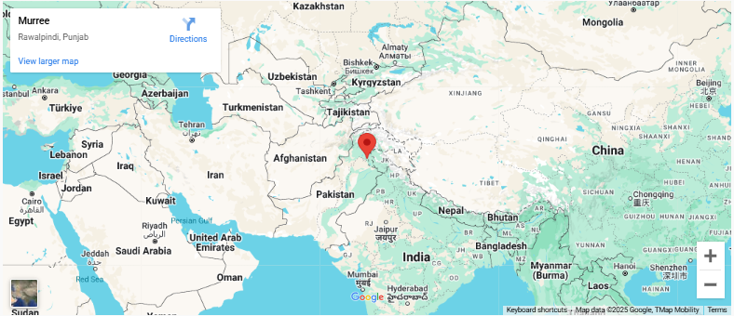

Murree is a popular hill station located in the Punjab province of Pakistan. It lies about 60 kilometers (37 miles) northeast of Islamabad, the capital city. Situated in the Pir Panjal Range, Murree is known for its cool weather, scenic landscapes, and pine forests, making it a popular tourist destination, especially in the summer.

**Why Visit Murree?**

**Murree offers stunning landscapes, cool mountain air, and a peaceful retreat. Its scenic spots and rich culture make it the perfect escape for nature lovers and adventure seekers.**

**FEATURED PRODUCT**



