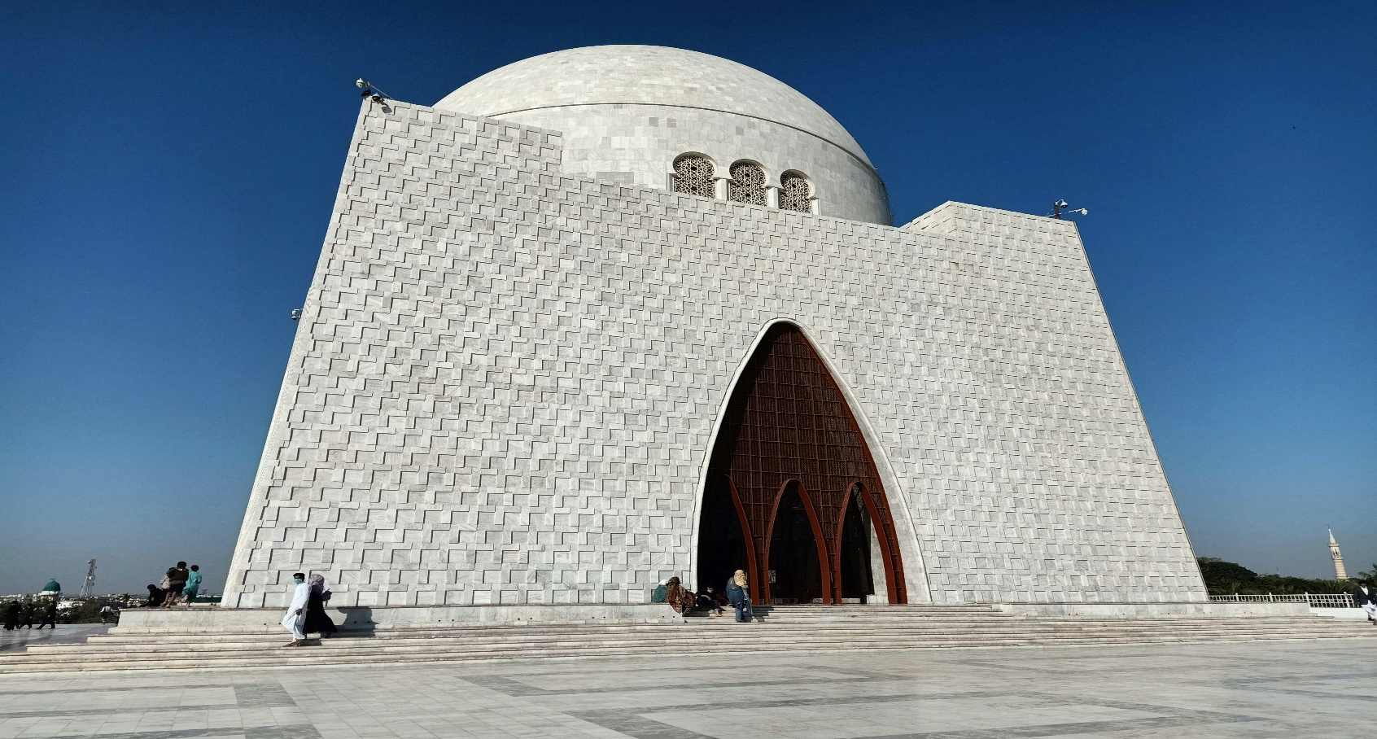

**QUAID-E-MAUSOLEUM**

**A Symbol of National Unity and Respect**

The Quaid-e-Mausoleum, also known as Mazar-e-Quaid, is the final resting place of Muhammad Ali Jinnah, the founder of Pakistan. Located in the heart of Karachi, this iconic mausoleum stands as a beacon of national pride and unity. Completed in 1970, the structure is a masterpiece of modernist architecture, designed by renowned architect Yahya Merchant. Its striking white marble façade, complemented by a lush surrounding park, creates a serene and dignified atmosphere that pays homage to the Father of the Nation. The mausoleum is not only a symbol of Jinnah’s enduring legacy but also a focal point for people to gather and reflect on the sacrifices made during Pakistan’s struggle for independence. Visitors from around the world come to pay their respects, admire the mausoleum’s architectural beauty, and experience the profound sense of patriotism it inspires. As a landmark that embodies Pakistan’s history and aspirations, the Quaid-e-Mausoleum remains an integral part of the country’s cultural and historical heritage.

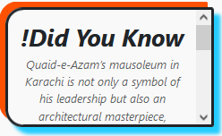

**A Tribute to Pakistan’s Founder**

Nestled amidst the bustling city of Karachi, the Quaid-e-Mausoleum stands as a solemn and majestic tribute to Muhammad Ali Jinnah, the visionary leader who led the creation of Pakistan. This iconic mausoleum is more than just a resting place; it is a symbol of the nation’s respect, gratitude, and admiration for its founder. Constructed with gleaming white marble and featuring a distinctive dome, the structure exudes elegance and simplicity, reflecting Jinnah’s own ideals of unity, faith, and discipline. The mausoleum is surrounded by beautifully manicured gardens and fountains, offering a peaceful retreat from the city’s chaos. It also houses the graves of other prominent leaders, such as Liaquat Ali Khan, the first Prime Minister of Pakistan. As a site of national importance, the Quaid-e-Mausoleum attracts thousands of visitors daily, who come to honor Jinnah’s legacy and reflect on the values that shaped Pakistan. It is a must-visit destination for anyone seeking to connect with the country’s history and its founding principles.

**Mazar-e-Quaid: A National Landmark**

The Quaid-e-Mausoleum, also known as Mazar-e-Quaid, is an iconic monument that holds a special place in the hearts of Pakistanis. Located in Karachi, this grand mausoleum commemorates the life and legacy of Muhammad Ali Jinnah, the Father of the Nation. Designed by Indian architect Yahya Merchant, the mausoleum’s modernist design features a large square platform, a circular dome, and intricate marble patterns, symbolizing strength and unity. Its central chamber houses Jinnah’s tomb, surrounded by an ambiance of reverence and respect. The mausoleum’s serene gardens and reflecting pools add to its majestic aura, making it a prominent landmark and tourist attraction. National events, ceremonies, and commemorations are often held here, reinforcing its role as a symbol of patriotism and unity. For those visiting Karachi, the Quaid-e-Mausoleum offers an opportunity to not only admire its architectural beauty but also to delve into the history and values that led to the creation of Pakistan.

**A Testament to Vision and Leadership**

The Quaid-e-Mausoleum is more than just a resting place for Muhammad Ali Jinnah; it is a testament to his vision, leadership, and unwavering dedication to the creation of Pakistan. Situated in Karachi, the mausoleum is a striking example of modernist architecture, crafted from pure white marble that shines brilliantly under the sun. Its geometric design and towering dome evoke a sense of strength and grandeur, while the tranquil surroundings offer a space for reflection and reverence. The mausoleum is not just a site of historical significance; it is also a source of inspiration for the people of Pakistan, reminding them of Jinnah’s enduring principles of justice, equality, and democracy. Visitors are drawn to its peaceful ambiance, stunning architecture, and the opportunity to pay homage to the man who changed the course of history. The Quaid-e-Mausoleum remains a symbol of hope, resilience, and the enduring spirit of Pakistan, making it an essential part of the nation’s identity.

# ENJOYABLE ACTIVITIES

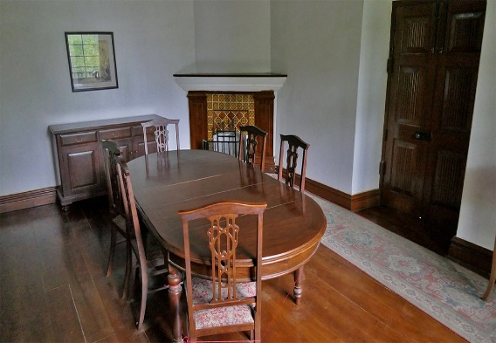

! Quaid-e-Azam's car, a symbol of his leadership and simplicity, was a 1947 Packard, used by him during Pakistan's early days. It reflects his modesty and commitment to the country, despite the grandeur it represented.

! Quaid-e-Azam Dining Boots combine style and comfort, reflecting the elegance and grace of Pakistan's founding father. Crafted with precision, these shoes are a timeless tribute to leadership and quality craftsmanship.

! The Quaid-e-Azam dining table is a symbol of simplicity and elegance, reflecting the disciplined lifestyle of Pakistan's founding father, Muhammad Ali Jinnah. It is a reminder of his commitment to modesty and his focus on leadership and service to the nation.

**The Legacy of Quaid-e-Mausoleum**

The Quaid-e-Mausoleum, also referred to as Mazar-e-Quaid, is an enduring symbol of Pakistan’s struggle for independence and the vision of its founding father, Muhammad Ali Jinnah. Situated in Karachi, this mausoleum serves as a solemn monument commemorating Jinnah’s extraordinary leadership and dedication to the creation of Pakistan. The structure is a stunning example of modernist architectural design, featuring a gleaming white marble exterior and an impressive dome that can be seen from afar. Surrounded by sprawling, beautifully landscaped gardens, the mausoleum provides a tranquil setting that contrasts with the vibrant life of the city. Visitors are drawn to this sacred site not only to pay homage to Jinnah but also to reflect on the values of unity, faith, and discipline that he championed. The mausoleum also houses the graves of other prominent figures in Pakistan’s history, making it a repository of the nation’s heritage. By blending historical reverence with architectural elegance, the Quaid-e-Mausoleum stands as a powerful reminder of Pakistan’s journey towards sovereignty and the enduring legacy of its founder.

**An Icon of National Pride and Reverence**

The Quaid-e-Mausoleum is more than a burial place for Muhammad Ali Jinnah; it is an iconic representation of Pakistan’s identity and aspirations. Located in the bustling metropolis of Karachi, the mausoleum is an architectural marvel crafted from pristine white marble and designed to evoke a sense of strength and grandeur. The monument’s geometric design and towering dome are both timeless and imposing, reflecting the resilience and unity of the Pakistani people. Surrounded by expansive gardens and pathways, the mausoleum offers visitors a serene escape where they can connect with their country’s rich history. The site holds significant cultural and historical importance, serving as a venue for national celebrations, ceremonies, and tributes to Jinnah and other prominent leaders interred here. For millions of Pakistanis and international visitors, the Quaid-e-Mausoleum is a place of reverence, inspiration, and reflection on the sacrifices made for the creation of the nation. Its enduring presence in the heart of Karachi cements its role as a cornerstone of Pakistani heritage and a beacon of national pride.

# LOCATION

The Quaid-e-Azam Mausoleum is located in Karachi, Sindh, Pakistan. It is the final resting place of Muhammad Ali Jinnah, the founder of Pakistan. The mausoleum is situated in the heart of the city, near the city center, and is a significant landmark.

# Why Visit Quaid-E-Mausoleum?

**Visiting the Quaid-e-Mausoleum is a journey into the heart of Pakistan's history and heritage. This iconic landmark honors Muhammad Ali Jinnah, the founder of Pakistan, and offers a serene escape amidst Karachi's bustling cityscape.**

# FEATURED PRODUCT