1. Firstly, I am selecting a fake news from my topic (political news) –
2. Suppose, I find the following fake newses:
   1. <https://www.kalerkantho.com/online/national/2019/10/12/825653/> (সাড়ে চার কোটি টাকা ফেরত দিলেন ছাত্রলীগ নেতা)
3. I write a new row in the excel file:
   1. First column: ID – kalerkantho0001F (0001 my given number, as it is the first news I got from Kalerkantho, and F as it is a fake news. If it was a real news I would put R)
   2. Second column: URL is the news url.
   3. Third column: Title is the news title.
4. Now, I go to Twitter and search there with the title of the news and find multiple post sharing the Kalerkantho news on Twitter:

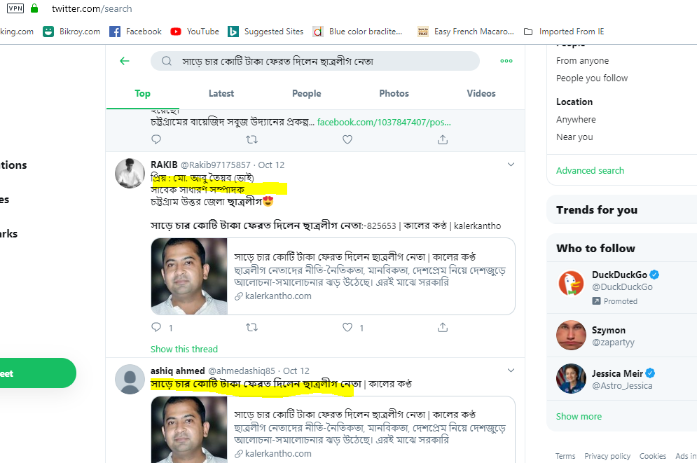

1. Next I open each of these posts (in new tabs) by clicking on the highlighted area and copy the post ID, highlighted in the picture below. I save this post ID in the SharedID field.



1. I get multiple IDs from all these posts and save them in new tabs on the right

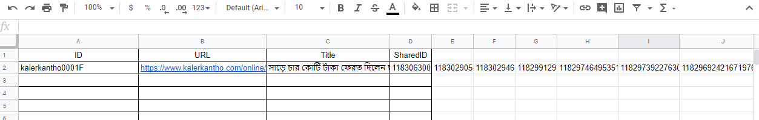

1. **Next I go to Google, search and find more fake (and real) news on the same topic. I do the above steps for each of these news.**
2. <https://docs.google.com/spreadsheets/d/1pwWFs0CMwx30RHuKDXYGXeqfyeYhpqEAYN5ZZoBwvTY/edit?usp=sharing>
3. I (Minhaz) is working with political news (fake & real). Lipon is working with Religion related news. Sabrina please work with Celebrity related or Sports related news.