**Ahsanullah University of Science and Technology**



**Distributed Database Lab**



**CSE 4126**



***Project name:*** National patient Management System.

***Submitted by:***

Md. Shakhawat Hossain Mridha (15-01-04-067)

***Submitted to:***

Mr. Mohammad Imrul Jubair Asst. Prof., AUST

Mrs. Safun Nesa Saira Lecturer, AUST

National Patient management system

**Project Abstract:**

This will be a database of patient management system which will be able to be operated nationally. There will be the information of all patients around Bangladesh so that when a patient will go to a new doctor at new hospital, they will be able to check his/her past history through this database. So, the diagnosis will be more perfect and easy for the doctor and patient will be benefited at most.

**User of this database:**

Hospital authority.

**Need of having distributed database for this project:**

As this will be a national patient database so the data will be entered from every hospital around Bangladesh. That’s why we need distributed database management system.

**Global relations of this project:**

**Doctors** (dr_id, dr_name, dr_age, dr_sex , dr_phn,dr_email, dr_hospital_chamber, designation, degree, department, experience, time,

Fee, day, primary key (dr_id))

2

**Reports** (rep_id, rep_date, impression, primary key(rep_id))

**Medicine** (med_id, med_name, med_generic_name,med_company, med_work, med_per_price, primary key (med_id))

**Diagnosis** (dia_id, dia_name, dia_cost, dia_requirements,dia_hospital, rep_id, primary key (dia_id), foreign key(rep_id) references reports(rep_id))

**History** (his_id, his_date, problem, rep_id, dr_id, med_id,primary key (his_id), foreign key(rep_id) references

reports(rep_id),foreignkey(dr_id)references

doctors(dr_id), foreign key(med_id) references medicine(med_id))

**Surgical_history** (s_his_id, s_date, s_name, s_hospital,s_cost, dr_id, primary key (s_his_id), foreign key(dr_id) references doctors(dr_id))

**Patient** (pt_id, pt_name, pt_age, pt_sex, pt_phn, pt_house,pt_road, pt_block, pt_section, pt_district, bl_grp, weight, height, dia_id, his_id, s_his_id, primary key (pt_id), foreign key(dia_id) references diagnosis(dia_id), foreign

key(his_id) references history(his_id), foreign key(s_his_id) references surgical_history(s_his_id))

**Functions and procedures of the database:**

* **Function 1 (blood_group):**

This is a function which counts the patients of same blood group of given ID as parameter.

3

* **Procedure 2 (same_bl_group):**

This is a procedure which gives the patients ID, corresponding number of patients of same blood group and corresponding blood group (fetched from the cursor) using function 1.

* **Function 3 (dr):**

This is a function which finds the doctor ID who hasn’t done any surgery till now (this works for only single ID).

* **Function 4 (rep):**

This is a function which counts the patients who have report impression as ‘normal report’.

* **Procedure 5 (rep_date):**

This is a procedure which gives the patients’ ID and name whose reports were made on 21-05-2016.

* **Procedure 6 (his):**

This is a procedure which shows the history date and problem of a patient.

* **Procedure 7 (shis):**

This is a procedure which gives the patients’ name and phone number whose surgical cost was greater than 60 thousands.

* **Procedure 8 (dd):**

This is a procedure which shows the name and designation of the doctor who operated on desired patient.

* **Blood_group_find:**

Search patient of a special blood group from server at site.

**Fragments of this project:**

Doctors1 = SL dr_hospital_chamber=”Square Hospital” Doctors

Doctors2 = SL dr_hospital_chamber =”Medinova Diagnostic” Doctors

4

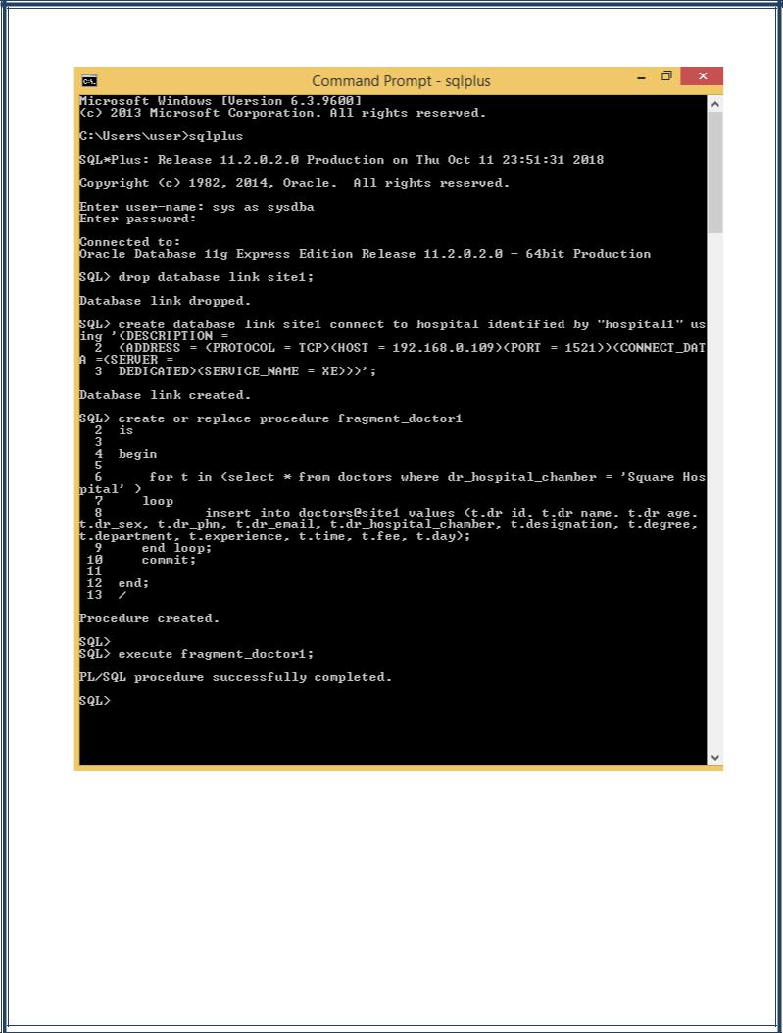

5

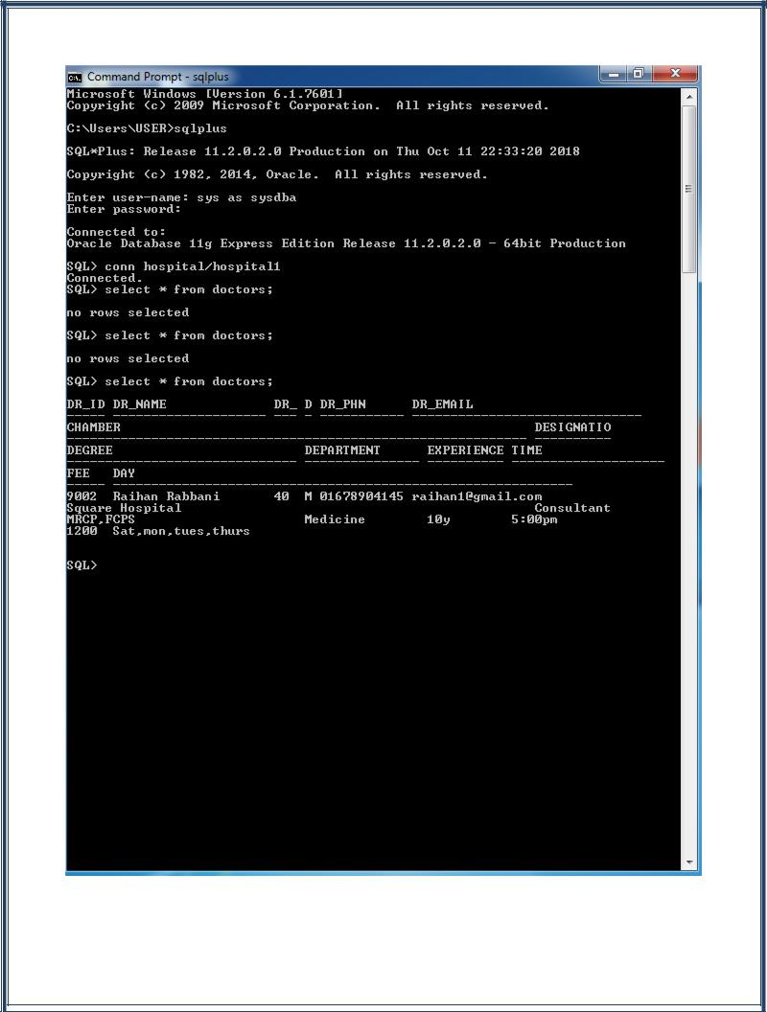

6

**Sites of this project:**

Site1 (Square Hospital) : Doctors1, patient, reports, medicine, diagnosis, history, surgical_history.

Site2 (Apollo Hospital) : Doctors2, patient, reports, medicine, diagnosis, history, surgical_history.

**Triggers of this project:**

Trigger 1: There are two tables at site 1 where male and female patients are differentiated.

Trigger 2: There is a new table at site 1 when a phone number of a patient is changed it is stored there.

**Level-3 distribution transparency:**

When Square changes their medicine price it will be updated

on server too.

Select med_name, med_generic_name, med_company, med_work into $med_name, $med_generic_name, $med_company, $med_work from medicine where med_id = 02

IF #FOUND then,

Delete medicine at site1 where med_id = 02;

Insert into medicine at site1: (02, $med_name, $med_generic_name, $med_company, $med_work, “35tk”);

Delete medicine at server where med_id = 02;

Insert into medicine at server: (02, $med_name, $med_generic_name, $med_company, $med_work, “35tk”);

7

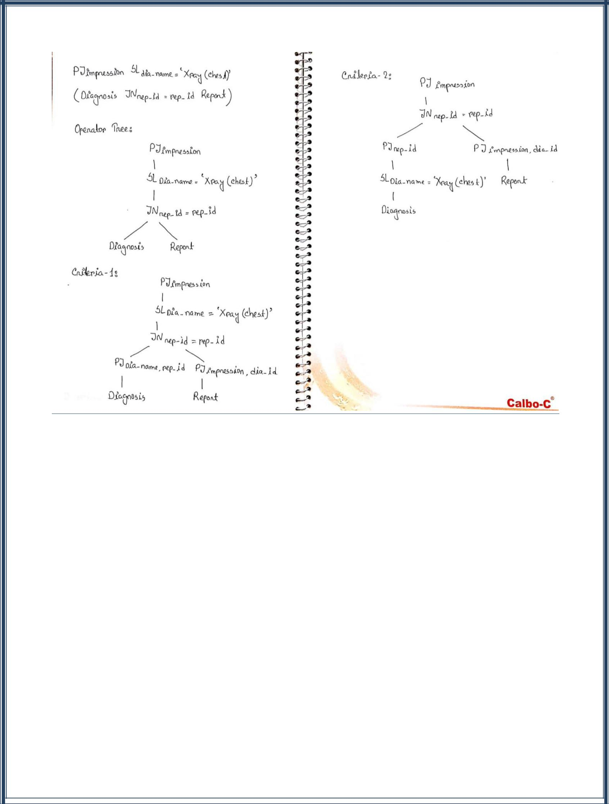**Operator Tree:**

**Conclusion:**

We have tried our best to implement a patient management database system. Hope this will help to maintain patient history if implemented nationally.

8