**Ahsanullah University of Science and**

**Technology**



**Distributed Database Lab**



**CSE 4126**



***Project name:*** National patient Management System.

***Submitted by:***

Farzana Sharmin Mou (15-01-04-076)

***Submitted to:***

Mr. Mohammad Imrul Jubair Asst. Prof., AUST

Mrs. Safun Nesa Saira Lecturer, AUST

National Patient management system

**Project Abstract:**

This will be a database of patient management system which will be able to be operated nationally. There will be the information of all patients around Bangladesh so that when a patient will go to a new doctor at new hospital, they will be able to check his/her past history through this database. So, the diagnosis will be more perfect and easy for the doctor and patient will be benefited at most.

**User of this database:**

Hospital authority.

**Need of having distributed database for this project:**

As this will be a national patient database so the data will be entered from every hospital around Bangladesh. That’s why we need distributed database management system.

**Global relations of this project:**

**Doctors** (dr_id, dr_name, dr_age, dr_sex , dr_phn, dr_email, dr_hospital_chamber, designation, degree, department, experience, time, Fee, day, primary key (dr_id))

**Reports** (rep_id, rep_date, impression, primary key (rep_id))

2

**Medicine** (med_id, med_name, med_generic_name,med_company, med_work, med_per_price, primary key (med_id))

**Diagnosis** (dia_id, dia_name, dia_cost, dia_requirements,dia_hospital, rep_id, primary key (dia_id), foreign key(rep_id) references reports(rep_id))

**History** (his_id, his_date, problem, rep_id, dr_id, med_id, primarykey (his_id), foreign key(rep_id) references reports(rep_id), foreign key(dr_id) references doctors(dr_id), foreign key(med_id) references medicine(med_id))

**Surgical_history** (s_his_id, s_date, s_name, s_hospital, s_cost, dr_id,primary key (s_his_id), foreign key(dr_id) references doctors(dr_id))

**Patient** (pt_id, pt_name, pt_age, pt_sex, pt_phn, pt_house, pt_road,pt_block, pt_section, pt_district, bl_grp, weight, height, dia_id, his_id, s_his_id, primary key (pt_id), foreign key(dia_id) references diagnosis(dia_id), foreign key(his_id) references history(his_id), foreign key(s_his_id) references surgical_history(s_his_id))

**Fragments of this project:**

Doctors1 = SL dr_hospital_chamber=”Square Hospital” Doctors

Doctors2 = SL dr_hospital_chamber =”Medinova Diagnostic” Doctors

3

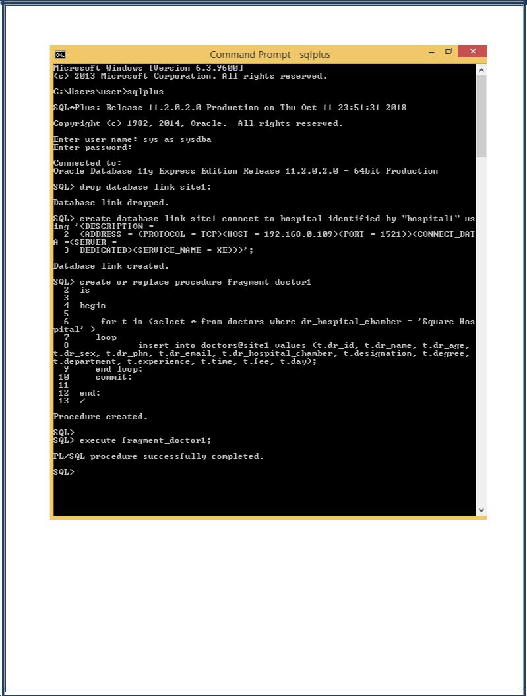

4

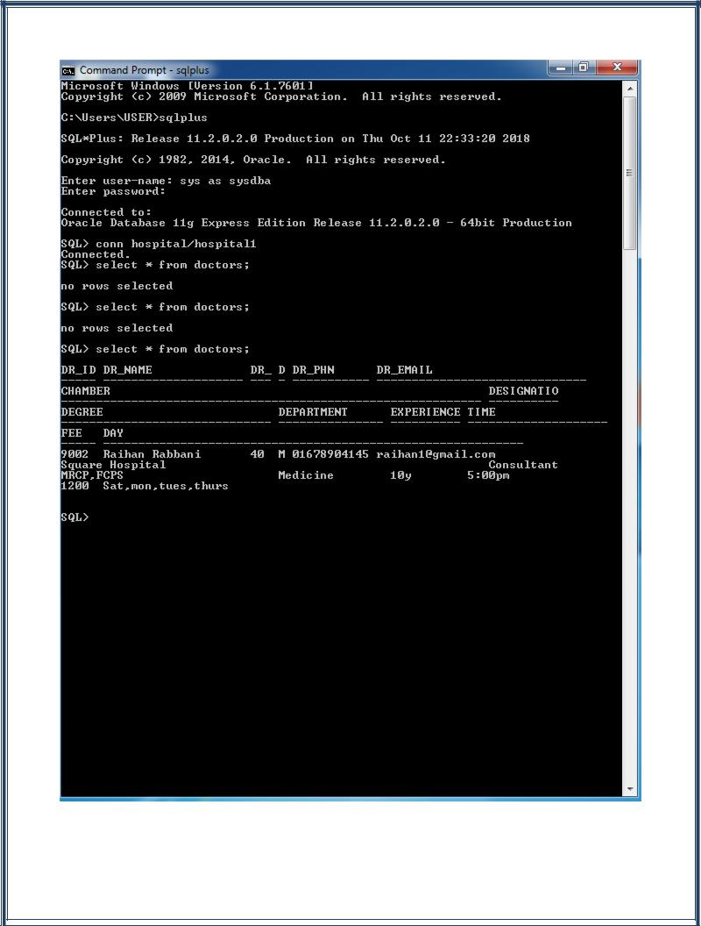

5

**Sites of this project:**

Site1 (Square Hospital) : Doctors1, patient, reports, medicine, diagnosis, history, surgical_history.

Site2 (Apollo Hospital) : Doctors2, patient, reports, medicine, diagnosis, history, surgical_history.

**Triggers of this project:**

Trigger 1: There are two tables at site1 where male and female patients are differentiated.

Trigger 2: There is a new table at site 1 when a phone number of a patient is changed it is stored there.

**A procedure which works from site to server:**

There is a procedure named blood_group_find where from site1 means

from Square Hospital they can search patients of blood group B+ from

server’s patient table.

**Level-3 distribution transparency:**

If a doctor of Square hospital changes his chamber to Medinova diagnostic center then his information will be deleted from site 1 and inserted to site 2.

Select dr_name, dr_age, dr_sex, dr_phn, dr_email, designation, degree, department, experience, time, fee, day into $dr_name, $dr_age, $dr_sex, $dr_phn, $dr_email, $designation, $degree, $department, $experience, $time, $fee, $day from doctors1 at site1

Where dr_id = 9002

IF #FOUND then,

Insert into doctors2 at site2: (9002, $dr_name, $dr_age, $dr_sex,

6

$dr_phn, $dr_email, “Medinova”, $designation, $degree, $department, $experience, $time, $fee, $day);

Delete doctors1 at site1 where dr_id = 9002;

**Operator Tree:**

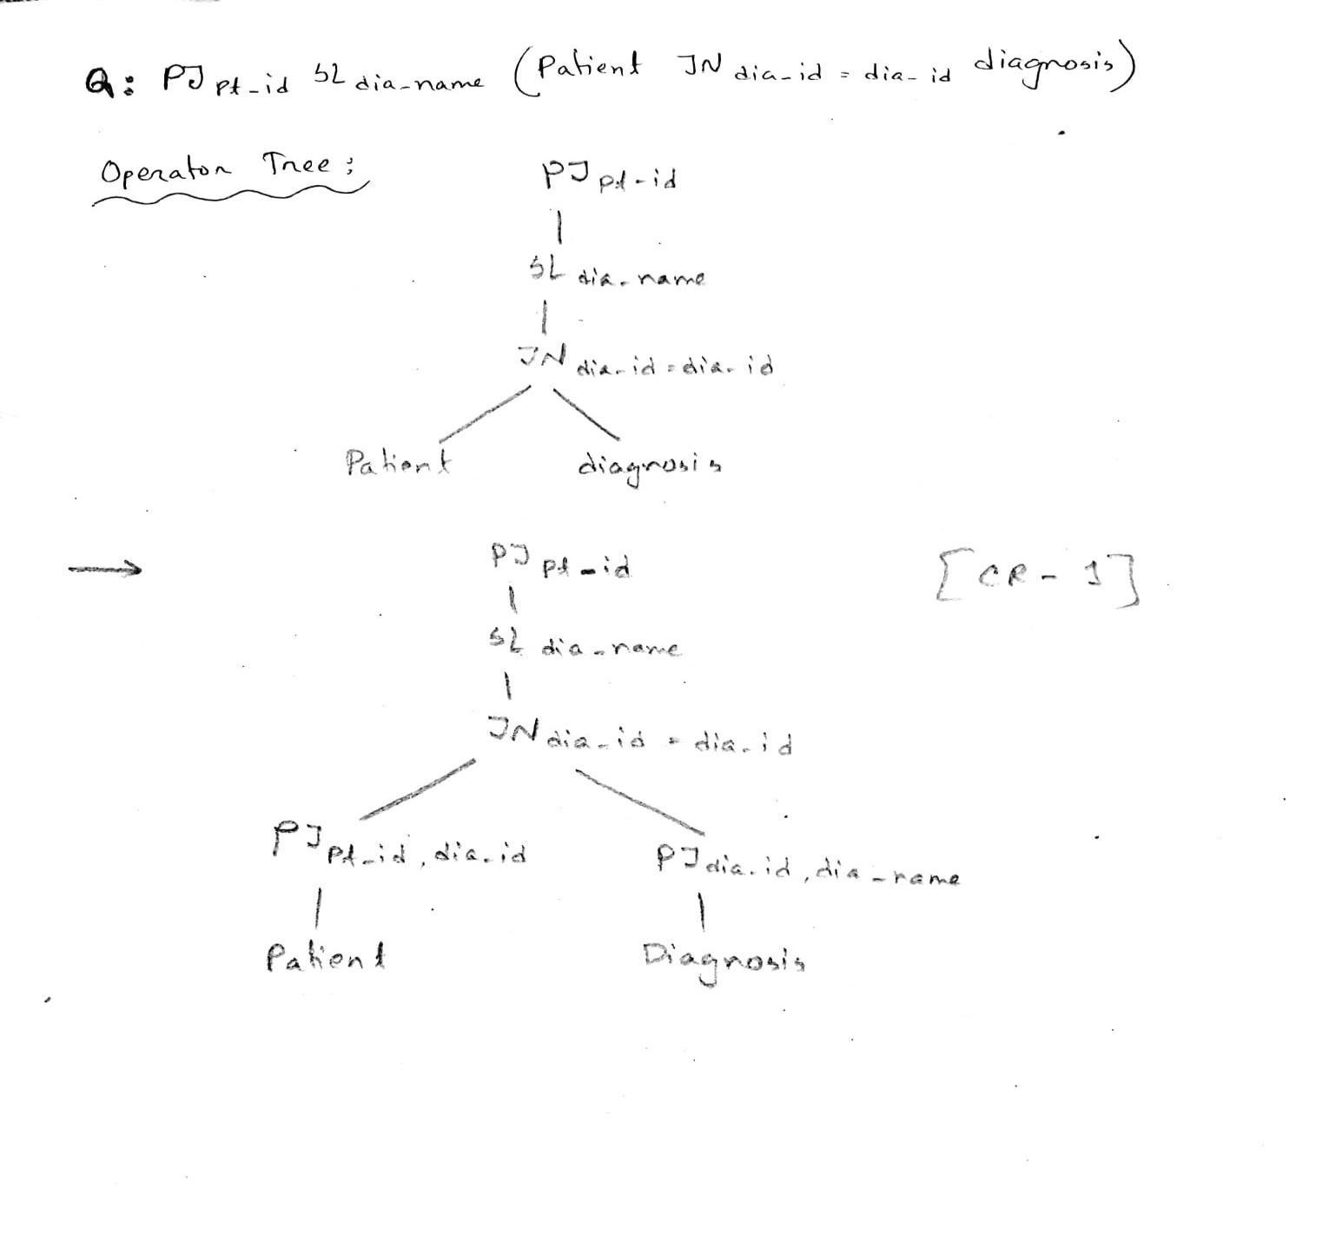

7

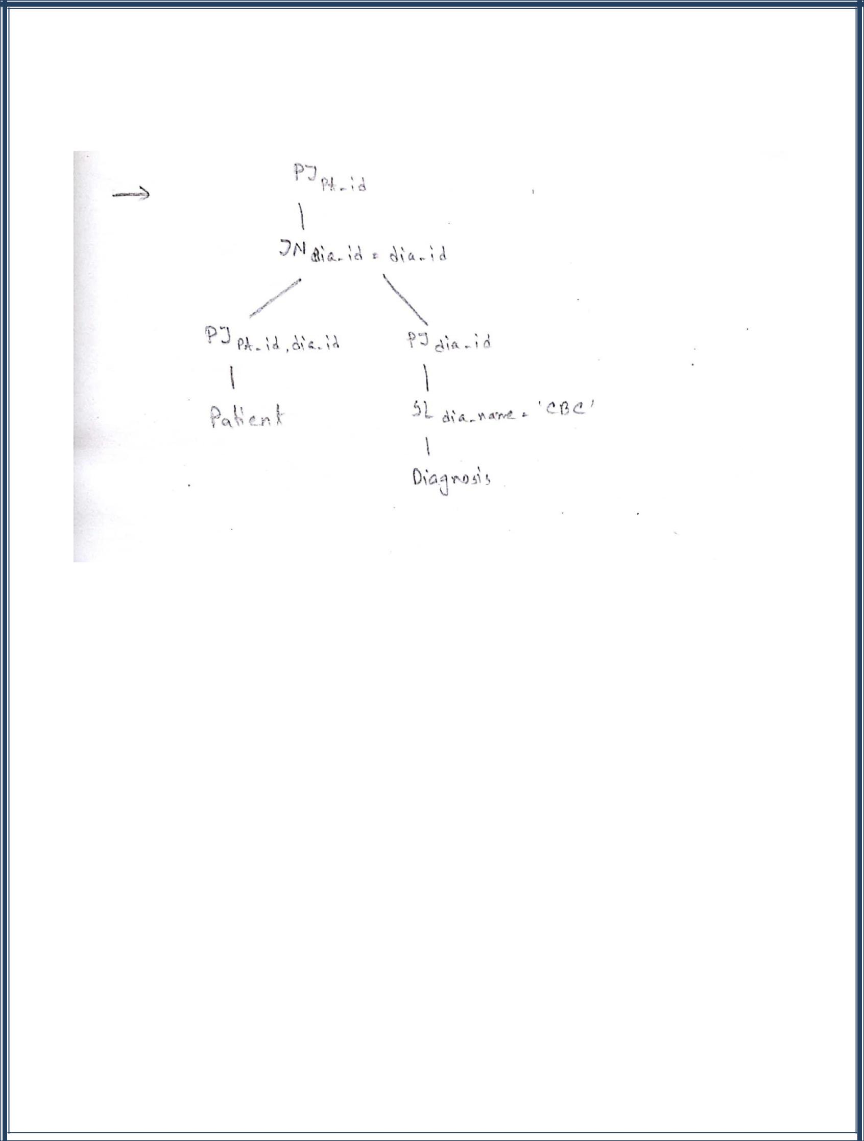

**Conclusion:**

We have worked this far on this project. We hope that this project will be really helpful at our medical sector.

8