LegalEase-Ai project

Project Information Details
Project Name | LegalEase
Application Type | AI-assisted legal document drafting web application
Frontend | Streamlit
Backend | FastAPI
AI Engine | Google Gemini with deterministic local mock mode
Document Export | TXT, DOCX and PDF, with HTML preview
Validation | Pydantic request validation and frontend required-field checks
Testing | Pytest-based API and document formatter tests
This documentation follows the structure and milestone/activity presentation of the supplied old reference document, while the technical descriptions are rewritten from the current LegalEase project archive. The current implementation uses the Google GenAI SDK and defaults to gemini-3.8-flash; it also provides MOCK_AI=true for local testing without an API key.
Actual Python Source Code – Gemini
001 from __future__ import annotations
002
003 from backend.config import Settings
004 from backend.schemas import DocumentRequest
005
006
007 SYSTEM_INSTRUCTION = """
008 You are LegalEase, an AI-assisted legal drafting engine.
009
010 Your task is to create professional legal-document DRAFTS
011 using only facts supplied by the user.
012
013 Rules:
014
015 1. Never invent names, dates, addresses, amounts, obligations,
016 governing law, jurisdiction, or other material facts.
017
018 2. If a material fact is missing, use a clear placeholder such as:
019 [GOVERNING LAW]
020 [PARTY NAME]
021 [EFFECTIVE DATE]
022
023 3. Preserve every material user-provided term.
024
025 4. Use professional and formal legal language.
026
027 5. Organize the document with clear headings and numbered sections.
028
029 6. Include signature blocks where appropriate.
030
031 7. Do not claim that the document is legally valid.
032
033 8. Do not claim that an attorney reviewed the document.
034
035 9. Do not claim compliance with a particular jurisdiction unless
036 the user supplied the jurisdiction.
037
038 10. Begin with the document title.
039
040 11. Include parties and effective date.
041
042 12. Include relevant clauses based on the supplied terms.
043
044 13. End with appropriate signature blocks.
045
046 14. Return plain text only.
047
048 15. Do not return Markdown code fences.
049
050 16. This is an AI-assisted legal draft and should be reviewed
051 by an appropriately qualified legal professional where appropriate.
052 """.strip()
053
054
055 def _mock_document(request: DocumentRequest) -> str:
056 """
057 Creates a deterministic document without using Gemini.
058
059 This allows developers to test the complete application
060 without an API key.
061 """
062
063 terms = [
064 part.strip()
065 for part in request.terms.split(";")
066 if part.strip()
067 ]
068
069 term_lines = "\n".join(
070 f"{index}. {term}"
071 for index, term in enumerate(terms, start=1)
072 )
073
074 if not term_lines:
075 term_lines = "1. [TERMS TO BE PROVIDED]"
076
077 return f"""
078 {request.document_type.upper()}
079
080 PARTIES
081
082 {request.parties}
083
084 EFFECTIVE DATE
085
086 {request.effective_date}
087
088 PURPOSE
089
090 This AI-assisted draft records the principal terms supplied
091 by the user and is intended for review and editing before execution.
092
093 TERMS AND CONDITIONS
094
095 {term_lines}
096
097 GENERAL PROVISIONS
098
099 1. Any missing jurisdiction-specific or transaction-specific
100 provision should be completed after appropriate review.
101
102 2. This draft does not constitute legal advice.
103
104 SIGNATURES
105
106 Party 1:
107
108 Name: ______________________________
109
110 Signature: _________________________
111
112 Date: ______________________________
113
114
115 Party 2:
116
117 Name: ______________________________
118
119 Signature: _________________________
120
121 Date: ______________________________
122 """.strip()
123
124
125 class GeminiDocumentGenerator:
126
127 def __init__(self, settings: Settings):
128 self.settings = settings
129 self.client = None
130

CONTENTS
1. Project Description and Use Scenarios
2. Pre-requisites and Project Workflow
3. Milestone 1: Model Selection and System Architecture
Actual Python Source Code – System Architecture
001 from fastapi import FastAPI
002 from fastapi.middleware.cors import CORSMiddleware
003
004 from backend.config import get_settings
005 from backend.routes import router
006
007
008 settings = get_settings()
009
010
011 app = FastAPI(
012 title="LegalEase API",
013 version="1.0.0",
014 description=(
015 "AI-assisted legal document "
016 "drafting API"
017 ),
018 )
019
020
021 app.add_middleware(
022 CORSMiddleware,
023 allow_origins=settings.cors_origin_list,
024 allow_credentials=True,
025 allow_methods=[
026 "GET",
027 "POST",
028 ],
029 allow_headers=["*"],
030 )
031
032
033 app.include_router(router)
034
035
036 @app.get("/")
037 def root():
038 return {
039 "name": settings.app_name,
040 "status": "ok",
041 "service": "backend",
042 }
4. Milestone 2: Core Functionalities Development
5. Milestone 3: API Logic Integration
Actual Python Source Code – API Logic
001 from fastapi import APIRouter, HTTPException
002
003 from backend.ai_core.gemini_generator import (
004 GeminiDocumentGenerator,
005 )
006 from backend.config import get_settings
007 from backend.schemas import (
008 DocumentRequest,
009 DocumentResponse,
010 )
011
012
013 router = APIRouter()
014
015
016 @router.post(
017 "/generate",
018 response_model=DocumentResponse,
019 )
020 def generate_document(
021 request: DocumentRequest,
022 ) -> DocumentResponse:
023
024 settings = get_settings()
025
026 generator = GeminiDocumentGenerator(
027 settings
028 )
029
030 try:
031
032 content, mock = (
033 generator.generate_document(
034 request
035 )
036 )
037
038 except Exception as exc:
039
040 raise HTTPException(
041 status_code=502,
042 detail=(
043 "Document generation failed: "
044 f"{exc}"
045 ),
046 ) from exc
047
048 return DocumentResponse(
049 document_type=request.document_type,
050 content=content,
051 model=(
052 "mock"
053 if mock
054 else settings.gemini_model
055 ),
056 mock=mock,
057 )
6. Milestone 4: Frontend Development
Actual Python Source Code – Frontend Development
001 from __future__ import annotations
002
003 import os
004 from pathlib import Path
005
006 import requests
007 import streamlit as st
008 from dotenv import load_dotenv
009
010
011 # ==========================================
012 # Environment
013 # ==========================================
014
015 load_dotenv()
016
017
018 ROOT = Path(
019 __file__
020 ).resolve().parents[1]
021
022
023 BACKEND_URL = os.getenv(
024 "BACKEND_URL",
025 "http://127.0.0.1:8000",
026 ).rstrip("/")
027
028
029 LOGO = ROOT / "assets" / "logo.png"
030
031
032 # ==========================================
033 # Page configuration
034 # ==========================================
035
036 st.set_page_config(
037 page_title="LegalEase",
038 page_icon="⚖️",
039 layout="wide",
040 initial_sidebar_state="expanded",
041 )
042
043
044 # ==========================================
045 # Custom CSS
046 # ==========================================
047
048 st.markdown(
049 """
050 <style>
051
052 .main-title {
053 text-align: center;
054 font-size: 2.4rem;
055 font-weight: 700;
056 margin-bottom: 0.2rem;
057 }
058
059 .subtitle {
060 text-align: center;
061 color: #6b7280;
062 margin-bottom: 1.5rem;
063 }
064
065 .preview {
066 background: #17191c;
067 color: #f2f2f2;
068 padding: 1.5rem;
069 border-radius: 12px;
070 max-height: 600px;
071 overflow-y: auto;
072 font-family: Georgia, serif;
073 line-height: 1.65;
074 }
075
076 .preview h3 {
077 color: #ffffff;
078 margin-top: 1.2rem;
079 }
080
081 .preview p {
082 margin: 0.35rem 0;
083 white-space: pre-wrap;
084 }
085
086 .disclaimer {
087 font-size: 0.82rem;
088 color: #6b7280;
089 line-height: 1.5;
090 }
091
092 .info-card {
093 padding: 1rem;
094 border-radius: 10px;
095 background: #f3f4f6;
096 margin-bottom: 1rem;
097 }
098
099 </style>
100 """,
101 unsafe_allow_html=True,
102 )
103
104
105 # ==========================================
106 # Logo
107 # ==========================================
108
109 # Logo is optional.
110
111
112 # ==========================================
113 # Header
114 # ==========================================
115
116 st.markdown(
117 '<div class="main-title">LegalEase</div>',
118 unsafe_allow_html=True,
119 )
120
121 st.markdown(
122 '<div class="subtitle">'
123 'AI-powered legal document drafting '
124 'and export'
125 '</div>',
126 unsafe_allow_html=True,
127 )
128
129
130 # ==========================================
131 # Sidebar
132 # ==========================================
133
134 with st.sidebar:
135
136 st.header(
137 "Document Inputs"
138 )
139
140 document_type = st.selectbox(
141 "Document Type",
142 [
143 "Employment Contract",
144 "Lease Agreement",
145 "Non-Disclosure Agreement",
146 "Freelance Work Contract",
147 "Service Agreement",
148 "Custom Agreement",
149 ],
150 )
7. Core Functions and Document Formatting
Actual Python Source Code – Document Formatting
001 from __future__ import annotations
002
003 import html
004 import re
005 from io import BytesIO
006 from pathlib import Path
007
008 from docx import Document
009 from docx.enum.text import WD_ALIGN_PARAGRAPH
010 from docx.oxml import OxmlElement
011 from docx.oxml.ns import qn
012 from docx.shared import Inches, Pt
013 from fpdf import FPDF
014
015
016 def sanitize_text(text: str) -> str:
017 """
018 Normalize typographic characters that can cause
019 formatting/export problems.
020 """
021
022 replacements = {
023 "“": '"',
024 "”": '"',
025 "‘": "'",
026 "’": "'",
027 "–": "-",
028 "—": "-",
029 "…": "...",
030 "•": "-",
031 "\u00a0": " ",
032 }
033
034 for old, new in replacements.items():
035 text = text.replace(old, new)
036
037 return text.strip()
038
039
040 def split_sections(
041 text: str,
042 ) -> list[tuple[str, str]]:
043 """
044 Detect uppercase headings and split the document
045 into heading/body sections.
046 """
047
048 clean_text = sanitize_text(text)
049
050 lines = [
051 line.rstrip()
052 for line in clean_text.splitlines()
053 ]
054
055 sections: list[tuple[str, str]] = []
056
057 current_heading = ""
058 current_body: list[str] = []
059
060 for line in lines:
061 stripped = line.strip()
062
063 is_heading = bool(stripped) and (
064 (
065 stripped.isupper()
066 and len(stripped) <= 120
067 )
068 or re.match(
069 r"^(SECTION|ARTICLE)\s+[A-Z0-9IVX.-]+",
070 stripped,
071 re.IGNORECASE,
072 )
073 )
074
075 if is_heading:
076
077 if current_heading or current_body:
078 sections.append(
079 (
080 current_heading,
081 "\n".join(
082 current_body
083 ).strip(),
084 )
085 )
086
087 current_heading = stripped
088 current_body = []
089
090 else:
091 current_body.append(line)
092
093 if current_heading or current_body:
094 sections.append(
095 (
096 current_heading,
097 "\n".join(
098 current_body
099 ).strip(),
100 )
101 )
102
103 return [
104 (heading, body)
105 for heading, body in sections
106 if heading or body
107 ]
108
109
110 def _add_page_number(paragraph):
8. Milestone 5: Local Deployment and Testing
Actual Python Source Code – Testing
001 import os
002
003 # Force local mock mode during tests.
004 os.environ["MOCK_AI"] = "true"
005
006 from fastapi.testclient import TestClient
007
008 from backend.main import app
009
010
011 client = TestClient(app)
012
013
014 def test_root():
015
016 response = client.get("/")
017
018 assert response.status_code == 200
019
020 data = response.json()
021
022 assert data["status"] == "ok"
023
024
025 def test_health():
026
027 response = client.get(
028 "/health"
029 )
030
031 assert response.status_code == 200
032
033 data = response.json()
034
035 assert data["status"] == "healthy"
036
037
038 def test_generate_mock():
039
040 response = client.post(
041 "/generate",
042 json={
043 "document_type": (
044 "Freelance Work Contract"
045 ),
046 "parties": (
047 "Jane Doe (Freelancer), "
048 "TechNova Inc. (Client)"
049 ),
050 "terms": (
051 "Payment within 30 days; "
052 "Confidentiality applies; "
053 "Termination on 15 days notice"
054 ),
055 "effective_date": (
056 "April 15, 2026"
057 ),
058 },
059 )
060
061 assert response.status_code == 200
062
063 body = response.json()
064
065 assert body["mock"] is True
066
067 assert (
068 "FREELANCE WORK CONTRACT"
069 in body["content"]
070 )
071
072 assert (
073 "Payment within 30 days"
074 in body["content"]
075 )
001 from backend.services.document_formatter import (
002 format_docx,
003 format_html_preview,
004 format_pdf,
005 format_txt,
006 sanitize_text,
007 )
008
009
010 TEXT = """
011 FREELANCE WORK CONTRACT
012
013 PARTIES
014
015 Jane Doe (Freelancer),
016 TechNova Inc. (Client)
017
018 TERMS AND CONDITIONS
019
020 Payment within 30 days.
021 Confidentiality applies.
022 """
023
024
025 def test_sanitize_text():
026
027 result = sanitize_text(
028 "“Hello”—world…"
029 )
030
031 assert result == (
032 '"Hello"-world...'
033 )
034
035
036 def test_txt():
037
038 data = format_txt(
039 TEXT
040 )
041
042 assert (
043 b"FREELANCE"
044 in data
045 )
046
047
048 def test_docx():
049
050 data = format_docx(
051 TEXT,
052 "Freelance Work Contract",
053 None,
054 "LegalEase",
055 )
056
057 assert data[:2] == b"PK"
058
059
060 def test_pdf():
061
062 data = format_pdf(
063 TEXT,
064 "Freelance Work Contract",
065 None,
066 "LegalEase",
067 )
068
069 assert data.startswith(
070 b"%PDF"
071 )
072
073
074 def test_html_preview():
075
076 html = format_html_preview(
077 TEXT
078 )
079
080 assert (
081 "FREELANCE WORK CONTRACT"
082 in html
083 )
9. Exploring LegalEase
10. Document Generated and Editing
11. Downloading / Saving the Generated Document
12. Testing and Validation
13. Limitations and Future Enhancements
14. Conclusion

1. Project Description and Use Scenarios
LegalEase is an AI-assisted legal document drafting application that collects a document type, parties, terms and an effective date, then sends those inputs from a Streamlit interface to a FastAPI backend. The backend validates the request with Pydantic and routes it to a document-generation service that can use Google Gemini or a deterministic local mock generator.
Actual Python Source Code – FastAPI Backend
001 from fastapi import FastAPI
002 from fastapi.middleware.cors import CORSMiddleware
003
004 from backend.config import get_settings
005 from backend.routes import router
006
007
008 settings = get_settings()
009
010
011 app = FastAPI(
012 title="LegalEase API",
013 version="1.0.0",
014 description=(
015 "AI-assisted legal document "
016 "drafting API"
017 ),
018 )
019
020
021 app.add_middleware(
022 CORSMiddleware,
023 allow_origins=settings.cors_origin_list,
024 allow_credentials=True,
025 allow_methods=[
026 "GET",
027 "POST",
028 ],
029 allow_headers=["*"],
030 )
031
032
033 app.include_router(router)
034
035
036 @app.get("/")
037 def root():
038 return {
039 "name": settings.app_name,
040 "status": "ok",
041 "service": "backend",
042 }
The current project is designed around drafting rather than legal advice. The Gemini system instruction explicitly tells the generation engine not to invent material facts and to use placeholders when information is missing. Generated content is returned as plain text, stored in Streamlit session state, made editable, previewed as HTML, and exported as TXT, DOCX or PDF.
Use Scenarios
- Employment Contract: enter the parties, employment terms and effective date, then generate an editable employment-contract draft.
- Non-Disclosure Agreement: supply the parties and confidentiality-related terms and generate a structured NDA draft.
- Lease or Service Agreement: provide the relevant parties, terms and date and generate a draft for later review.
- Custom Agreement: select Custom Agreement and enter a user-defined document type.
Implementation Note
The current frontend offers predefined document types including Employment Contract, Lease Agreement, Non-Disclosure Agreement, Freelance Work Contract, Service Agreement and Custom Agreement. The actual generated wording depends on the supplied inputs and the selected generation mode.

2. Pre-requisites and Project Workflow
Pre-requisites
- Python 3.10 or newer; the project README recommends Python 3.12.
- A virtual environment for isolated dependency installation.
- FastAPI and Uvicorn for the backend.
- Streamlit for the frontend.
- Google GenAI SDK for live Gemini generation.
- python-docx and FPDF2 for document export.
- Requests and python-dotenv for frontend HTTP communication and environment configuration.
- Pytest and HTTPX for automated tests.
Project Workflow
- Activity 1: Select/configure the Gemini model and define the Streamlit → FastAPI → generation → export architecture.
- Activity 2: Develop legal-document generation, editable preview and TXT/DOCX/PDF formatting.
- Activity 3: Implement main.py, routes.py, Pydantic schemas and the /generate API.
Actual Python Source Code – Pydantic
001 from pydantic import BaseModel, Field, field_validator
002
003
004 class DocumentRequest(BaseModel):
005 document_type: str = Field(
006 ...,
007 min_length=2,
008 max_length=120,
009 )
010
011 parties: str = Field(
012 ...,
013 min_length=2,
014 max_length=5000,
015 )
016
017 terms: str = Field(
018 ...,
019 min_length=2,
020 max_length=12000,
021 )
022
023 effective_date: str = Field(
024 ...,
025 min_length=2,
026 max_length=100,
027 )
028
029 @field_validator(
030 "document_type",
031 "parties",
032 "terms",
033 "effective_date",
034 )
035 @classmethod
036 def strip_required(cls, value: str) -> str:
037 value = value.strip()
038
039 if not value:
040 raise ValueError(
041 "Field cannot be blank"
042 )
043
044 return value
045
046
047 class DocumentResponse(BaseModel):
048 document_type: str
049 content: str
050 model: str
051 mock: bool
- Activity 4: Build the Streamlit input interface, editable document area, preview and download controls.
- Activity 5: Run locally and prepare container/deployment configuration using Dockerfile, docker_compose.yml and Procfile.
- Activity 6: Test the complete flow, including mock generation and formatter outputs.
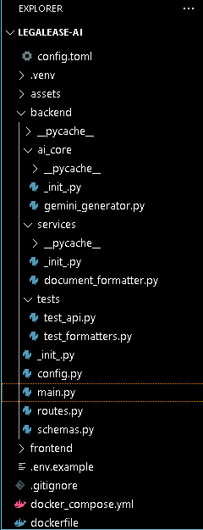
3. MILESTONE 1: Model Selection and System Architecture – LegalEase
This milestone establishes the current AI and application architecture. Unlike the older reference implementation, the new project uses the Google GenAI SDK through google-genai and configures the model through GEMINI_MODEL. The default model in backend/config.py is gemini-3.8-flash.
Activity 1.1: Research and Select the Appropriate Generative AI Model
1. Understand the Project Requirements
- Generate structured legal-document drafts from document type, parties, terms and effective date.
- Preserve material information supplied by the user.
- Avoid invented names, dates, amounts, jurisdictional claims and other material facts.
- Return plain text suitable for editing and export.
2. Current Model Configuration
GEMINI_MODEL=gemini-3.8-flash
MOCK_AI=true
3. Local Mock Mode
When MOCK_AI is enabled, or when a Gemini API key is not available, the generator returns a deterministic document created by _mock_document(). This provides a repeatable development and testing path without requiring an external AI request.
4. Live Gemini Mode
When a Gemini API key is configured and MOCK_AI is false, GeminiDocumentGenerator creates a Google GenAI client and calls generate_content with the configured model, system instruction, low temperature, and an output-token limit.

Activity 1.2: Define the Architecture of the Application
Architectural Components
- Frontend: frontend/app.py using Streamlit for document inputs, generation, editing, preview and downloads.
- Backend: backend/main.py and backend/routes.py using FastAPI.
- Schemas: backend/schemas.py defining DocumentRequest and DocumentResponse with Pydantic.
- AI Core: backend/ai_core/gemini_generator.py for Gemini and mock generation.
- Formatting Service: backend/services/document_formatter.py for sanitization, section detection, HTML preview and TXT/DOCX/PDF generation.
- Configuration: backend/config.py using pydantic-settings and .env values.
- Tests: backend/tests/test_api.py and backend/tests/test_formatters.py.
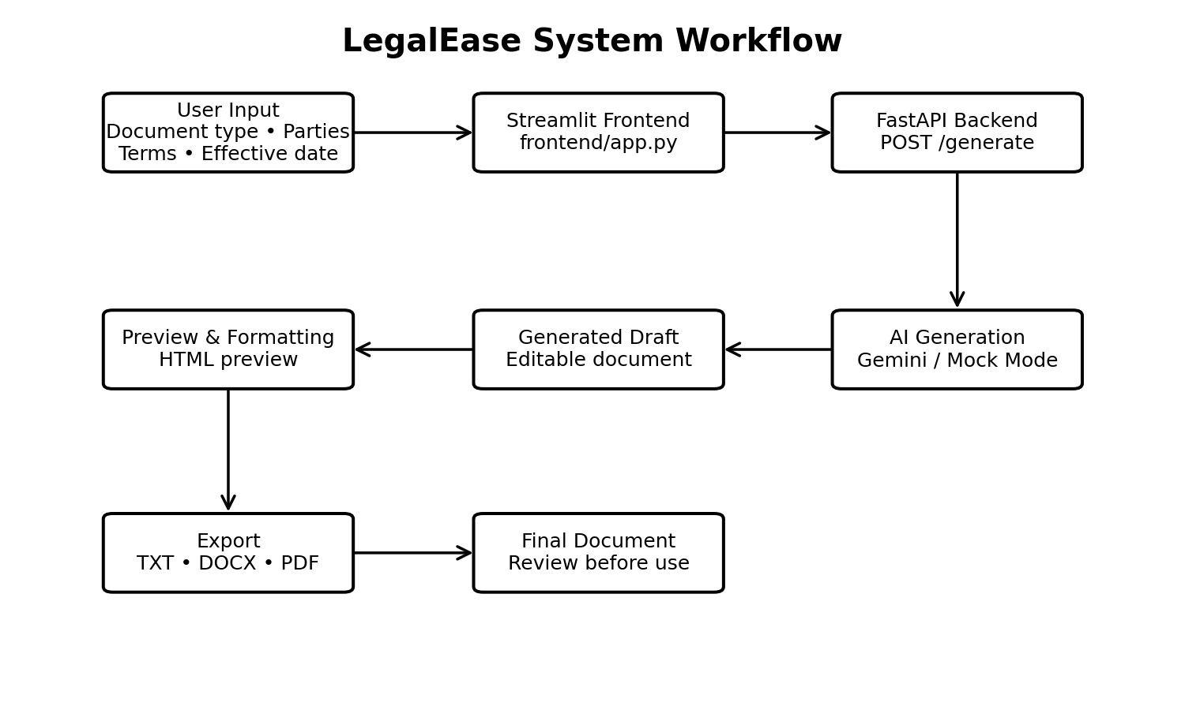
The current flow is: User Input → Streamlit Frontend → FastAPI /generate → Gemini or Mock Mode → Generated Draft → Editable Preview → TXT/DOCX/PDF Export.

Activity 1.3: Set Up the Development Environment
1. Install Python and Pip
The README requires Python 3.10 or newer and recommends Python 3.12.
2. Create and Activate a Virtual Environment
python -m venv .venv
.venv\Scripts\activate
3. Install Project Dependencies
pip install -r requirements.txt
4. Current Dependency Groups
- FastAPI, Uvicorn: backend API and server.
- Streamlit: browser-based frontend.
- google-genai: Gemini integration.
- Pydantic and pydantic-settings: request validation and configuration.
- python-docx, FPDF2 and Pillow: document generation and branding support.
- requests, python-dotenv: frontend-to-backend requests and environment variables.
- pytest, httpx: automated API and formatter tests.
5. Environment Configuration
# .env
MOCK_AI=true
GEMINI_API_KEY=YOUR_API_KEY
GEMINI_MODEL=gemini-3.8-flash
BACKEND_HOST=127.0.0.1
BACKEND_PORT=8000

4. MILESTONE 2: Core Functionalities Development
Activity 2.1: Develop the Core Functionalities
1. Legal Document Generation
The request model accepts four required values: document_type, parties, terms and effective_date. Each field has length constraints and a validator that strips whitespace and rejects blank values.
class DocumentRequest(BaseModel):
document_type: str
parties: str
terms: str
effective_date: str
2. Generation Modes
- Mock mode: deterministic local draft for development and testing.
- Gemini mode: external AI generation through the Google GenAI SDK.
3. Generated Output Structure
- Document title.
- PARTIES section.
- EFFECTIVE DATE section.
- PURPOSE and TERMS AND CONDITIONS sections.
- GENERAL PROVISIONS.
- SIGNATURES.
4. Editable Output
The frontend stores the generated content in Streamlit session state and displays it in a text area so the user can modify the draft before export.

Document Output Formatting
The document_formatter.py module centralizes output processing so the same edited text can be converted into multiple formats.
format_docx(text, doc_type, logo_path, footer_text)
- Creates a Microsoft Word document using python-docx.
- Uses Times New Roman for the document body and title.
- Adds a centered title based on the selected document type.
- Detects uppercase headings and formats them as section headings.
- Adds a configurable footer and page field.
format_pdf(text, doc_type, logo_path, footer_text)
- Creates an A4 PDF using FPDF2.
- Uses a branded header when a logo is supplied.
- Adds section headings, body text, footer text and page numbers.
format_txt(text)
- Sanitizes typographic characters and returns UTF-8 encoded plain text.
format_html_preview(text)
- Escapes HTML-sensitive characters.
- Renders uppercase headings as h3 elements and other lines as paragraphs.

from __future__ import annotations

import html
import re
from io import BytesIO
from pathlib import Path

from docx import Document
from docx.enum.text import WD_ALIGN_PARAGRAPH
from docx.oxml import OxmlElement
from docx.oxml.ns import qn
from docx.shared import Inches, Pt
from fpdf import FPDF

def sanitize_text(text: str) -> str:
"""
Normalize typographic characters that can cause
formatting/export problems.
"""

replacements = {
"“": '"',
"”": '"',
"‘": "'",
"’": "'",
"–": "-",
"—": "-",
"…": "...",
"•": "-",
"\u00a0": " ",
}

for old, new in replacements.items():
text = text.replace(old, new)

return text.strip()

def split_sections(
text: str,
) -> list[tuple[str, str]]:
"""
Detect uppercase headings and split the document
into heading/body sections.
"""

clean_text = sanitize_text(text)

lines = [
line.rstrip()
for line in clean_text.splitlines()
]

sections: list[tuple[str, str]] = []

current_heading = ""
current_body: list[str] = []

for line in lines:
stripped = line.strip()

is_heading = bool(stripped) and (
(
stripped.isupper()
and len(stripped) <= 120
)
or re.match(
r"^(SECTION|ARTICLE)\s+[A-Z0-9IVX.-]+",
stripped,
re.IGNORECASE,
)
)

if is_heading:

if current_heading or current_body:
sections.append(
(
current_heading,
"\n".join(
current_body
).strip(),
)
)

current_heading = stripped
current_body = []

else:
current_body.append(line)

if current_heading or current_body:
sections.append(
(
current_heading,
"\n".join(
current_body
).strip(),
)
)

return [
(heading, body)
for heading, body in sections
if heading or body
]

def _add_page_number(paragraph):
"""
Add a Word PAGE field to the footer.
"""

paragraph.alignment = (
WD_ALIGN_PARAGRAPH.CENTER
)

run = paragraph.add_run("Page ")

field = OxmlElement("w:fldSimple")
field.set(
qn("w:instr"),
"PAGE",
)

run._r.addnext(field)

def format_docx(
text: str,
doc_type: str,
logo_path: Path | None = None,
footer_text: str = "",
) -> bytes:

doc = Document()

section = doc.sections[0]

section.top_margin = Inches(0.7)
section.bottom_margin = Inches(0.7)
section.left_margin = Inches(0.85)
section.right_margin = Inches(0.85)

# Logo
if (
logo_path
and logo_path.exists()
):
paragraph = doc.add_paragraph()

paragraph.alignment = (
WD_ALIGN_PARAGRAPH.CENTER
)

run = paragraph.add_run()

run.add_picture(
str(logo_path),
width=Inches(1.35),
)

# Main title
title = doc.add_paragraph()

title.alignment = (
WD_ALIGN_PARAGRAPH.CENTER
)

title_run = title.add_run(
sanitize_text(
doc_type
).upper()
)

title_run.bold = True
title_run.font.name = "Times New Roman"
title_run.font.size = Pt(16)

# Content
for heading, body in split_sections(text):

if heading:

paragraph = doc.add_paragraph()

paragraph.paragraph_format.space_before = Pt(9)
paragraph.paragraph_format.space_after = Pt(4)

run = paragraph.add_run(
heading
)

run.bold = True
run.font.name = "Times New Roman"
run.font.size = Pt(12)

for line in body.splitlines():

if not line.strip():
continue

paragraph = doc.add_paragraph()

paragraph.paragraph_format.space_after = Pt(5)
paragraph.paragraph_format.line_spacing = 1.15

run = paragraph.add_run(
line.strip()
)

run.font.name = "Times New Roman"
run.font.size = Pt(11)

# Footer
footer = section.footer.paragraphs[0]

footer.alignment = (
WD_ALIGN_PARAGRAPH.CENTER
)

footer_run = footer.add_run(
footer_text
or (
"LegalEase - AI-assisted draft - "
"review before use"
)
)

footer_run.font.name = "Times New Roman"
footer_run.font.size = Pt(8)

_add_page_number(footer)

output = BytesIO()

doc.save(output)

return output.getvalue()

class BrandedPDF(FPDF):

def __init__(
self,
logo_path: Path | None,
footer_text: str,
):

super().__init__(
orientation="P",
unit="mm",
format="A4",
)

self.logo_path = logo_path
self.footer_text = footer_text

self.set_auto_page_break(
auto=True,
margin=18,
)

def header(self):

if (
self.logo_path
and self.logo_path.exists()
):
self.image(
str(self.logo_path),
x=88,
y=8,
w=34,
)

self.ln(22)

else:
self.ln(8)

def footer(self):

self.set_y(-14)

self.set_font(
"Times",
size=7,
)

self.cell(
0,
5,
self.footer_text[:150],
align="C",
)

self.set_y(-9)

self.cell(
0,
5,
f"Page {self.page_no()}",
align="C",
)

def format_pdf(
text: str,
doc_type: str,
logo_path: Path | None = None,
footer_text: str = "",
) -> bytes:

pdf = BrandedPDF(
logo_path,
footer_text
or (
"LegalEase - AI-assisted draft - "
"review before use"
),
)

pdf.set_title(
sanitize_text(doc_type)
)

pdf.add_page()

# Title
pdf.set_font(
"Times",
"B",
16,
)

pdf.multi_cell(
0,
9,
sanitize_text(
doc_type
).upper(),
align="C",
)

pdf.ln(4)

# Sections
for heading, body in split_sections(text):

if heading:

pdf.set_font(
"Times",
"B",
11,
)

pdf.multi_cell(
0,
6,
heading,
)

pdf.ln(1)

if body:

pdf.set_font(
"Times",
size=10.5,
)

for line in body.splitlines():

line = line.strip()

if not line:
continue

pdf.multi_cell(
0,
5.4,
line,
)

pdf.ln(0.8)

pdf.ln(1.5)

return bytes(
pdf.output()
)

def format_txt(
text: str,
) -> bytes:

return sanitize_text(
text
).encode("utf-8")

def format_html_preview(
text: str,
) -> str:

escaped = html.escape(
sanitize_text(text)
)

output = []

for line in escaped.splitlines():

if not line.strip():
continue

clean_line = line.strip()

if (
clean_line.isupper()
and len(clean_line) <= 120
):
output.append(
f"<h3>{clean_line}</h3>"
)

else:
output.append(
f"<p>{line}</p>"
)

return "".join(output)

Activity 2.2: Implement the FastAPI Backend
The current backend is split into main.py, routes.py, schemas.py, config.py and the AI/formatter services. This modular design keeps the HTTP layer separate from generation and export logic.
backend/main.py
- Creates the FastAPI application with title, version and description.
- Configures CORS using values from backend/config.py.
- Includes the router from routes.py.
- Exposes GET / and GET /health.
@app.get("/")
def root():
return {
"name": settings.app_name,
"status": "ok",
"service": "backend",
}
backend/config.py
Settings are loaded from .env and include the application name, company name, Gemini API key, model, mock flag, backend host/port, CORS origins, logo path, document font and footer text.
from functools import lru_cache
from pathlib import Path

from pydantic import Field
from pydantic_settings import BaseSettings, SettingsConfigDict

BASE_DIR = Path(__file__).resolve().parent.parent

class Settings(BaseSettings):
model_config = SettingsConfigDict(
env_file=BASE_DIR / ".env",
env_file_encoding="utf-8",
extra="ignore",
)

app_name: str = Field(
default="LegalEase",
alias="APP_NAME",
)

company_name: str = Field(
default="LegalEase",
alias="COMPANY_NAME",
)

gemini_api_key: str = Field(
default="",
alias="GEMINI_API_KEY",
)

gemini_model: str = Field(
default="gemini-3.8-flash",
alias="GEMINI_MODEL",
)

mock_ai: bool = Field(
default=True,
alias="MOCK_AI",
)

backend_host: str = Field(
default="127.0.0.1",
alias="BACKEND_HOST",
)

backend_port: int = Field(
default=8000,
alias="BACKEND_PORT",
)

cors_origins: str = Field(
default=(
"http://localhost:8501,"
"http://127.0.0.1:8501"
),
alias="CORS_ORIGINS",
)

logo_path: str = Field(
default="assets/logo.png",
alias="LOGO_PATH",
)

document_font: str = Field(
default="Times New Roman",
alias="DOCUMENT_FONT",
)

document_footer: str = Field(
default=(
"Generated with LegalEase - "
"AI-assisted drafting - review before use"
),
alias="DOCUMENT_FOOTER",
)

@property
def cors_origin_list(self) -> list[str]:
return [
item.strip()
for item in self.cors_origins.split(",")
if item.strip()
]

@property
def logo_file(self) -> Path:
return BASE_DIR / self.logo_path

@lru_cache
def get_settings() -> Settings:
return Settings()

5. MILESTONE 3: API Logic Integration
Milestone 3 connects the frontend request to the generation engine through a typed FastAPI API. The route is intentionally small: it validates input through Pydantic, constructs the generator, handles generation errors and returns a DocumentResponse.
Activity 3.1: Create and Configure main.py
- Initialize the FastAPI app.
- Configure CORS for the Streamlit origins.
- Include the API router.
- Provide a root service-status response.
- Provide a health response showing Gemini configuration and mock mode.
Activity 3.2: Handle Document Generation Logic in routes.py
@router.post("/generate", response_model=DocumentResponse)
def generate_document(request: DocumentRequest):
settings = get_settings()
generator = GeminiDocumentGenerator(settings)
content, mock = generator.generate_document(request)
return DocumentResponse(
document_type=request.document_type,
content=content,
model="mock" if mock else settings.gemini_model,
mock=mock,
)
Generation exceptions are converted into an HTTP 502 response with a descriptive error message.

API Request and Response Design
POST /generate
Request fields:
- document_type: 2–120 characters.
- parties: 2–5000 characters.
- terms: 2–12000 characters.
- effective_date: 2–100 characters.
Response fields
- document_type: selected document type.
- content: generated legal-document draft.
- model: mock or configured Gemini model name.
- mock: boolean indicating local mock generation.
GET /health
{
"status": "healthy",
"gemini_configured": true,
"mock_ai": false
}
Interactive API Documentation
FastAPI automatically exposes interactive Swagger documentation at /docs when the backend is running.
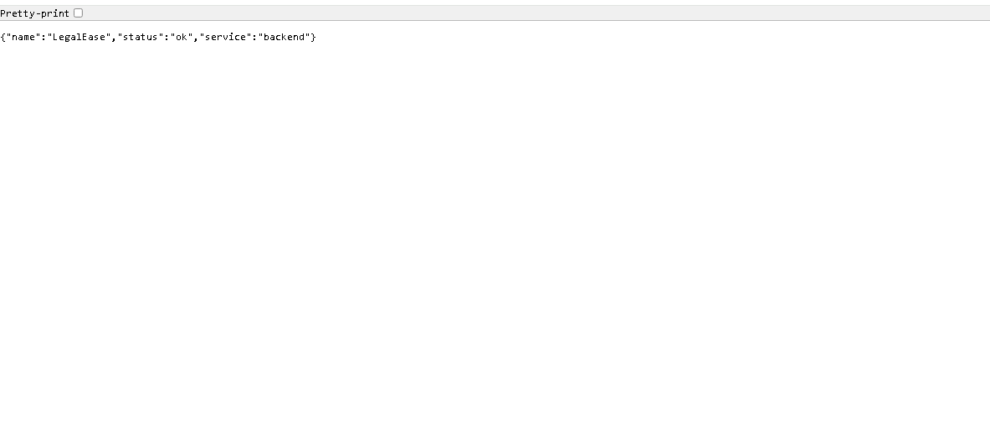
6. MILESTONE 4: Frontend Development – LegalEase
Milestone 4 implements the user-facing Streamlit application in frontend/app.py. The current interface is wide-layout, uses an expanded sidebar for inputs, and provides an editable document workspace after successful generation.
Activity 4.1: Designing and Developing the User Interface
- Configure page title, icon, wide layout and expanded sidebar.
- Display the LegalEase title and AI-powered legal document drafting subtitle.
- Collect document type through a selectbox, with a custom document-type option.
- Collect parties and terms through text areas.
- Collect effective date through a text input.
- Provide a Generate Document button.
- Display a legal-drafting disclaimer.
Input Validation
The frontend first checks that all four required values are non-empty. The backend then applies the stronger Pydantic length and blank-value validation.
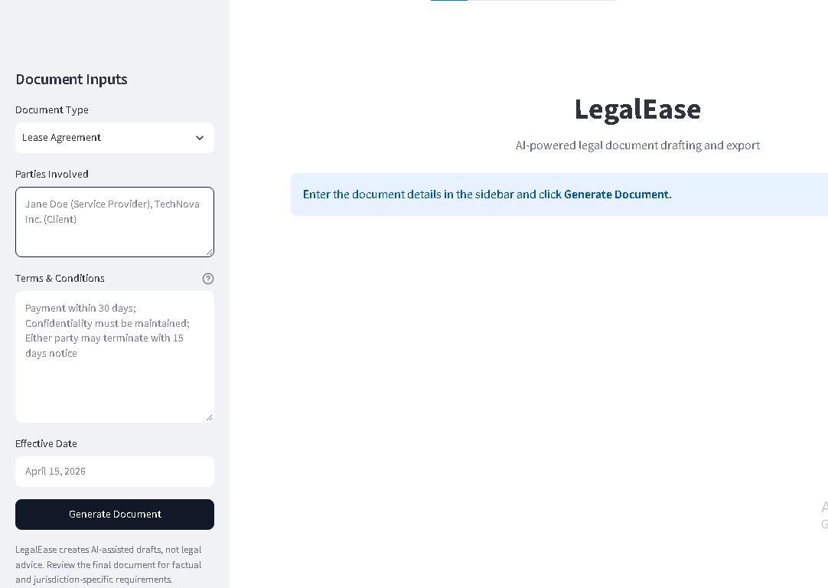
Activity 4.2: Creating Dynamic Previews and Export Options
Step 1: Generate Document with Backend AI
When Generate Document is pressed, the frontend sends a POST request to BACKEND_URL/generate with a JSON payload containing the four input fields. A timeout of 180 seconds is used for the request.
Step 2: Store Generated Data
The response content, document type, model name and mock status are stored in Streamlit session state.
Step 3: Editable Document Preview
The generated text is displayed in a large text area. Changes are written back to session state so the edited version becomes the source for preview and download.
Step 4: HTML Preview
format_html_preview() sanitizes and escapes the edited content and converts detected uppercase headings into HTML headings inside the styled preview card.
Step 5: Multi-Format Download
- TXT: plain UTF-8 text.
- DOCX: formatted Word document.
- PDF: A4 formatted document with footer and page number.
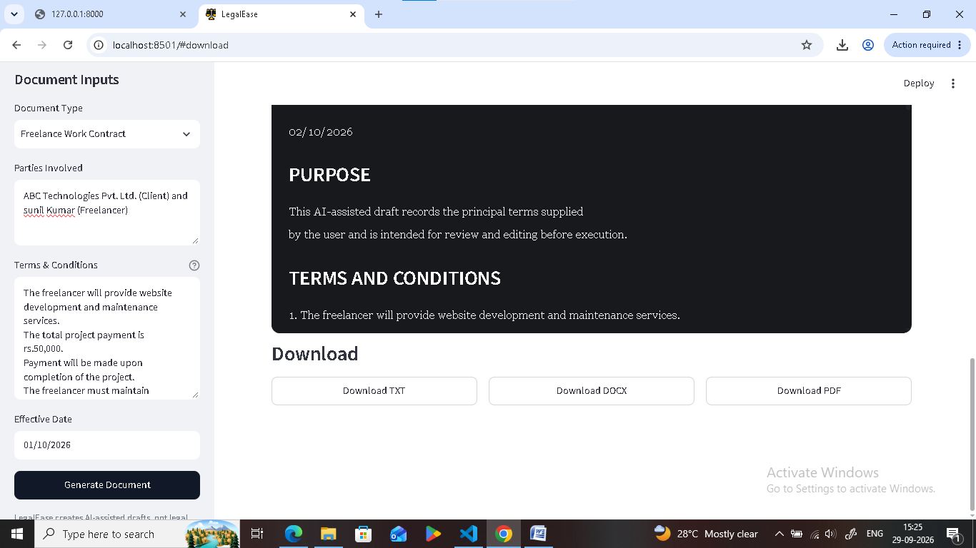
7. Core Functions & Utilities
sanitize_text(text)
Normalizes curly quotation marks, apostrophes, en/em dashes, ellipsis, bullets and non-breaking spaces so generated text is safer for downstream formatters.
split_sections(text)
Sanitizes the text, detects uppercase headings or SECTION/ARTICLE patterns, and returns heading/body pairs. The DOCX, PDF and HTML formatters use this structure.
GeminiDocumentGenerator.generate_document()
- Uses local mock generation when MOCK_AI is true or the Gemini API key is missing.
- Uses Google GenAI when live generation is enabled.
- Applies a system instruction that prohibits invented material facts and unsupported legal-validity claims.
Formatting Utility Summary
sanitize_text(text)
split_sections(text)
format_txt(text)
format_docx(text, doc_type, logo_path, footer_text)
format_pdf(text, doc_type, logo_path, footer_text)
format_html_preview(text)
These functions provide a single formatting pipeline from the user's edited draft to the available output formats.

8. MILESTONE 5: Local Deployment and Testing
Milestone 5 focuses on running the current application locally and verifying that the backend, frontend, AI generation path and document formatters work together.
Activity 5.1: Preparing the Application for Local Deployment
Step 1: Create the virtual environment
python -m venv .venv
Step 2: Install dependencies
pip install -r requirements.txt
Step 3: Configure environment variables
MOCK_AI=true
BACKEND_HOST=127.0.0.1
BACKEND_PORT=8000
Step 4: Start the backend
python run_backend.py
Step 5: Start the frontend in another terminal
python run_frontend.py
The README documents the backend at http://127.0.0.1:8000 and the Streamlit frontend at http://localhost:8501.

Note: While setting up the LegalEase project, PowerShell may prevent activation of the Python virtual environment because of its execution policy. To allow the virtual environment activation script to run for the current user, the following command can be used: Set-ExecutionPolicy -ExecutionPolicy RemoteSigned -Scope CurrentUser after entering write terminal .venv\scripts\activate

Exploring LegalEase – User Inputs
1. Document Type
Purpose: selects the category of legal-document draft to generate.
- Employment Contract
- Lease Agreement
- Non-Disclosure Agreement
- Freelance Work Contract
- Service Agreement
- Custom Agreement
For Custom Agreement, the interface asks for a custom document type such as Partnership Agreement.
2. Parties Involved
Purpose: identifies the people or entities that the generated draft should mention.
Example: Jane Doe (Service Provider), TechNova Inc. (Client)
3. Terms & Conditions
Purpose: supplies the main clauses to preserve in the generated draft. The interface recommends separating major terms with semicolons.
Example: Payment within 30 days; Confidentiality must be maintained; Either party may terminate with 15 days notice
4. Effective Date
Purpose: identifies the date to be included in the draft.
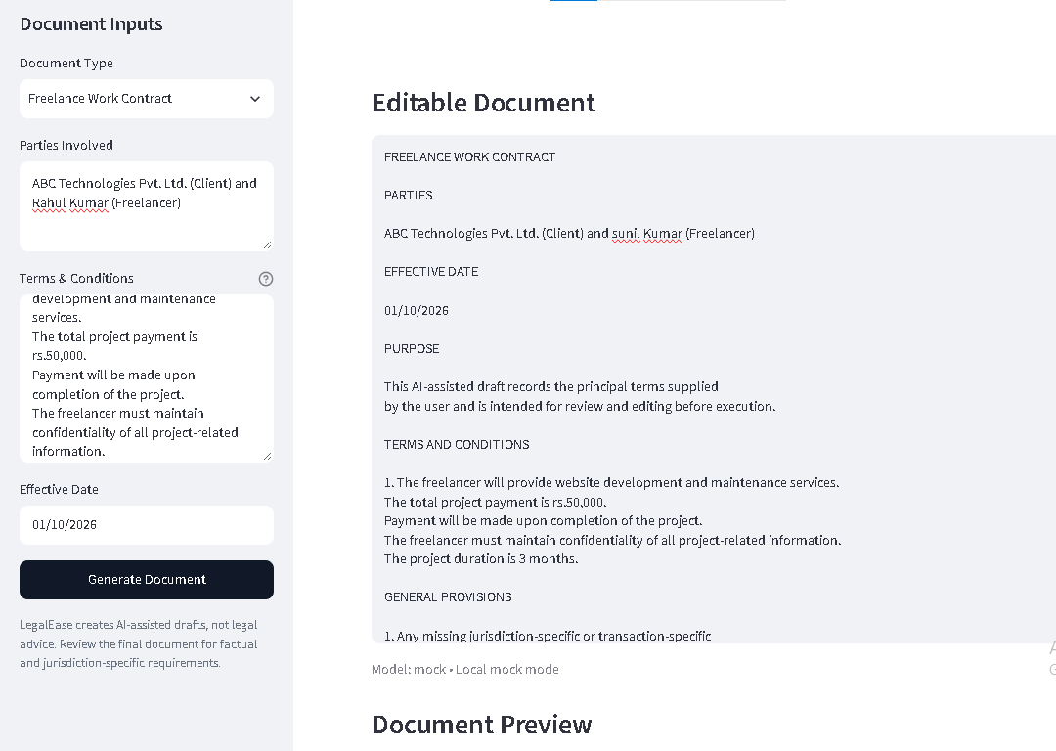

Generated Document – Generation Flow
After the user presses Generate Document, the frontend sends the four values to the FastAPI /generate endpoint. The backend validates the request, calls GeminiDocumentGenerator and returns the generated content plus model/mock metadata.
Mock Mode Output
In local mock mode, the generator creates a predictable document with the selected document type as the title, the supplied parties, the effective date, a purpose statement, numbered terms, general provisions and signature blocks.
Live Gemini Output
In live mode, the Gemini prompt asks for a professional legal-document draft using only supplied facts, placeholders for missing material facts, numbered sections, appropriate signature blocks and plain-text output.
The application does not present the generated text as attorney-reviewed or automatically legally valid. The frontend explicitly describes LegalEase as an AI-assisted drafting tool.
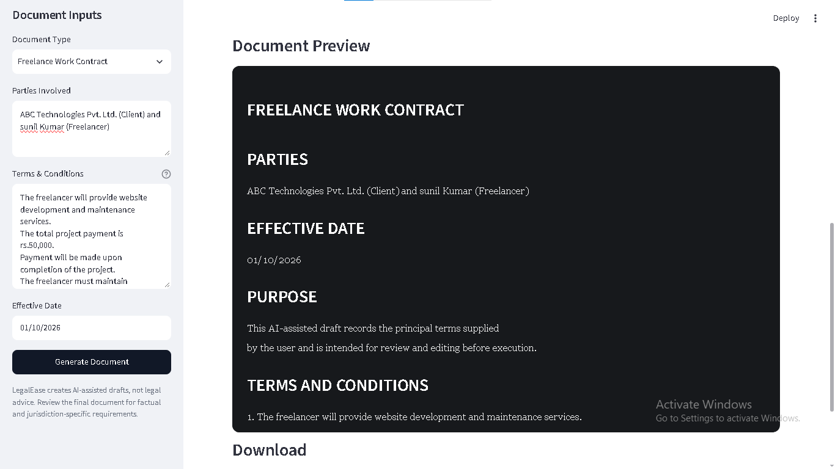
Editing the Generated Document
The current Streamlit application provides an 'Editable Document' section after successful generation. The generated text is loaded into a large text area, allowing the user to revise wording before preview and export.
Editing Sequence
- Generate the draft.
- Review the content in the editable text area.
- Correct names, dates, amounts, obligations and other factual details.
- Add or remove clauses as required.
- Use the resulting edited text for preview and export.
Preview
The Document Preview section uses format_html_preview() to render the edited text as styled HTML. Uppercase headings are shown as section headings and the remaining lines are displayed as paragraphs.
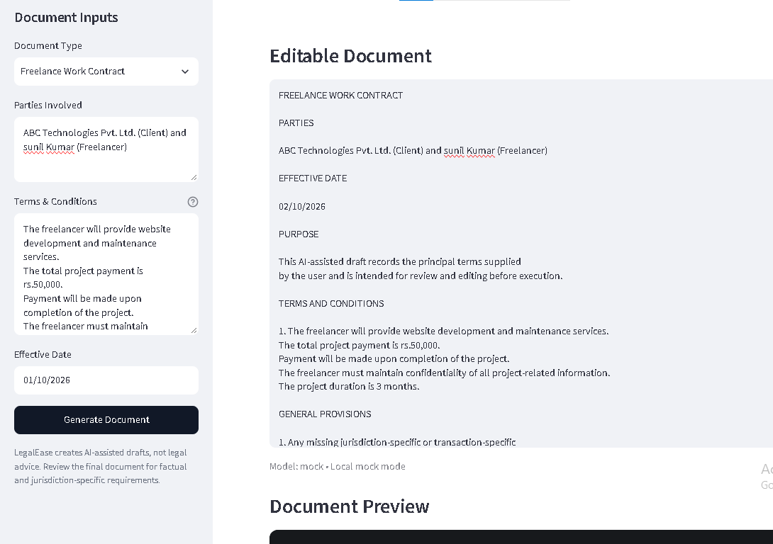
Downloading / Saving the Generated Document
The current project supports three download formats from the edited document.
1. TXT
format_txt() sanitizes the edited content and encodes it as UTF-8 bytes. This is the simplest portable representation of the draft.
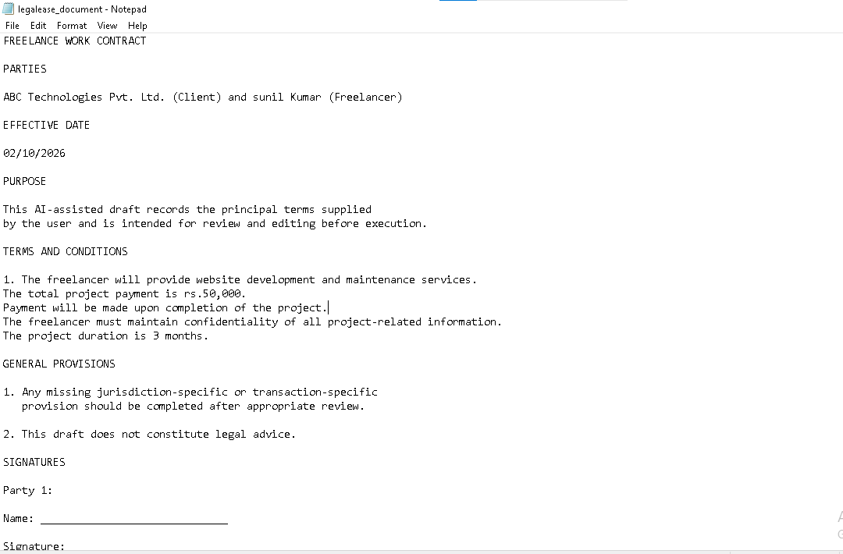
2. DOCX
format_docx() creates an editable Microsoft Word document. It applies Times New Roman formatting, a centered title, detected headings and a configurable LegalEase footer. A logo can be supplied when the expected logo file is present.
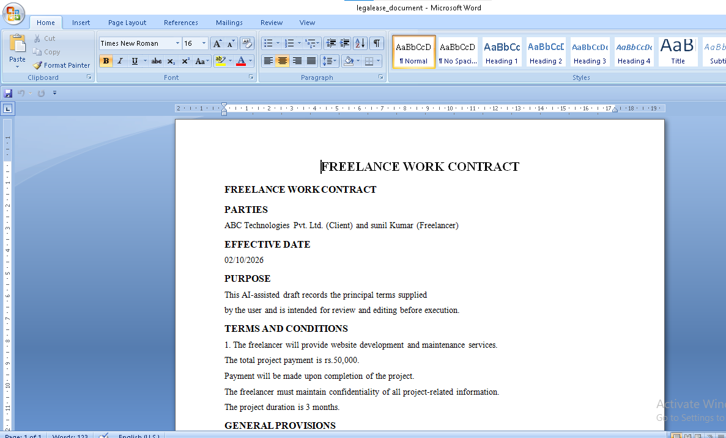
Downloading / Saving the Generated Document – PDF
3. PDF
format_pdf() generates an A4 PDF using FPDF2. The PDF formatter supports an optional logo in the header, section headings, body text, footer text and page numbers.
The footer defaults to a LegalEase message indicating that the document is an AI-assisted draft and should be reviewed before use. This wording is configurable through DOCUMENT_FOOTER.
DOCUMENT_FOOTER=
Generated with LegalEase - AI-assisted drafting - review before use
Output Consistency
All three exporters receive the same edited text. This means the user's final edits are preserved across TXT, DOCX and PDF generation rather than exporting the original unedited AI response.
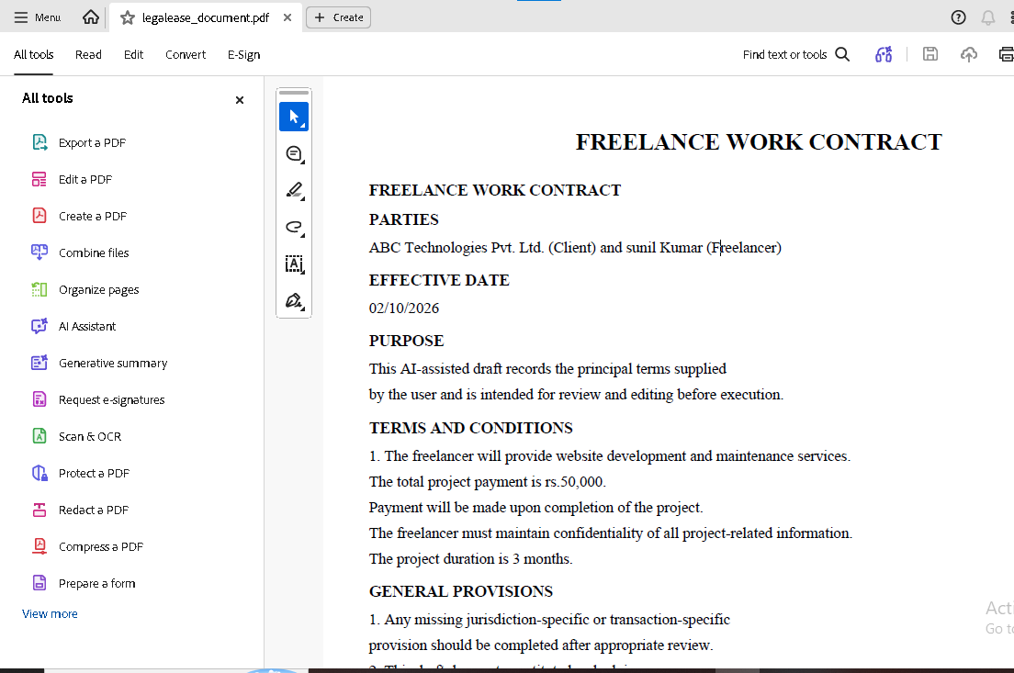
Testing, Deployment Configuration and Project Files
Testing Commands
python -m pytest -q
Backend and Frontend Launchers
python run_backend.py
python run_frontend.py
Container Deployment
The project includes a Dockerfile based on python:3.12-slim. It installs requirements, copies the project, exposes port 8000 and starts Uvicorn with backend.main:app.
Docker Compose
docker_compose.yml defines separate backend and frontend services. The frontend receives BACKEND_URL=http://backend:8000 and exposes port 8501.
Procfile
web: uvicorn backend.main:app --host 0.0.0.0 --port $PORT
Important Configuration Files
- .env and .env.example: environment configuration.
- requirements.txt: Python dependencies.
- dockerfile and docker_compose.yml: containerized deployment.
- procfile: web-process definition.
- makefile: project automation entry point.

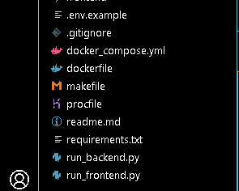
Limitations and Future Enhancements
Current Limitations
- LegalEase is an AI-assisted drafting application and does not provide legal advice.
- Generated drafts require human review for names, dates, amounts, obligations, jurisdiction, governing law and signatures.
- The test suite primarily validates mock generation and formatter/API behavior; live Gemini responses are not deterministic test fixtures.
- The current project does not implement user authentication or authorization.
- Public production exposure would require additional security controls such as HTTPS, authentication and rate limiting.
- Legal validity and jurisdiction-specific compliance are not automatically established by the generator.
Future Enhancements
- Authentication, secure document history and user-specific storage.
- Database-backed document persistence and version history.
- Jurisdiction-aware templates with controlled legal-source references.
- Reusable clause libraries and document templates.
- Document comparison and revision tracking.
- Stronger end-to-end tests for the Streamlit-to-FastAPI workflow.
- Production logging, monitoring, rate limiting and secure deployment.
- Additional branding and formatting controls.

Conclusion
LegalEase, in its current project implementation, provides an end-to-end workflow for AI-assisted legal-document drafting. The application connects a Streamlit user interface with a FastAPI backend, validates structured document requests through Pydantic, generates drafts through either Google Gemini or a deterministic local mock mode, and gives users an editable document before export.
The new project structure improves separation of responsibilities through dedicated configuration, schema, route, AI-generation and document-formatting modules. The formatting service provides TXT, DOCX, PDF and HTML-preview capabilities while preserving the edited draft as the common source for output generation.
The inclusion of MOCK_AI=true is particularly useful for development and automated testing because the complete workflow can be exercised without a Gemini API key. The Pytest suite covers API health/root behavior, mock generation and the principal formatter outputs.
The project also includes practical local-run and deployment assets such as run_backend.py, run_frontend.py, Dockerfile, Docker Compose configuration and a Procfile. These components provide a foundation for further development and controlled deployment.
LegalEase should be treated as a drafting aid rather than a replacement for qualified legal review. The current generator is deliberately instructed not to invent material facts or claim legal validity, and the final document should be checked for factual accuracy and jurisdiction-specific requirements before use.
References / Project Sources
- Current LegalEase project source archive: backend/, frontend/, tests, configuration and deployment files.
- Project README: installation, environment, local execution, testing, security and legal-disclaimer guidance.
- FastAPI, Streamlit, Google GenAI SDK, Pydantic, python-docx, FPDF2 and Pytest libraries as used by the project.
End of documentation.

