**Abstract-** **Crop cultivation plays an essential role in the agricultural field. Presently, the loss of food is mainly due to infected crops, which reflexively reduces the production rate. To identify the plant diseases at an untimely phase is not yet explored. The main challenge is to reduce the usage of pesticides in the agricultural field and to increase the quality and quantity of the production rate. Proposed system explores the leaf disease prediction at an untimely action. We propose an enhanced Machine Learning to predict the infected area of the leaves. A colour-based segmentation model is defined to segment the infected region and placing it to its relevant classes. Experimental analyses were done on samples images in terms of time complexity and the area of infected region. Plant diseases can be detected by image processing technique. Disease detection involves steps like image acquisition, image pre-processing, image segmentation Feature extraction and classification.**

I.INTRODUCTION

India is a land of Agriculture. Agriculture plays an important role because of rapid growth of population and increase in demand for food. It is the basic foundation of economic development of the country. Plant diseases seriously affect the normal growth of plants, the yield and quality of agricultural products. In recent years, with the dramatic changes in climate, the natural environment of the plant growth

has been damaged by pollution, frequent natural disasters. Normally, we can identify diseases by our naked eye but it is difficult to tell how the disease has occurred. In this proposed system, different image pro- cessing and machine-learning techniques called Support Vector Ma- chine is used in the identification of rice plant diseases based on im- ages of disease infected rice plants. One third of the population of India depends on the agriculture so we need more crop productivity for the entire population. But one of the major reasons for reduction in crop productivity is the plants gets effected to disease. The diseased should be identified and particular pesticides should be used for that particular disease to avoid unwanted soil pollution. The main objective is to detect rice plant diseases in advance and notify the name of the disease so that necessary precautions and pesticides can be used according to the disease type. So, for better identification of diseases, we can use machine learning techniques to ensure high accuracy.

II.LITERATURE SURVEY

This chapter gives the overview of literature survey. This chapter represents some of the relevant work done by the researchers. Many existing techniques have been studied by the researchers on plant dis- ease detection using Machine learning, we review some of them below.

1.Auother: Xin Yang, Ting wei Guo, Title:” Machine learning in plant disease research”, Year:2020, Method: K-means clustering used to segment the defected area Advantages: They create their own data set Disadvantage: The accuracy level is 92.2%. 2.Auother. Yang Lu,Shujuan Yi,Nianyin Zeng,Yurong Liu,Yong hang,Title of the paper:” Identification of rice diseases using deep convolutional neural networks”Year:2018,Method: we propose a novel rice diseases identification method based on deep convolutional neural networks (CNNs) techniques, Advantages: The simulation results for the identification of rice diseases show the feasibility and effectiveness Disadvantages: Less Number of dataset will be trained.3.Auother: P. R. Rothe and R. V. Kshirsagar,Title of the paper:” Cotton Leaf Disease Identification using Pattern Recognition Techniques”,Year:2017, Method: Uses Snake segmentation, Hu’s moments are taken as feature, Advantages: Active contour model used to minimize the energy inside the disease spot, BPNN solves the multiple class problems, average classification is found to be 85.52%.,Disadvantages: Snake segmentation is a very slow process.4.Auother: Aakanksha Rastogi, Ritika Arora and Shanu Sharma, Title of the paper:” Leaf Disease Detection and Grading using Computer Vision Technology &Fuzzy Logic”,Year:2017,Method: K-means clustering used to segment the defected area; GLCM is used for the extraction of Texture features, Disease grading using fuzzy logic. Advantages: Severity of the disease is checked, Fast and highly efficient. Disadvantages: Low-level segmentation 5. Author’s. S. Sannakki and V. S. Rajpurohit,Title of the paper: “Classification of Pomegranate disease based on convolution Neural Network”,Year:2015, Method: K-means clustering used to segment the defected area, colour and texture are used as the features. Advantages: RGB image is converted to L*a*b to extract chromaticity layers of image, classification is found to be 97.30%. Disadvantage: Only applicable for limited crops.

III.PROPOSED SYSTEM

Our project is to detect the plant diseases and provide the solutions to recover from the leaf diseases. In our proposed system we are providing a solution to recover from the leaf diseases and also show the affected part of the leaf by image processing technique. The existing system can only identify the type of diseases which affects the leaf. It’s not efficient. We will provide a result within fraction of seconds and guided you throughout the project. We briefly explain about the experimental analysis of our methodology. Samples of 1000 images are collected that comprised of different plant diseases like Alternaria Alternata, Anthracnose, Bacterial Blight, Cercospora leaf spot and Healthy Leaves. Different number of images is collected for each disease. The initial step of the proposed system is collection of datasets. The dataset comprises of three diseases namely leaf smut, bacterial leaf blight and brown spot. Next the step is image pre-processing in which the noise is removed and the quality of the image is enhanced. All the libraries are installed in this pre-processing step like cv2, NumPy, pandas, seaborn, jupyter etc.,. A classification is selected called SVM. From that dataset collected we train the machine using train dataset. This algorithm then classifies the disease type and gives the output of disease name.

Diagram:

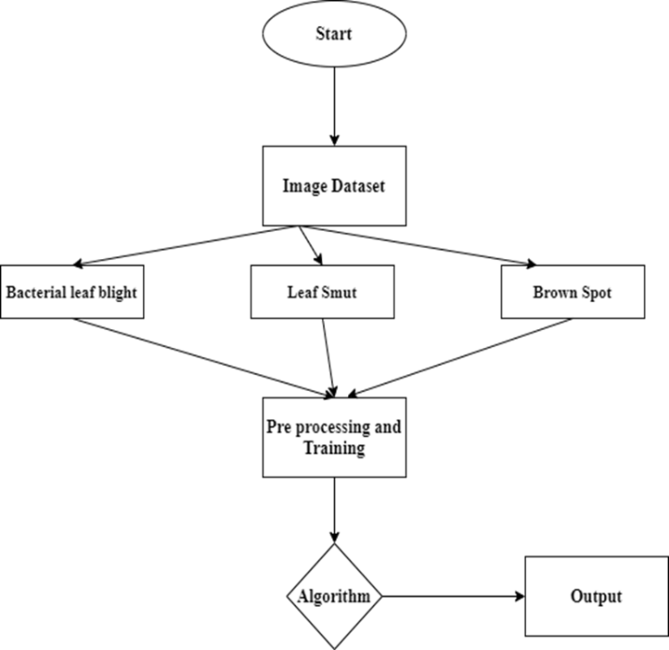

The input is nothing but the entire image data set which had been collected for the processing of the model.

**IV.SYSTEM ARCHITECTURE**

**J**K