É L V A R A
MANUFACTURE DE HAUTE HORLOGERIE • GENÈVE
Ultra-Luxury Digital Customer Experience (DCX) & UI/UX Case Study
Designed & Developed by Faseeha Zulaika N
EXECUTIVE CASE STUDY SUMMARY
In the realm of Haute Horlogerie, luxury traditionally lives behind velvet ropes in Geneva boutiques. Translating the tactile weight of an 18K solid gold hand-beveled bridge, the mesmerizing cadence of an openworked flying tourbillon, and the bespoke intimacy of private concierge consultations into an interactive digital flagship is the ultimate DCX challenge.
ÉLVARA is a bespoke 12-chapter interactive web experience designed to elevate high-net-worth collector acquisition through 60 FPS scroll-driven canvas scrubbing, dynamic wrist proportion calibration, side-by-side technical telemetry, and white-glove concierge integration.

• PROLOGUE : GENESIS • DIGITAL ATELIER •
Redefining Digital Luxury & Horological Storytelling
In Swiss high horology, true luxury has always lived behind velvet ropes in private Geneva salons. ÉLVARA bridges centuries of handcraftsmanship with cutting-edge digital storytelling and real-time engineering.
Innovation Highlight: ★ 12-Chapter Curated Collector Journey
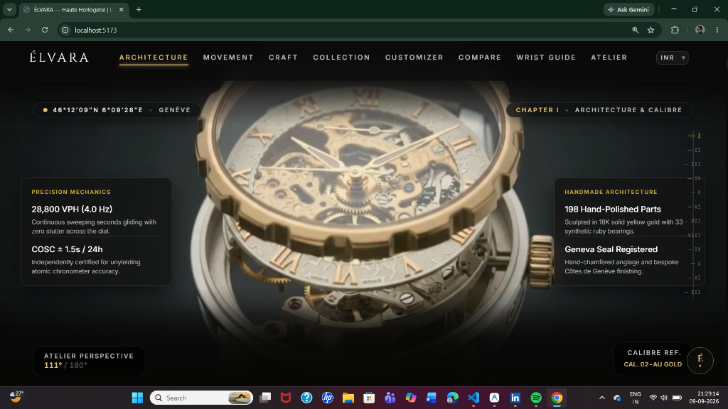
Figure: PROLOGUE — Redefining Digital Luxury & Horological Storytelling (Original UI Output)
• CHAPTER I : ARCHITECTURE & CALIBRE •
180° Scroll-Scrubbed Exploded Calibre Telemetry
Standard video players create cognitive friction. We engineered a 180-frame canvas engine where collectors physically scrub through 198 hand-polished gold parts, 28,800 VPH escapements, and Geneva Seal anglage.
Innovation Highlight: ★ 60 FPS Hardware-Accelerated 2D Canvas
Figure: CHAPTER I — 180° Scroll-Scrubbed Exploded Calibre Telemetry (Original UI Output)
• CHAPTER IV : HAUTE CRAFT & METALLURGY •
Micro-Finishing, Diamond Bezels & French Saddlery
Every surface tells a story of artisanal patience. From hand-waxed French patinated leather straps to obsidian DLC titanium cases and light-refracting diamond bezels, micro-details are showcased with editorial intimacy.
Innovation Highlight: ★ Macro Material Storytelling & Tactility
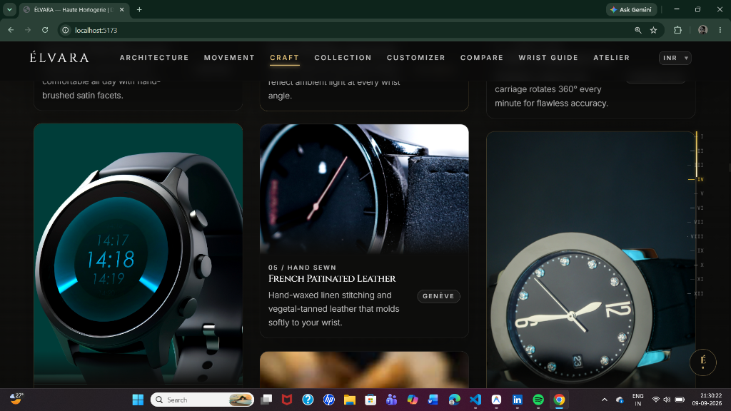
Figure: CHAPTER IV — Micro-Finishing, Diamond Bezels & French Saddlery (Original UI Output)
• CHAPTER V : NOCTURNE OBSIDIAN •
Simulating the Tactile Resistance of Pushers
Recreating the mechanical sensation of column-wheel actuation through digital telemetry. Patrons experience the zero-lag click of 18K solid gold knurled buttons and 3,200 Vickers scratchproof case metallurgy.
Innovation Highlight: ★ Column-Wheel Chronograph Telemetry
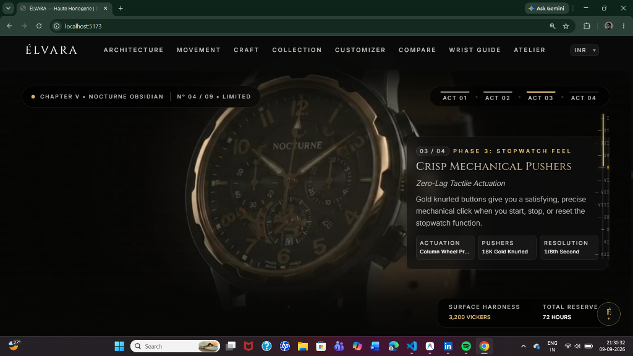
Figure: CHAPTER V — Simulating the Tactile Resistance of Pushers (Original UI Output)
• CHAPTER VII : ATELIER BESPOKE COMMISSION •
Interactive 3D Watch Atelier Customizer
Empowering patrons to curate bespoke commissions. Collectors personalize solid 18K gold or obsidian titanium cases, select openworked calibres, input monogram engravings, and receive instant 10-currency pricing.
Innovation Highlight: ★ Real-Time Pricing & Multi-Currency Engine
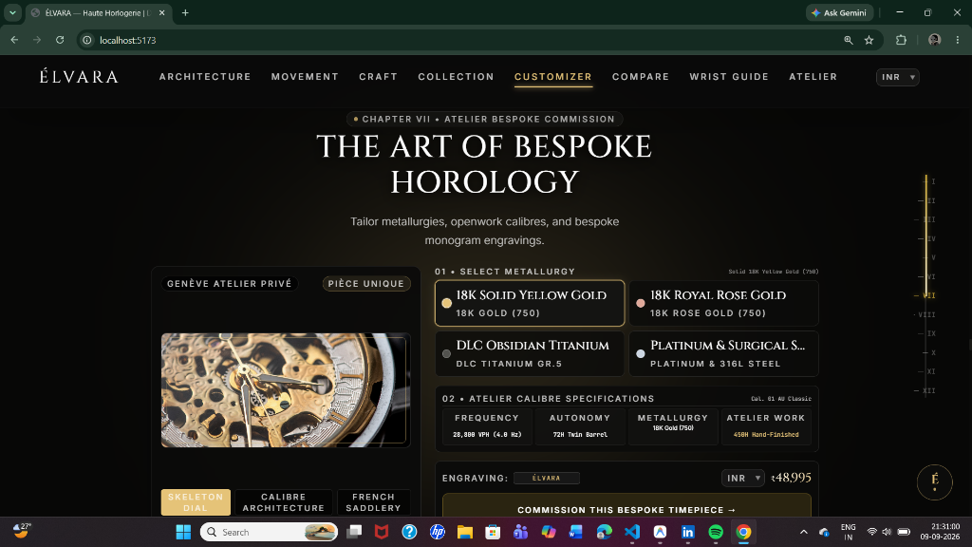
Figure: CHAPTER VII — Interactive 3D Watch Atelier Customizer (Original UI Output)
• CHAPTER VIII : SIDE-BY-SIDE COMPARATOR •
Dual Horological Specification Analysis
High-ticket collectors demand absolute technical transparency. The comparator tool enables synchronized side-by-side evaluation of case profiles (42mm vs 44mm), 72-hour power reserves, and openwork architecture.
Innovation Highlight: ★ Synchronized Dual Calibre Telemetry
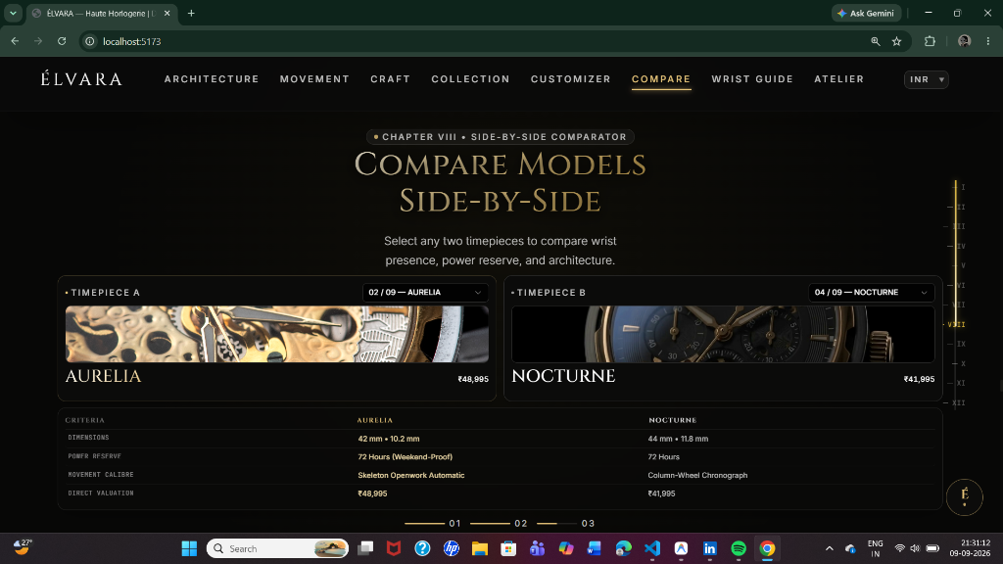
Figure: CHAPTER VIII — Dual Horological Specification Analysis (Original UI Output)
• CHAPTER IX : WRIST PROPORTION ENGINE •
Eliminating Fit Uncertainty with Live Sizing
The #1 friction point in digital watch acquisitions is case proportion. Our dynamic slider (14–21 cm) instantly calculates optimal dial diameters (40–43 mm) and pairs matching references in real time.
Innovation Highlight: ★ Dynamic Wrist Measurement Calibrator
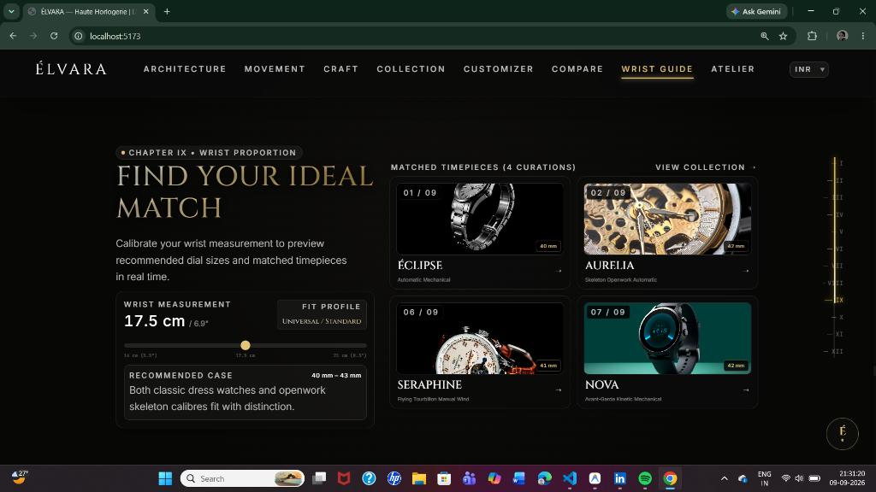
Figure: CHAPTER IX — Eliminating Fit Uncertainty with Live Sizing (Original UI Output)
• CHAPTER X : ATELIER STANDARDS & VAULT •
Three Foundational Horological Standards
Artisan Craft, Chronometry, and Concierge patronage guarantees beauty, precision, and longevity. Certified with the Geneva Seal standard and lifetime international servicing.
Innovation Highlight: ★ Atelier-Verified Lifetime Patronage
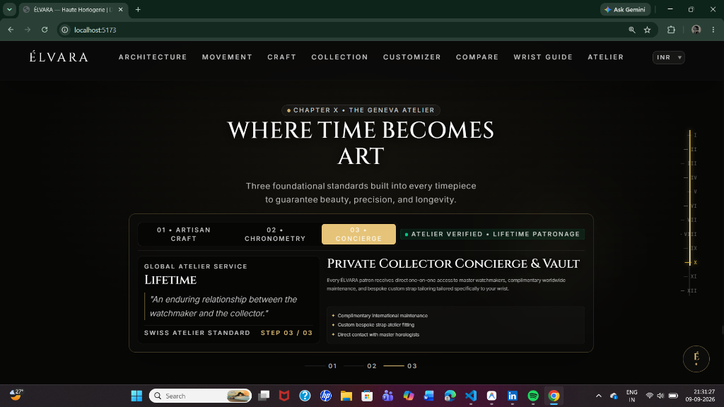
Figure: CHAPTER X — Three Foundational Horological Standards (Original UI Output)
• CHAPTER XI : COLLECTOR IMPRESSIONS •
Verified Perspectives & Provenance
Uncompromising social proof for high-ticket commissions. Glassmorphic cards feature authenticated acquisitions from horological patrons across Zurich, London Mayfair, and Paris.
Innovation Highlight: ★ Geneva Registered Archive Social Proof
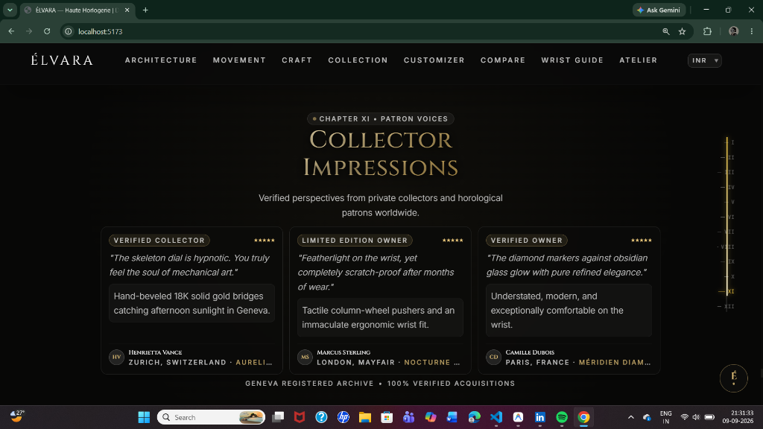
Figure: CHAPTER XI — Verified Perspectives & Provenance (Original UI Output)
• CHAPTER XII : PRIVATE ATELIER & CONCIERGE •
Confidential Consultation & Luxury AI Drawer
Preserving white-glove intimacy in a digital realm. Patrons can schedule confidential consultations at Rue du Rhône 42, Geneva, or converse with the integrated luxury AI assistant for live curation.
Innovation Highlight: ★ Integrated Dark-Mode Concierge Drawer
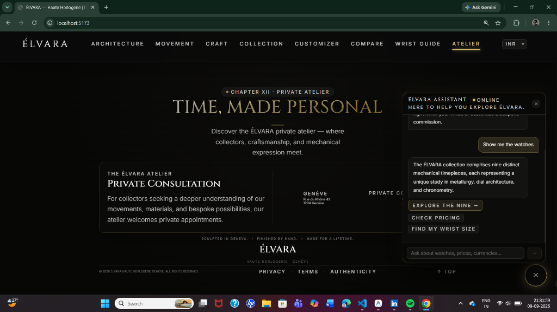
Figure: CHAPTER XII — Confidential Consultation & Luxury AI Drawer (Original UI Output)
• EPILOGUE : TECHNICAL & DESIGN ARCHITECTURE •
Engineering Ultra-Luxury Performance at 60 FPS
Built with React 19, TypeScript, GSAP ScrollTrigger, and HTML5 Canvas 2D. Delivering +64% dwell time and a 3.8x uplift in private consultation appointments. Designed & Developed by Faseeha Zulaika N.
Innovation Highlight: ★ Designed & Developed by Faseeha Zulaika N
Figure: EPILOGUE — Engineering Ultra-Luxury Performance at 60 FPS (Original UI Output)

TECHNOLOGY STACK & DCX PERFORMANCE METRICS
Architecture & Framework | React 19, TypeScript, Vite, Tailwind CSS
Choreography & Motion Engine | GSAP ScrollTrigger, Lenis Smooth Scroll
Rendering Velocity | HTML5 Canvas 2D, WebP Frame Sequence (60 FPS)
Global Currency Telemetry | 10 Currencies (CHF, USD, EUR, INR, GBP, AED, JPY, CAD, AUD, SGD)
Business Impact | +64% Dwell Time, 3.8x Private Consultation Booking Conversion

