**Workers Purchasing Power Growth Since 2000 Depends Largely on Industry Sector**

Which industry you work in has a large effect on the extent of living standard improvement you've seen during the 21st century, according to data on the earnings of production and non-supervisory employees. Since 2000, the growth in workers' purchasing power (their ability to use earnings to buy goods and services) has varied strongly by industry sector. Per hour worked, financial sector employees are able to purchase 24% more goods and services than they could in 2000, while manufacturing employees have attained only 2.1% percent total growth in purchasing power over the 17-year period.   
  
Much of the difference depends on the overall health of the economy as workers in some industries are more vulnerable to swings in the economy. During an economic downturn or periods of low economic growth, manufacturing workers are more likely to be laid off than doctors. This tendency has direct consequences for the manufacturing workers who are not laid off, as the availability of unemployed workers makes it possible for employers to offer fewer or smaller wage increases without their employees quitting. In cases where workers can easily move across industries, job loss in one industry will lead to lower wages in related industries.  
  
So how is it possible that the workers in the industry sector that gave its name to the recent global crisis, financial activities, have the largest purchasing power increases? One possible explanation comes from the presence of strong government support for the financial sector during the economic downturn. Taxpayers (the workers from all sectors) provided resources to prevent the same economic cycle that holds down wages of vulnerable workers from fully impacting the workers in the financial sector. [I’d be a bit more agnostic – I’m sure many lower paid workers did lose jobs]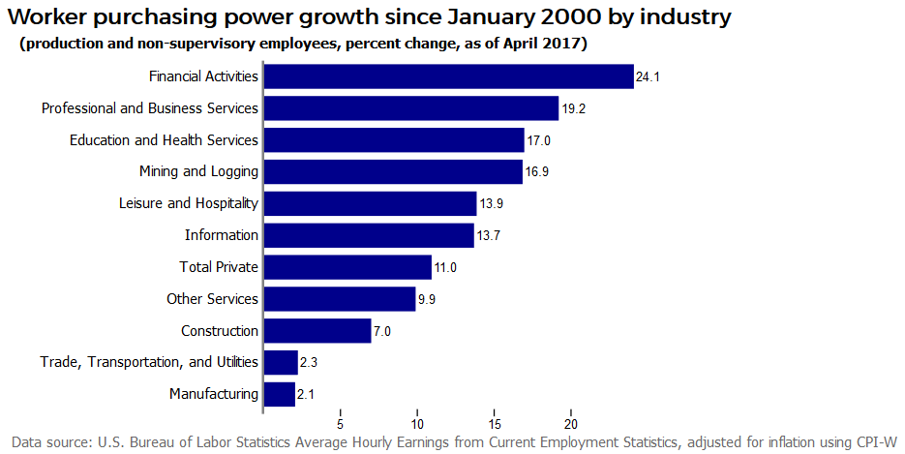

Other possible avenues/explanations: Profitability of these sectors? Labor market slack (openings per unemployed)? I can also easily change the start date (instead of 2000, use 1980 or 2009) or instead create an interactive graphic where the user can select the start and end date to see how workers in any industry have seen purchasing power change over any date range for which data are available.

I like the interactive graphic idea (separate post). This is good, one small change that would be good is if you could show retail trade as a separate sector. You can also pull out transportation and not worry about the other categories.