**Workers Purchasing Power Growth Since 2000 Depends Largely on Industry Sector**

Which industry you work in has a large effect on the extent of living standard improvement you've seen during the 21st century, according to data on the earnings of production and non-supervisory employees. Since 2000, the growth in workers' purchasing power (their ability to use earnings to buy goods and services) has varied strongly by industry sector. Per hour worked, financial sector employees are able to purchase 24% more goods and services than they could in 2000, while manufacturing employees have attained only 2.1% percent total growth in purchasing power over the 17-year period.   
  
As discussed in chapter 3 of Rigged (available for free online) workers in some industries are simply more vulnerable to swings in the economy. During an economic downturn or periods of low economic growth, manufacturing workers are more likely to be laid off than doctors. This tendency has direct consequences for the manufacturing workers who are not laid off, as the availability of unemployed workers makes it possible for employers to offer fewer or smaller wage increases without their employees quitting. Because of the many ways in which people are connected through the economy, a lower wage for one group of workers also tends to lower wages for workers in other groups.  
  
So how is it possible that the workers in the industry sector that gave its name to the recent global crisis, financial activities, have the largest purchasing power increases? One possible explanation comes from the presence of strong government support for financial sector workers during the economic downturn. Taxpayers (the workers from all sectors) provided resources to prevent the same economic cycle that holds down wages of vulnerable workers from fully impacting the workers in the financial sector. The success of taxpayer support in preventing wages from falling for financial sector employees (and thereby to a lesser extent for all employees) is encouraging, though it is unfortunate to see it selectively applied.

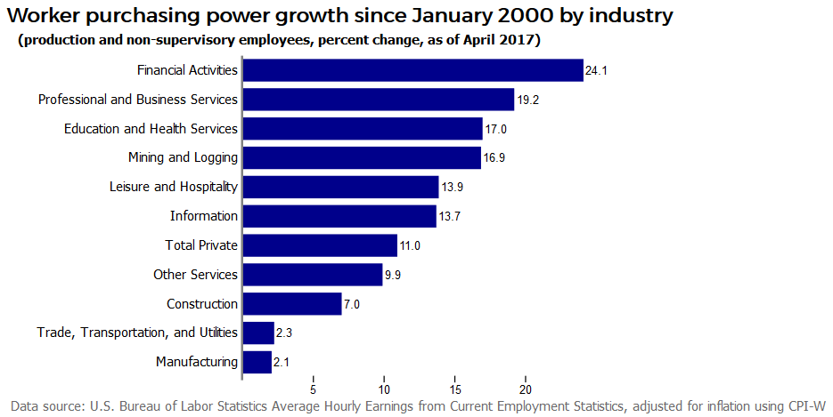

Other possible avenues/explanations: Profitability of these sectors? Labor market slack (openings per unemployed)? I can also easily change the start date (instead of 2000, use 1980 or 2009) or instead create an interactive graphic where the user can select the start and end date to see how workers in any industry have seen purchasing power change over any date range for which data are available.