**10. Corporate profit share of net domestic product vs. non-residential investment share**

**Preliminary finding**: No indication of co-movement between before- or after-tax corporate profit share of net domestic product (NDP) and non-residential fixed investment share of NDP.

Correlation is weakly negative, as follows:

1. Corporate profit (after tax) share of NDP and investment share of NDP: -0.14
2. Corporate profit (before tax) share of NDP and investment share of NDP: -0.26
3. Corporate profit (after tax) share of NDP and investment share of NDP (one-year percent change): -0.23
4. Corporate profit (before tax) share of NDP and investment share of NDP (one-year percent change): -0.16

Some basic plots:

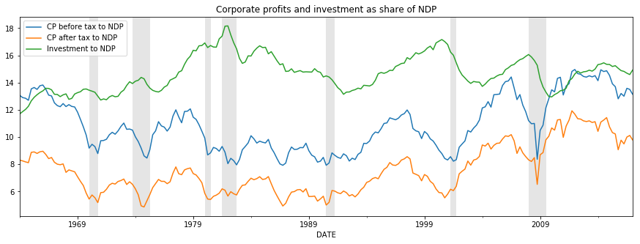

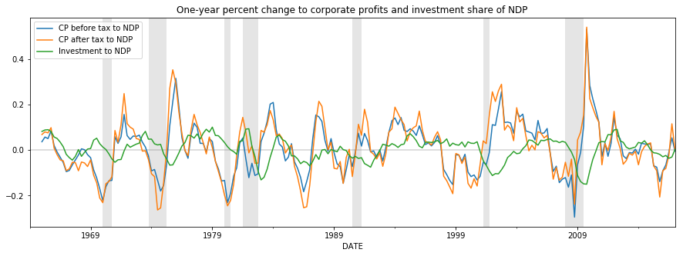

Looking at the plots suggests the possibility that investment (which is often a longer-term decision for firms) may have a weak lagged response to corporate profit increases. Including, for example, a one-year lag to investment share of NDP does yield a weakly positive correlation:

1. Corporate profits (after tax) share of NDP and one-year lagged investment share of NDP (one-year percent change): 0.32

I additionally considered the possibility that firms’ cost of capital, measured as BAA-rated corporate bond yields, could be a stronger determinant of investment share of NDP (which could support a lower FF rate path to spur investment). However, the counter-cyclicality of monetary policy seems to result in a weakly positive (0.21) correlation between BAA corporate bond yield one-year-changes and one-year changes in non-residential fixed investment, where a negative correlation is expected. A one-year lag to investment again flips the correlation to be weakly negative (-0.21).

**Notes on series used:**

* Start date selected by me for all series is January 1, 1964.
* Corporate profit after tax and corporate profit before tax both include Inventory Valuation Adjustment (IVA) and Capital Consumption Adjustment (CCAdj) and are found in NIPA table 1.12
* Non-residential private fixed investment from NIPA table 5.3.5 is used.
* Net Domestic Product (NDP), equal to gross domestic product (GDP) less consumption of fixed capital (CFC) is found as an addenda item in GDP News Release Table 3.
* All series are retrieved initially as nominal and seasonally adjusted at an annual rate.
* ‘National’ corporate profits are used rather than ‘domestic’, which I believe is customary.From the BEA: “The profits component of domestic income excludes the income earned abroad by U.S. corporations and includes the income earned in the United States by foreign residents“

**Technical Notes:**

* I actually used FRED to get the data and cross-checked the FRED data against the BEA’s interactive tables to confirm that the same series were used.
* I've completed the initial inquiry in a way that allows very quick adjustment if you would prefer that I use a different series for any component (for example, corporate profits without IVA and CCAdj). ([Link to code](https://github.com/bdecon/Python/blob/master/CEPR/Profit-Investment.ipynb))