**10. Corporate profit share of net domestic product vs. non-residential investment share**

**Preliminary finding**: No indication of co-movement between before- or after-tax corporate profit share of net domestic product (NDP) and non-residential fixed investment share of NDP.

Correlation is weakly negative, as follows:

1. Corporate profit (after tax) share of NDP and investment share of NDP: -0.14
2. Corporate profit (before tax) share of NDP and investment share of NDP: -0.26
3. Corporate profit (after tax) share of NDP and investment share of NDP (one-year percent change): -0.23
4. Corporate profit (before tax) share of NDP and investment share of NDP (one-year percent change): -0.16

Some basic plots:

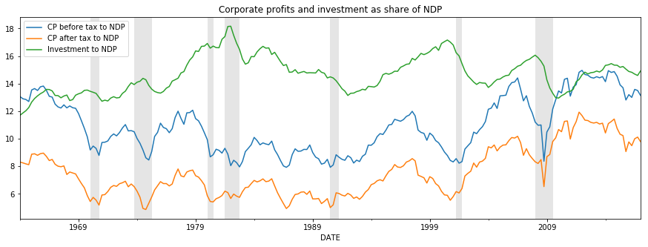

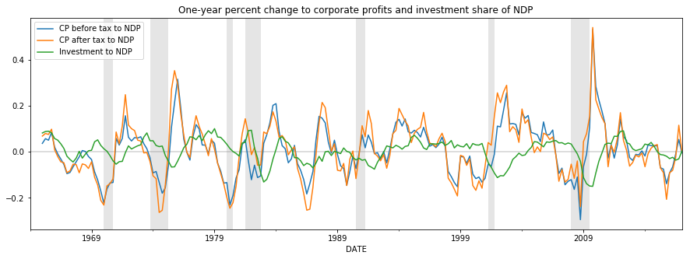

Looking at the plots suggests the possibility that investment (which is often a longer-term decision for firms) may be a weak lagging indicator of corporate profits. A one-year lag to investment share of NDP does yield a weakly positive correlation:

1. Corporate profits (after tax) share of NDP and one-year lagged investment share of NDP (one-year percent change): 0.32

I additionally considered the possibility that cost of capital, in the form of BAA-rated corporate bond yields, could be a stronger determinant of investment share of NDP (which would support a lower FF rate path to spur investment). However, the counter-cyclicality of monetary policy seems to result in a weakly positive (0.21) correlation between BAA corporate bond yield one-year-changes and one-year changes in non-residential fixed investment, where a negative correlation is expected. The one-year lag to investment flips the correlation to be weakly negative (-0.21).

**Notes on series used:**

Corporate profit after tax and corporate profit before tax both include Inventory Valuation Adjustment (IVA) and Capital Consumption Adjustment (CCAdj) and are found in NIPA table 1.12

BEA notes: <https://www.bea.gov/national/pdf/ch13%20profits%20for%20posting.pdf>

Non-residential private fixed investment from NIPA table 5.3.5 is used.

BEA notes; <https://www.bea.gov/national/pdf/NIPAhandbookch6.pdf>

Net Domestic Product (NDP), equal to gross domestic product (GDP) less consumption of fixed capital (CFC) is found as addenda item in GDP News Release Table 3.

Note: I actually used FRED to get the data and cross-checked the result against the BEA’s interactive tables.

All series are retrieved initially as nominal and seasonally adjusted at an annual rate.

‘National’ corporate profits are used rather than ‘domestic’, which I believe is customary.From the BEA: “The profits component of domestic income excludes the income earned abroad by U.S. corporations and includes the income earned in the United States by foreign residents“