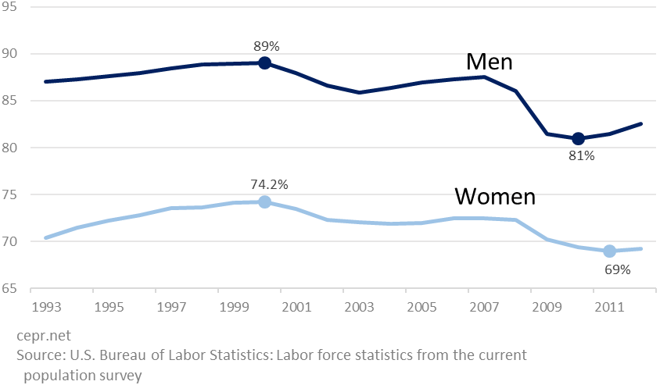

Prime age employment-to-population ratio

*Age 25-54, share of population that is employed, by gender*

lower-tax period (2001-2012)

higher-tax period

(1993-2001)

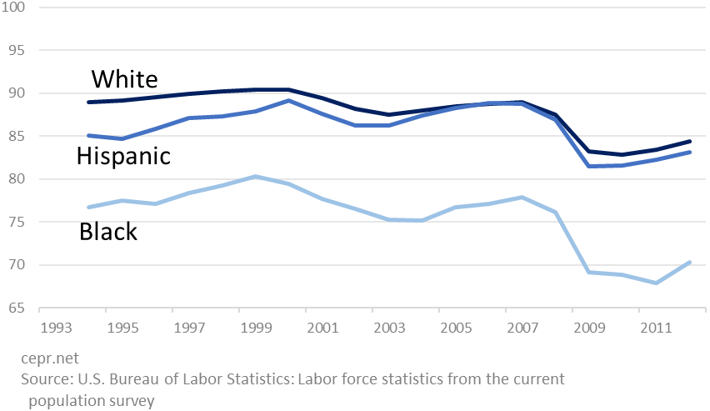

Prime age employment-to-population ratio, men

*Age 25-54, share of population that is employed, by race or origin*

lower-tax period (2001-2012)

higher-tax period

(1993-2001)

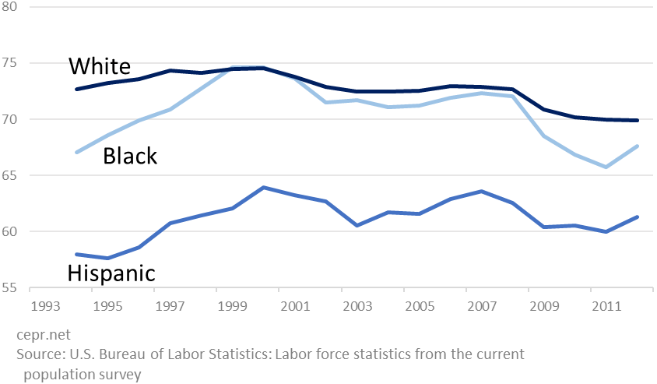

Prime age employment-to-population ratio, women

*Age 25-54, share of population that is employed, by race or origin*

lower-tax period (2001-2012)

higher-tax period

(1993-2001)

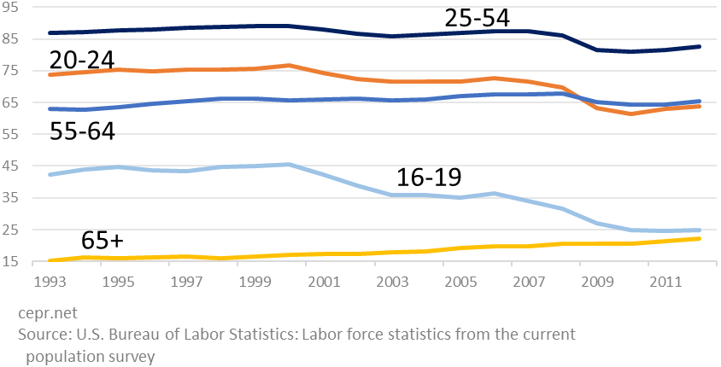

Employment-to-population ratio, men

*Share of population that is employed, by age group*

lower-tax period (2001-2012)

higher-tax period

(1993-2001)

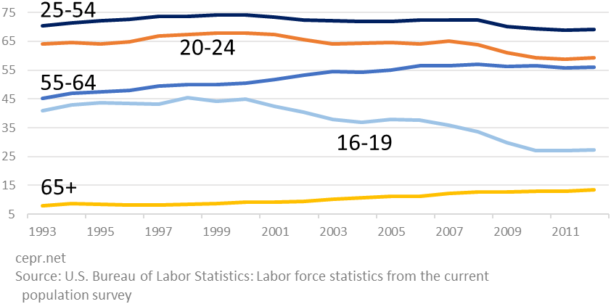

Employment-to-population ratio, women

*Share of population that is employed, by age group*

lower-tax period (2001-2012)

higher-tax period

(1993-2001)