**Access to paid sick days shows encouraging increase according to BLS estimates**

Since 2014, 14 million workers have gained access to paid sick days. The expansion of access has been particularly strong for part-time workers and those earning low wages. Since 2014, nearly 2.7 million part time workers have obtained paid sick days. Over the same period, more than 4.6 million workers in the lowest income quartile (those earning $12.86 per hour or less in 2017) have gained access.

Calculations:

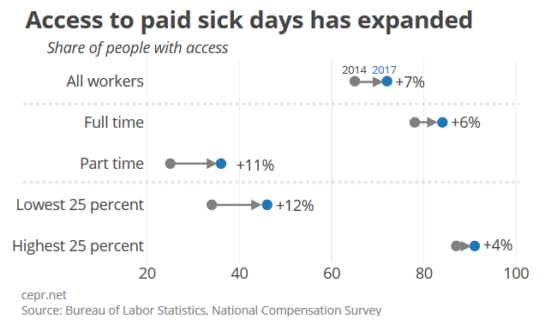2014: 65% of total civilian workers (total=128,093,600) or 83,260,840 have access

2017: 72% of total civilian workers (total=135,130,100) or 97,293,672 have access

Difference is 14,032,832 additional workers with access

Part-time is trickier, since BLS doesn’t indicate the share of total civilian workers that are part time. However, from other BLS series, roughly 19 percent of workers were part time (35 hours or fewer per week) in 2014 and roughly 18 percent in 2017. This estimate applied to the totals above yields:

2014: 25% of part time workers (total = 24,315,939) or 6,078,984 have access

2017: 36% of part time workers (total = 24,379,059) or 8,776,461 have access

Difference is 2,697,476 additional workers with access (rough estimate so around 2.7m)

For the bottom quartile I just used 25% of the total number of civilian workers as the denominator:

2014: 34% of the bottom quartile wage earners (total = 32,023,400) or 10,887,956 have access

2017: 46% of the bottom quartile wage earners (total = 33,782,525) or 15,539,961 have access

Difference is 4,652,005 additional workers with access.

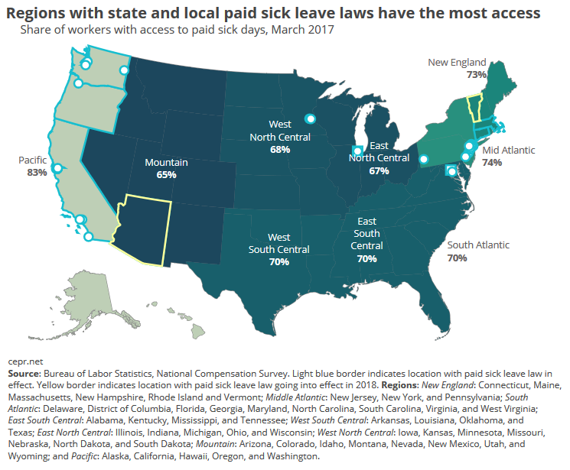

|  |  |  |  |
| --- | --- | --- | --- |
| Law_Year | Location | sID | Type |
| 2006 | San Francisco, CA | CA | City |
| 2008 | Washington, DC | DC | City |
| 2011 | Seattle, WA | WA | City |
| 2013 | New York, NY | NY | City |
| 2013 | Jersey City, NJ | NJ | City |
| 2013 | Portland, OR | OR | City |
| 2014 | Oakland, CA | CA | City |
| 2014 | Newark, NJ | NJ | City |
| 2014 | East Orange, NJ | NJ | City |
| 2014 | Irvington, NJ | NJ | City |
| 2014 | Passaic, NJ | NJ | City |
| 2014 | Paterson, NJ | NJ | City |
| 2014 | Montclair, NJ | NJ | City |
| 2014 | Trenton, NJ | NJ | City |
| 2015 | Emeryville, CA | CA | City |
| 2015 | Bloomfield, NJ | NJ | City |
| 2015 | Elizabeth, NJ | NJ | City |
| 2015 | New Brunswick, NJ | NJ | City |
| 2015 | Philadelphia, PA | PA | City |
| 2015 | Pittsburgh, PA | PA | City |
| 2015 | Tacoma, WA | WA | City |
| 2016 | Los Angeles, CA | CA | City |
| 2016 | Santa Monica, CA | CA | City |
| 2016 | Plainfield, NJ | NJ | City |
| 2016 | Spokane, WA | WA | City |
| 2016 | Minneapolis, MN | MN | City |
| 2016 | San Diego, CA | CA | City |
| 2016 | Chicago, IL | IL | City |
| 2016 | Berkeley, CA | CA | City |
| 2016 | St. Paul, MN | MN | City |
| 2016 | Morristown, NJ | NJ | City |
| 2011 | Connecticut | CT | State |
| 2014 | California | CA | State |
| 2014 | Massachusetts | MA | State |
| 2015 | Oregon | OR | State |
| 2016 | Vermont* | VT | State |
| 2016 | Washington | WA | State |
| 2016 | Arizona* | AZ | State |
| 2015 | Montgomery Co., MD | MD | County |
| 2016 | Cook Co., IL | IL | County |
|  | *Goes into effect fully in 2018 |  |  |

**The wins from Family Values @ Work (jurisdictions that have passed PSD laws)**

Links to the PDF reports:

[March 2010](https://www.bls.gov/ncs/ebs/benefits/2010/ebbl0046.pdf)

[March 2011](https://www.bls.gov/ncs/ebs/benefits/2011/ebbl0048.pdf)

[March 2012](https://www.bls.gov/ncs/ebs/benefits/2012/ebbl0050.pdf)

[March 2013](https://www.bls.gov/ncs/ebs/benefits/2013/ebbl0052.pdf)

[March 2014](https://www.bls.gov/ncs/ebs/benefits/2014/ebbl0055.pdf)

[March 2015](https://www.bls.gov/ncs/ebs/benefits/2015/ebbl0057.pdf)

[March 2016](https://www.bls.gov/ncs/ebs/benefits/2016/ebbl0059.pdf)

[March 2017](https://www.bls.gov/news.release/pdf/ebs2.pdf)