**State and local laws have extended paid sick leave access to millions**

Since 2014, 14 million workers have gained access to paid sick days. Breakdowns of this headline finding, part of the [latest National Compensation Survey](https://www.bls.gov/news.release/pdf/ebs2.pdf) conducted by the Bureau of Labor Statistics (BLS), show across-the-board increases in workers' ability to take time off when they are ill without facing additional financial burden. State and local laws, [now totaling 40](http://familyvaluesatwork.org/media-center/paid-sick-days-wins), have been instrumental in extending paid sick leave benefits to more workers.

**More workers now have access to paid sick days**

According to the BLS report, 72 percent of civilian workers, or 97.3 million people, have access to paid sick days as of March 2017, compared with 83.3 million people (65 percent) in March 2014. Over just three years, access expanded by seven percentage points, with 14 million additional workers covered. As shown below, the increase in access since 2014 covers all groups but is particularly strong for part-time workers and those earning lower wages.

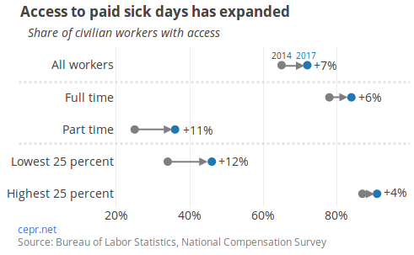

Prior to legislative efforts, it was rare for part-time workers to have access to paid sick leave benefits. In 2014, only 25 percent of part-time workers, or roughly 6.1 million people, had access.[1] The most recent data show 36 percent or roughly 8.8 million part-time workers now have access to paid sick leave. Over the three-year period, nearly 2.7 million part-time workers have obtained paid sick days.

Another encouraging result in the BLS report is the shrinking gap between low-wage and high-wage earners' access to paid sick days. In 2014, only 34 percent of the bottom quartile of wage earners (those earning $11.75 or less per hour in 2014) had access compared with 87 percent of those in the top quartile of wage earners (hourly earnings of $28.13 or more in 2014). Both of these groups (and wage earners in between) now have increased access to paid sick leave, but the growth is far more rapid for the low-wage group. Since 2014, lowest quartile wage earners have seen a 12 percentage point increase in access (4.6 million additional workers have gained access) compared to a 4 percentage point increase for the top quartile of wage earners.

**Legislative efforts have been instrumental in this outcome**

Paid sick leave laws are the instrument that has allowed the rapid expansion of access to more workers over the past three years. Beyond workers' benefits from paid sick days, which include reductions in the spread of illness in the workplace, improved morale, and additional financial stability, research was integral in showing that the early paid sick leave laws had very little, if any, negative effect on businesses. The popularity with workers and the research showing little cost to business led to large increases in the number of jurisdictions with paid sick leave laws.

In 2011, Connecticut became the first state to pass paid sick day legislation. [Thorough analysis](http://cepr.net/publications/reports/good-for-business-connecticuts-paid-leave-law) of Connecticut employers' experience with the law, conducted by CEPR's Eileen Appelbaum and the Murphy Institute, showed that most employers reported modest or no impact on their costs, business operations, or administrative workload. Many fears about the legislation expressed by business interests were unfounded.

In June 2013, New York City passed the Earned Sick Time Act, which was at the time the largest (by jurisdiction size) paid sick leave law. Following the encouraging results of previous legislative efforts, the law extended paid sick day coverage to an additional 1.4 million workers. CEPR and the Murphy Institute again conducted surveys and [analyzed the results](http://cepr.net/publications/reports/no-big-deal-the-impact-of-new-york-city-s-paid-sick-days-law-on-employers) to better understand what impact the law had on businesses. The vast majority of respondents (nearly 85 percent) reported no overall effect on business costs, while a few even saw costs decline. Notably, 18 months after the law went into effect, 86 percent of surveyed employers expressed support for the law.

Encouraged by findings of little to no negative effect on businesses from the Connecticut and NYC laws, there have been 35 new state, country, and city laws since the passage of the NYC law. Notably, California, Massachusetts, Oregon, Vermont, Washington, Arizona, Chicago, Philadelphia, Pittsburgh, and Minneapolis and St. Paul have all passed similar legislation requiring employers to allow workers to earn paid sick days. As a result, nearly 70 million working-age people are now living in jurisdictions covered by laws, as shown below[2]. While many workers in these jurisdictions newly gained access to paid sick days, even workers who already have this benefit gained extended legal protections.

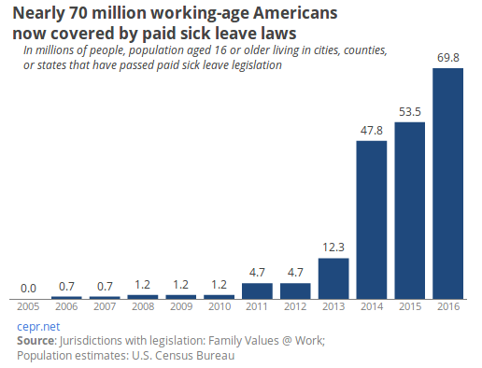

**Regions that contain paid sick leave law jurisdictions have more coverage**

The BLS report also includes information on how paid sick day access varies by region. The regions that include many states, counties, and cities with paid sick leave laws have much higher rates of access. The Pacific region, which includes California, Oregon, and Washington (all three states have paid sick leave laws), as well as Hawaii and Alaska, has by far the most access, with paid sick days available to 83 percent of civilian workers in the region. The regional breakdown of 2017 survey results, as well as which jurisdictions have paid sick day laws, is shown in the map below.

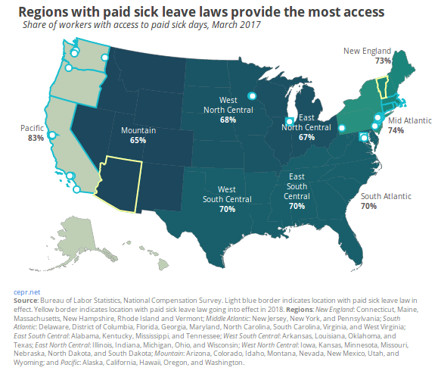

The New England and Mid-Atlantic regions also have strong paid sick leave legislation and higher rates of access. In the Mid-Atlantic region, which includes New York, Pennsylvania, and New Jersey, 74 percent of civilian workers have access to paid sick days, compared with 73 percent in the New England region (Connecticut, Massachusetts, Rhode Island, Vermont, New Hampshire, and Maine). The New England region should see further growth in access as the Vermont paid sick leave law is fully in effect in 2018. The region with the lowest access rate for civilian workers, the Mountain region, is also expected to see an increase following the Arizona state paid sick leave law going into effect in 2018.

The effect of paid sick day laws is particularly visible when comparing the jurisdictions with legislation to the regional results of the BLS survey. Among workers, access to this important benefit has helped all groups but particularly those with part-time jobs or earning relatively lower wages. However, even those outside of the labor force benefit from lower rates of workplace illness and from less financial stress among workers. As additional states and voters consider laws to extend paid sick day benefits to more workers, they should keep in mind the encouraging results shown by the latest BLS figures as well as the research showing a very minimal impact on businesses.

1. While the BLS report does not list how many part-time workers are represented by the National Compensation Survey, other BLS estimates suggest that roughly 19 percent of all workers are part-time in 2014 and roughly 18 percent are part-time in 2017.
2. Working-age population is measured as the total population aged 16 or older