**Trends around restaurant employment**

The U.S. unemployment rate has fallen to its lowest level since 2001 and the economy has added a net total of nearly 15 million jobs since the end of the Great Recession. Yet despite the apparent labor market recovery, inflation shows no sign of acceleration and productivity growth has been low. Perhaps it makes more sense to think about recent changes to the labor market as an evolution rather than a recovery. A shift in the composition of jobs, specifically a shift towards restaurant employment (and away from manufacturing) has direct effects on aggregate trends in wages and productivity.

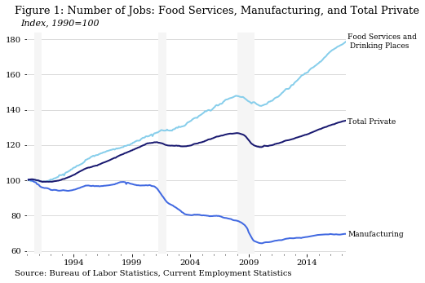

In 1990, restaurant workers[1] comprised six percent of total private non-farm payrolls. Since 2008, more than a quarter of new jobs added have been in restaurants and bars. Restaurants’ growing share of total jobs is not an entirely new trend; restaurants and bars account for more than 20 percent of the 7.6 million jobs added from 2000 to 2007. As a result of these trends around the composition of new jobs, restaurant workers now make up eight percent of total private non-farm payrolls.

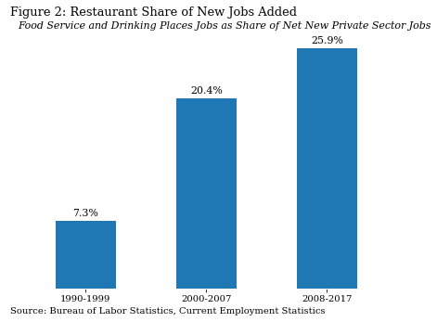

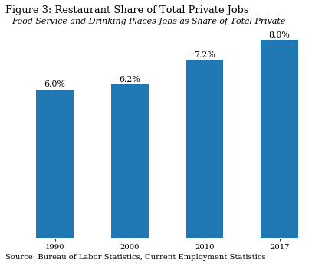

The shifting composition of jobs affects aggregate wages and income levels. Restaurant workers earn both lower hourly wages and work fewer hours per week than employees in the manufacturing sector. The result is an overall reduction in total worker income, especially, for example, for workers who move to lower-paid food service work after losing manufacturing jobs.

At an aggregate level, the changing composition of jobs and resulting reduction in wages for segments of the population reduces the demand for goods and services in the economy. Workers with less income don’t have the ability to make as many new purchases. Weaker demand results in fewer people bidding up the price of the same goods, and may be partially responsible for the low levels of inflation.

One difference between manufacturing and restaurant jobs is how the pace of work varies during the day. Manufacturing jobs tend to have a steady pace of output throughout the day, as workers keep pace with the assembly line. In contrast, restaurants tend to have rushes and lulls. During the day, there may be a large crowd in for lunch or an event, followed by a period in which customer numbers are lower. As the composition of jobs in the economy shifts towards restaurant work and away from manufacturing, the total productivity rates are likely to be lower.

Additionally, as more and more restaurant jobs are added, each individual new job tends to be less productive. That is, the lunch rush and dinner shifts may be the first staffed, while competition between restaurants may incentivize longer hours. The total check amounts per hour (which is roughly how productivity would be measured in this case) will be lower in these marginal shifts.

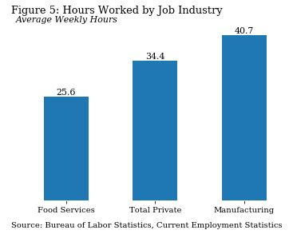

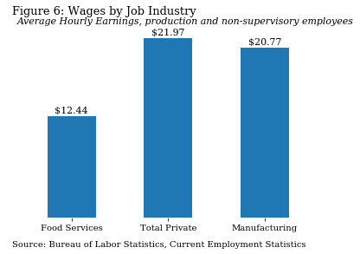

Traditionally, one feature of the food services industry has been higher turnover. As better jobs become available to restaurant workers, they leave to pursue them. The quits rate is one way to measure how likely workers are to voluntarily leave the current jobs. This accommodation and food services quits rate, which measures the number of quits as a share of the total number of jobs in the industry, hovered between four and six percent during 2001-2008, but fell to three percent as better job opportunities vanished during the Great Recession, and has not returned to its pre-recession level.

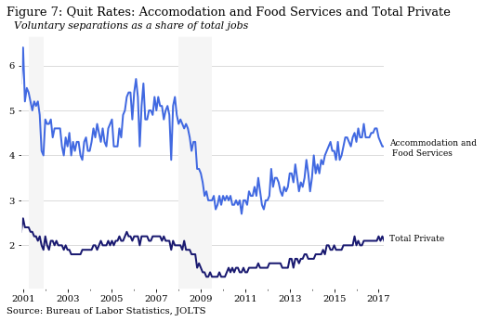

Pay increases may also be helping to keep quits rates down in the accommodation and foods services sectors. While, as shown above, this industry has one of the lowest average hourly wages, some recent legislative actions have resulted in higher minimum wages for workers in certain geographic areas. When someone decides whether to leave their job, the prospect of pay increases may tilt the scales towards staying.

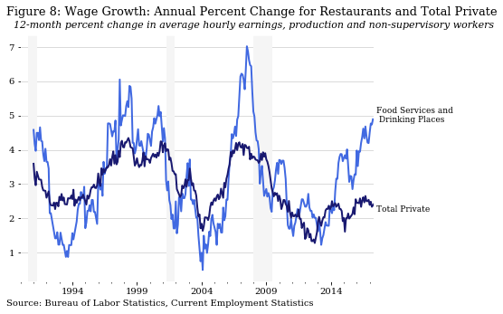

Possible alternate chart:

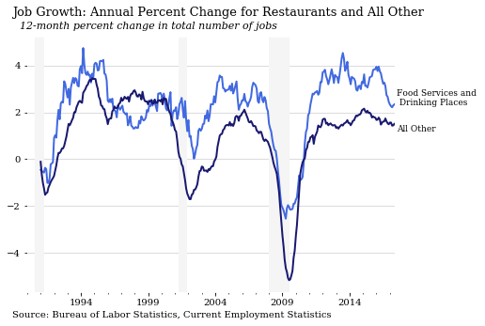

1. Employees in the NAIC Food Services and Drinking Places subcategory (722).