**Note to Employers: the Construction Labor Market Not as Tight as Advertised**

Numerous recent news stories describe the labor market for construction jobs as excessively tight[1]. Construction employers struggle to find blue-collar workers, these stories claim, and therefore are supposedly [offering luxurious compensation packages](https://www.bloomberg.com/news/articles/2017-06-27/want-a-1-million-paycheck-skip-college-and-go-work-in-a-lumberyard) to entice people to take jobs in the industry, or being [forced to turn down work](https://www.wsj.com/articles/labor-shortage-squeezes-real-estate-developers-1498595109). These employers and journalists often make basic errors when telling these stories. They conflate blue- and white-collar workers, and many never even think about whether anyone has tried raising wages to find workers. While there may be labor shortages in specific areas, and there may be some anecdotal evidence that some employers have a hard time finding workers, the data point to another possibility: in the industry as a whole, management do not consider using wage hikes to find workers and instead plead for policies that keep new workers coming in while wages remain low. In fact, [some construction employers](http://cepr.net/blogs/beat-the-press/lessons-on-labor-economics-for-the-owner-of-a-roofing-company-in-nebraska) directly say they can’t or won’t raise wages.

**The tight construction labor market doesn’t show up in data**

If a labor market is “tight,” a few things should happen and show up in economic data. First, there will be very few skilled unemployed people. In a tight labor market, employers will take more steps to find and hire the people who are looking for work and have skills the employers need. One way to measure this tendency in the construction industry as a whole is to calculate the ratio of unemployed construction workers to the number of construction job openings. Currently, there are more than three unemployed construction industry employees per opening. This is almost triple the ratio for all jobs, meaning the construction sector is nearly three times as likely to have unemployed workers available as the average for all sectors. While this data does not look specifically at blue-collar, unskilled and skilled workers that are often talked about, the results likely hold for these workers, which make up 75 percent of industry employment. Some set of the non-production employees and managers, including accountants and other office staff, are also more likely to quickly find work outside of the field than those with expertise that is more industry-specific.

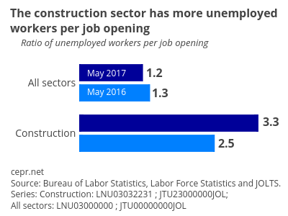

<div>

<a href="https://plot.ly/~bdew/144/?share_key=FdLPvj6b6z9b0NNIXgaFSY" target="_blank" title="Construction_Labor_Market_fig1" style="display: block; text-align: center;"><img src="https://plot.ly/~bdew/144.png?share_key=FdLPvj6b6z9b0NNIXgaFSY" alt="Construction_Labor_Market_fig1" style="max-width: 100%;width: 400px;" width="400" onerror="this.onerror=null;this.src='https://plot.ly/404.png';" /></a>

<script data-plotly="bdew:144" sharekey-plotly="FdLPvj6b6z9b0NNIXgaFSY" src="https://plot.ly/embed.js" async></script>

</div>

Second, in a tight labor market construction workers who are already hired will be given additional hours. Since a tight labor market makes it difficult to find and hire new staff, those already employed will often have to work more to compensate. This shows up in economic data as an acceleration in average hours worked per week including overtime. Construction industry production and nonsupervisory employee hours worked, on a seasonally adjusted basis, are flat over the past three years. If the labor market were excessively tight, management would be incentivized to offer more hours to existing workers. Recent data do not confirm this possibility for the construction industry.

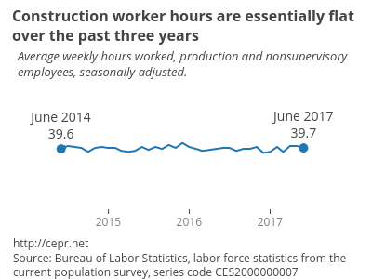

<div>

<a href="https://plot.ly/~bdew/140/?share_key=POMfzJEesrU6rIEAPUUpif" target="_blank" title="Construction_Labor_Market_fig2" style="display: block; text-align: center;"><img src="https://plot.ly/~bdew/140.png?share_key=POMfzJEesrU6rIEAPUUpif" alt="Construction_Labor_Market_fig2" style="max-width: 100%;width: 400px;" width="400" onerror="this.onerror=null;this.src='https://plot.ly/404.png';" /></a>

<script data-plotly="bdew:140" sharekey-plotly="POMfzJEesrU6rIEAPUUpif" src="https://plot.ly/embed.js" async></script>

</div>

Perhaps most importantly, real wage growth should be strong if the supply of available workers is far below the demand for workers. Managers can simply raise wages to pull workers in from other locations and industries and entice workers on the sidelines to apply. They also would be trying to pull workers away from their competitors. In a tight labor market, businesses compete for workers just as they compete for customers. The ones that can’t afford to pay high enough wages to attract workers go out of business, just as companies that can’t attract customers go out of business.

Wages are supposed to adjust keep supply and demand in line in the labor market. Looking at the data on production and non-supervisory workers, real wage growth in all sectors has been weak and construction is no exception. The most recent data on average hourly earnings, from June 2017, adjusted for inflation, show annual real wage growth of 0.61 percent for the construction sector compared to 0.8 percent for all jobs. The story of strong wage growth just doesn’t hold up.

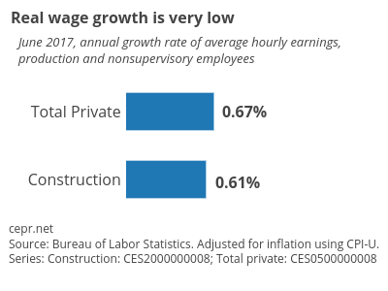

<div>

<a href="https://plot.ly/~bdew/148/?share_key=UmEHkIksCVfczUh6XlN6Y8" target="_blank" title="Construction_Labor_Market_fig3" style="display: block; text-align: center;"><img src="https://plot.ly/~bdew/148.png?share_key=UmEHkIksCVfczUh6XlN6Y8" alt="Construction_Labor_Market_fig3" style="max-width: 100%;width: 400px;" width="400" onerror="this.onerror=null;this.src='https://plot.ly/404.png';" /></a>

<script data-plotly="bdew:148" sharekey-plotly="UmEHkIksCVfczUh6XlN6Y8" src="https://plot.ly/embed.js" async></script>

</div>

On a national level, the data [doesn’t support the notion](http://cepr.net/blogs/cepr-blog/is-there-a-labor-shortage-in-the-construction-industry) that there is a labor shortage for construction workers. This is not to say that specific geographic locations could not be experiencing shortages, but the overall story that is reported does not hold up when looking at the evidence.

**Policies can increase the supply of workers without higher wages**

Executives face many options for influencing their industry’s labor market. The obvious options, to offer more hours and higher wages to increase the available supply, are not being applied according to recent data. What does seem to be happening could perhaps be described as lobbying for labor policies that are more favorable for management, such as increased immigration and public funding for firm specific training Construction industry associations consistently promote these policies and the labor shortage narrative, even in the years right after the Great Recession, when the labor market was obviously very loose.

If there is a government role in resolving the labor “shortage” in the construction industry, it should perhaps be directed for training at the top rather than the bottom. A bit of education on the workings of the labor market, and how wages are supposed to adjust to equate supply and demand, could go far towards rectifying the problem. At the very least, it should quiet the complaints over labor shortages.

1. There are also claims that the overall labor market is excessively tight. While the unemployment rate is low, measures of labor force participation, as well as recent data on jobs growth, suggest that there is still [room for the overall labor market to grow](http://cepr.net/data-bytes/jobs-bytes/jobs-2017-07).