WEB DEVELOPMENT PROJECT PROPOSAL

Event Management System
  - A Professional Web-Based Software Solution for Event Planning, Booking, and Administration

Student Name | Mohsin
Project Type | Web Development Project
Technology Stack | HTML, CSS, JavaScript, PHP, MySQL
Document Type | Software Project Proposal
Academic Year | 2026

Prepared as a complete academic proposal for a dynamic event management web application.

1. Executive Summary
The Event Management System is a professional web-based software project designed to simplify the planning, publishing, booking, and administration of events. The system will allow users to browse upcoming events, register for events, book tickets, and receive booking information, while administrators can manage events, venues, categories, users, bookings, feedback, and reports from a secure dashboard.
This proposal presents the complete concept, scope, features, technology stack, database design, development plan, testing approach, and expected deliverables of the Event Management System. The application will be developed using HTML, CSS, JavaScript, PHP, and MySQL, making it suitable for academic demonstration as well as real-world small-to-medium event operations.

2. Problem Statement
Many small organizations, colleges, clubs, hotels, and event planners still manage events manually through paper forms, phone calls, spreadsheets, and social media messages. This creates problems such as duplicate bookings, missing attendee records, poor communication, slow reporting, and difficulty managing event capacity.
A centralized web application is required to manage event information, bookings, users, payments, attendance records, and feedback in one organized system. The proposed software will reduce manual work, improve accuracy, and provide a better experience for both attendees and administrators.

3. Project Aim and Objectives
The aim of this project is to develop a complete Event Management System that allows users and administrators to manage the full event lifecycle through a responsive and secure web application.

Specific Objectives
- Design an attractive and responsive user interface for event browsing and booking.
- Create a secure login and registration system for users and administrators.
- Allow administrators to add, update, delete, approve, and manage events.
- Allow users to search events, view details, and submit bookings online.
- Store all users, events, bookings, venues, categories, and feedback in a MySQL database.
- Generate basic reports for bookings, attendees, revenue records, and event performance.
- Improve data accuracy by replacing manual event records with a centralized database system.

4. Proposed Solution
The proposed solution is a PHP and MySQL based web application with two main sides: a public user interface and an admin dashboard. The public side will help visitors view event details, register accounts, and book events. The admin side will help authorized staff manage events, users, bookings, venues, reports, and system settings.
The system will be developed using structured PHP, reusable front-end components, responsive CSS, client-side JavaScript validation, server-side PHP validation, and relational MySQL tables. This approach keeps the project easy to understand, easy to demonstrate, and expandable in the future.
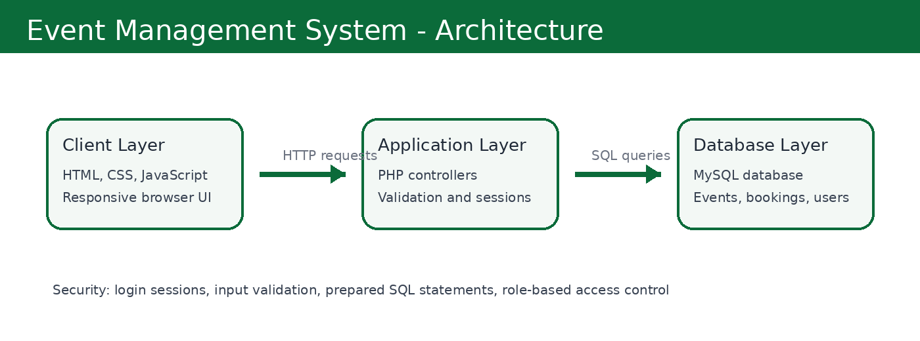

5. Scope of the Project

Included in Scope
- User registration, login, profile management, and logout.
- Event listing with event title, description, date, time, location, category, image, and price.
- Admin panel for managing events, venues, categories, bookings, and users.
- Booking management with booking status such as pending, confirmed, cancelled, or completed.
- Basic payment record management for cash, manual payment, or optional online payment integration.
- Feedback and rating section after event completion.
- Dashboard reports for total events, total bookings, total users, and event-wise statistics.

Out of Scope for Initial Version
- Full payment gateway integration such as Stripe, JazzCash, or Easypaisa.
- Native Android or iOS mobile application.
- Advanced AI-based recommendation system.
- Large-scale enterprise multi-branch deployment.

6. Target Users
User Type | Role in System
Visitor | Can view public event pages and search upcoming events.
Registered User | Can create an account, book events, view booking history, and submit feedback.
Event Organizer | Can request or manage assigned events depending on admin permission.
Administrator | Can manage the complete system, including users, events, bookings, venues, categories, and reports.

7. Main Modules and Features
Module | Description
Authentication Module | User registration, login, logout, password validation, session management, and role-based access.
Event Management Module | Admin can create, update, delete, publish, cancel, and categorize events.
Venue Management Module | Admin can manage venue name, address, seating capacity, contact details, and availability.
Booking Module | Users can book events, view booking status, cancel eligible bookings, and see booking history.
Admin Dashboard | Dashboard cards, quick statistics, recent bookings, event status, and management shortcuts.
Search and Filter Module | Users can search by event name, category, date, location, and price range.
Feedback Module | Users can submit ratings and feedback after attending an event.
Reports Module | Admin can view event-wise bookings, total attendees, revenue records, and user activity summaries.
Notification Module | Basic email or on-screen notifications for booking confirmation and event updates.

8. Functional Requirements
- The system shall allow new users to register with valid information.
- The system shall authenticate users before allowing bookings.
- The admin shall be able to add, edit, delete, and publish events.
- The user shall be able to view event details before booking.
- The user shall be able to submit a booking request for available events.
- The admin shall be able to approve, reject, or cancel bookings.
- The system shall prevent bookings beyond venue capacity.
- The system shall store booking records in the MySQL database.
- The system shall display booking history to users.
- The admin shall be able to generate basic event and booking reports.

9. Non-Functional Requirements
Requirement | Description
Performance | Pages should load quickly and common operations should be completed within a few seconds.
Security | The system should use server-side validation, password hashing, secure sessions, and prepared statements.
Usability | The interface should be simple, clean, responsive, and easy for non-technical users.
Reliability | The database should maintain accurate records for users, events, and bookings.
Maintainability | Code should be organized into reusable files, functions, and clear folders.
Compatibility | The system should work properly in modern browsers such as Chrome, Edge, Firefox, and mobile browsers.

10. Technology Stack
Technology | Use in Project
HTML5 | Structure of web pages, forms, tables, navigation, and content sections.
CSS3 | Responsive design, layout styling, colors, spacing, buttons, cards, and dashboard interface.
JavaScript | Client-side validation, dynamic UI interactions, search filters, modal windows, and form improvements.
PHP | Backend logic, user sessions, authentication, CRUD operations, database communication, and admin panel functions.
MySQL | Relational database for users, events, venues, bookings, payments, feedback, and reports.
XAMPP/WAMP | Local development environment using Apache, PHP, and MySQL.
phpMyAdmin | Database creation, table management, and testing SQL queries.

11. System Architecture and Workflow
The application will follow a three-layer architecture. The front-end layer will handle the user interface. The PHP application layer will process business rules, sessions, form submissions, and validation. The MySQL database layer will store and retrieve structured data.
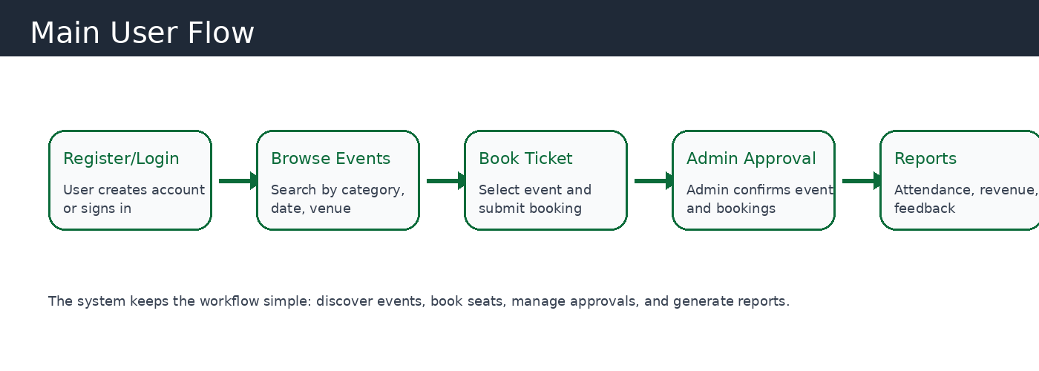

12. Database Design
The database will be designed using relational tables with primary keys and foreign keys. This structure will reduce duplicate data and maintain proper relationships between users, events, venues, bookings, and payments.
Table | Important Fields | Purpose
users | user_id, name, email, password, phone, role, status, created_at | Stores registered users and admin accounts.
categories | category_id, category_name, description, status | Stores event categories such as seminar, wedding, concert, workshop.
venues | venue_id, venue_name, address, capacity, contact_no, status | Stores venue details and seating capacity.
events | event_id, category_id, venue_id, title, description, event_date, event_time, price, status | Stores all event details.
bookings | booking_id, user_id, event_id, seats, total_amount, booking_status, booking_date | Stores user booking records.
payments | payment_id, booking_id, amount, payment_method, payment_status, payment_date | Stores payment record against each booking.
feedback | feedback_id, user_id, event_id, rating, comments, created_at | Stores attendee reviews and ratings.
notifications | notification_id, user_id, title, message, status, created_at | Stores basic system notifications.

Key Relationships
- One category can have many events.
- One venue can host many events, but one event is assigned to one venue.
- One user can create many bookings.
- One event can have many bookings.
- One booking can have one payment record.
- One user can give feedback for attended events.

13. Proposed Website Pages
Page | Purpose
Home Page | Intro section, featured events, upcoming events, categories, and call-to-action buttons.
Events Page | Complete event listing with search and filter options.
Event Detail Page | Detailed event information, venue, date, price, seats available, and booking button.
Register/Login Page | User account creation and secure login form.
User Dashboard | Booking history, profile details, feedback, and notifications.
Admin Dashboard | Overview of total events, bookings, users, revenue, and recent activity.
Manage Events | Admin CRUD operations for events.
Manage Bookings | Admin can approve, cancel, and view booking records.
Reports Page | Event-wise and booking-wise reports.
Contact Page | Contact form and organization details.

14. Development Methodology
The project will follow an incremental development methodology. Each module will be designed, developed, tested, and then integrated with the next module. This approach is suitable for student projects because progress can be demonstrated step by step.
- Requirement gathering and proposal approval.
- User interface design using HTML, CSS, and JavaScript.
- Database design and table creation in MySQL.
- Backend development using PHP.
- Module-wise testing and integration.
- Final testing, documentation, and project presentation.

15. Project Timeline
Duration | Planned Work
Week 1 | Requirement analysis, proposal finalization, and basic layout planning.
Week 2 | Database design, ER relationships, and front-end page structure.
Week 3 | Authentication module, user dashboard, and admin dashboard setup.
Week 4 | Event management, venue management, category management, and search filters.
Week 5 | Booking module, feedback module, reports, and notification features.
Week 6 | Testing, bug fixing, documentation, screenshots, and final presentation.

16. Testing Plan
Testing Type | Testing Purpose
Unit Testing | Each PHP function and individual page will be tested separately.
Form Validation Testing | Registration, login, event creation, and booking forms will be tested with valid and invalid data.
Database Testing | Insert, update, delete, and select operations will be verified using MySQL and phpMyAdmin.
Security Testing | Login sessions, input validation, password hashing, and SQL injection prevention will be checked.
Responsive Testing | The website will be tested on desktop, tablet, and mobile screen sizes.
User Acceptance Testing | A sample user flow will be tested from account creation to event booking and feedback submission.

17. Security Considerations
- Passwords will be stored using password hashing instead of plain text.
- PHP sessions will be used to protect user and admin areas.
- Prepared statements will be used to reduce SQL injection risk.
- Server-side validation will be applied to all important forms.
- Admin routes will be restricted to administrator accounts only.
- User input will be sanitized before display to reduce script injection risk.
- Database access credentials will be stored in a separate configuration file.

18. Expected Deliverables
- Complete project proposal document.
- Responsive front-end pages built with HTML, CSS, and JavaScript.
- PHP backend files for authentication, CRUD operations, and booking logic.
- MySQL database file with tables and relationships.
- Admin dashboard and user dashboard.
- Testing report and screenshots.
- Final presentation or viva-ready project explanation.

19. Future Enhancements
- Online payment gateway integration.
- QR code based ticket scanning and attendance verification.
- Email and SMS notification integration.
- Organizer subscription plans and commission model.
- Advanced analytics dashboard with charts.
- Mobile application version for Android and iOS.
- Multi-language support for English and Urdu.

20. Conclusion
The Event Management System is a practical and useful web development project that solves a real organizational problem. It provides a centralized platform for event listing, user registration, booking management, admin control, and reporting. By using HTML, CSS, JavaScript, PHP, and MySQL, the project remains achievable for a student while still demonstrating important professional software development concepts such as database design, authentication, CRUD operations, validation, security, responsive design, and system testing.
This project will help the student demonstrate both front-end and back-end development skills and can be expanded in the future into a complete commercial event management platform.

