**Augmented Reality Research in Various Museums: Utilization of Augmented Reality in The Educating of Museum Objects**

**Ketut Agustini**

Informatics Engineering Education Department, Universitas Pendidikan Ganesha, Indonesia [*ketutagustini@undiksha.ac.id*](mailto:ketutagustini@undiksha.ac.id)

**Ni Made Ratminingsih**

English Education Department, Universitas Pendidikan Ganesha, Indonesia [*made.ratminingsih@undiksha.ac.id*](mailto:made.ratminingsih@undiksha.ac.id)

**Dessy Seri Wahyuni**

Informatics Engineering Education Department, Universitas Pendidikan Ganesha, Indonesia [*seri.wahyuni@undiksha.ac.id*](mailto:seri.wahyuni@undiksha.ac.id)

**Fashan Saraya**

Informatics Engineering Education Department, Universitas Pendidikan Ganesha, Indonesia [*fashan@undiksha.ac.id*](mailto:fashan@undiksha.ac.id)

**I Nengah Eka Mertayasa**

Informatics Engineering Education Department, Universitas Pendidikan Ganesha, Indonesia [*eka.mertayasa@undiksha.ac.id*](mailto:eka.mertayasa@undiksha.ac.id)

This literature review system aims to analyze the use of Augmented Reality in Museums based on 30 international journals reporting on the use of Augmented Reality in Museums in 2019-2021. Content analysis is used as a methodology to investigate methodologies, fields of study, technological tools, and developments in the use of Augmented Reality in Museums, frequently used keywords, and cited/referenced works. The results of the analysis were interpreted using descriptive, percentage, and frequency analysis. This analysis found that many technological tools are used for Augmented Reality in the Museum. The impact analysis found that the use of Augmented Reality had a major impact along with an increase in visits from tourists. There are several problems found in this discussion and it is hoped that later this discussion can be useful for researchers to improve existing problems. This research also has implications for the government or policymakers to determine that Augmented Reality should be applied in all museums in Indonesia.

Keywords: Augmented Reality, Museum, Application, Visitors

**INTRODUCTION**

Museums are part of social institutions in society because museums are used as a vehicle to provide knowledge, education, and development to every community through a community or public system. Ambrose and Crispin (1993). Culture is a field that is currently entering a revolutionary phase, no longer being a privilege for a few, but extending to new audiences who are urged to not only passively consume cultural heritage content, but participate and assimilate it themselves. Museums in this age are considered very boring places because of the shape of the building, the things in it. In today's era of globalization, everyone can do everything from the palm of their hand, therefore boring things like visiting museums are not important to people. Museums are places that give us a lot. With the characteristics of ubiquitous connectivity, smartphones have become an inevitable device for almost everyone in this modern era. Currently, many software developments can help humans work in the field of marketing and object recognition. This technology is known as Augmented Reality (AR) which is a combination of virtual objects with real objects that can be used to design or create 3-dimensional artificial images that have similarities to real objects (Udin, 2012; Udin, 2014).

From the statement above, an innovation was found that made researchers create various ways to combine today's technology with historical objects in the past. This is intended to increase the interest of visitors when visiting the museum. AR has grown ubiquitous in the wider educational community and is designated as one of the key developments of this type of instructional innovation. The use of AR has been widely adopted for various fields, including the tourism sector to enhance the overall visitor experience. AR promotes the study of history through the delivery of multimedia (e.g. text, images, audio, video, and animation) sensitive to certain displays and artifacts at various sites. history and heritage. AR implementation enables the presentation of information addition to the museum as a medium and create a visual integration of the physical world and virtual environment for users. Extended reality aims to simplify users' lives by bringing virtual information not only into the surrounding environment but also for indirect viewing of real-world environments, such as live broadcasts. AR improves the user's perception of and interaction with the real world. Although Virtual Reality (VR) technology or Virtual environment as Milgram calls it, the user's total immersion in the synthetic world without seeing the real world, AR technology adds to the meaning of reality with super Virtual objects and gestures to the real world directly (Furht, B. (Ed.), 2011). knowledge of history in our country.

**Review of Related Literature and Theoretical Framework**

In recent years, Augmented Reality technology has been developed very intensively. This technology is very useful for human life, especially in the field of promotion of something. Until now, there have been many software developments that can help humans work in the field of marketing and object recognition. This technology is known as Augmented Reality (AR) which is a combination of virtual objects with real objects that can be used to design or create 3-dimensional artificial images that have similarities to real objects (Udin, 2012; Udin, 2014).

The museum is currently the least visited place because many museums have dusty corners, buildings are not maintained, and so on. These problems add to the attention of researchers to create very innovative solutions to combine the two things. The theory used in this problem is of course Augmented Reality, namely in terms of Merging real objects and virtual objects into a single unit. Currently, AR technology has been widely used by the public to support various sciences, one of which is in cultural science. heritage and museums. This technology is very useful for museums that cannot display informational content in the form of artifacts or atmospheres that are difficult to bring into the world tangible, for example, artifacts that are very fragile and have limited contact with visitors or restoring historical images may be difficult to enjoy again (Wojciechowski, et al: 2004).

According to Kamelia (2015) in principle, there are several minimal components used to use this AR technology, namely: (1) Computer, (2) Head Mounted Display (HMD), (3) Markers, (4) Camera. These things are needed so that an object can be made into a virtual form.

**Study Objectives and Research Questions**

This literature review system aims to analyze articles that use Augmented Reality in Museums based on 30 international journals reporting on the use of Augmented Reality in Museums in 2019-2021. Content analysis is used as a methodology to investigate methodologies, fields of study, technological devices from various articles that use Augmented Reality in the Museum. The results of the analysis were interpreted using descriptive, percentage, and frequency analysis. This analysis finds that there are several methods and technological tools used for the utilization of Augmented Reality in the Museum. There are several problems found in this discussion and it is hoped that later this discussion can be useful for researchers to improve existing problems. This research also has implications for the government or policymakers to determine that the use of Augmented Reality must be applied in various sectors, especially in all museums in Indonesia.

This discussion will answer several questions, namely:

1. What methodologies are often used in the application of Augmented Reality in Museums?
2. What is the purpose of implementing Augmented Reality in Museums?
3. What is the impact of implementing Augmented Reality in Museums?
4. What are the challenges of implementing Augmented Reality in Museums?
5. What equipment is used in the application of Augmented Reality to the Museum?

**METHOD**

**Research design**

This study was conducted through content analysis to analyze 30 journal articles referred to the museum published from 2019 to 2021. Creswell (2012) noted that content analysis is a method that studies the content of written texts, artifacts, images, and recordings. The reason for using content analysis in this study is because this method can carefully evaluate the publishing stack, analysis process, and interpretation of articles including evolving categories, frequency of counting, and stages of interpretation (Falkingham & Reeves, 1998). Another reason is that this analysis can unite the data and can compare the data and the text that is read.

**Sample**

This study investigated 30 peer-reviewed journal articles published from 2019-2021. 30 journals were taken and analyzed for the following reasons: Special focus on research on the application of Augmented Reality in Museums to attract visitors to study historical buildings or objects.

The 30 articles were accessed and found through electronic databases such as ScienceDirect(<http://www.sciencedirect.com/>), SpringerLink([http://www.springer.co](http://www.springer.co/)m) and Google Scholar (https://scholar .google.com/).

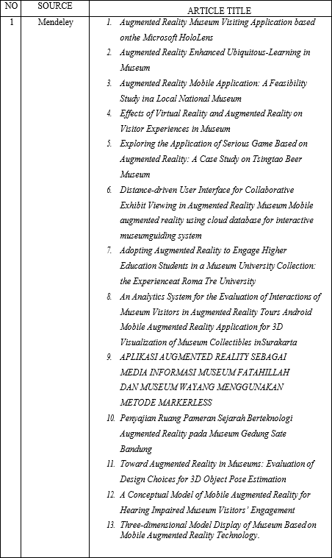

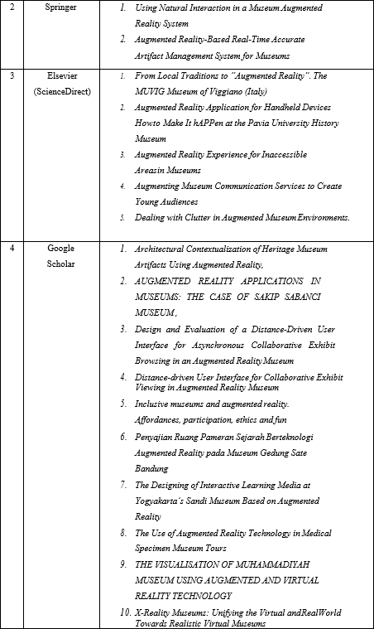

Fig.1, Source and Article Title

**FINDINGS AND DISCUSSION**

In this study, 30 journals were examined over three years of publication, namely (2019-2021). Descriptive analysis in the form of percentage and frequency was used in analyzing the data. Discussions were conducted based on percentages reported systematically starting with the most frequently used methodologies, technology tools, most common keywords com/) and Mendeley (https:/[/www](http://www.mendeley.com/search/)).[mendeley.com/search/)](http://www.mendeley.com/search/)) used and the works of authors cited, impact visits to museums, and innovations created. From the articles reviewed, the results of this study are described as follows.

**Research Methodology Used in Augmented Reality Research at Museums**.

Various methodologies were used in the Augmented Reality at Museum research from 30 journals examined. The first analysis explores research questions about what methodologies are often used in Augmented Reality at Museums. This analysis found that the most frequently used methodology in Augmented Reality research at the Museum is a mixed method, namely qualitative & quantitative. The quantitative method is centered on the relationship between variables, testing theories, and generalizing the research object. The qualitative method aims to gain an in-depth understanding, develop theories, describe reality and social complexities.

This analysis begins with findings that use multiple instruments to gather rich information and identify effective Augmented Reality practices in Museums (eg [Cerra et al. 2016], [Reffat and Nofal 2013], [Azuma et al. 2001], [Mohammed - Amin 2015; Nofal 2013], [Li et al. 2012], (Charsky 2010; Anderson et al. 2010; Mortara et al. 2014), (Ioannides et al. 2017) The instruments used in data collection mainly tests, and interviews, which aims to find out how far the augmented reality product has attracted visitors and also to find out how visitors respond to the augmented reality product or tool that was made, for example [Nechita F and Rezeanu CL 2019] who conducted a questionnaire in 2017 which was conducted by taking samples. respondents were as many as (200 respondents with primary and secondary education and 200 students with higher education; M = 17 years; SD = 3 years).

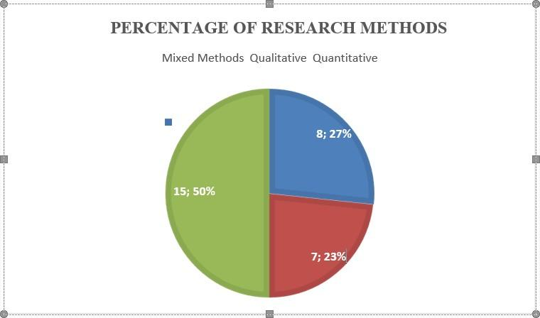

Fig.2, Percentage of Research Methods

Based on the methodology used (Figure 2), 8 articles are using mixed methods and 15 articles use quantitative methods, and 7 articles use qualitative methods.

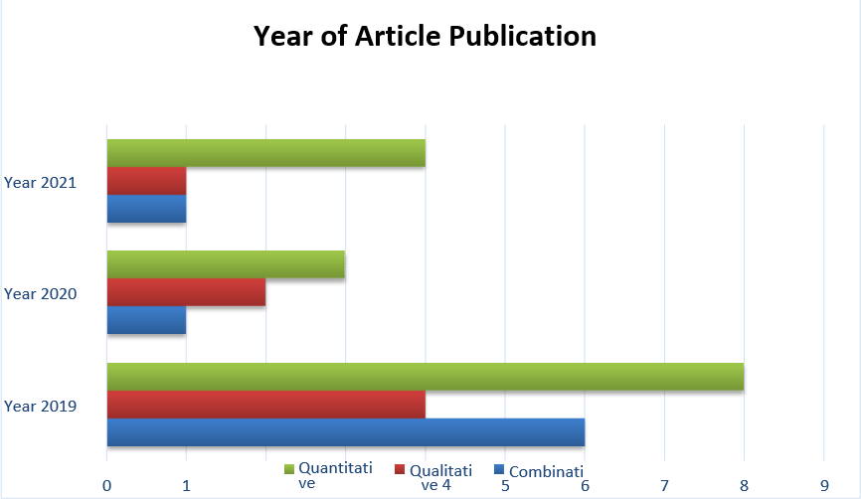

Fig.3, Year of Article Publication

Based on the year of publication of the article, it can be seen from (Figure 3) that in 2019 there were 8 quantitative articles, 4 qualitative articles, and 6 combination articles. In 2020 there were 3 quantitative articles, 2 quantitative articles, and 1 combination article. While in 2021 there were 4 quantitative articles. 1 quantitative article and 1 combination article.

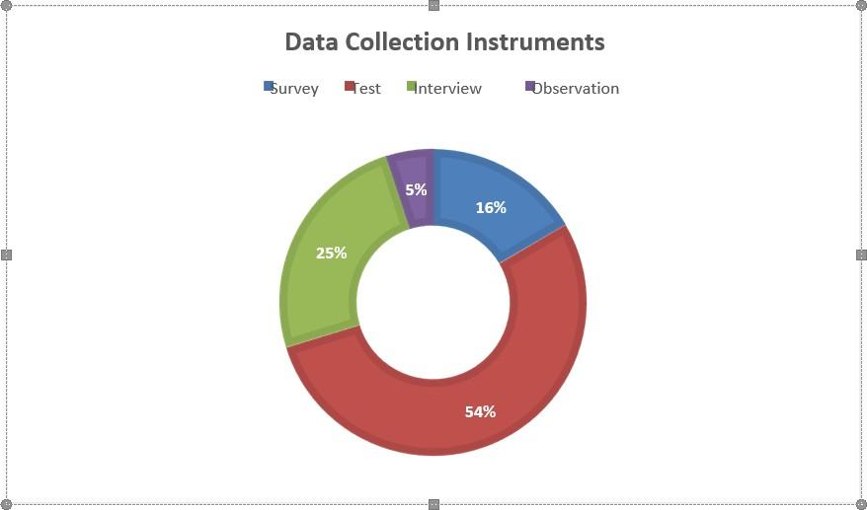

Fig.4 Data Collection Instruments

In terms of data collection, (Figure 4) shows that the most widely used instrument is Augmented Reality research tests (54%), followed by an interview (25%), survey (16%), observation (5%).

Studies Used in the Use of Augmented Reality in Museums In addition to the different methodologies used in augmented reality research in museums, there are many fields of study in which augmented reality has been applied over the past three years. This analysis explores the widespread application of Augmented Reality in various fields. Studies that are often used by researchers to conduct Augmented Reality research are Field Studies. From a field study, it can be described that the conditions, problems, or potentials can be used as a reference for the development of research products. This field study requires researchers to conduct observations, tests, interviews, and surveys in the field to find out the extent to which Augmented Reality can be applied. Next is the Literature Study which requires researchers to read previous research on Augmented Reality, this study aims to inspire researchers and gain knowledge about what obstacles were experienced in previous research.

**Technological Tools Used in Augmented Reality Research in Museums**

Various technological tools or online platforms have also been used in Augmented Reality research. Therefore, this section will answer three research questions “What equipment is used in the application of Augmented Reality in Museums? "In applying Augmented Reality to Museums, there are various technological tools such as Mobile Phones and Head-Mounted Displays (HMD) that can be used as tools to interact virtually with objects in the museum. While several technological tools are used to create Augmented Reality itself, such as Unity, Blender 3D, and so on. Therefore, by using these various technological media, visitors will indirectly be able to enjoy the experience of visiting the museum in a more interesting and modern way.

**Keyword Indicated**

In addition to titles and abstracts, keywords play an important role in journal publications and have a great impact on user searches or basic information in Internet search engines (Day & Gastel, 2012). Researchers need to choose the right keywords for their articles or journals that aim to do indexing, well-chosen keywords allow their articles (researchers) to be more quickly identified and cited by others.

Otherwise, readers will not be able to find or cite their articles because they are not using relevant keywords. Through this analysis, readers will find out the most commonly used keywords in 30 Augmented Reality journal articles that reflect the topic of the research problem. In this study, the researcher found a total of 136 keywords from the analysis of 30 selected articles. Of the 136 keywords identified in 30 articles, the ten most frequently appeared in several articles, and augmented reality was used as the main keyword, followed by the museum, reality, 3D, interaction, cultural heritage, Education, exhibition, experience, technology, visitors. Figure 5 summarizes the most commonly used keywords in augmented reality research.

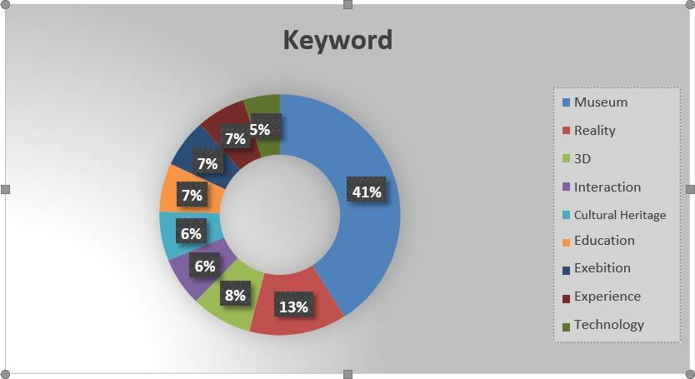

Fig.5, The most frequently used keywords

**Challenges in Implementing Augmented Reality in Museums**

Activity has its challenges and it has been shown that in these 30 articles there are several challenges faced by researchers. On the other hand, there is no concrete evidence regarding Augmented Reality that can increase visits to the Museum, this is one of the challenges. This analysis investigates research question number 4, namely "What are the challenges of implementing Augmented Reality in Museums?". In the 30 articles, there are several challenges in implementing Augmented Reality such as the state of the area, samples, research time and challenges in making historical objects using Unity 3D. From this statement, it can be seen that there are still many inhibiting factors from the application of Augmented Reality in the Museum, and this can be additional knowledge for subsequent research activities.

**The purpose of implementing Augmented Reality in the Museum**

An activity carried out must have a goal to be achieved. Likewise, with this research on augmented reality, augmented reality research aims to increase the number of visitors to the museum every day by using a modern and attractive way for all people from the young to the old. This analysis investigates research question number 2, namely "What is the purpose of implementing Augmented Reality in Museums?" This augmented reality research has involved many respondents from various circles to conduct trials on the use of the augmented reality that has been made. For the results of the responses obtained so far from the 30 articles, almost 85% of the use of augmented reality has captivated the hearts of the respondents in this case who act as museum visitors.

**Impact on Visitor Increase**

Several studies show that the use of Augmented Reality in museums has a positive impact on increasing the number of museum visitors. This analysis explores the research question in number 3, namely "What is the impact of implementing Augmented Reality in the Museum?" In this study, researchers found several positive impacts in the use of augmented reality in museums: the increase in museum visitors, and visitor knowledge.

**Museum Visitor Increase**

The increase in visitors to the museum is a reciprocal desired by every researcher who researches the use of augmented reality in museums. In one of the studies, a focus group session was applied, starting with a short presentation by the researcher. All participants were explained about the 20 elements that were assessed and given a detailed description of each element of the assessment. They are allowed to ask questions relating to the elements. Participants were then asked to fill out a prepared form to select the most appropriate or suitable element of the MAR engagement to provide. Based on this assessment, it produces responses, namely eleven elements that are given there are several assessments are selected and have a frequency of ten or eleven "yes" responses, namely; Aesthetics, Usefulness, Motivation, Focused Attention, Perceived Control, Curiosity, Enjoyment, Self-Efficacy, Interests, Satisfaction, and Interaction. (Abu Bakar J. A & Zulkifli A.N,2015) From this explanation, it can be seen that the opportunity for additional visitors is in line with the visitor experience in the museum itself, indirectly the good and improved visitor experience will attract visitors to come again and bring their family to the museum. According to the researcher's interpretation, a good visitor experience will bring a distinct impression in the minds of visitors when they enter the museum. This is a plus when you want to increase the number of visits to the museum.

**Museum Visitor Knowledge**

The knowledge of museum visitors is very important in the use of augmented reality in museums because the increasing knowledge of visitors is a form of success from the research that has been applied. Knowledge of museum visitors can increase due to information in the application of augmented reality in museums. Based on the test results, there are several conclusions for the Augmented reality application as an Information Media for the Fatahillah Museum and the Android-based Puppet Museum. AR applications can be an alternative to problems caused by the lack of information media, from the results of the average use of the application obtained 93.2% which means that the application design is by the wishes of the user. The designed application can be used on Android v4.1.2 (Jelly Bean). AR cameras can display 3D Objects at a distance of >100cm and without using markers with excess Objects that can move dynamically. Information is equipped with a video in the form of animation about the explanation of the museum, some of the rooms, and objects in it Farhany, et al. (2019). From this explanation, it can be concluded that visitors' knowledge can increase when visitors use the application of augmented reality in museums.

**CONCLUSIONS**

This study aims to analyze augmented reality research in museums based on 30 articles reporting on initiatives to utilize augmented reality in museums in 2019 – 2021. It was found that research on augmented reality in museums uses several methodologies, technological tools, the most commonly used keywords and the work of authors frequently cited, the impact of visiting the museum, and the innovations created. The use of augmented reality is also very useful for visitors, especially visitors who are still students because knowledge of museums is very important to increase their knowledge of history. apply augmented reality.

Some museums in Indonesia have indeed implemented augmented reality, but it still feels lacking if there is no equal distribution in every museum. Therefore, it is hoped that this research will be able to move the implementation of augmented reality in museums in Indonesia. With the application of augmented reality at the museum, the number of visits to the museum will increase significantly and people can learn in a fun and cheerful way in a very historic museum.

Some of the problems in this discussion become implications that can be taken into consideration for further research. Some of the challenges found in the application of augmented reality need to be addressed by future researchers, such as the suitability of using augmented reality on objects and clues that are not clear. Therefore, this research must be continued and developed in further research to fill the literature on augmented reality in museums. In terms of the compatibility of augmented reality with objects, augmented reality videos are interesting and should encourage the viewer to learn and interact. Designing 3D animated images on objects in the museum can include several elements such as bright colors, smooth textures, and music to attract the attention of visitors.

**REFERENCES**

1. Margetis, G., Apostolakis, K. C., Ntoa, S., Papagiannakis, G., & Stephanidis, C. (2020). X- Reality Museums: Unifying the Virtual and Real World Towards Realistic Virtual Museums. Applied Sciences, 11(1). <https://doi.org/10.3390/app11010338>
2. Kyriakou, P., & Hermon, S. (2019). Can I touch this? Using Natural Interaction in a Museum Augmented Reality System. Digital Applications in Archaeology and Cultural Heritage, 12. <https://doi.org/10.1016/j.daach.2018.e00088>
3. Panteleris, P., Michel, D., & Argyros, A. (2021). Toward Augmented Reality in Museums: Evaluation of Design Choices for 3D Object Pose Estimation. Frontiers in Virtual Reality, 2. <https://doi.org/10.3389/frvir.2021.649784>
4. Putra, F. D. B. S., Umar, R., & Sunardi, S. (2021). THE VISUALISATION OF MUHAMMADIYAH MUSEUM USING AUGMENTED AND VIRTUAL REALITY TECHNOLOGY. SINERGI, 25(2). <https://doi.org/10.22441/sinergi.2021.2.002>
5. Sugiura, A., Kitama, T., Toyoura, M., & Mao, X. (2019). The Use of Augmented Reality Technology in Medical Specimen Museum Tours. Anatomical Sciences Education, 12(5). <https://doi.org/10.1002/ase.1822>
6. Haryani, P. (2020). The Designing of Interactive Learning Media at Yogyakarta’s Sandi Museum Based on Augmented Reality. JOIV : International Journal on Informatics Visualization, 4(1). <https://doi.org/10.30630/joiv.4.1.157>
7. Nazhar, R. D., & Rosid, Y. S. (2020). Penyajian Ruang Pameran Sejarah Berteknologi Augmented Reality pada Museum Gedung Sate Bandung. Waca Cipta Ruang, 6(1). <https://doi.org/10.34010/wcr.v6i1.4193>
8. Sari, I. P., & Fajrin, H. R. (2019). Mobile augmented reality using cloud database for interactive museum guiding system. Journal of Physics: Conference Series, 1193. <https://doi.org/10.1088/1742-6596/1193/1/012030>
9. Sheehy, K., Garcia Carrizosa, H., Rix, J., Seale, J., & Hayhoe, S. (2019). Inclusive Museums and Augmented Reality: Affordances, Participation, Ethics, and Fun. The International Journal of the Inclusive Museum, 12(4). [https://doi.org/10.18848/1835-2014/CGP/v12i04/67- 85](https://doi.org/10.18848/1835-2014/CGP/v12i04/67-%2085)
10. Cianciarulo, D. (2015). From Local Traditions to “Augmented Reality”. The MUVIG Museum of Viggiano (Italy). Procedia - Social and Behavioral Sciences, 188. <https://doi.org/10.1016/j.sbspro.2015.03.349>
11. Li, X., Xie, M., & Chu, J. (2019). Exploring the Application of Serious Games Based on Augmented Reality: A Case Study on Tsingtao Beer Museum. IOP Conference Series: Materials Science and Engineering, 573. <https://doi.org/10.1088/1757-899X/573/1/012069>
12. Jung, T., Tom Dieck, M. C., Lee, H., & Chung, N. (2016). Effects of Virtual Reality and Augmented Reality on Visitor Experiences in Museums. In Information and Communication Technologies in Tourism 2016. Springer International Publishing. <https://doi.org/10.1007/978-3-319-28231-2_45>
13. Li, X., Chen, W., & Wu, Y. (2019, October 14). Distance-driven User Interface for Collaborative Exhibit Viewing in Augmented Reality Museum. The Adjunct Publication of the 32nd Annual ACM Symposium on User Interface Software and Technology. <https://doi.org/10.1145/3332167.3357109>
14. Chen, W., Shan, Y., Wu, Y., Yan, Z., & Li, X. (2021). Design and Evaluation of a Distance- Driven User Interface for Asynchronous Collaborative Exhibit Browsing in an Augmented Reality Museum. IEEE Access, 9. <https://doi.org/10.1109/ACCESS.2021.3080286>
15. Zhao, W., Stevenson, D., Gardner, H., & Adcock, M. (2019, November 14). Dealing with Clutter in Augmented Museum Environments. The 17th International Conference on Virtual- Reality Continuum and Its Applications in Industry. <https://doi.org/10.1145/3359997.3365683>
16. Nechita, F., & Rezeanu, C.-I. (2019). Augmenting Museum Communication Services to Create Young Audiences. Sustainability, 11(20). <https://doi.org/10.3390/su11205830>
17. Chan, B. Y., Ismail, Z. I. B. A., Jack, L. P., & Asli, M. F. (2019). Augmented Reality Mobile Application: A Feasibility Study in a Local National Museum. Journal of Physics: Conference Series, 1358. <https://doi.org/10.1088/1742-6596/1358/1/012057>
18. Abbas, Z., Chao, W., Park, C., Soni, V., & Hong, S. H. (2019). Augmented Reality-Based Real-Time Accurate Artifact Management System for Museums. PRESENCE: Virtual and Augmented Reality, 27(1). <https://doi.org/10.1162/pres_a_00314>
19. Hou, W. (2019). Augmented Reality Museum Visiting Application based on the Microsoft HoloLens. Journal of Physics: Conference Series, 1237. [https://doi.org/10.1088/1742- 6596/1237/5/052018](https://doi.org/10.1088/1742-%206596/1237/5/052018)
20. Germak, C., di Salvo, A., & Abbate, L. (2021, July). Augmented Reality Experience for Inaccessible Areas in Museums. <https://doi.org/10.14236/ewic/EVA2021.7>
21. Lin, Y.-H., Chang, S.-H., Huang, T.-C., Lin, Y.-T., & Chen, Y.-J. (2019). Augmented Reality Enhanced Ubiquitous-Learning in Museum. International Journal of Information and Education Technology, 9(8). <https://doi.org/10.18178/ijiet.2019.9.8.1263>
22. AYTEKİN, H., & KOÇAK, N. (2020). MÜZELERDE ARTIRILMIŞ GERÇEKLİK UYGULAMALARI: SAKIP SABANCI MÜZESİ ÖRNEĞİ. Dokuz Eylül Üniversitesi İşletme Fakültesi Dergisi. <https://doi.org/10.24889/ifede.839762>
23. Falomo Bernarduzzi, L., Bernardi, E. M., Ferrari, A., Garbarino, M. C., & Vai, A. (2021). Augmented Reality Application for Handheld Devices. Science & Education, 30(3). <https://doi.org/10.1007/s11191-021-00197-z>
24. Nofal, E., Elhanafi, A. M., Hameeuw, H., & vande Moere, A. (2018). Architectural Contextualization of Heritage Museum Artifacts Using Augmented Reality. Studies in Digital Heritage, 2(1). <https://doi.org/10.14434/sdh.v2i1.24500>
25. Farhany, N. M., Andryana, S., & Komalasari, R. T. (2019). Aplikasi Augmented Reality Sebagai Media Informasi Museum Fatahillah Dan Museum Wayang Menggunakan Metode Markerless. Jurnal ELTIKOM, 3(2). <https://doi.org/10.31961/eltikom.v3i2.140>
26. Supriyono, H. (2020). Android Mobile Augmented Reality Application for 3D Visualization of Museum Collectibles in Surakarta. International Journal of Emerging Trends in Engineering Research, 8(8). <https://doi.org/10.30534/ijeter/2020/40882020>
27. Poce, A., Amenduni, F., de Medio, C., Valente, M., & Re, M. R. (2019). Adopting Augmented Reality to Engage Higher Education Students in a Museum University Collection: the Experience at Roma Tre University. Information, 10(12). <https://doi.org/10.3390/info10120373>
28. Baker, E. J., Abu Bakar, J. A., & Zulkifli, A. N. (2020). A Conceptual Model of Mobile Augmented Reality for Hearing Impaired Museum Visitors’ Engagement. International Journal of Interactive Mobile Technologies (IJIM), 14(17). <https://doi.org/10.3991/ijim.v14i17.16649>
29. Haryani, P., & Triyono, J. (2020). The designing of interactive learning media at Yogyakarta’s sandi museum based on augmented reality. International Journal on Informatics Visualization, 4(1). <https://doi.org/10.30630/joiv.4.1.157>
30. Serravalle, F., Ferraris, A., Vrontis, D., Thrassou, A., & Christofi, M. (2019). Augmented reality in the tourism industry: A multi-stakeholder analysis of museums. In Tourism Management Perspectives (Vol. 32). <https://doi.org/10.1016/j.tmp.2019.07.002>
31. Fattah, A., Gunawan, A. A., Taufik, R. B., & Pranoto, H. (2021). Effect of the implementation of attractive augmented reality for museum visit. ICIC Express Letters, Part B: Applications, 12(6). <https://doi.org/10.24507/icicelb.12.06.541>
32. Kyriakou, P., & Hermon, S. (2019). Can I touch this? Using Natural Interaction in a Museum Augmented Reality System. Digital Applications in Archaeology and Cultural Heritage, [https://doi.org/10.1016/j.daach. 2018.e00088](https://doi.org/10.1016/j.daach.%202018.e00088)
33. Furht, B. (Ed.). (2011). Handbook of Augmented Reality. Springer New York. <https://doi.org/10.1007/978-1-4614-0064-6>
34. Mailizar., & Johar, R. (2021). Examining Students’ Intention to Use Augmented Reality in a Project-Based Geometry Learning Environment. International Journal of Instruction, 14(2), 773-790. <https://doi.org/10.29333/iji.2021.14243a>
35. Wahyu, Y., Suastra, I. W., Sadia, I. W., & Suarni, N. K. (2020). The Effectiveness of Mobile Augmented Reality Assisted STEM-Based Learning on Scientific Literacy and Students’ Achievement. International Journal of Instruction, 13(3), 343-356. <https://doi.org/10.29333/iji.2020.13324a>
36. Tsai, C-C. (2020). The Effects of Augmented Reality to Motivation and Performance in EFL Vocabulary Learning. International Journal of Instruction, 13(4), 987-1000. <https://doi.org/10.29333/iji.2020.13460a>