**NXTFolio**

**Team Members**

* Balmaseda del Campo, Vicente – Scrum Master
* Fletcher, Lance
* Jain, Ayushri – Product Owner
* Li, Baichuan
* Li, Wenyuan
* Price, Niah

**Summary**

NXTFolio is a web application aimed to become a networking platform for the creative industry and help professionals to find other professionals based on their requirements, saving them from paying talent agencies. It aims to help someone find professionals based on custom requirements like 'looking for graphic designer for pottery' or 'who is good at Runway photography in Dallas' along with establishing their own portfolio. The web application is expected to be used by three main categories of professionals - Creators, Services, and Makers. The stakeholder for this project is Prasenjit Tito Chowdhury, who is the Chief Executive Officer and Executive Producer of FashioNXT, a marketing agency in Portland, OR. The primary customer need is to improve the user interface of the existing legacy application and enhance the search engine so that the project can go live by the end of this term. The search engine should be improved by using Artificial Intelligence based on the user's profile and user's search habits.

The existing legacy project has a user interface and functionalities like login-logout, register, keyword search, and messaging. Based on our first meeting with the client, the aim is to improve the user interface - home page, user feed page, search results page, login window, registration page, rating window, chat window, and notifications so that the web application is mobile-friendly. Simultaneously, the target is to fine-tune the search engine and the user feed page using Artificial Intelligence based on the user's interests, profile, search history, and location.

**Other Information**

**Customer Meeting:** Zoom, Friday, 6pm

**GitHub repo:** <https://github.com/vibalcam/match-my-fashion-public-CodeCreators>

**Pivotal Tracker**: <https://www.pivotaltracker.com/n/projects/2630237>

**Strategy to learn the Legacy Code**

We initially watched a demonstration video that gave us a comprehensive overview of the project. This matching application is specifically designed for fashion professionals, who can upload their profiles onto the website. Visitors to the site can access the information and, if they find the professional suitable for their needs, they have the option to hire them. This application is like LinkedIn, but with a more focused approach to accurate matching.

We arranged our first meeting with the client and were provided with a basic introduction to NXTFolio. During the meeting, we discussed why we chose this project, and many group members expressed their strong interest in matching machine learning and AI (Artificial Intelligence) algorithms, which are the main focus of this project. After reviewing the legacy code, we identified several issues that needed to be addressed. The client also shared some desired features that they wanted us to work on, and we made a rough plan to meet once every week to track progress.

When we tried to deploy the application, we encountered difficulties along the way. The original documentation did not provide sufficient information about deployment on the cloud and the instructions provided were complex and challenging to understand and implement. As a result, we created a script, ‘setup.sh’, which automizes the process of downloading and setting up the app (database, rvm, ruby, etc.), taking care of the installation issues we were having. We also created a Dockerfile, based on Ubuntu 18, that can be used for development instead of AWS E2C. We modified the 'readme.md' file to make it clearer and added a section of instructions to assist individuals with deploying the application on the cloud. We also added a "frequently met errors and solutions" section, to make it easier for users to find solutions in the future if they encounter any similar problems.

Once we completed the deployment, we encountered some issues with the website. We were unable to access the original database and there was no seeding, so we tried to contact the previous team to obtain it to test the site's functionality. We also generated several profiles and thoroughly tested the website to identify any bugs. For instance, when a customer fills out the sign-up form and submits it, an error message is displayed if there is something wrong with the form (such as an incorrect password format). However, the message does not specify what specifically is wrong. Improving the error message by specifying what is wrong would enhance the user experience. Additionally, some buttons were not functioning properly, the "add gallery" function was broken, the colors of the input fields in the sign-up form should be black, and some of the search user interfaces were not working as expected.

Moving forward, we will first create characterization tests for the legacy code and fix these bugs, which will also serve as an opportunity to become more familiar with the code. By fixing these issues, we aim to improve the website's overall functionality and user experience and make the application stable for deployment to Heroku. We will then upgrade the ruby version (the legacy code is using ruby 2.4, so we want to upgrade it to ruby 3.2). Doing so will require us to deal with “integration hell” and fix whatever is needed so the tests are successful. After that, we will start to add more functionality and find a suitable machine learning algorithm for the matching feature.

**User Stories**

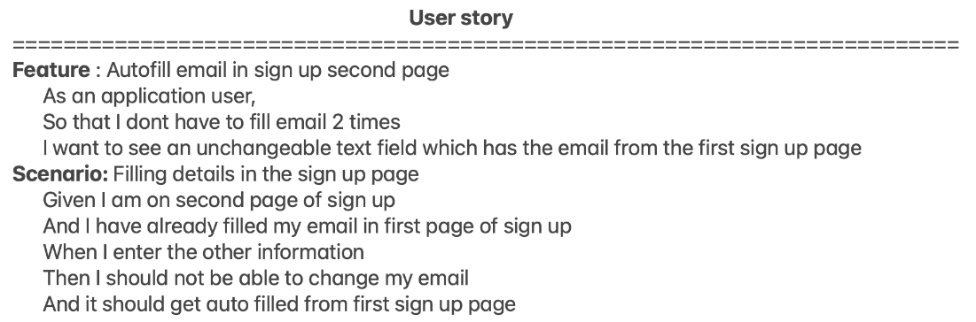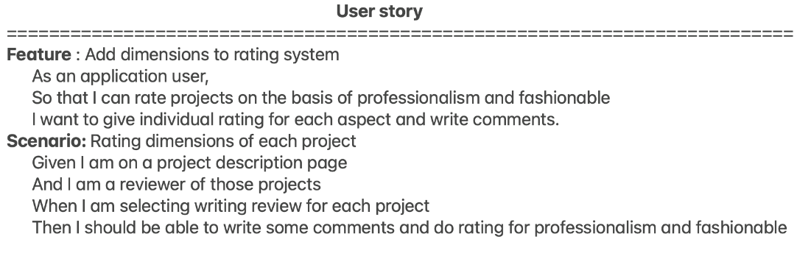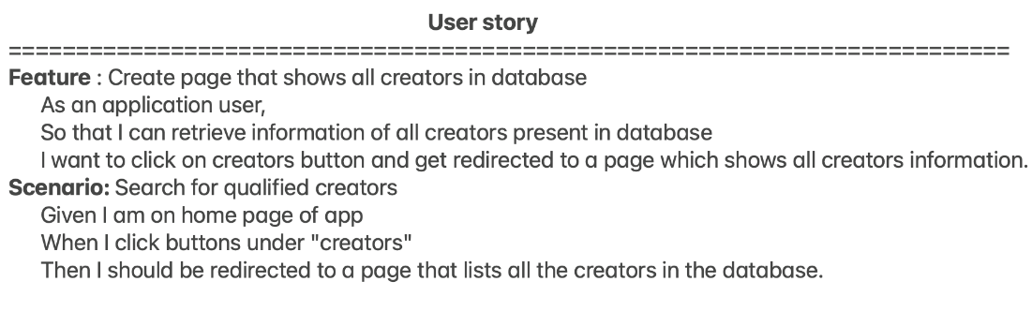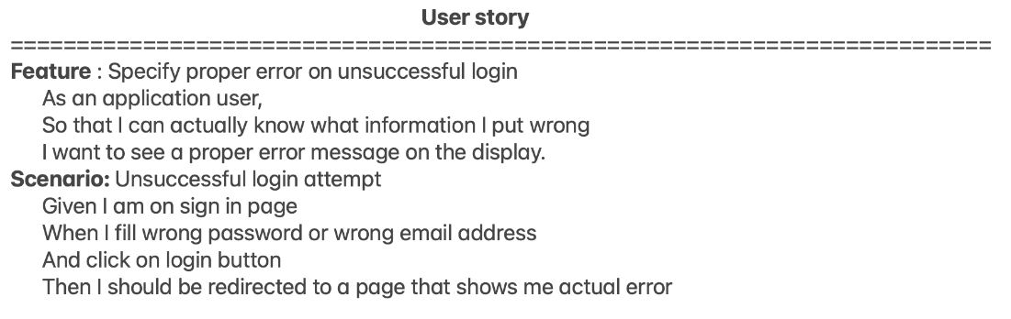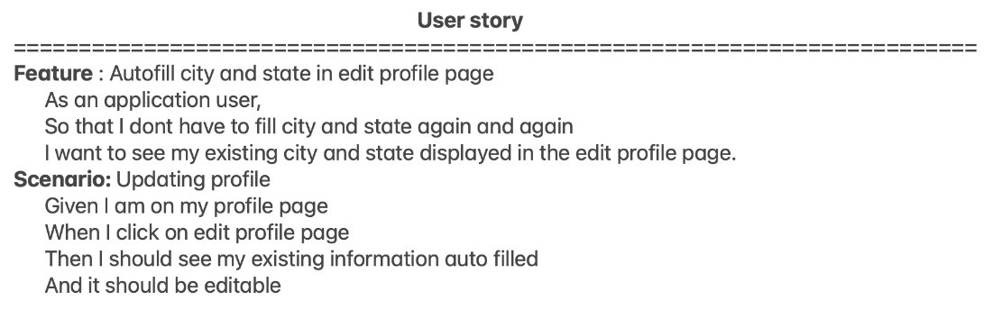

**Scenario:**

As a Professional,

So that I can find a photographer in Houston

I want to be able to search for the photographer by name, city, and state.

**Scenario:**

As a Brand,

So that I can build clientele and display my work to professionals as well as receive feedback

I want to be able to post my work.



NXTFolio

Profile

Notifications

Direct Message

Search (name, city, state, occupation)

User Feed

- Shared Projects

- Creators

- Services

NXTFolio

Profile

Notifications

Direct Message

Search (name, city, state, occupation)

Profile #1

Profile #2



NXTFolio

Profile

Notifications

Direct Message

Search (name, city, state, occupation)

User Feed

- Shared Projects

- Creators

- Services

NXTFolio

Profile

Notifications

Direct Message

Name Media Handles

Company

City, State, Country

Profession

Ratings

Highlights

**Scenario:**

Rating each project

Given I am a reviewer of those projects

When I am rating each project

Then I should be able to write some comments and do the rating from different dimensions like how fashion it is, how professional it is, etc.

**Scenario:**

Search for some qualified creators

Given I am a professional and trying to get some information about creators including brand owners and designers

When I click the buttons under “Creators”

Then I should be redirected to a page that lists some brief introductions about creators in the database.

