***Got Food?***

Create a write-up summarizing your major findings. This should include a heading for each "question" you asked of your data, and under each heading, a short description of what you found and any relevant plots.

1. What is the carbon footprint impact of plant-based foods versus animal-based foods?
2. What types of food production should be encouraged to consume nutritious diet in a sustainable way?

Overall animal-based foods have a much lower carbon footprint than do animal-based foods. Measuring total emissions, emissions per kcal, or emissions by g of protein all lead us to the conclusion that overall animal-based foods emit at levels significantly higher than those of plant-based foods.

Beef cattle, dairy cattle and lamb are the largest contributor to greenhouse emissions from land-based foods. Coffee and dark chocolate are the largest contributors to greenhouse emissions from plant-based foods.

After a closer inspection though we can see that it’s not as simple as eliminating animal-based foods, but rather eliminating or sharply reducing the largest contributors in each category. There are plant-based foods that emit at levels on par with some of the worst offending animal-based foods. Finding alternatives that meet dietary needs while reducing greenhouse gas emissions can be achieved by smartly adjusting diets to take advantage of low emitting foods that offer nutritional value on par with those that are higher emitting. Poultry, fish, pork, and eggs all provide similar nutritional levels for significantly less emissions than the largest contributors of animal-based foods. Groundnuts, rice, and root vegetables also provide similar nutritional levels for significantly less emissions than the largest contributors from plant-based foods.

1. *Which food products have the most negative impact on the environment? Which food products have the least negative impact on the environment?*

Coffee, beef (beef herd) and dark chocolate have the most negative impact on the environment. Nuts and groundnuts have the least negative impact on the environment. This was determined by looking at the level of total emissions, eutrophying emissions, and greenhouse gas emissions of every food product since all of these emissions have a negative impact on the environment. Based on the analysis and results, food production of nuts and groundnuts should be encouraged to consume a nutritious diet in a sustainable way. Food production of coffee, beef (beef herd) and dark chocolate should not be encouraged to consume a nutritious diet in a sustainable way.

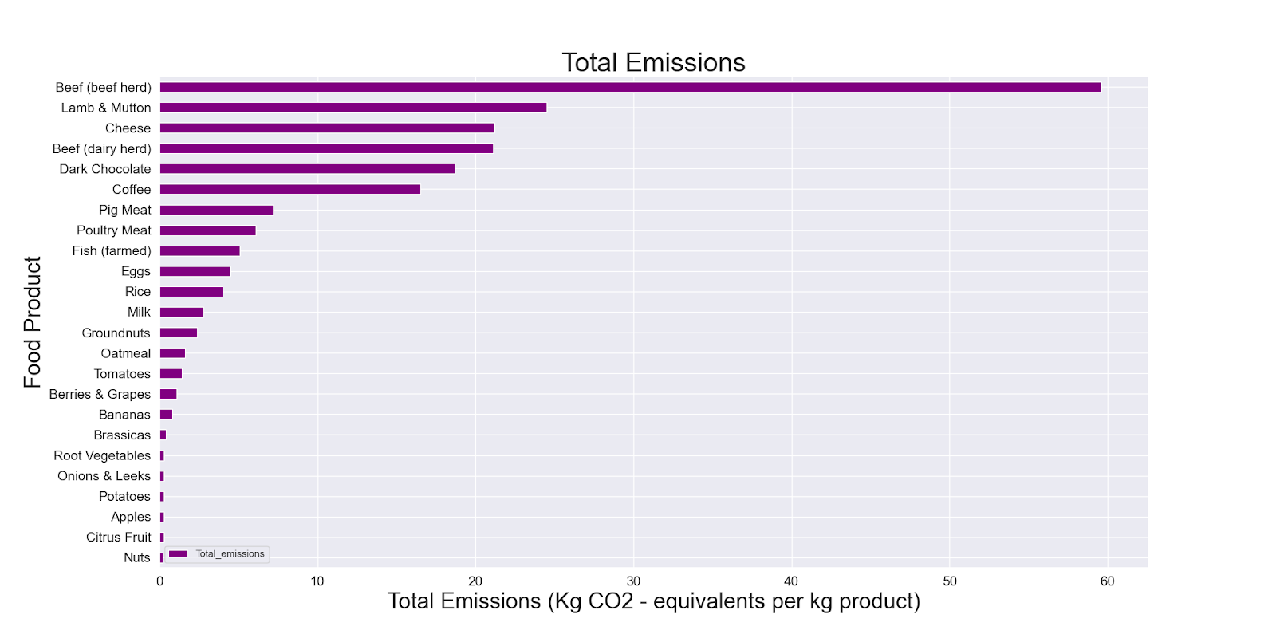

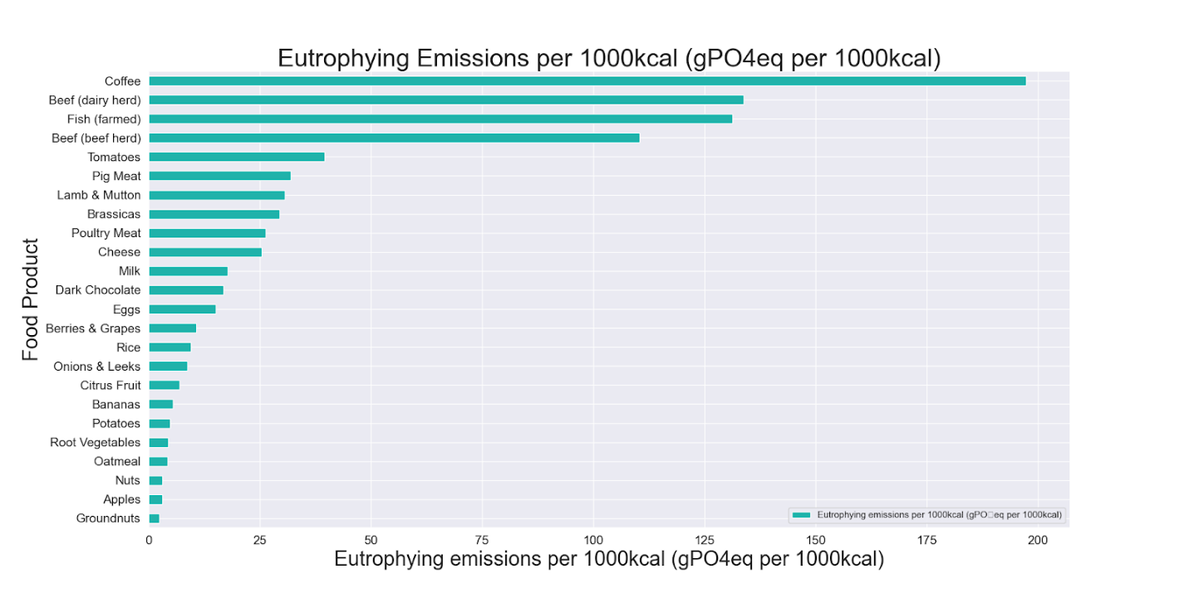

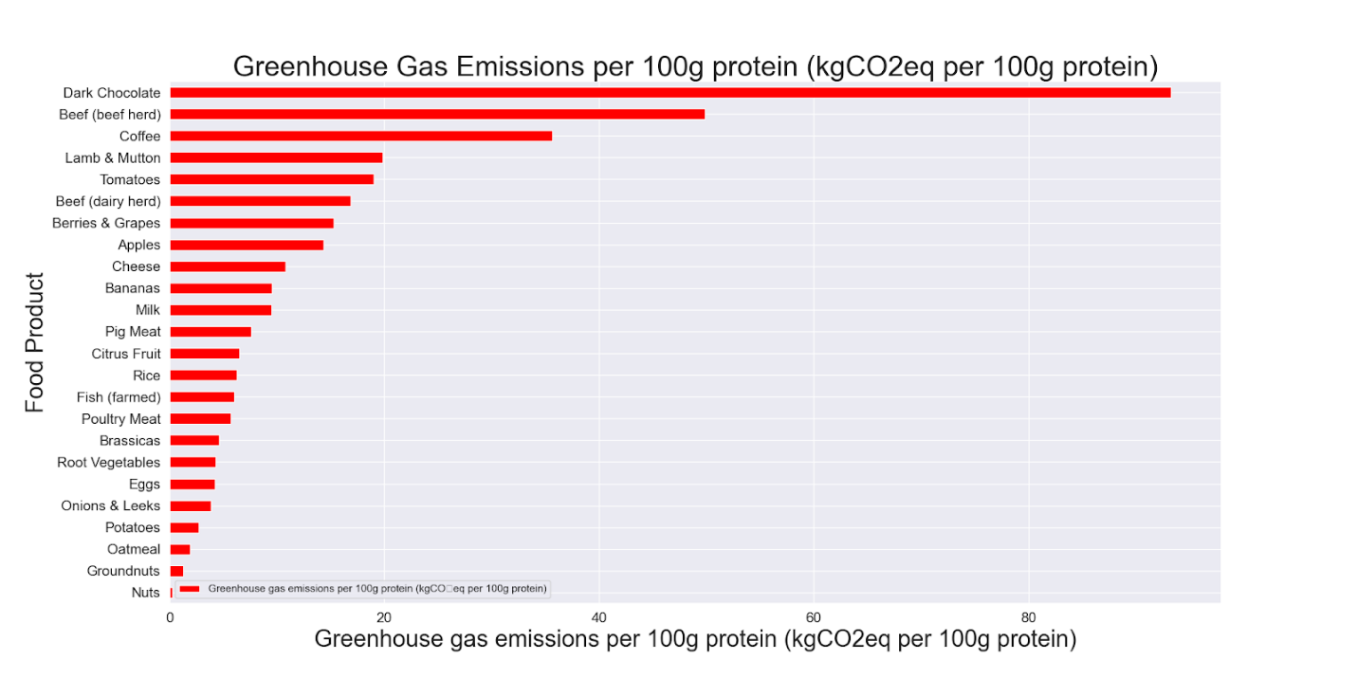

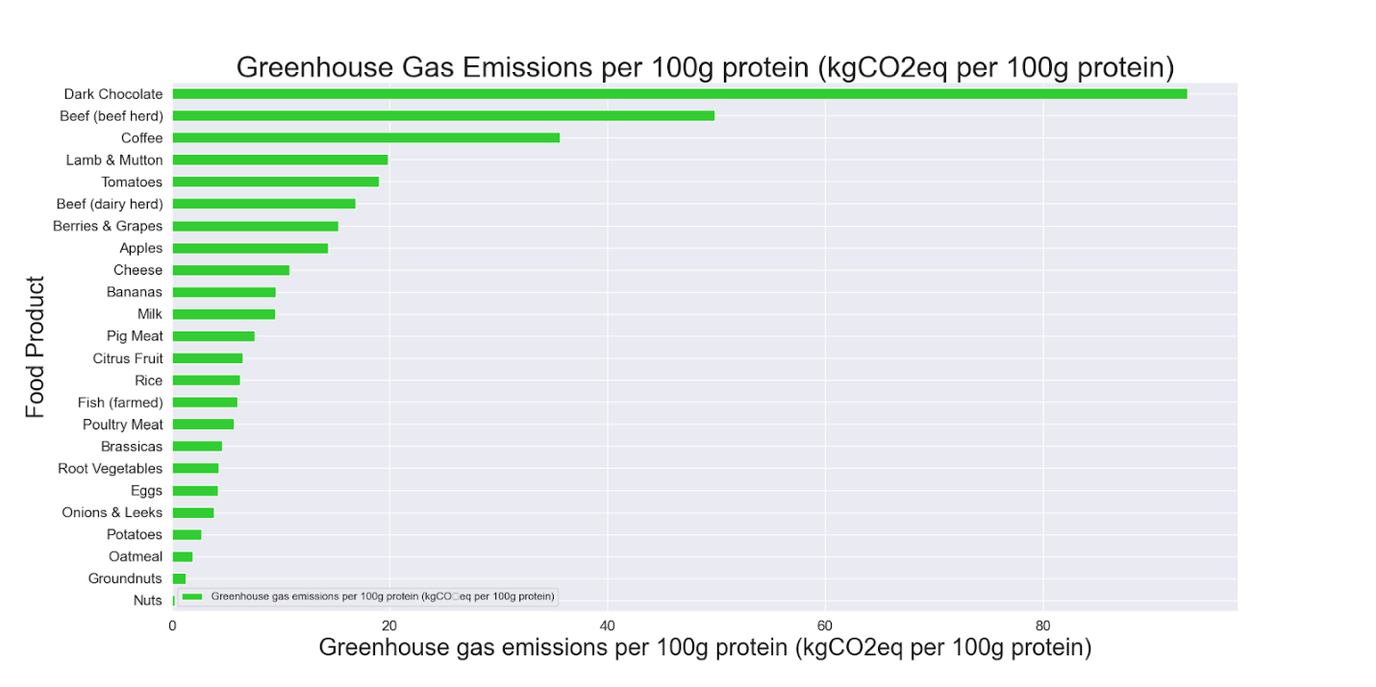

|  |  |  |
| --- | --- | --- |
|  | **Most Negative**  **Impact** | **Lease Negative Impact** |
| **Total Emissions (Kg CO2 - equivalents per kg product)** | Beef (beef herd) - 59.6 | Nuts - 0.2 |
| **Eutrophying Emissions per 1000kcal (gPO4eq per 1000kcal)** | Coffee - 197.36 | Groundnuts - 2.44 |
| **Greenhouse Gas Emissions per 1000kcal (kgCO2eq per 1000kcal)** | Coffee - 50.95 | Nuts - 0.67 |
| **Greenhouse Gas Emissions per 100g protein (kgCO₂eq per 100g protein)** | Dark Chocolate - 93.3 | Nuts - 0.26 |

1. *What stage of food production contributes the most to greenhouse gas emission?*

Summary Results: Beef (beef herd), lamb & mutton, and cheese emit the most greenhouse gasses from farm emissions(green) and land usage(blue). Where we see the least emissions is in plant food products for example citrus fruit and onion & leeks.

Our results show that land use and farming make up the vast majority of greenhouse gas emission all other stages of the supply chain make up a very small share of the greenhouse gas emissions. Agricultural innovators should focus on the land usage and farming stages of the supply chain to reduce the greenhouse gas.

Land Usage - Aboveground changes in biomass from deforestation, and belowground changes in soil carbon

Farm - Methane emissions from cows, methane from rice, emissions from fertilizers, manure, and farm machinery

Feed - On farm emissions from crop production and its processing into feed for livestock

Processing - Emissions from energy use in the process of converting raw agricultural products into final food items

Transport - Emissions from energy use in the transport of food items in country and internationally

Retail - Emissions from energy use in refrigeration and other retail processes

Packaging - Emissions from the production of packaging materials, material transport and end of life disposal

**How do the land footprint of different food products compare? Which foods used the most and least land in their production?**[**¶**](http://localhost:8888/notebooks/LearnPython/DataAnalyticsJHU/Project1/Food_ProductionResults.ipynb#How-do-the-land-footprint-of-different-food-products-compare?-Which-foods-used-the-most-and-least-land-in-their-production?)

In the visualizations below we show the land footprint of foods, measured in meters squared (m2) per kilogram, 100 grams of protein, and per 1000 kilocalories.

Summary Results: Beef (beef herd), Lamb & Muttons use the most land to produce one kilogram of food product at 369.81 meters squared and 326.21 meters squared. Where root vegetables and onion & leeks use the least land to produce one kilogram of food at .33 and .39 meters squared.

When it comes to determing which which foods provide the most or least calories the chart shows that beef and lamb & muttons use the most land to produce 1000 kilocalories of food. Where rice and root vegetable use the the least amount of land to produce 1000 kilocalories of food.

