**Kimowno Sewing Pattern**

Fashion Freedom Initiative (<https://fashionfreedom.eu>), April 22, 2020  
**License:** [[CC-by-4.0](https://creativecommons.org/licenses/by/4.0/)](https://creativecommons.org/licenses/by/4.0/) **Creative Commons’ Attribution 4.0 International (CC BY 4.0)**

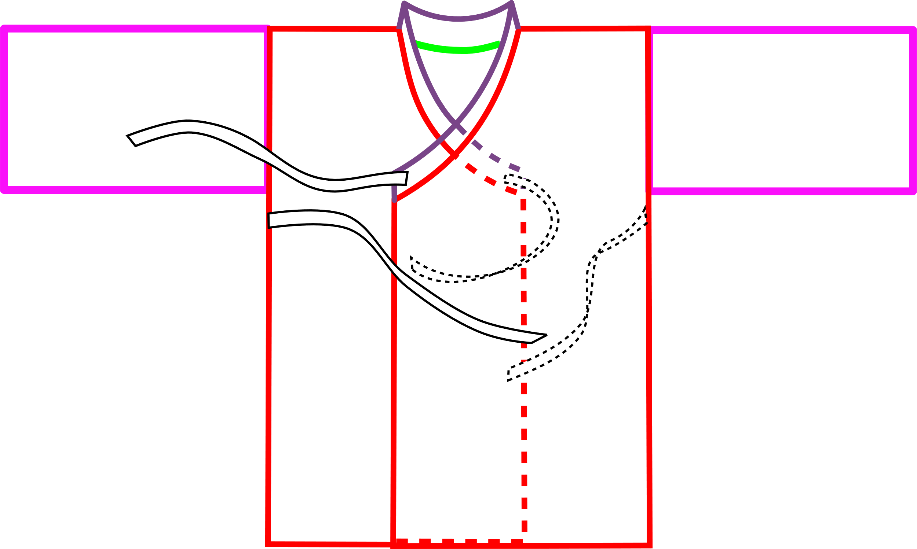

s

You’ll need a Full, Queen or King Sized BedSheet, flat or fitted

Sewing machine, thread, scissors, iron, ruler, pen

NOteS:

* + Cut with Scissors, Don’t rip sheets--The Weft is usually skewed.
  + Avoid using sheet hems. they’re heavy and don’t match up well at seams
  + Use lots of pins. Big pieces slide around while sewing.
  + Draw Lines, Curves, etc. on wrong side of sheet.
  + All seam allowances are 1/2"
  + All Hems are Double Rolled 1/2" , Total Folded Hem is 1”



* + **W**rong Side of Fabric **is** shown in Gray

____________________MEASURE______________________

1. Measure from shouldertip to shouldertip across your chest then add 6”

This is your patternwidth

**The ex**ample in this pattern:

shouldertip to shouldertip = 18”

18” + 6” = 24”

____________________CUT______________________

1. Layout the Bedsheet, folded lengthwise from top to bottom
2. Draw a line down the middle
3. Draw two more lines the patternwidth away from Middle line
4. Draw another line 4” away from a patternwidth line
5. Cut through all thicknesses on the lines
6. Cut through the foldline on the PATTERNWIDTH pieces, don’t cut through the 4” wide piece

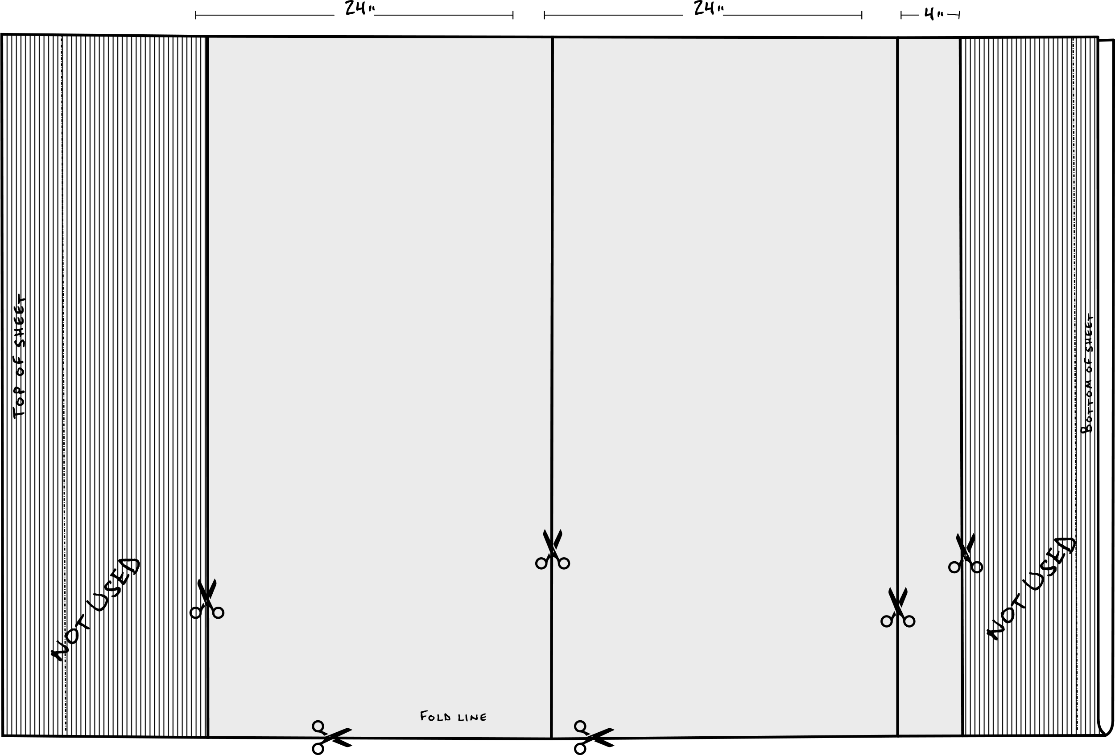You’ll have four (4) Patternwidth pieces and one (1) facing piece

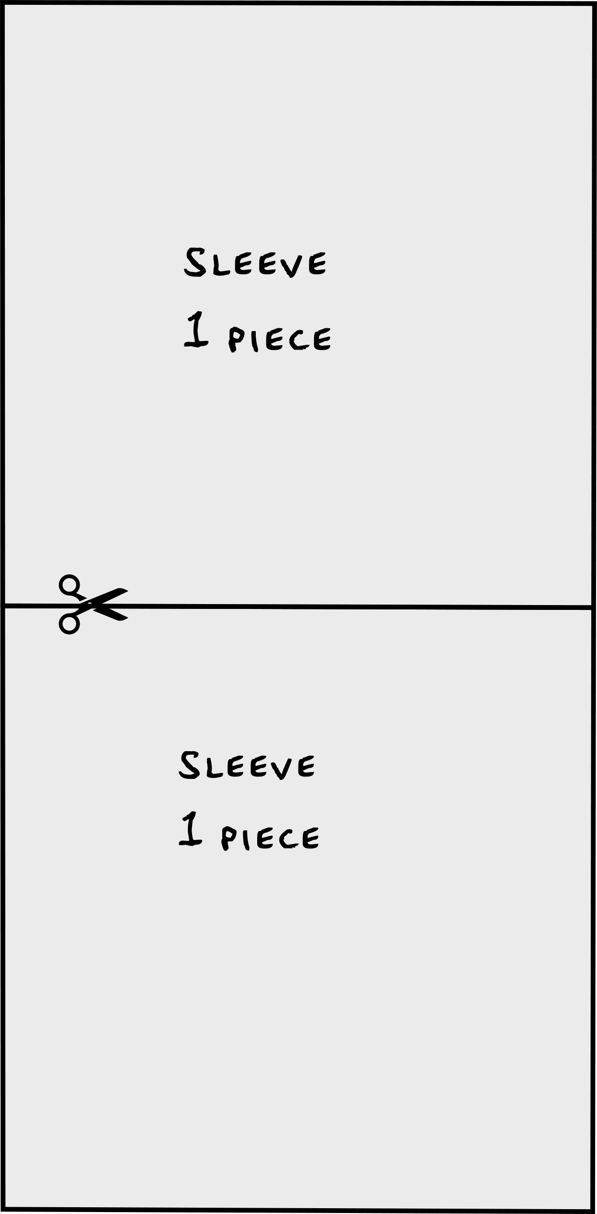

1. Take One PATTERNWIDTH piece.   
   Draw a line across the middle.   
   Cut along the line.   
   These are SLEEVE PIECES.
2. Take another PATTERNWIDTH Piece and fold Lengthwise.   
   -From top left corner, Mark 4” across top edge and 1” down foldline.

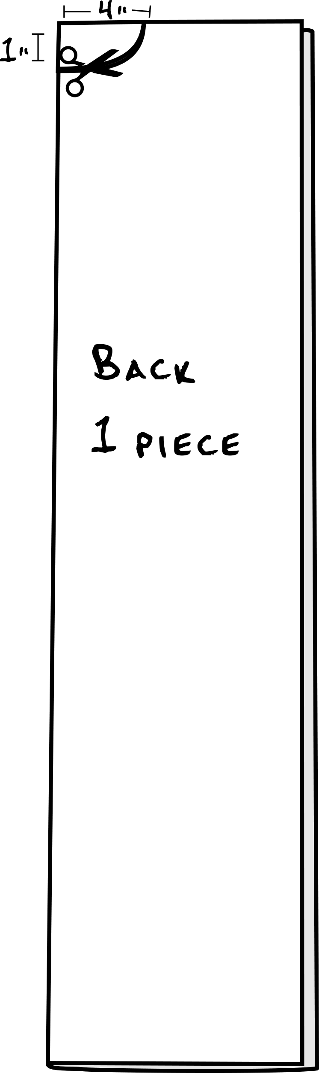-Draw the neck curve and cut.   
  
This is The BACK PIECE.

1. 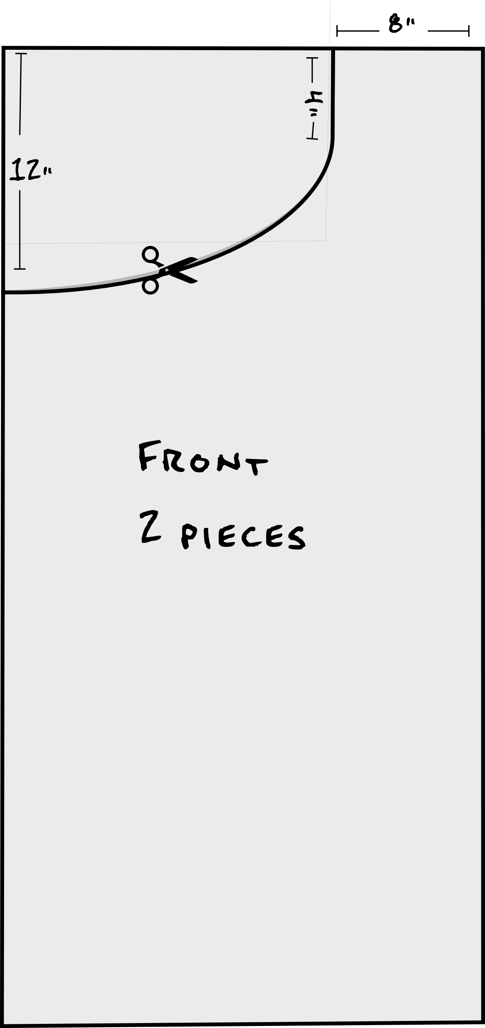Take Two PATTERNWIDTH Pieces right sides together.   
   From Top Left corner, Measure 12” down left edge.  
   From Top Right corner, Measure 8” across top edge, then down 4”.  
   Draw line from 8” mark to 4” mark.  
   Draw Curve from 4” mark to 12” mark.  
   These are the RIGHT FRONT and LEFT FRONT PIECES.

___________________________SEW_____________________________

1. Body

-Sew Back to Front at Shoulder, right sides together.

- Repeat for other side

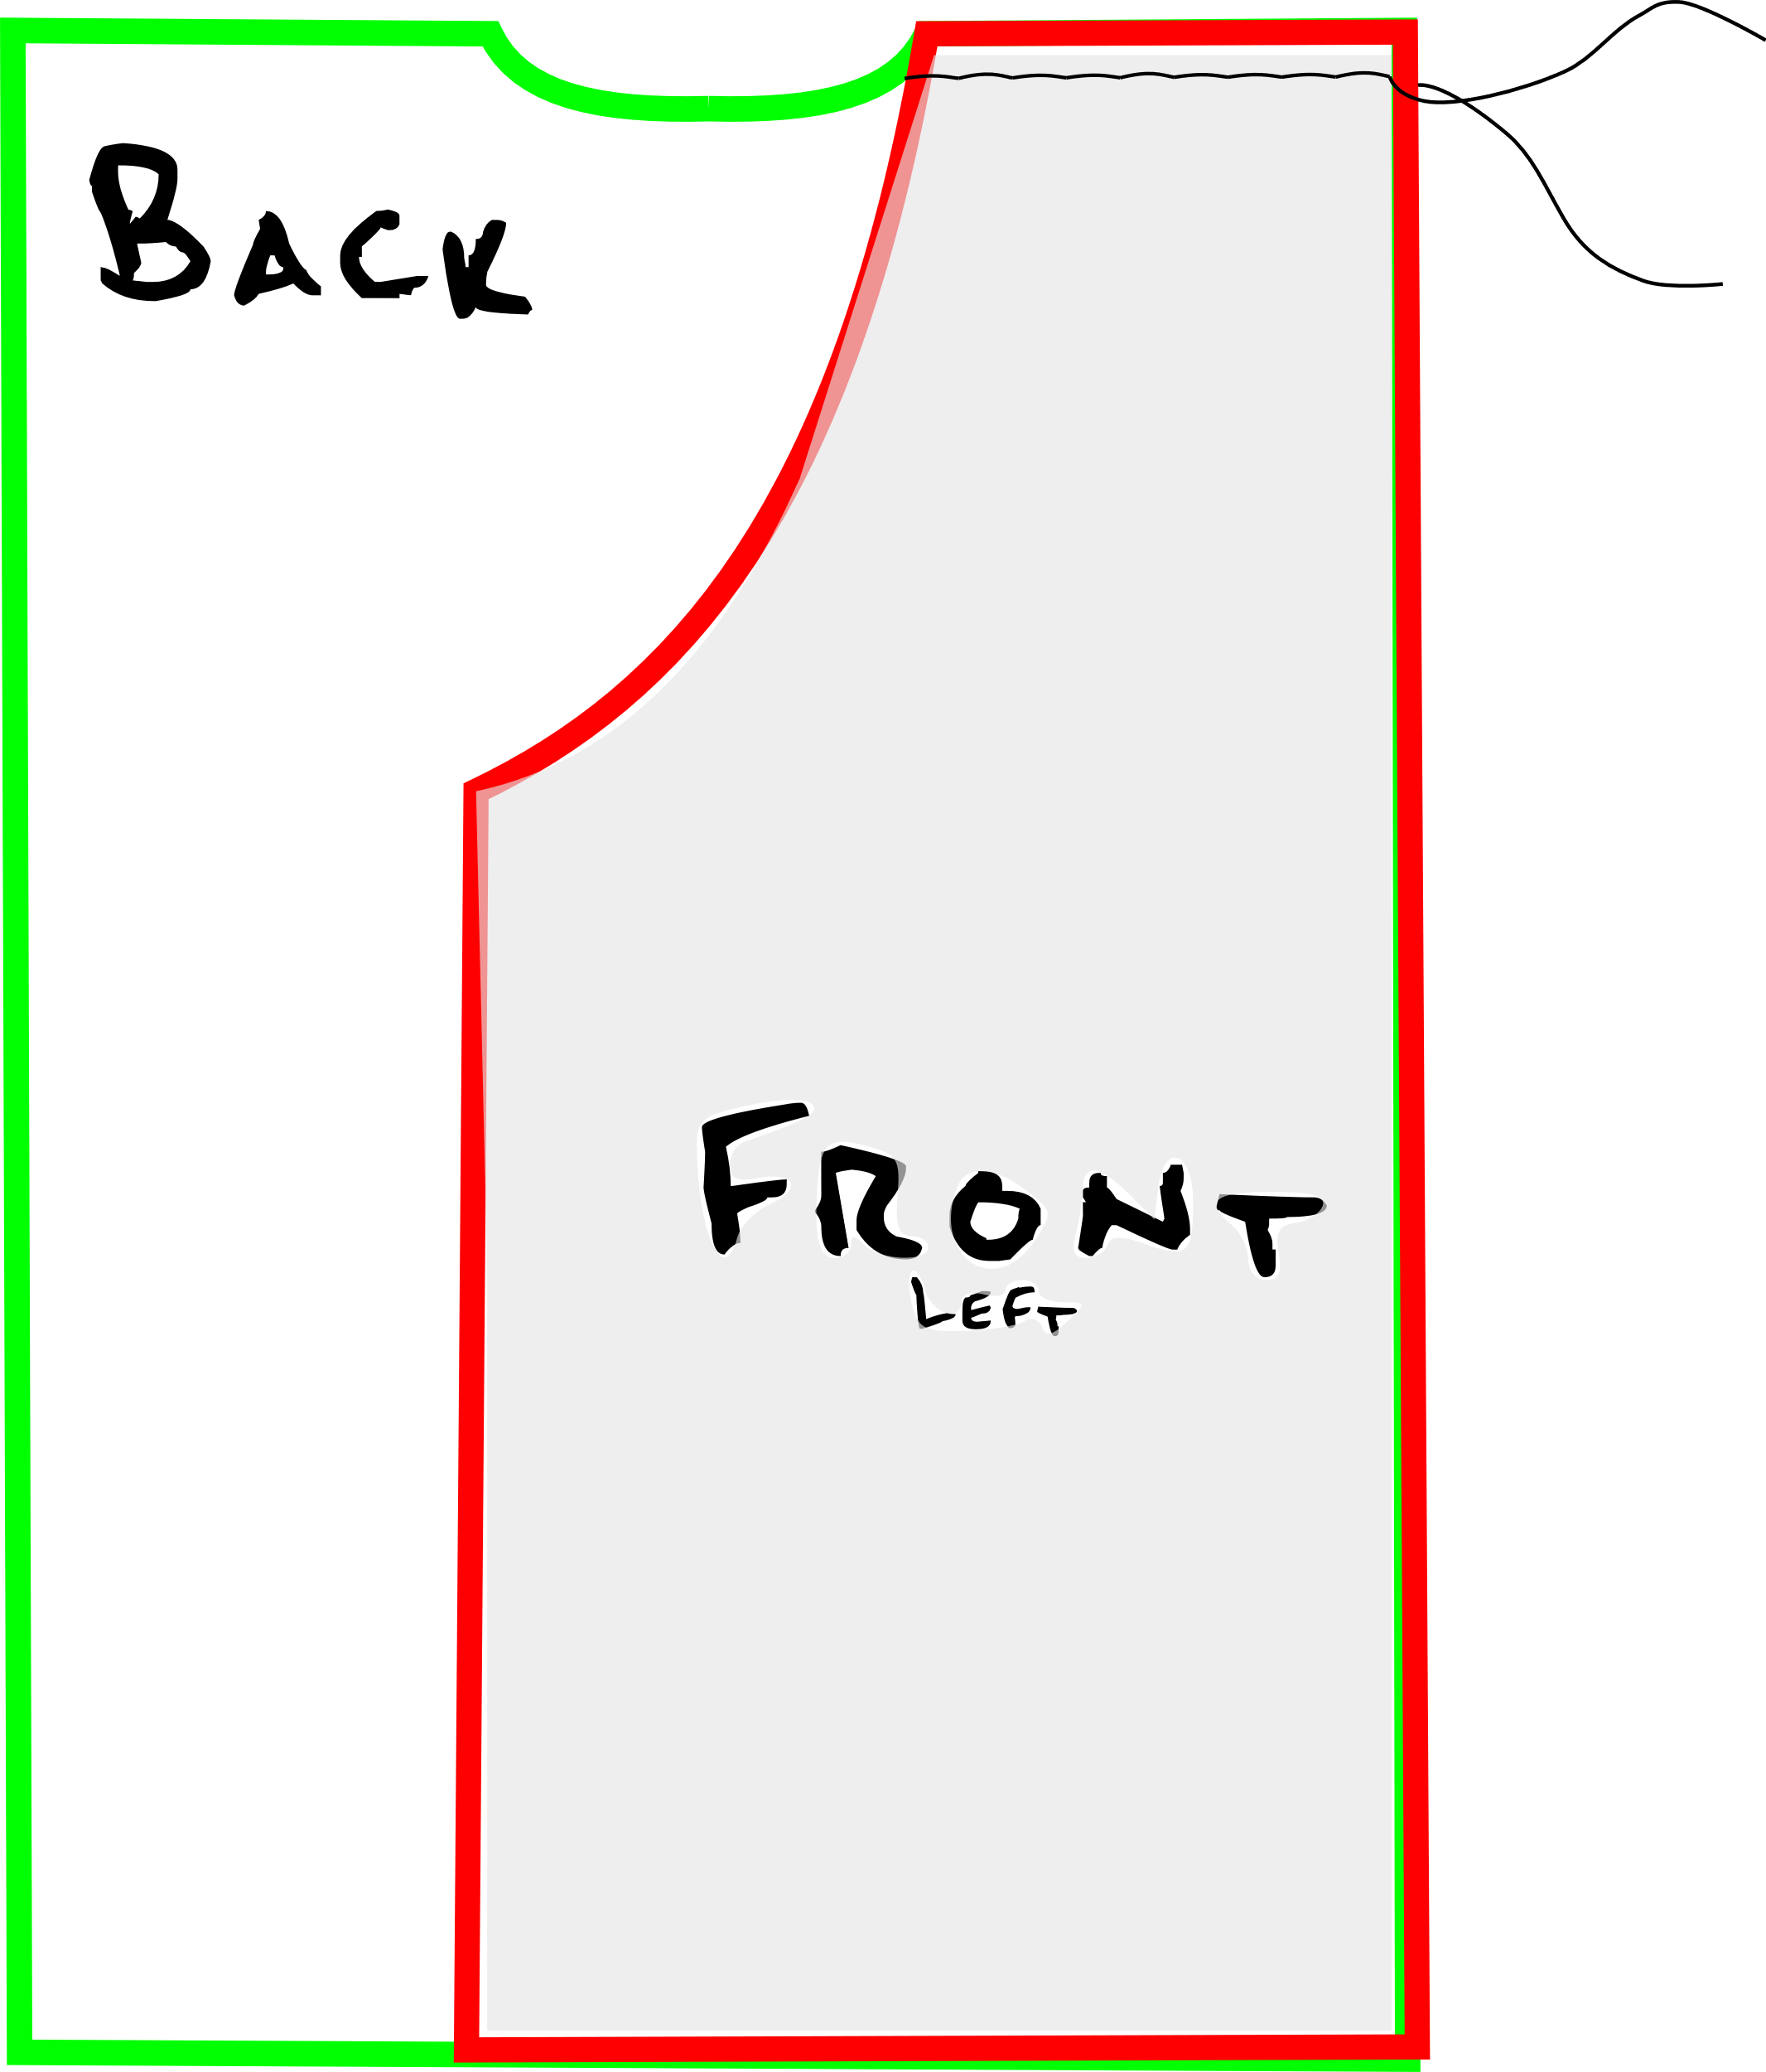

2. Sleeves-  
-Mark the midpoint along the longest edge of sleeve.

- Pin Sleeves to Body, right sides together with Sleeve midpoint at Shoulder Seam.

- Repeat for other side.

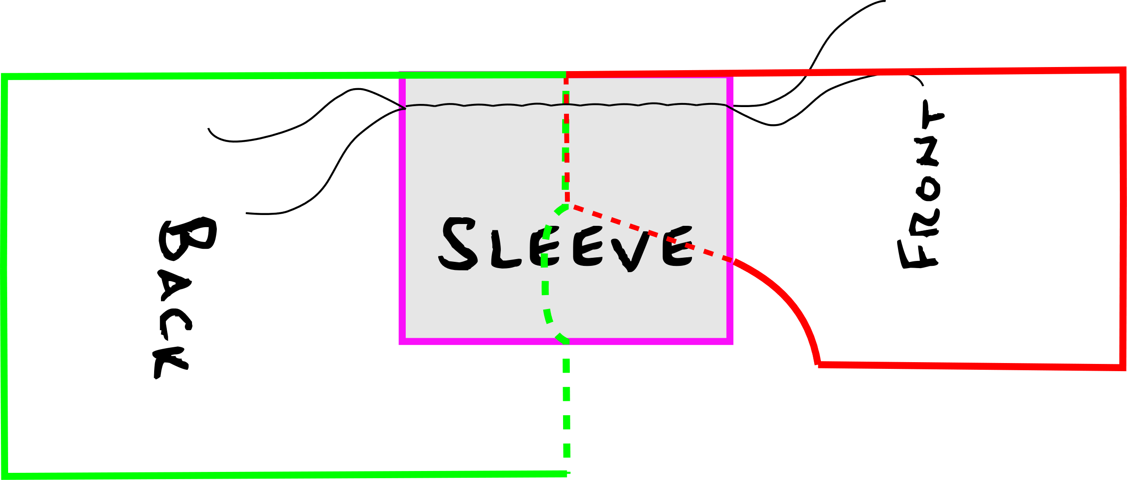

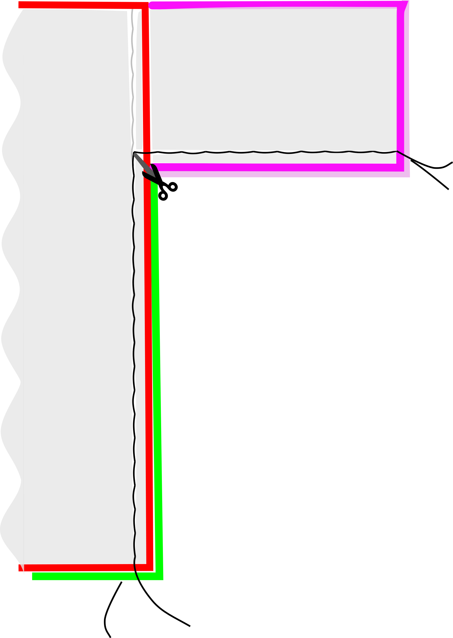3.Side Seams:

-Sew Side Seam from Body Hem up to Sleeve edge.

-Sew another 1./2” past sleeve edge then pivot to sew the sleeve seam

- Clip diagonally through the seam allowance at the corner, (but don’t cut through your stitching!).

- Repeat for other side.

- Turn Gown Inside out and press seams.

It will Look like This:

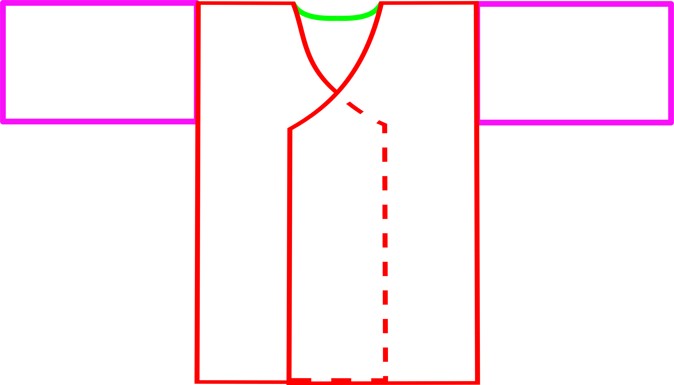

4. Neck Facing

- Fold Neck facing longways in half, wrong sides together.

- Iron the foldline into a crease.



-find the midpoint of the long edge of the neck facing

- find the midpoint of the neck curve on the back piece

- pin midpoint of neck facing to midpoint of BACK PIECE.

-

- pin the remaining neck facing along the front neck edges, and Sew. The neck facing will be too long for the neck

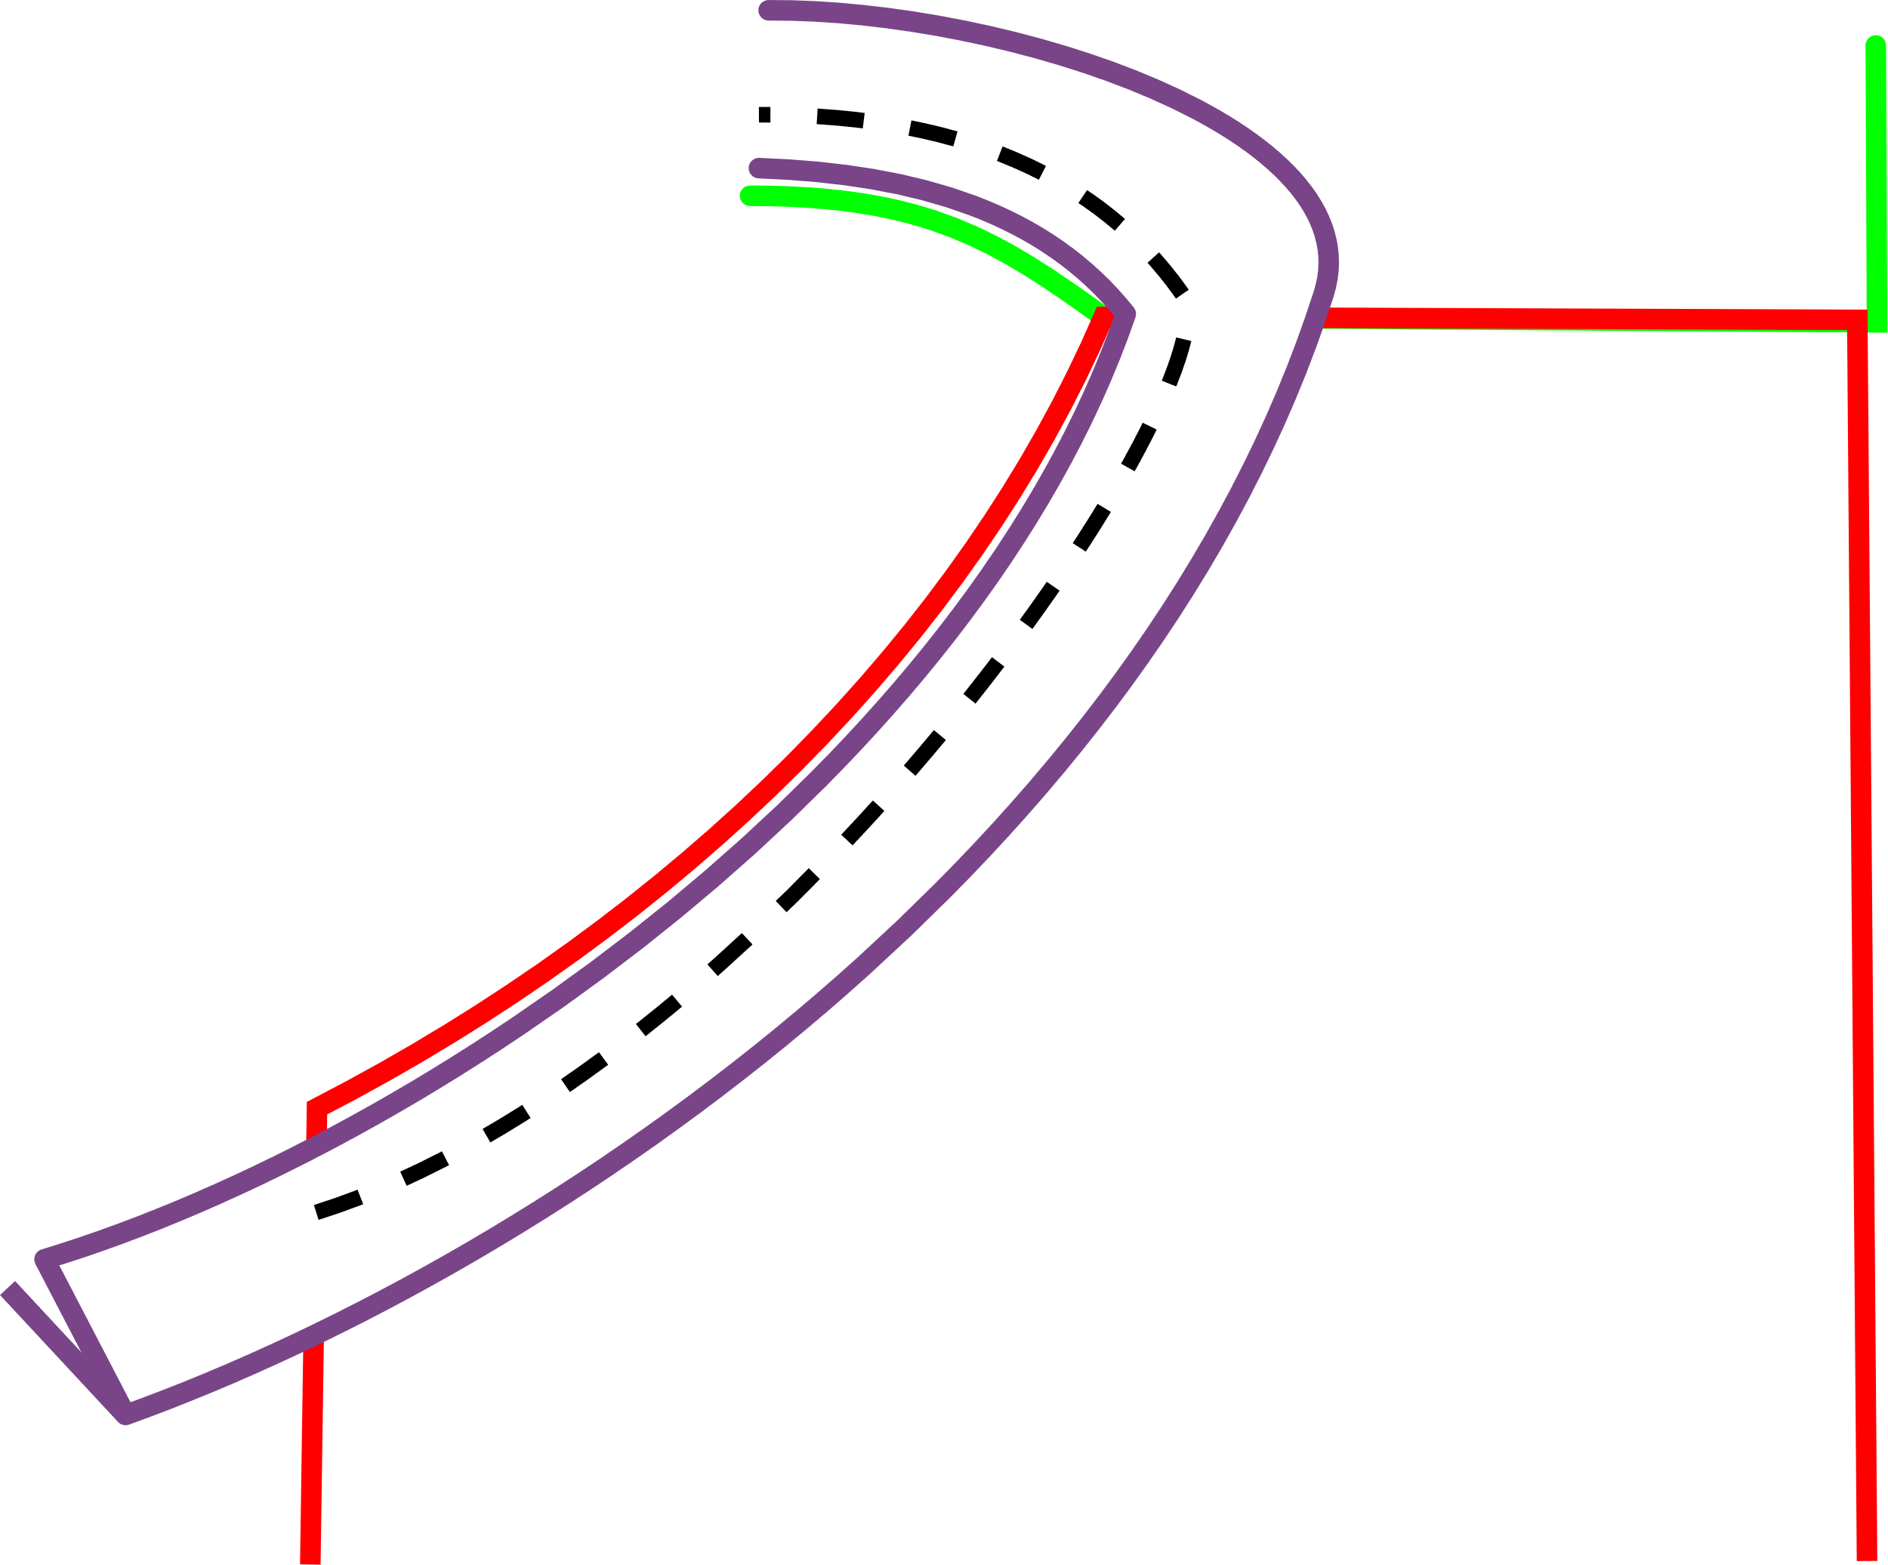

-Fold Facing up and Iron.

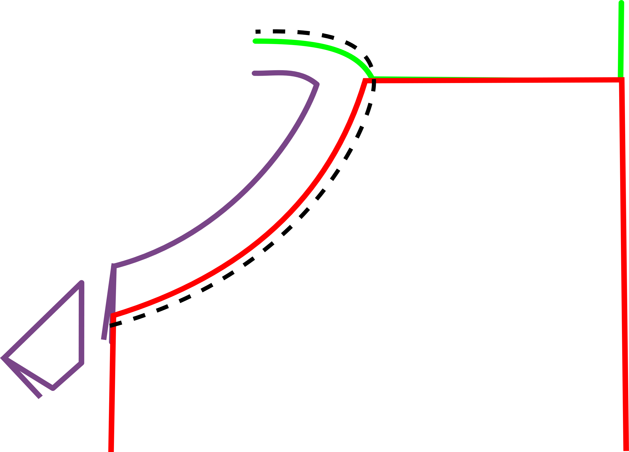-Topstitch on the FRONT PIECE close to stitching.

-Trim excess NECK FACING length.

(Keep trimmed pieces for making ties)

-Trim the seam allowance close to topstitching.

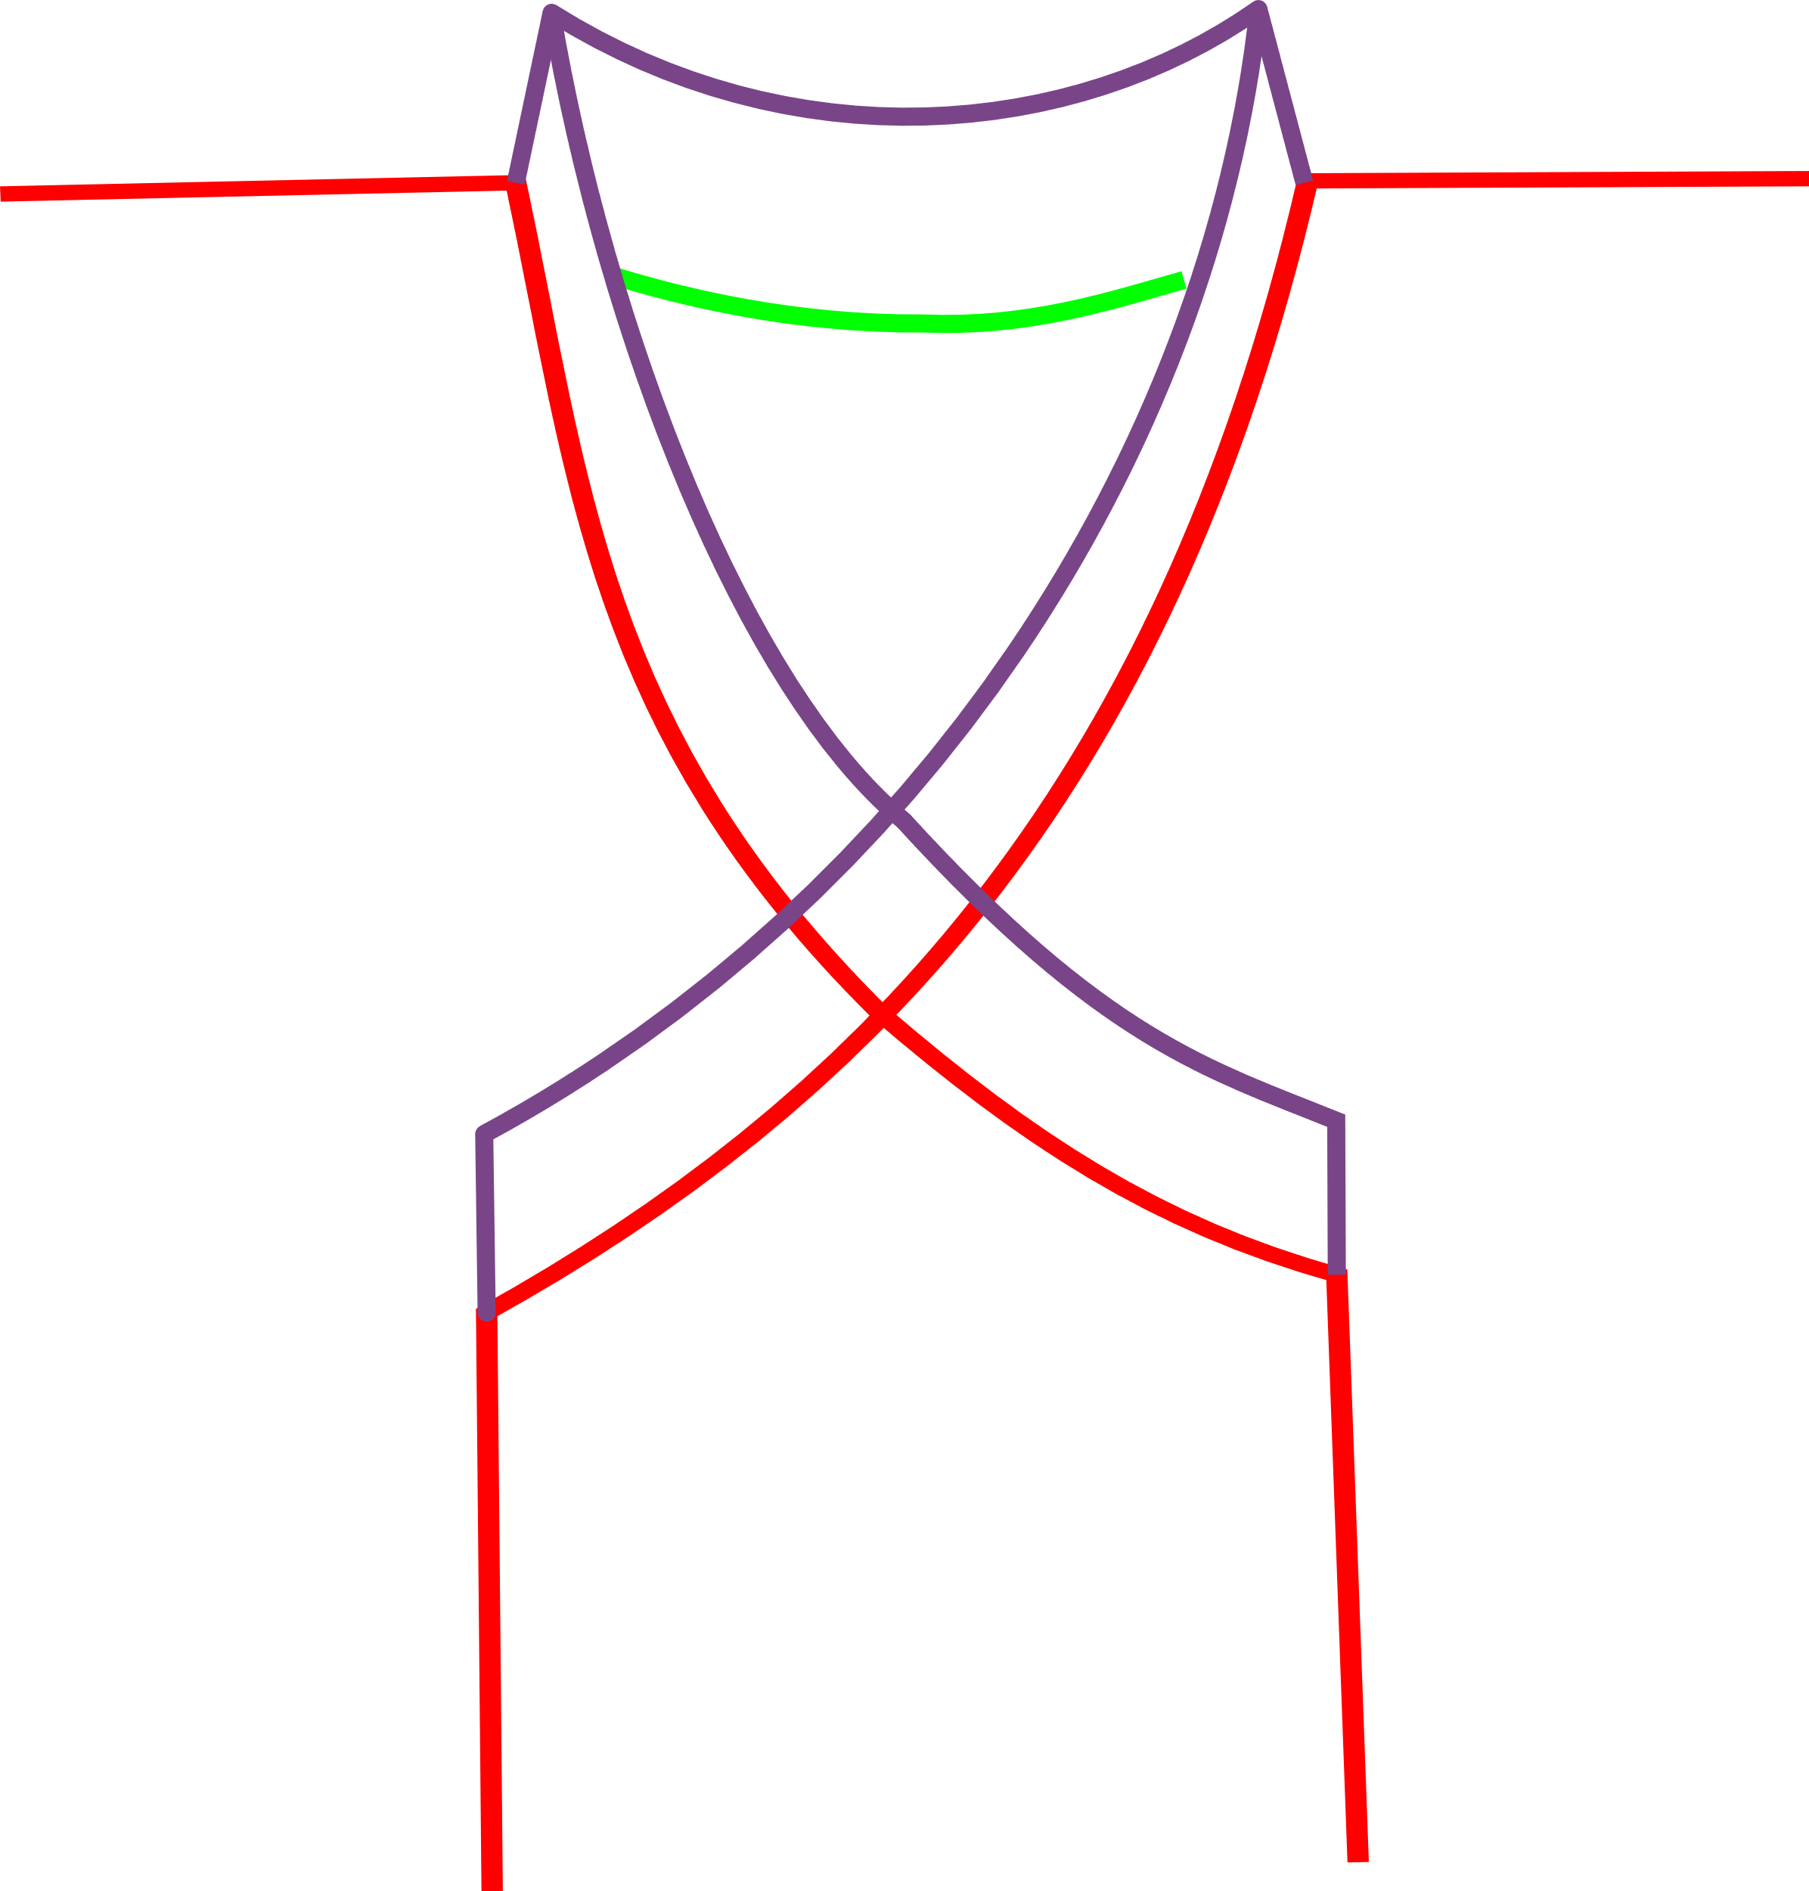)

]t will look like this:

5. Body hem:

-Double-Fold 1/2" (Total 1”) along the Bottom Edge. Iron.

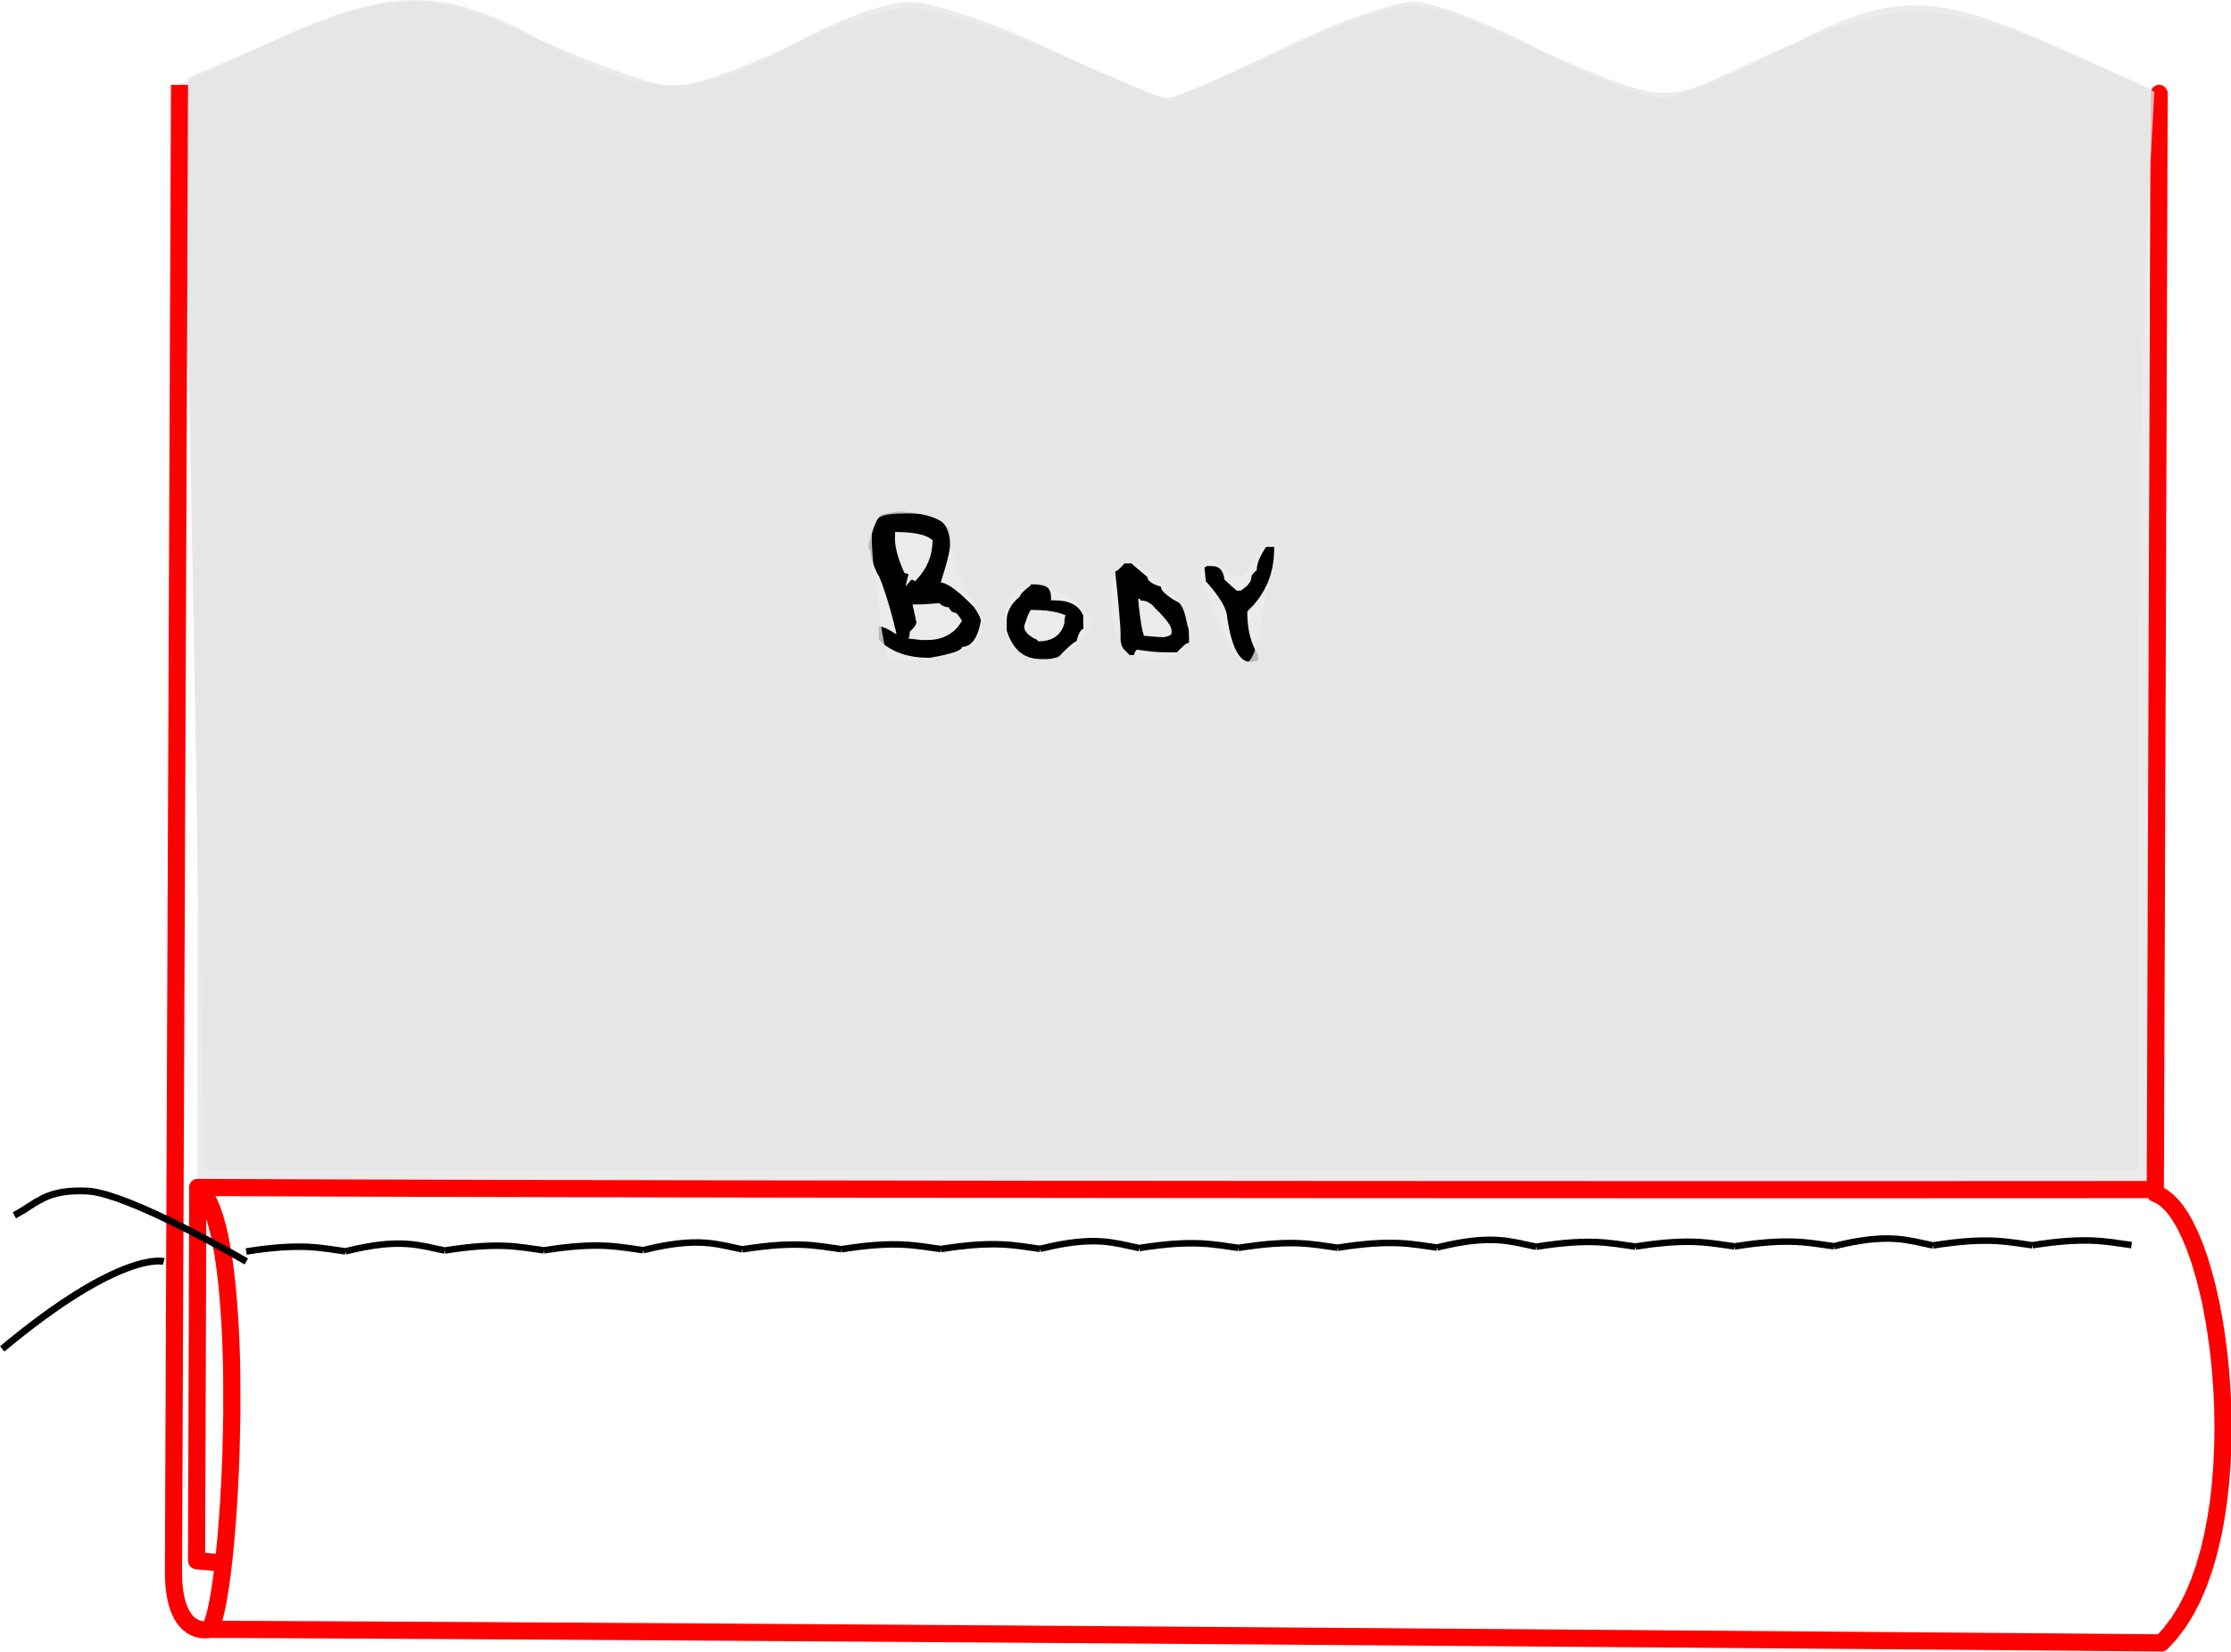-TopStitch 3/8" away from fold.

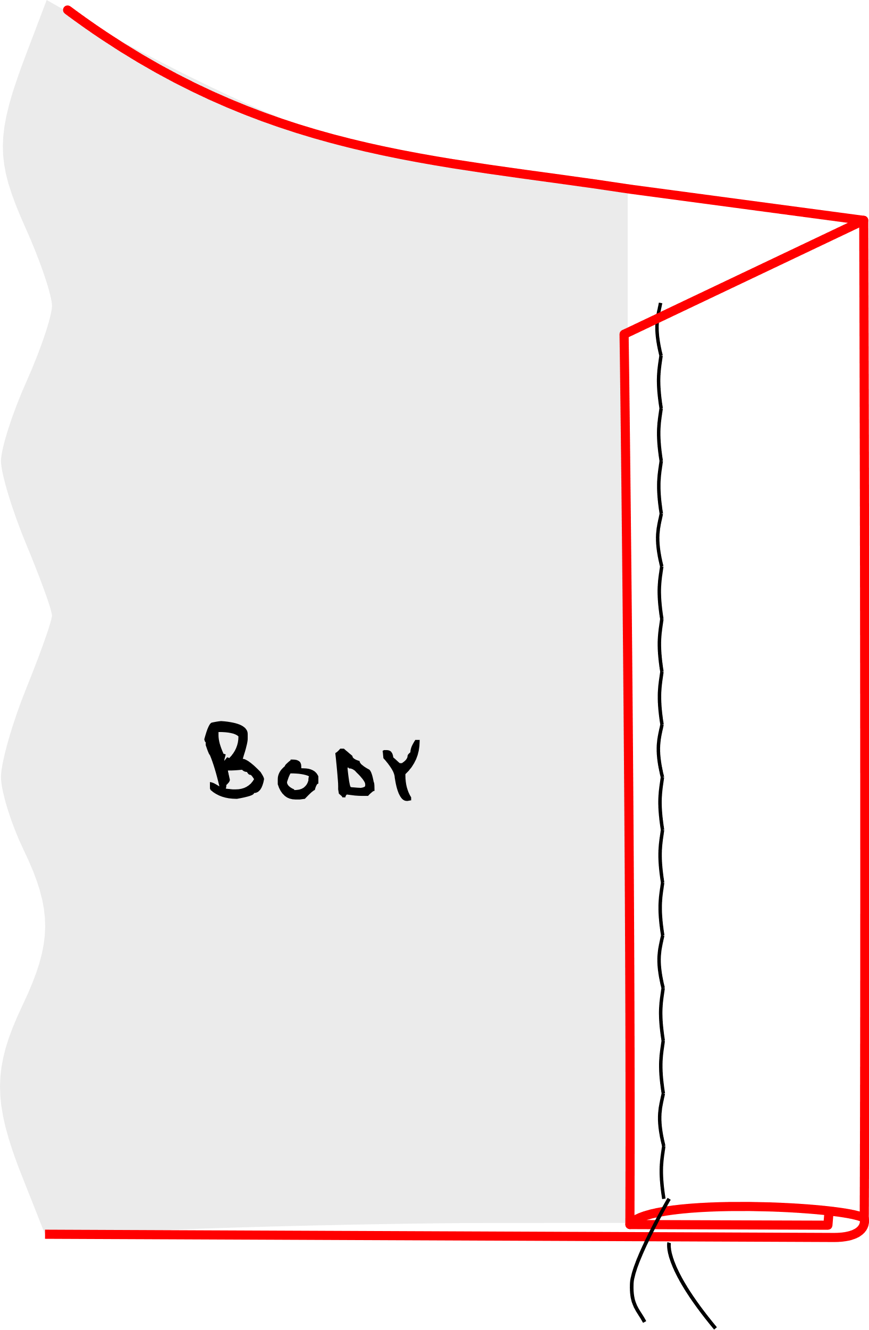6. Front edge hem:

- Double-Fold 1/2” (Total 1”) along the Front Edges

Towards wrong side of fabric. Iron.

- TopStitch 3/8" away from fold.

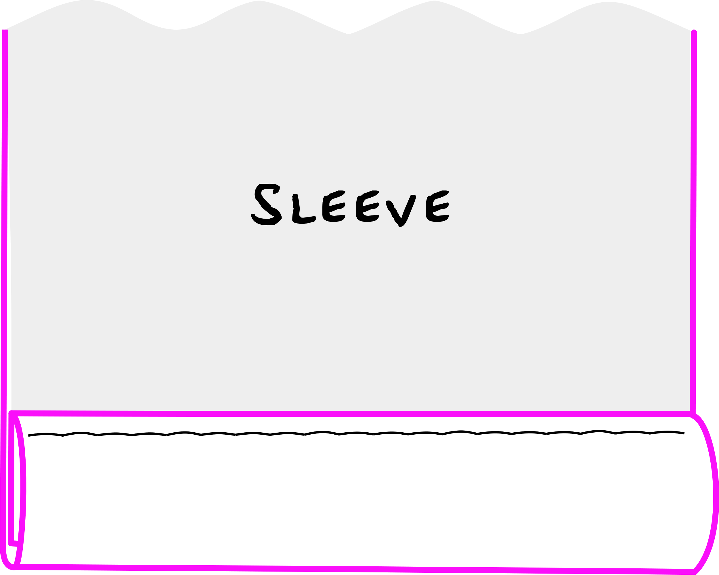7. Sleeve hem:

-Double-fold 1/2" (total 1”) along Sleeve edges. Iron.

-Topstitch 3/8” away from fold.

8. Ties:

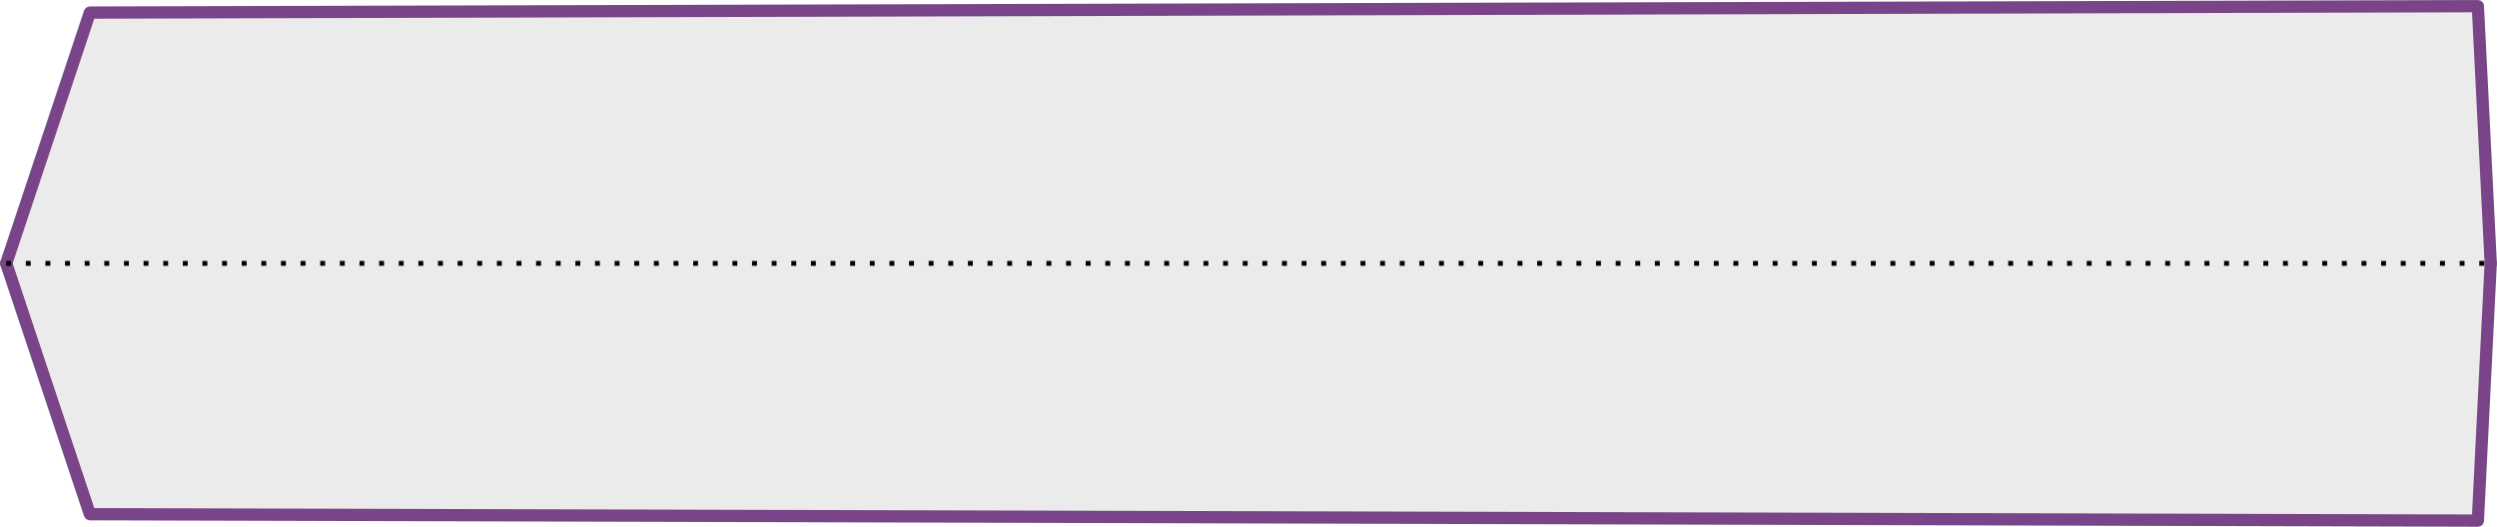- Open the fold of the four saved facing pieces from step #4, Wrong side up.

- Fold edges towards middle Fold line. Iron.

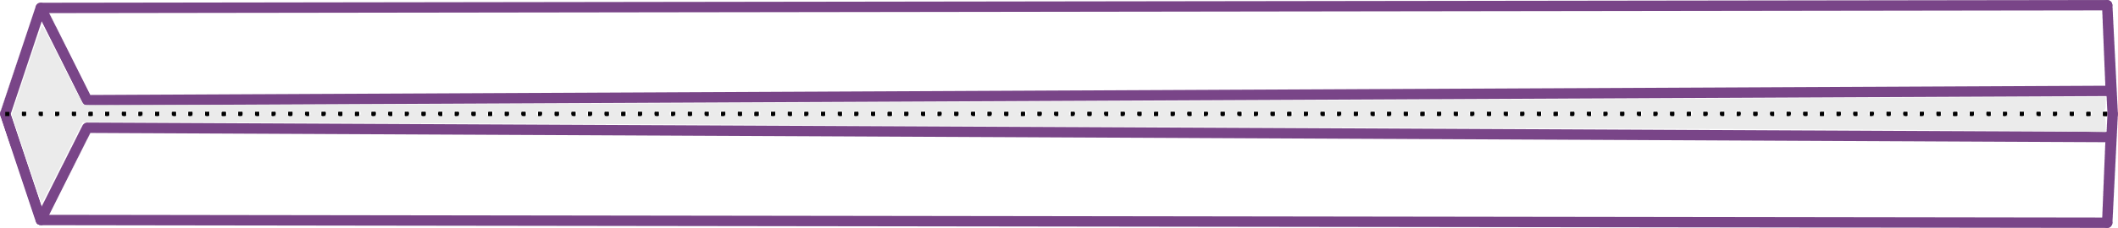

- Fold along middle fold line. Iron.



- Top stitch down the middle of each tie.



- Tack one tie each to The Right Front Facing. And to the Left front facing.

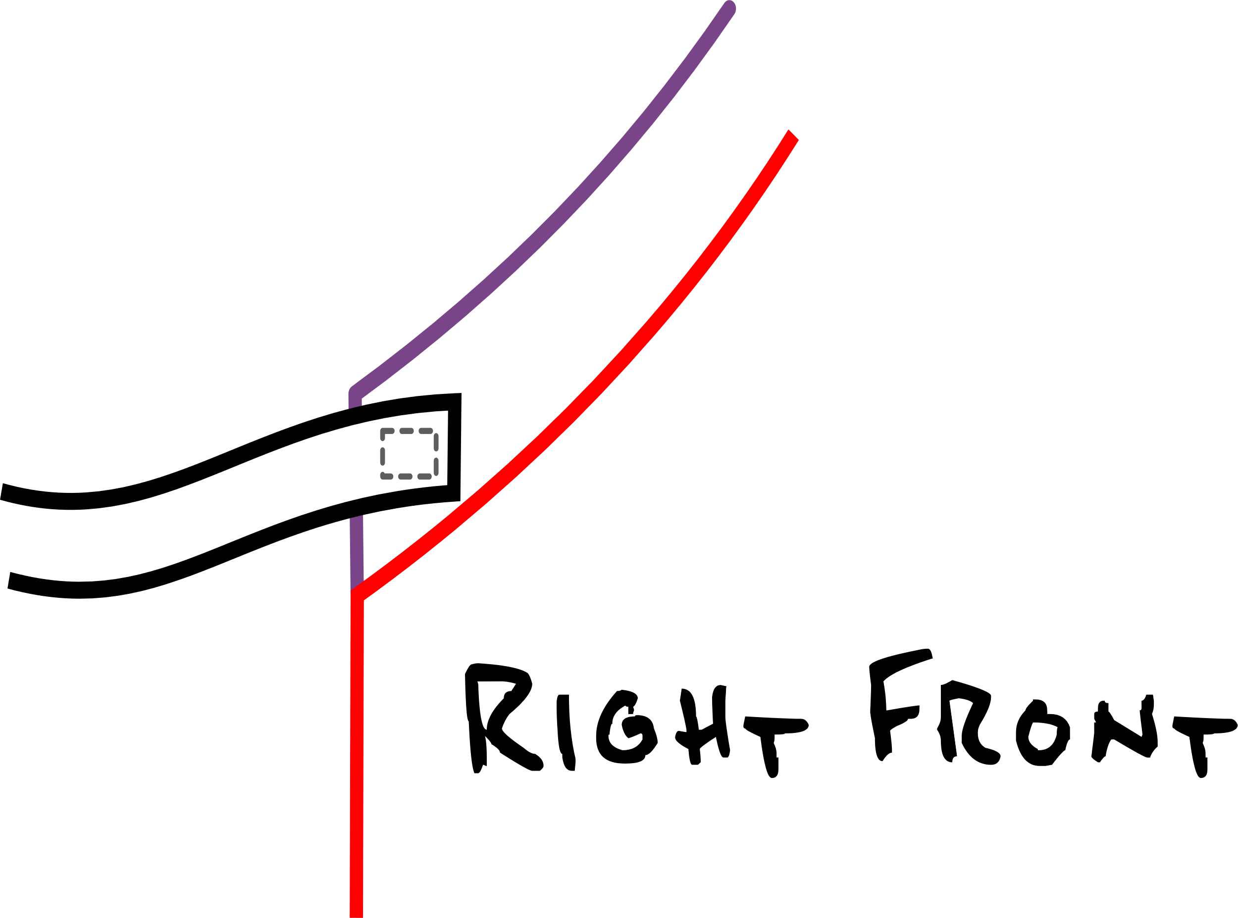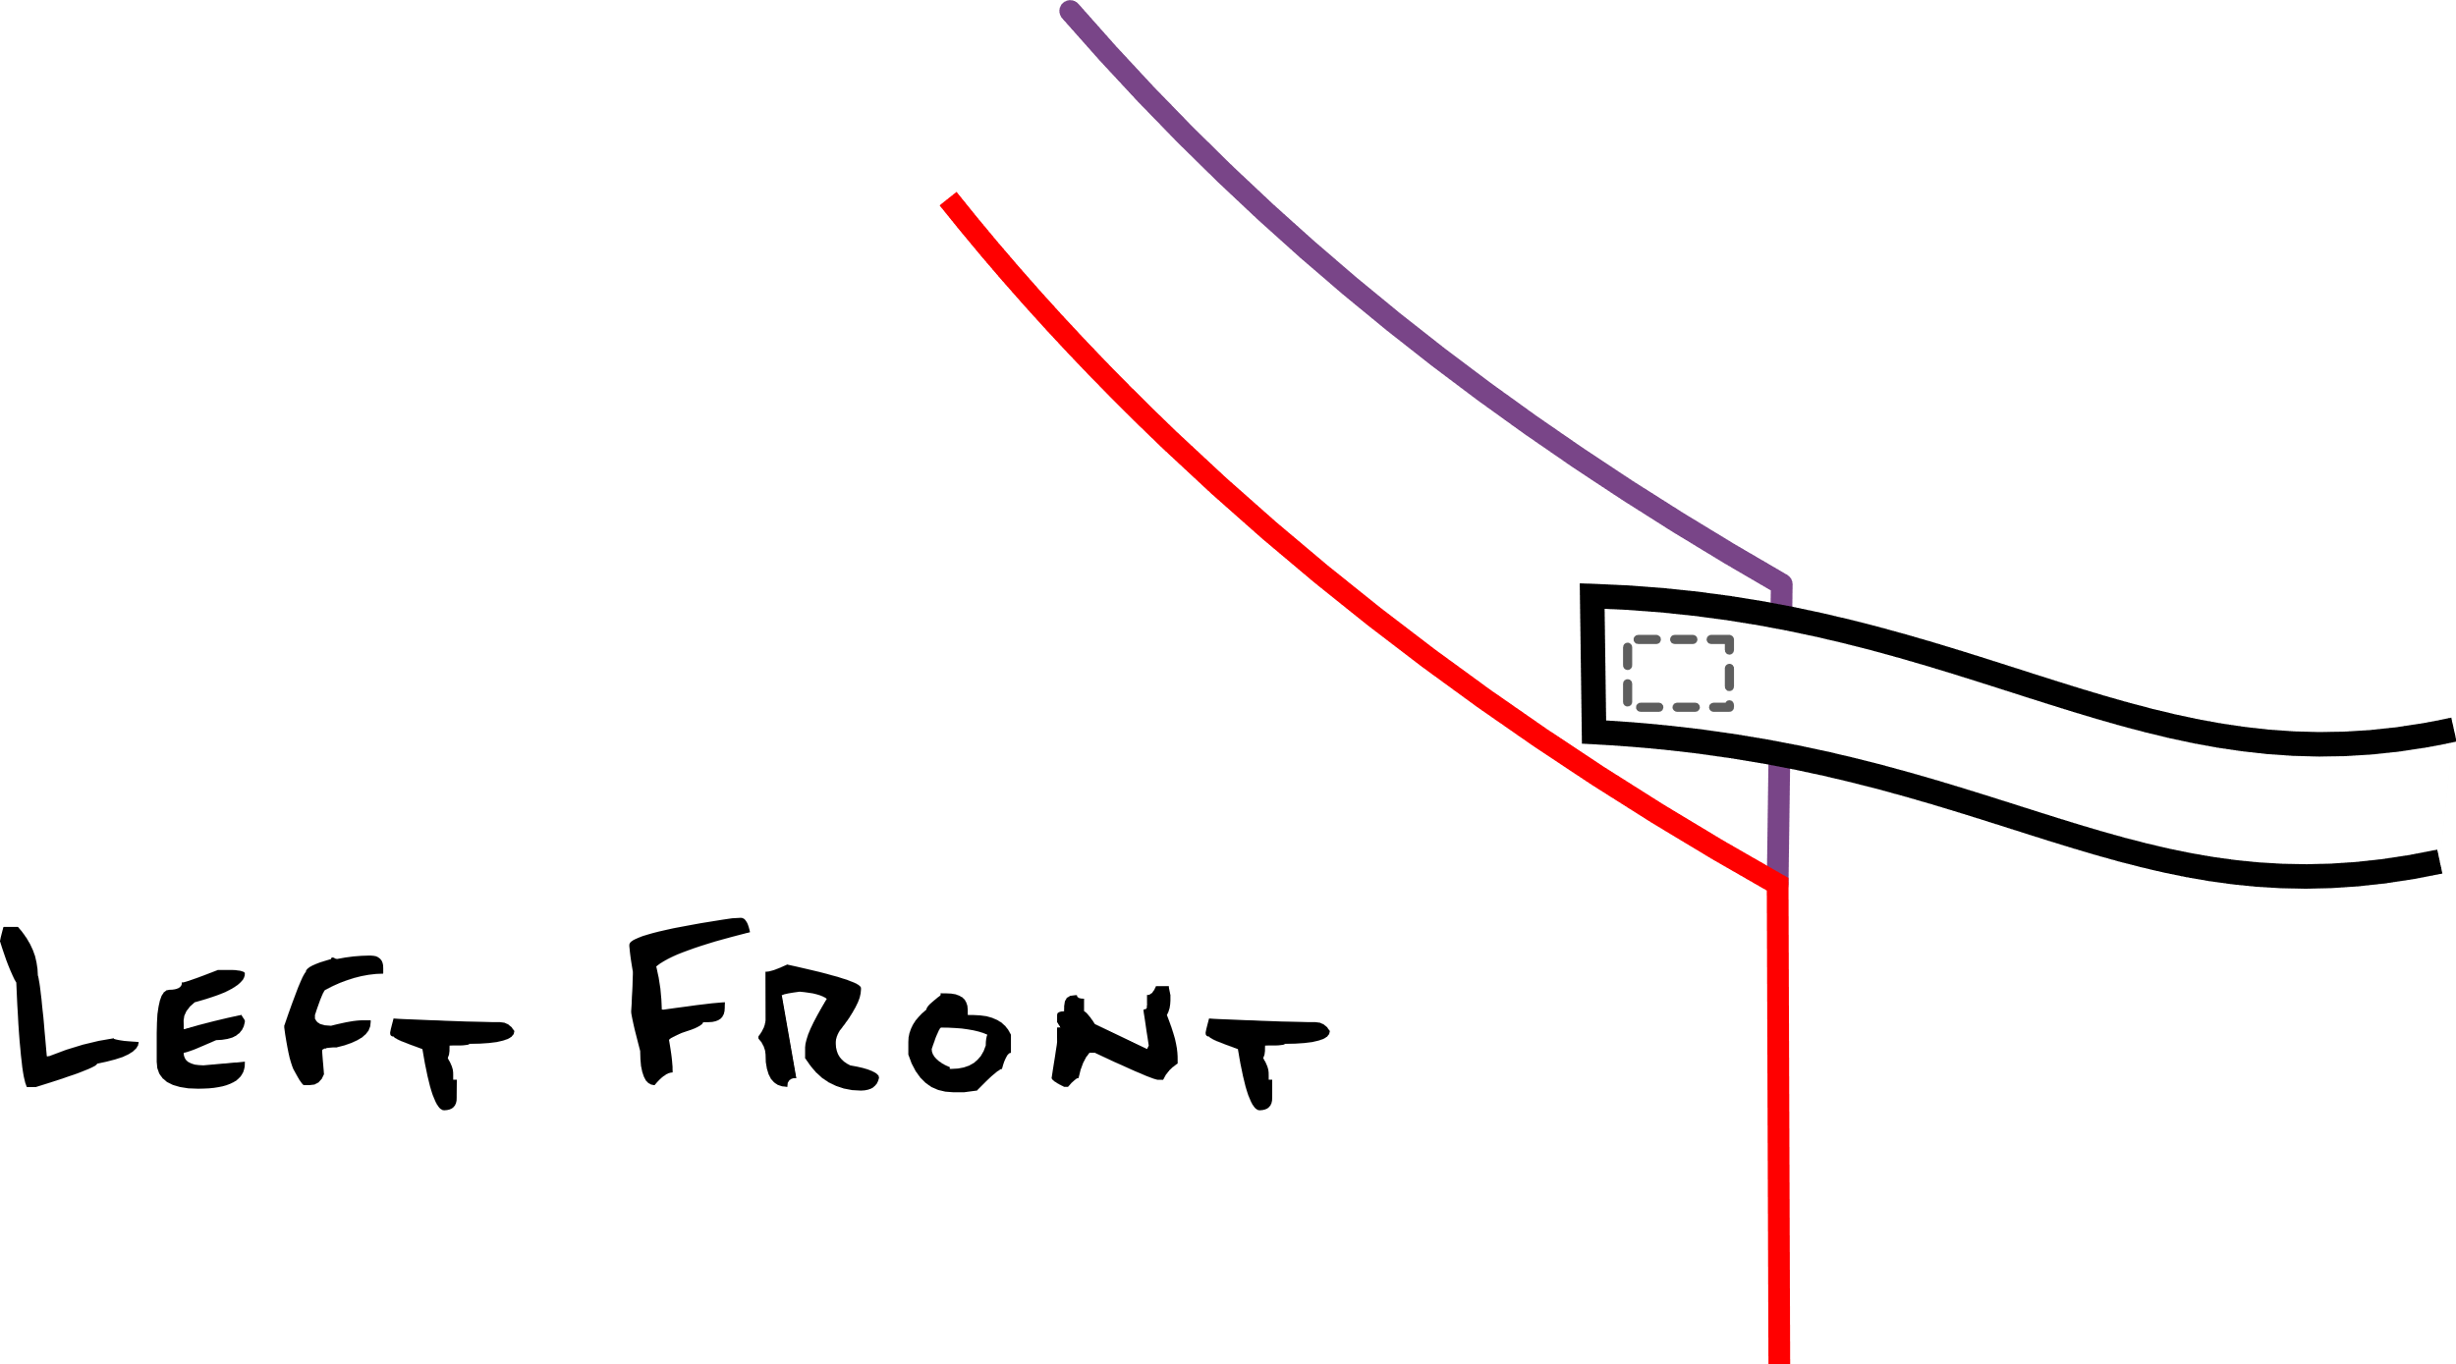

-Tack one tie to the LEFT FRONT Side seam, on the right Side of the fabric below the sleeve, with the seam allowance under the tack.

- Tack the last tie to the RIGHT FRONT side seam, on the WRONG side of fabric below the sleeve with the seam allowance under the tack.

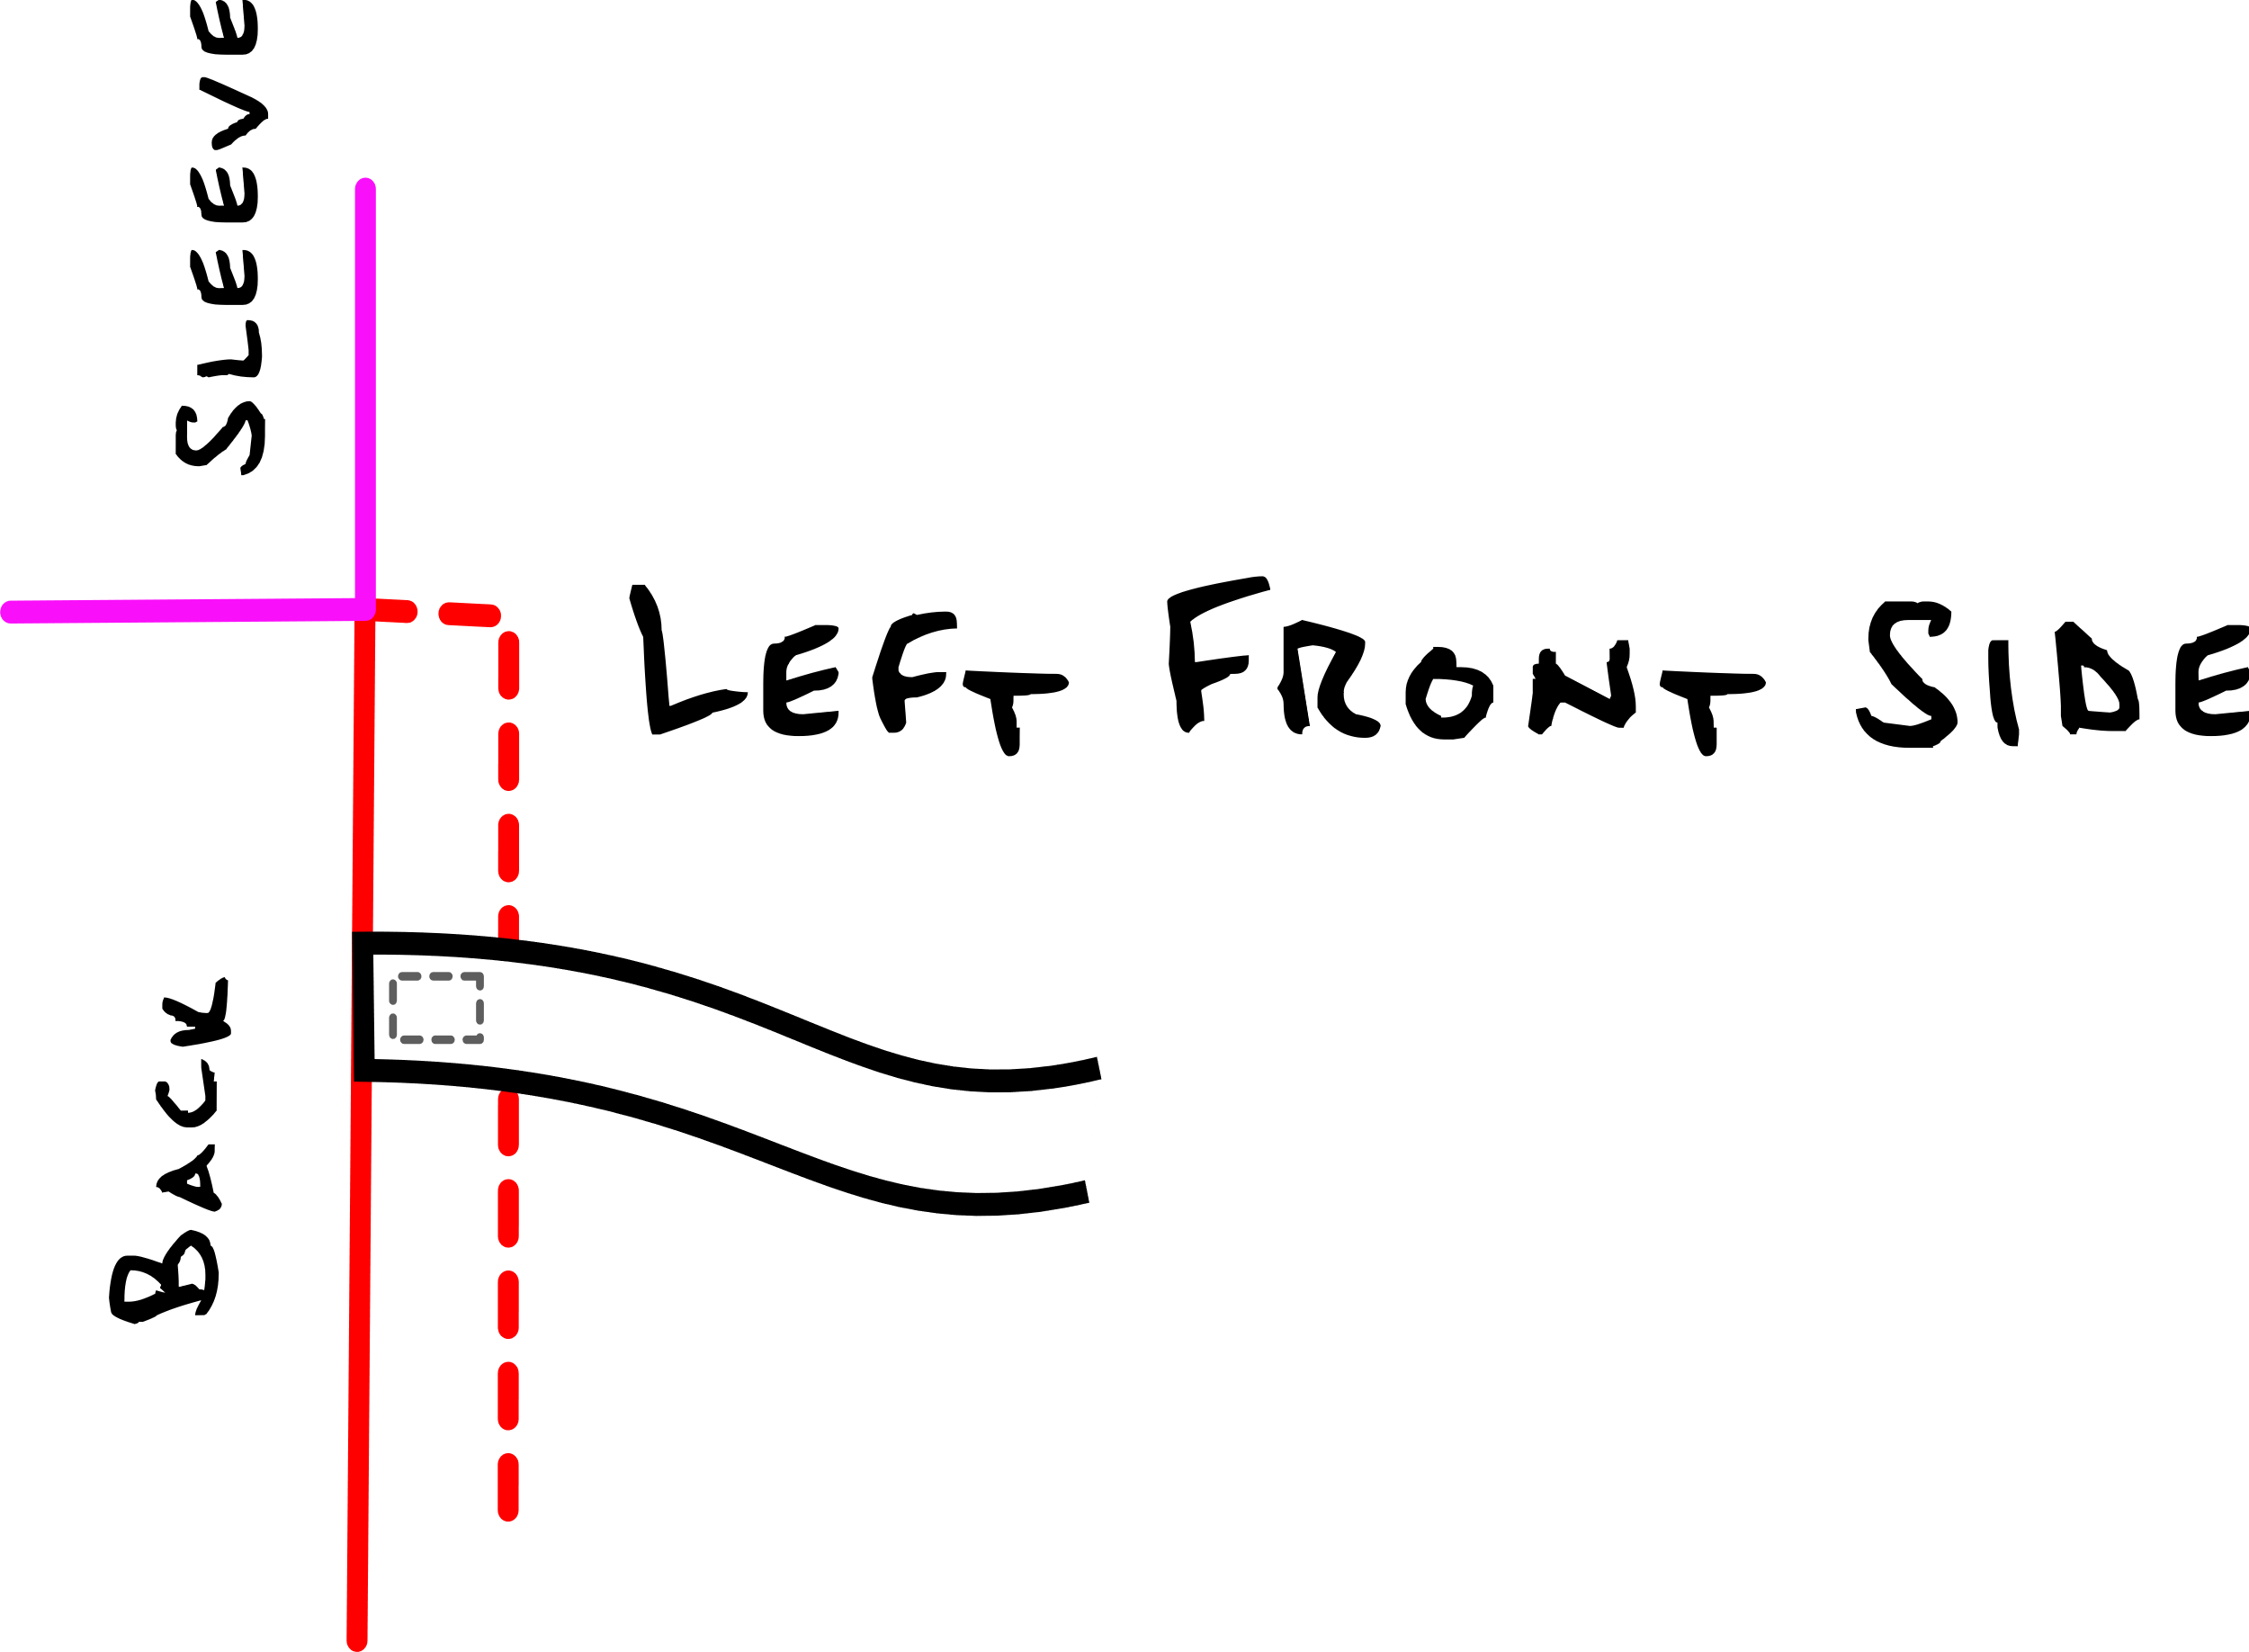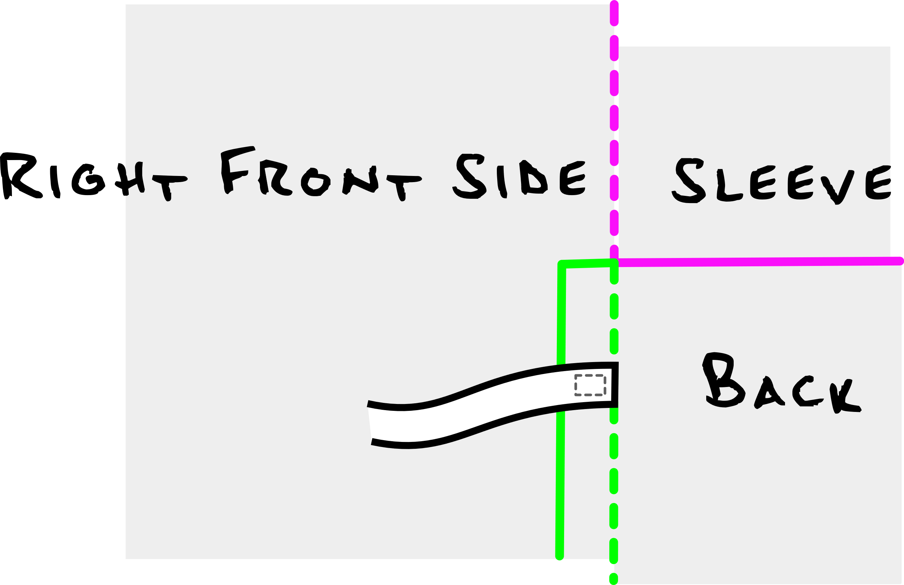

____FINAL RESULTS____



s

Send us your pics when you make the KIMOWNO

to HELLO@FASHIONFREEDOM.EU