# **1. Database Schema:**

**Table Name:** agents

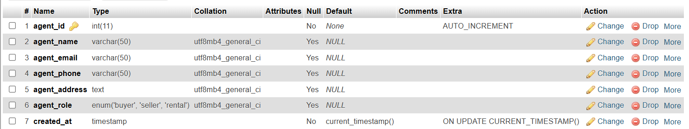

**Table Name:** images

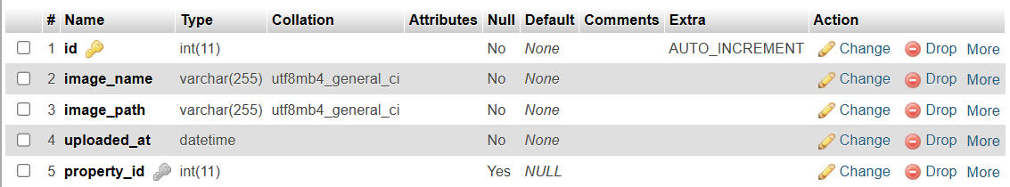

**Table Name:** leases

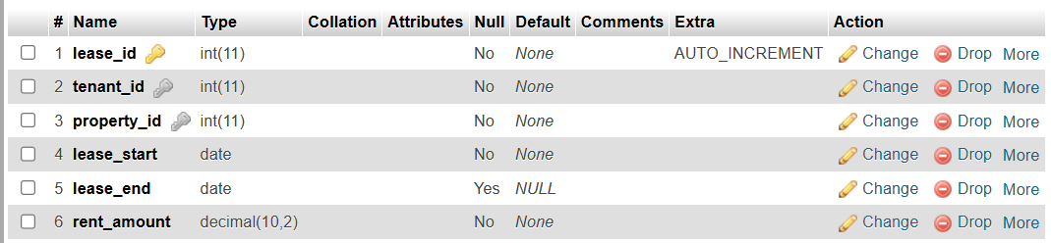

**Table Name:** maintenance requests

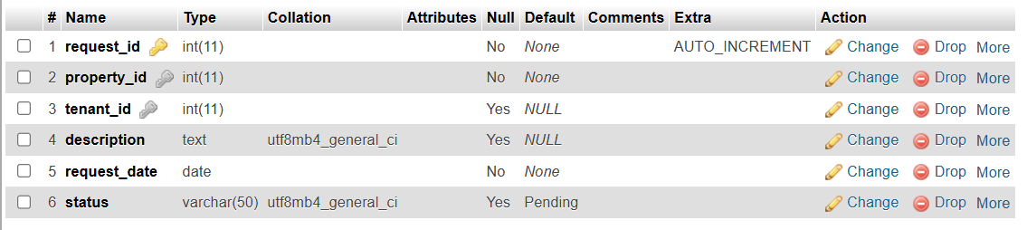

**Table Name:** payments

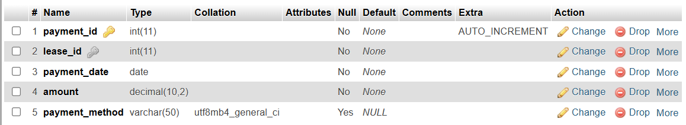

**Table Name:** tenants

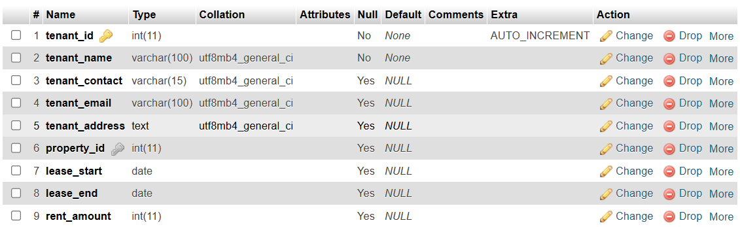

**Table Name:** users

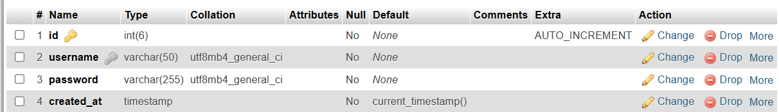

**Table Name:** properties

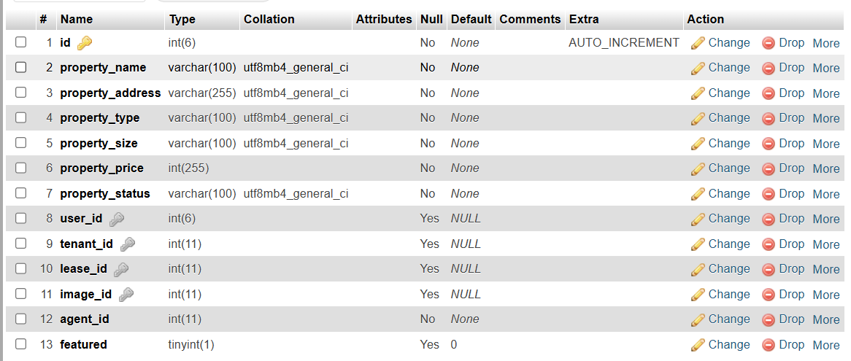

# **2. Data Population:**

**Agents Table**



**Images Table**



**Leases Table**

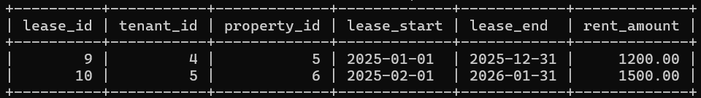

**Maintenance_Requests Table**

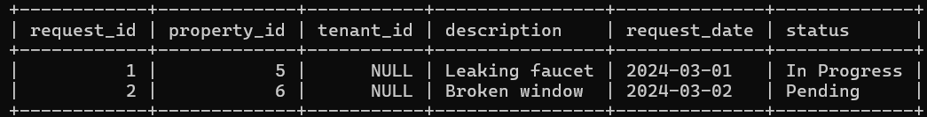

**Payments Table**

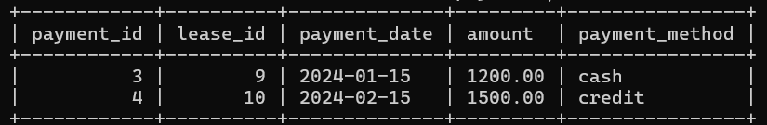

**Properties Table**



**Tenants Table**



**Users Table**

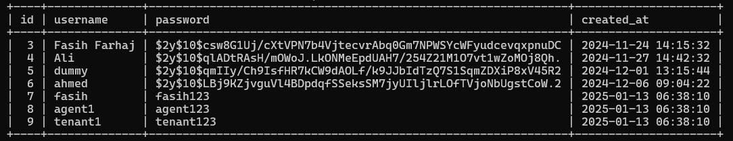

# **3. SQL Queries:**

Below are 25 SQL queries that will demonstrate the various querying capabilities of the database:

1. SELECT property_id, rent_amount FROM Leases;

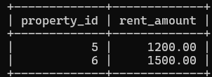

2. SELECT tenant_id, lease_start, lease_end, rent_amount FROM Leases;

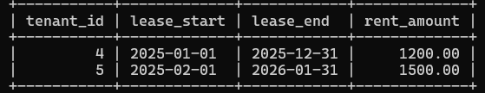

3. SELECT id, property_address, agent_id FROM Properties;

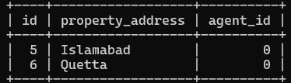

4. SELECT COUNT(*) AS total_tenants FROM Tenants;

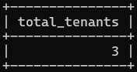

5. SELECT MAX(rent_amount) AS highest_rent FROM Leases;

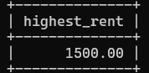

6. SELECT * FROM Leases WHERE YEAR(lease_start) = 2025;

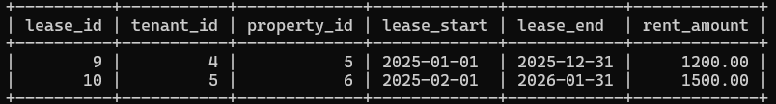

7. SELECT tenant_id FROM Leases WHERE rent_amount > 1300;

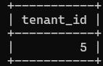

8. SELECT * FROM Properties WHERE property_price > 300000;



9. SELECT * FROM Properties

WHERE id NOT IN (SELECT property_id FROM Leases);



10. SELECT * FROM Leases WHERE lease_end <= DATE_ADD(CURDATE(), INTERVAL 6 MONTH);



11. SELECT T.tenant_name, P.property_address

FROM Tenants T

JOIN Leases L ON T.tenant_id = L.tenant_id

JOIN Properties P ON L.property_id = P. id;

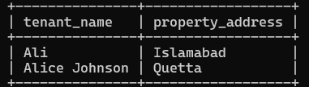

12. SELECT P.property_address, A.agent_name

FROM Properties P

JOIN Agents A ON P.agent_id = A.agent_id;



13. SELECT L.lease_id, T.tenant_name, L.rent_amount

FROM Leases L

JOIN Tenants T ON L.tenant_id = T.tenant_id;

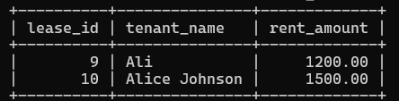

14. SELECT DISTINCT A.agent_name

FROM Agents A

JOIN Properties P ON A.agent_id = P.agent_id

JOIN Leases L ON P.id = L.property_id

WHERE YEAR(L.lease_start) = 2025;



15. SELECT T.tenant_name, L.lease_start, P. property_price

FROM Tenants T

JOIN Leases L ON T.tenant_id = L.tenant_id

JOIN Properties P ON L.property_id = P. id;

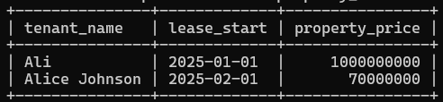

16. SELECT AVG(rent_amount) AS avg_rent FROM Leases;

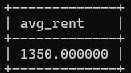

17. SELECT agent_id, COUNT(*) AS total_properties

FROM Properties

GROUP BY agent_id;

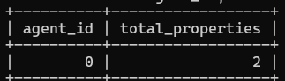

18. SELECT SUM(rent_amount) AS total_rent FROM Leases;

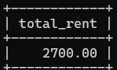

19. SELECT YEAR(lease_start) AS lease_year, COUNT(*) AS total_leases

FROM Leases

GROUP BY lease_year;

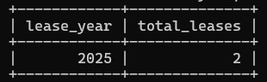

20. SELECT property_id, COUNT(*) AS tenant_count

FROM Leases

GROUP BY property_id;

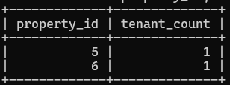

21. SELECT *

FROM Leases

WHERE rent_amount = (SELECT MAX(rent_amount) FROM Leases);

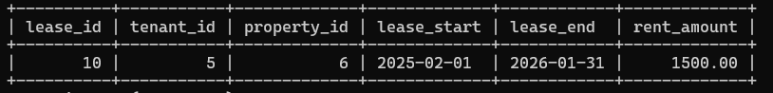

22. SELECT * FROM Tenants

WHERE tenant_id NOT IN (SELECT tenant_id FROM Leases);



23. SELECT L.lease_id, A.agent_name

FROM Leases L

JOIN Properties P ON L.property_id = P.id

JOIN Agents A ON P.agent_id = A.agent_id;



24. SELECT property_id

FROM Leases

GROUP BY property_id

HAVING COUNT(*) > 1;



25. SELECT T.tenant_name, SUM(L.rent_amount) AS total_rent

FROM Tenants T

JOIN Leases L ON T.tenant_id = L.tenant_id

GROUP BY T.tenant_name;

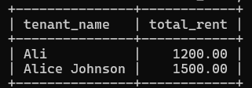

# **4. Relational Algebra Queries:**

Below are 20 Relational Algebra queries that will demonstrate the various querying capabilities of the database:

1. σ (Leases.tenant_id = Tenants.tenant_id) (Leases ⨝ Tenants)



2. σ price > 300000 (Properties)



3. σ lease_start >= '2025-01-01' ∧ lease_start <= '2025-12-31' (Leases)

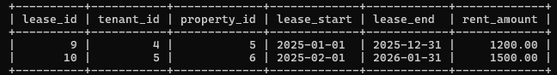

4. π tenant_id (σ rent_amount > 1500 (Leases))



5. σ agent_id = 'A001' (Properties)



6. π tenant_id, lease_id, rent_amount (Leases)

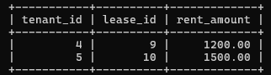

7. Properties - π property_id (Leases)



8. Tenants × Properties



9. σ lease_end >= '2025-01-01' ∧ lease_end <= '2025-12-31' (Leases)

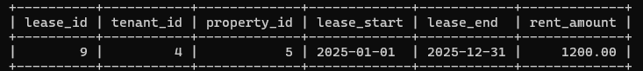

10. γ agent_id, COUNT(property_id) (Properties)

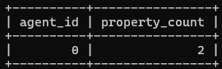

11. σ rent_amount < AVG(rent_amount) (Leases)

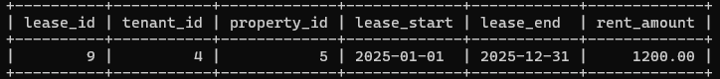

12. σ lease_end - lease_start > 12 months (Leases)



13. π property_id (Leases ⨝ Properties)

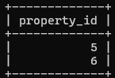

14. σ lease_id = 'L001' (Leases ⨝ Tenants)



15. γ property_id, SUM(rent_amount) (Leases)

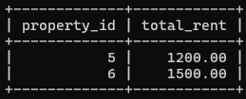

16. π property_id (Properties) ÷ π property_id (Leases)



17. σ rent_amount = MAX(rent_amount) (Leases ⨝ Tenants)

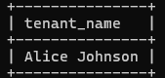

18. γ agent_id, COUNT(property_id) HAVING COUNT(property_id) > 2 (Properties)



19. σ agent_id = '0' (Tenants ⨝ Leases ⨝ Properties ⨝ Agents)

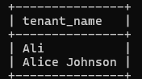

20. γ tenant_id, AVG(rent_amount) (Leases)

