HOME

**Pictures ( one picture a time and 1 sec between each transition )**

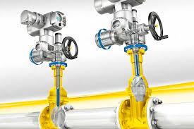 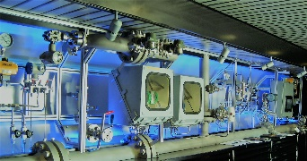 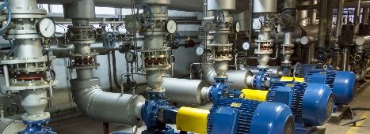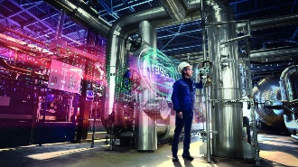

MIDMAC has been actively supporting the energy sector with cutting edge technologies from world leading solution providers. Integrating divergent divisions that match the Technical / Engineering organization and conversant with the procurement and contracting practices of their major customers in UAE and the region.

MIDMAC established in 2014 serving oil & Gas, Power, Utility Sector and Infrastructure in UAE. Our mission is to provide our valuable client with best possible Technical Solution to meet their requirement with the most cost-effective way without compromising on quality for Sales &Services.

**ABOUT US**

MIDMAD was established in 2014 and its CEO Mr. Thani Jumaa Al Rumaithi. One of the well reputed name in UAE, our mission is to provide local companies and the region with cost effective products and solutions in a timely manner using most effective talent, technologies and practices for serving in various sectors as follow:

1. Oil & GAS.
2. Power
3. Refining
4. Petrochemicals
5. Marine
6. Major & small Industries
7. Utility & Infrastructure.

**OUR VISION:**

To develop, provide and sustain economically feasible key solution for the market in UAE and the region by investing in talent and industry leaders.

**OUR MISSION:**

To turn prospective opportunities into profitable ventures and create value for our internal and external customers by utilizing own resources or by integrating capabilities or our partners while meeting the highest professional ethical and QHSE standards exceeding stake holder expectations.

**MANAGEMENT**

Mr. Thani Al Remeithi is the former Director at the naturalization Department of the Federal Naturalization & Residency Directorate, he is one of the well reputed names in UAE,

His mission is to provide local companies and the region with cost effective products and solutions in a timely manner using most effective talents, technologies and practices for serving in various sectors

**DIVISIONS**

**Environmental & Renewable Energy**

Water distributions network

Waste Water Applications

Water treatment Applications

Pressure Vessels application

Skid applications

Water hammering

Separation technology

Heat Transfer applications

**Valve Automation**

Supply of Gate, Globe, Check, Ball & Butterfly valves in Oil and Gas, UTILITY AND severe applications.

ESD, MOV Packages

Valve Actuation (Electrical, Pneumatic, Hydraulic & Electro-Hydraulic)

Choke & Control Valves.

PFP for ESD MOV and others

Safety Valves Interlocks

**Electrical, Instrumentation & Control**

Pressure gauge, Transmitter, Switch, Logger& Converter,

Regulation, Control and Testing with Calibration

Flow logger, Transmitter for Water Distribution

Temperature gauge, transmitter & Switch.

Level gauge, Transmitter & Switch

Analyzers of all related to water quality

Electric Ex. Panels, lighting & Glands.

Smart Positioner and Switches

Sight Glasses

I/P, P/I and IR regulator

Instrument Fittings and Valves

Instrument Hoses & Tubes

**Service & Value-Added Division**

Valve Actuation Retrofit

Sizing Assembling and testing ESD, MOV Package

Valve Interlock Services

PFP Services

Turbine Services

Process Equipment’s Cleaning

**Rotating Equipment**

Centrifugal Pumps

Submersible pumps

Submersible motors

Gas Compressors and turbine

Air compressors

**SECTORS**

**Pictures (With sectors names under each image)**

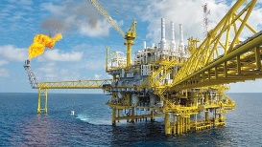

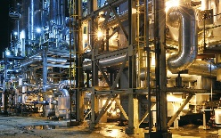

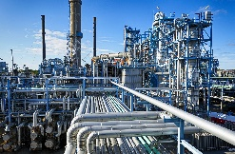



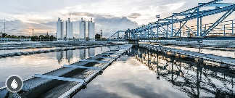





**QHSE Safety & Quality**

**ALL POLICIES and CERTICATE OF ISO**

**ORGANIZATION STRUCTURE**

**BUSNIESS PARTNERS**

* **FIRE PROTECTION ENCLOUSERS & SS316 SPECIAL COATINGS**
* **MECHANICAL KEY INTERLOCKS**
* **MANUAL VALVES (BALL. GGC, BUTERFFLY)**
* **MOV PACKAGES**
* **ESD PACKAGES**
* **CONTROL VALVE SPECIAL PACAKGES RELATED TO OFFSHORE**
* **PUNUEMATIC POSITIONER CONTROL VALVE PACAKAGE**
* **LINEAR GATE VAKVE SUPPLY**
* **UL/FM VALVES SUPPLY (Ductile Iron)**
* **BUTTERFLY VALVES AL TYPES (Ductile Iron)**
* **EXPLOSION PROOF BOXES.**
* **EXPLOSION-PROOF ELECTRIC CONTROL DEVICES**
* **EXPLOSION-PROOF ELECTRIC CONTROL BOXES**
* **EXPLOSION-PROOF JUNCTION BOXES,**
* **EXPLOSION-PROOF TERMINAL BOXES,**
* **EXPLOSION-PROOF CONTROL STATIONS**
* **EXPLOSION-PROOF ACCESS POINT**
* **EXPLOSION-PROOF PRESSURIZED CONTROL CABINETS**
* **EXPLOSION-PROOF ALARM DEVICES,**
* **EXPLOSIONPROOF LED LIGHT FITTINGS**
* **EXPLOSIONPROOF LIGHTING FIXTURES**
* **DUST EXPLOSION PROOF (HIGH PROTECTION) POWER DISTRIBUTION CONTROL DEVICES**
* **WEATHER-PROOF POWER DISTRIBUTION BOXES**
* **WEATHER-PROOF LIGHTING FIXTURES**
* **STREET LIGHTING/POLES**
* **LV DISTRIBUTION BOARDS&LIGHTING PANELS FOR SAFE AND HAZARDOUS AREA**
* **ALL TYPES OF INSTRUMENTATIONS NSTRUMNET & CABELS**

**REFRENCES/ DOWNLOAD**

**PROCESS OF PREQUALIFICATION**

* **AGENCY AGREEMENT**
* **Prequalification Process**
* **Qualification Submittal Required**

**REFRENCES**

**PHOTOS OF INSTALLATIONS**

**API STANDARDS**

* **API 527**
* **API 598**
* **API STANDARD OF VALVE**
* **API6D Valve Insp & Testing 3.2**
* **ASME B31.3 Codes**
* **VALVE MANUAL BOOK**
* **API 6D**
* **API 6A**

**STANDARD DIMENSION**

* **An overview of the American Petroleum Institute, API, valves standards**
* **ANSI, ASTM and API Designations for Piping**
* **API Trim Chart**
* **ASTM PIPE STANDARDS**
* **Fitting Standard Specifications**
* **Flanges Standard**
* **Piping Schedule**

**Organization Structure**

**CONTACT US**

**Contact Details Enquiry FORM**

**Location :**

Name

Company Name

Contact Number

Email

Enquiry

Delma Street , Sultan Manea Al Muhairi Building ,

Mez. Floor . P.O Box: 111303

**PHONE:**

+971 (0)2 667 1717

**EMAIL :**

info@midmac.ae

**LOCATION MAP**

