Membership fee

A plugin for the free online membership management software Admidio

Documentation

January 2024

Rainer M. Binder

1. **Prolog**

In the fall of 2010, I was asked by my then 1st chairman whether I would like to take on the post of secretary in the local sports club. I agreed after a moment's thought. The activity included, among other things, the ad­ministration of members and the calculation of membership fees.  
  
A membership management program was in place, but despite having worked in IT for 30 years, I couldn't get by with this program. Various functions could only be accessed using special, undocumented key combi­nations.

So I went looking for another program and found it at Admidio. In 2011 the **membership fee** plugin was al­ready available in version 1.0.1. With the consent of the author Gerald Lutter, I took it over from him and have continuously developed it since then.

In 2012 the plugin was completely revised and provided with an accordion menu. In 2013 came the next ma­jor leap in version and **membership fee** was expanded to include SEPA functionalities. Up to this point, there were still very few SEPA-enabled programs. Free ones were almost impossible to find.

**Membership fee** is different than other programs. This is mainly due to the fact that the plugin uses the role structure specified by Admidio to calculate the contributions (a contribution and a contribution period can be assigned to a role in Admidio. The plugin evaluates this information). **Membership fee** was designed from the ground up, no other program served as a model.

**Version history**

47 updates have been released since 2011, the current version is 5.3.0. A [change history](https://www.admidio.org/dokuwiki/doku.php?id=en:plugins:mitgliedsbeitrag" \l "mitgliedsbeitrag) can be found on admidio.org.

**Demo version**

A demo version of Membership Fee is available on my website [admidiopluginsdemo.rmb.de](http://admidiopluginsdemo.r-m-b.de/).

**Source code**

The source code is available on GitHub (<https://github.com/rmbinder/Mitgliedsbeitrag>).

Content

Function 5

Installation 6

Upload the files 6

Creating a menu item 7

The first call 7

The first basic settings 10

Contribution settings 10

Account details 10

Mandate management 10

View definitions 10

Testing the basic functions 11

The views 11

Contribution calculation 13

Update 13

The menu structure 14

Fees menu 14

Mandate management menu 14

Export menu 15

Options menu 15

Preferences menu 16

Age-based roles 17

Basics 17

Usage 17

Remapping of age-based roles 18

Reference time/month offset 18

Family roles 19

Basics 19

Usage 19

Payer 20

Multiplier roles 20

Fixed Contribution Roles 21

Basics 21

Usage 21

Individual contributions 22

Basics 22

Usage 22

Basic amount 22

Consumption amount 23

Contribution calculation 24

Contribution and contribution period 24

Prorated contribution calculation 24

Prorated contribution calculation of family roles 25

Recalculation 25

Individual contributions 26

Contribution payments 27

Payment reminder 28

Delete Amounts 29

Membership fee analysis 30

Contribution history 30

Export 31

SEPA 31

Due date 31

XML file 33

Control file 33

Pre-notification 34

Invoice 36

The Export button 36

The E-mail button 36

Mandate management 38

Create mandate references 38

Edit mandate 39

Options 40

Generate membership number(s). 40

Update family roles 41

Copy 42

Tests 43

Age-bases roles 43

Role membership (age-based roles) 43

Role membership (mandatory) 43

Role membership (exclusion) 43

Family roles 43

Account details 43

Mandate management 43

IBAN test 43

BIC test 44

Overview of roles 45

Plugin information 45

Preferences 46

Contribution settings 46

Age-based roles 46

Family roles 47

Multiplier roles 47

Advanced role editing 47

Individual contributions 48

Account details 49

Mandate management 50

The prefix 50

The zeros 50

The sequential number 50

View definitions 51

Export 51

Email notifications 52

Tests 52

Enable tests 52

Role membership (age-based roles) 53

Role membership (mandatory) and Role membership (exclusion) 53

Family roles 54

Access permission for preferences 56

Uninstall 56

Saving the configuration 58

Procedure for a contribution calculation 59

Rough process 59

Schedule 59

Admission of the new member 59

Generate membership number 59

Create mandate reference 59

Enter mandate date 59

Perform remapping 60

Contribution calculation 60

Due Date 60

XML file 60

Pre-notification 60

Distribution of the XML file 60

Completion of a contribution calculation 60

1. Membership fee

# Function

The **membership fee** plugin is used to calculate membership fees and export them either as a SEPA XML file or in the form of a list (XLSX, CSV). Since **membership fee** does not offer a way to send a SEPA XML file directly to a bank, an external home banking application (e.g. Jameica/Hibiscus) must be used for this. If the bank allows it, it may even be possible to submit the SEPA XML file using a USB stick.

The contribution calculation and the export are two processes that run independently of one another.

1. First, contributions are calculated based on role memberships and stored in a member's profile data (The required additional profile fields were created during the installation routine). After the data has been saved, this process is complete. The values for contribution, contribution period or sequence type can be changed later in a member's profile at any time.
2. For the export, all members are run through in a loop and it is checked whether there is data from **membership fees** (such as contribution or contribution period) in the profile fields. If yes, they will be read. No further calculation is carried out. After the data has been imported, it can be exported as a SEPA XML file or in the form of a list (Excel, CSV).

Since the contributions are determined based on role memberships, various role types have been defined for this purpose. These will be referred to as **contribution roles** in the following.

* **Age-based roles**
  + Contribution calculation depending on the age of a member
* **Family roles**
  + Contribution calculation for families or groups where one member is the contributor
  + as a special form of family roles, there are multiplier roles in which the contribution value of the role is not added, but serves as a multiplier
* **Fixed Contribution roles**
  + Calculation of contributions for divisions, honorary members, young people, etc.

In addition to these contribution roles, there are also **individual contributions** that can be used to calculate individual contributions such as electricity or water consumption.

**Notice**

References in this description to certain menu items of the plugin are shown as follows:

*→ <Tab> - <menu item> - <possible single point>*

(e.g. *→ Preferences – Contribution settings - Separator*)

# Installation

## Upload the files

In the first step, the program files must be uploaded to the server in a subdirectory of adm_plugins. The name of the directory can be chosen arbitrarily. However, it is recommended to use the name "membership_fee".

There are two options here:

1st possibility:

* Unzip the file "mitgliedsbeitrag_x.y.z.zip". A directory with the name "membership_fee" is created with program files contained in it.
* In the Admidio directory adm_plugins create a new folder called "membership_fee".
* Copy all files and folders from the local subscriptions folder to the subscriptions folder on the server.

2nd possibility:

Many file managers offer the option of uploading and unpacking ZIP files in one step.

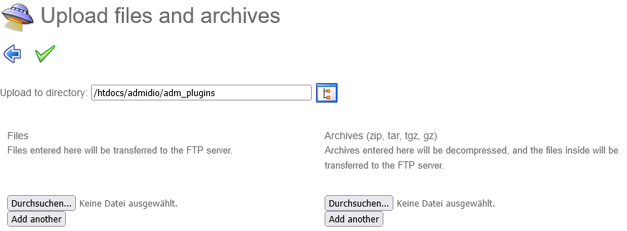

If this option is available, the "mitgliedsbeitrag_x.y.z.zip" file only needs to be uploaded to the adm_plugins directory and unzipped. The sub folder "membership_fee" is created automatically.

After the program files have been uploaded, a new menu item must be created via the Admidio menu.

## Creating a menu item

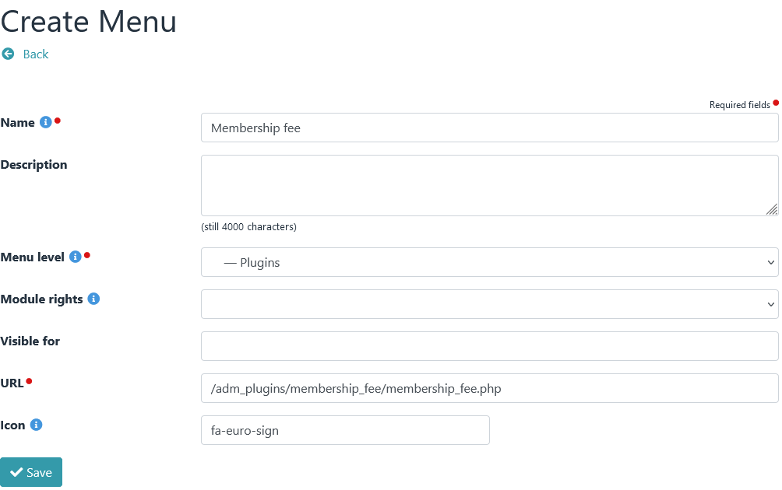The correct URL is important: adm_plugins/membership_fee/membership_fee.php

It is strongly recommended to specify one or more roles under "Visible for".

If roles are specified here, then the link to the plugin (in the menu bar) will only be visible to members of the specified roles and, more importantly, the plugin and all main subroutines (PHP files) can only be called by members of the specified roles.

The plugin reads in all roles that are entered in the "Visible for" field and creates an access authorization only for the members of these roles. It is then no longer possible for non-members of these roles to call up a pro­gram directly via the address line of the browser, such as .../adm_plugins/membership_fee/payments.php.

## The first call

At each start, the plugin checks whether the values of "version" and "stand" of the file version.php match the data stored in the database.

If there are differences, an installation routine is called up and further checks are carried out:

1. If configuration data is already available (the plugin has already been called), then the existing configura­tion data is reinitialized and overwritten with current data.

2. If no configuration data is available (the plugin was started for the first time), then installation.php is called and all necessary profile fields and categories are created.

This installation process consists of two passes:

First pass: Creation of missing profile fields and categories

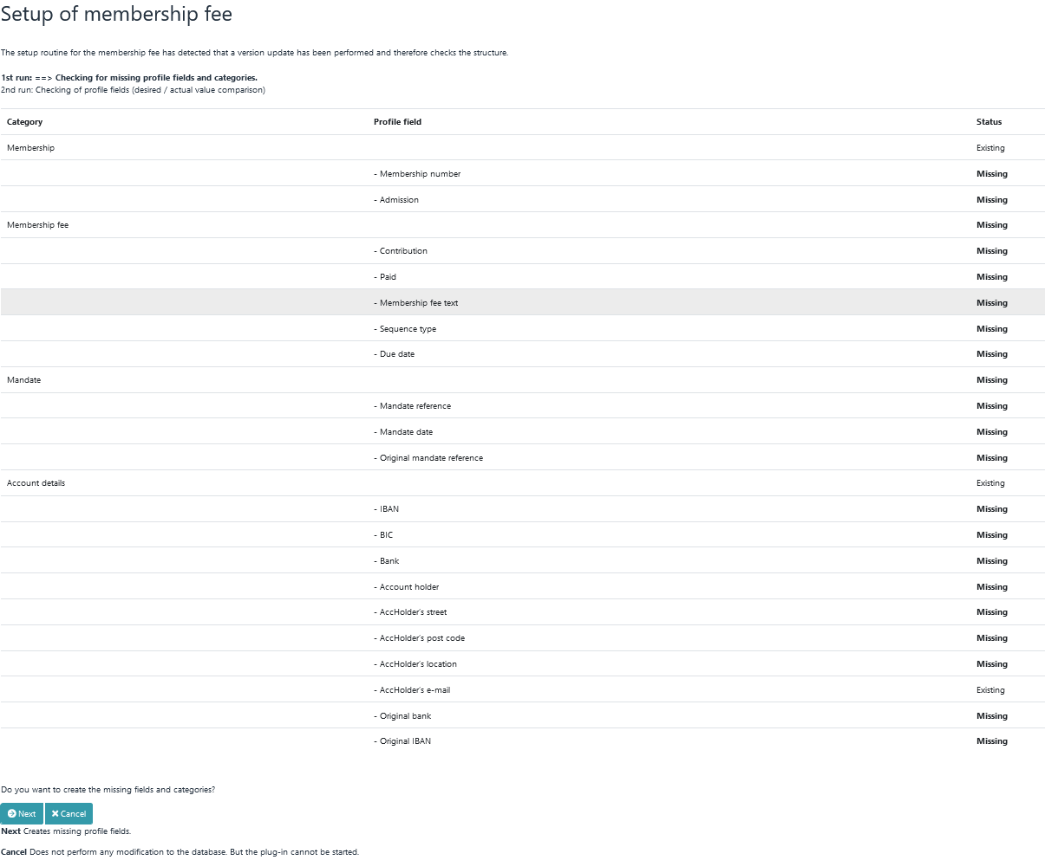

In the first pass of the installation routine, the database is checked for missing profile fields and categories. If profile fields or categories are missing, they can be created using the "Next" button.

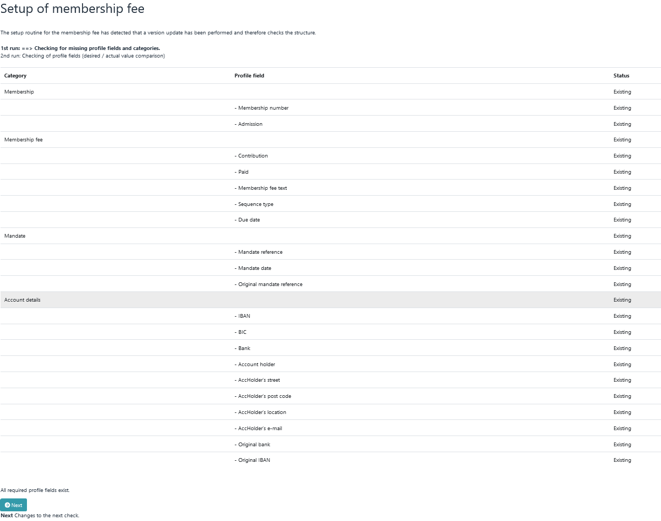

You can only switch to the second round if all the necessary profile fields are available.

Second pass: target/actual comparison

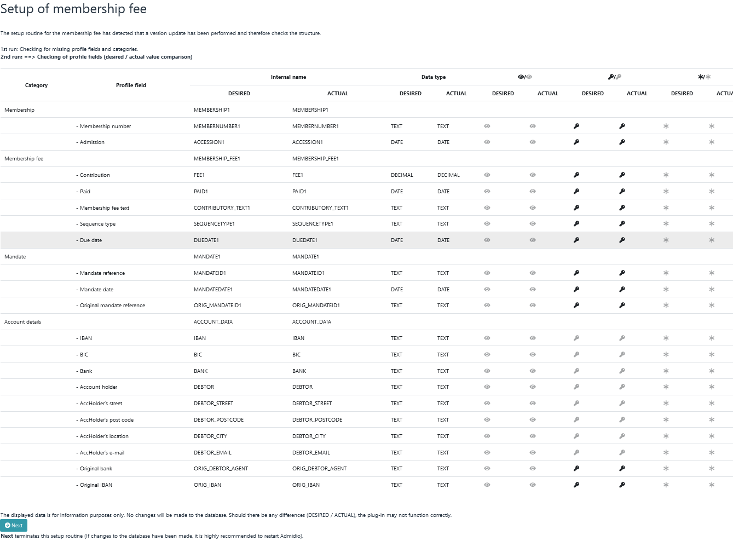

The second pass of the installation routine is only a target/actual comparison to show how necessary cate­gories and profile fields should be defined. Differences are highlighted in bold.

For example, it's possible that a profile field called "Membership number" already exists, but it's not the cor­rect data type. Necessary changes are not carried out by the installation routine.

After an initial installation, Admidio should always be closed and restarted.

## The first basic settings

After successful installation, important basic settings must be made. To do this, call up the **Preferences** menu of the plugin.

### Contribution settings

The first settings, such as the proportional calculation of contributions, are to be made under *→ Preferences - Contribution settings*. All individual points are provided with a short help text.

### Account details

The account details of the association must be entered under *→ Preferences - Account details*.

### Mandate management

Under *→ Preferences - Mandate management* it is important to make the right selection under **Data field for sequence number**. The data field selected here determines an important segment of the mandate refer­ence. Once a decision has been made, it should not be changed.

### View definitions

In *→ Preferences – View definitions*, a content field must be specified for each column (no field may be empty)

**Background**

*In some cases, IDs from profile fields cannot be read out correctly during the installation process. This can be recognized by the fact that the content field for some columns is empty. In this case, click the "Save" but­ton once in the view definitions module.*

## Testing the basic functions

After installation, the basic functions should be tested.

### The views

**Membership fee** offers views in several modules in which data is only displayed if certain requirements are met.

These modules are:

1. Contribution payments
2. Invoice
3. Due date
4. Advance information

Data is only displayed in the Contribution payments and Edit invoice data modules if the profile field **Fee** is NOT EMPTY.

To test this, we call up a member's profile and enter the number 99 under **Fee**.

**Notice**

*The number 99 is now displayed for the total in the overview.*

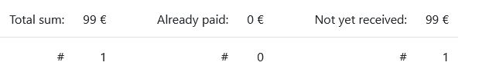

If we now call up the **Contribution payments** module (→ Fees - Contribution payments - Edit contribution payments) or the Invoice module (→ Export - Invoice - Edit invoice data), this one member (for whom the €99 was entered) is displayed.

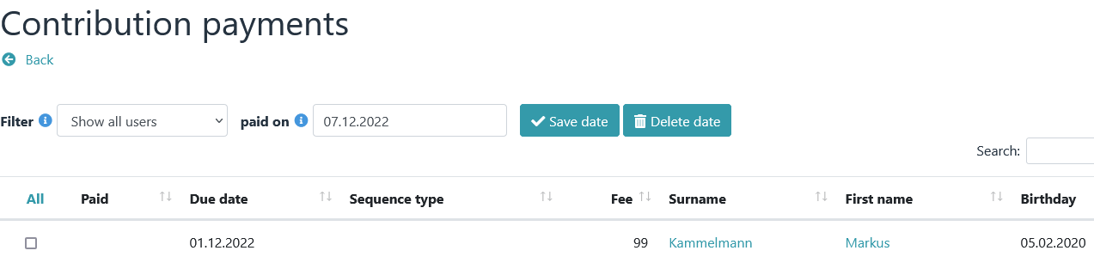

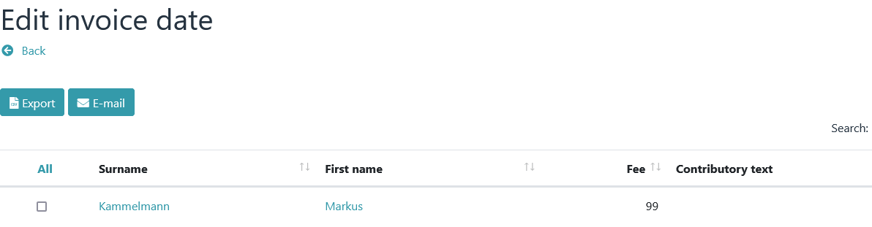

The **Due date** module requires the following as minimum requirements for an ad:

* Fee
* Mandate reference
* Mandate date
* IBAN
* and: the Paid date must be empty

In the next step, we therefore open the profile of the member (where the €99 was entered) and enter values under Mandate reference, Mandate date and IBAN.

Then we open the Due date module (*→ Export - SEPA - Due date*). Since all requirements are met, the member concerned should also be displayed here.

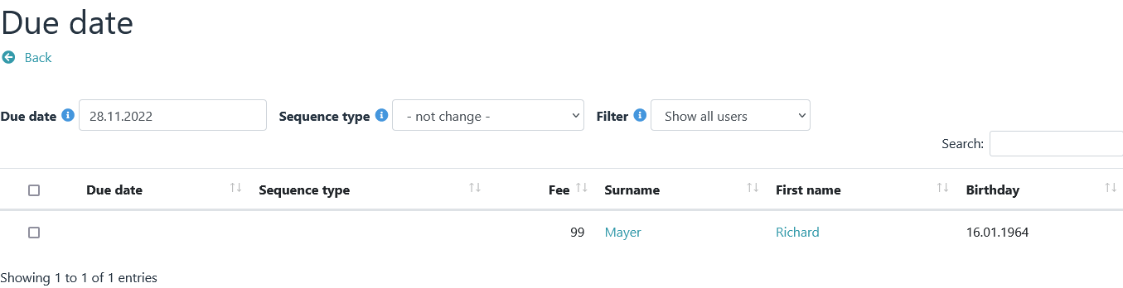

Now click the check box in the first column. The current date is entered in the Due date column.

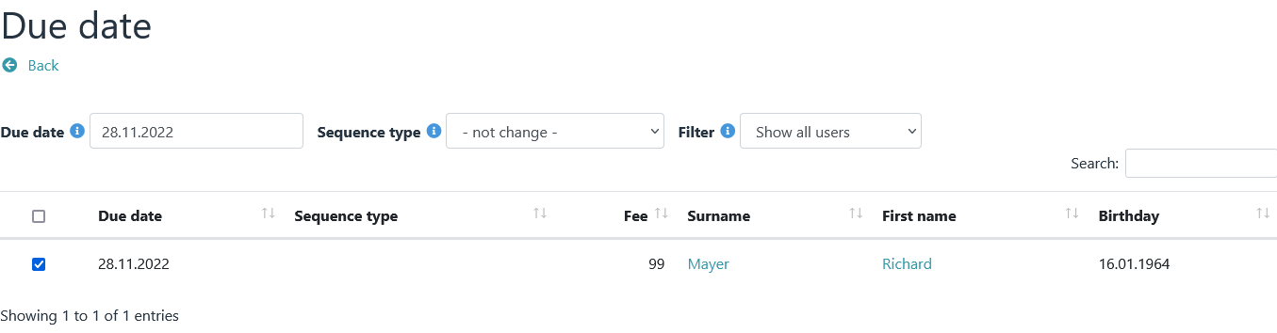

We go back one step using the **Back** button.

A new line with checkboxes should now appear under → Export – SEPA – Due date/Sequence type.

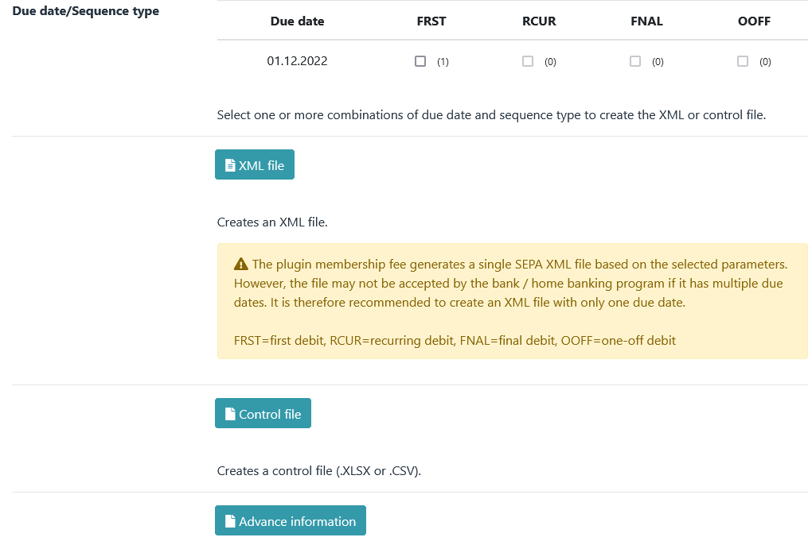

We click on FRST and first select XML file and then control file. We have now created our first export files. The control file contains the same data as the XML file, only edited to be more readable.

This would test the most important views once.

### Contribution calculation

First, all data that was entered for a member in the previous section (contribution, mandate reference, man­date date, due date, etc.) will be deleted again.

To test the contribution calculation, we first create a role and enter **99** for contribution and **Annually** for con­tribution period.

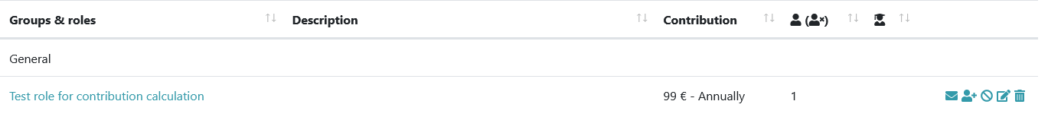

We then add a member to this role and carry out a contribution calculation (*→ Fees - Recalculation - Recal­culation*).

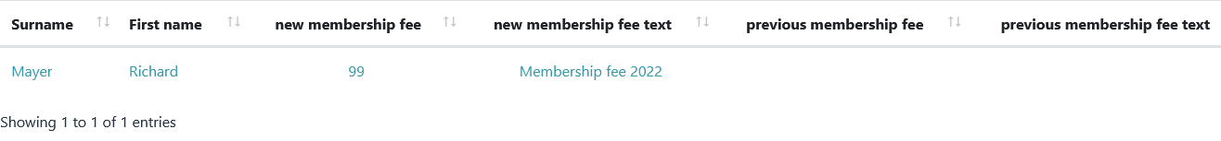

If the contribution now calculated is displayed correctly in the Contribution Payments module (*→ Fees – Con­tribution Payments – Edit Contribution payments*), all the basic functions have been successfully tested and are working.

The created test roll can now be deleted again. The calculated contribution is removed again via *→ Fees - Delete – Delete – Delete all*.

# Update

1. In the case of an update, all files from membership fee must always be replaced.
2. If the file manager offers the possibility to upload and unpack ZIP files, then the following procedure should be followed:
3. Delete the entire membership fee installation directory (including all files and folders).
4. Use the file manager to upload and unzip the file "mitgliedsbeitrag_x.y.z.zip". (The subfolder "mem­bership_fee" will be created automatically).
5. If the file manager does not offer the option of unpacking, then proceed as follows:
6. First delete all files and folders in the plugin directory from membership fee.
7. Then copy all files and folders of "membership_fee" from the unzipped zip file into the plugin direc­tory.

# The menu structure

1. All functions of the plugin are accessible via a menu.
2. 
3. The current status of the premium calculation is shown above the menu.

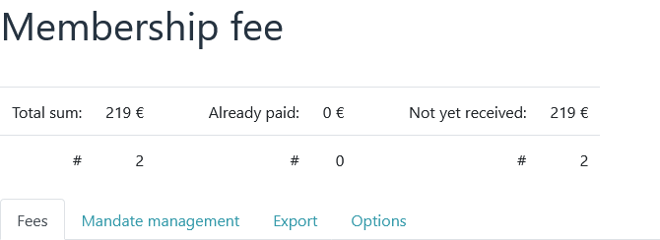

## Fees menu

1. 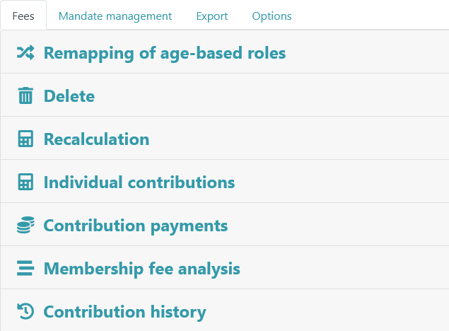
2. The main functions of the plugin, such as remapping, recalculation and payment of contributions, can be ac­cessed via the menu items of the Fees tab.

## Mandate management menu

1. 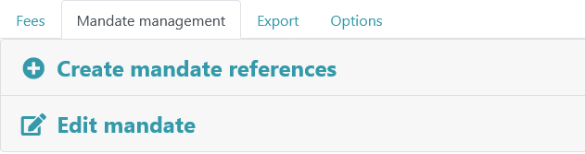
2. Mandates can be edited and mandate references generated via the mandate management.

## Export menu

1. 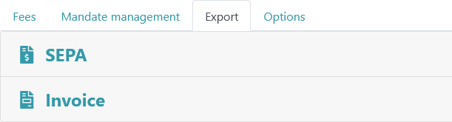

All export functions are accessible via Export.

## Options menu

1. 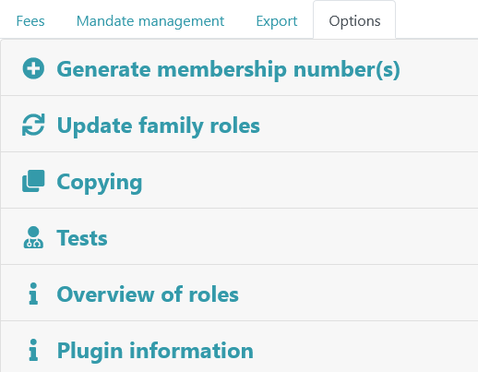

Options offers the possibility of generating membership numbers, copying profile data, displaying a role over­view or various checks.

## Preferences menu

1. 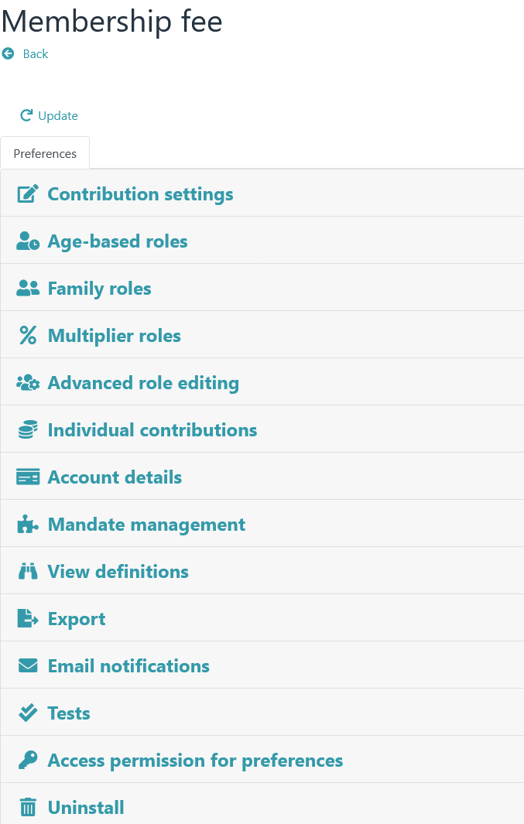
2. All basic settings can be accessed via the separate Preferences menu (in the menu bar).
3. **Notice**
4. *By default, this menu is only visible to administrators.*

# Age-based roles

## Basics

A corresponding role must be created for each age range for an age-based determination of contributions. The entire age range must be covered without gaps.

The role name is crucial as it indicates the age range. The relevant age information must be surrounded by separators (*→ Preferences - Age-based roles - Separator*).

Possible separators would be eg * or # or + or - or _ or ! or %.

Syntax:

any text<separator><age from><separator>any text<separator><age to><separator>any text

Examples of role names with different separators:

* Members between *0* and *14* years
* Members from *15* to *17* years
* any text *18* any text *99*
* -0- to -18-
* Members -19- to -80- years

Example of a grading with the separator *:

* Members between *0* and *14* years
* Members between *15* and *17* years
* Members between *18* and *59* years
* Members between *60* and *110* years

*A new member will be placed in one or more of these age-based roles (which does not matter) upon initial admission. Via → Fees - Remapping of age-based roles, a routine is triggered that reassigns all members of age-based roles to the age-based roles based on their age. The reference time is always December 31st. of the past year (→ Preferences - Age-based roles - Monthly offset).*

**Notice**

*Members who were born after the reference time are not allowed in an age-based role because they do not yet exist for the program (relative to the reference time). Therefore, place these members either in a family or in a separate fixed contribution role.*

## Usage

* + 1. In the first step, one or more separators are defined via *→ Preferences - Age-based roles - Separator*.

The roles are then created for the defined separators and the members are added (Because these are con­tribution roles, contribution and contribution period must be specified).

Example of role names for a scale with the separator *:

* Members between *0* and *14* years
* Members between *15* and *17* years
* Members between *18* and *59* years
* Members between *60* and *100* years

*Notice*

*In the above example, if a member of → Fees - Remapping of age-based roles is older than 100 years, an error message is displayed.*

After all roles have been created, you should check via *→ Options - Overview of roles* whether all age-based roles are correctly recognized by the plugin.

After that, the members can be reassigned to the age-based roles via the remapping.

## Remapping of age-based roles

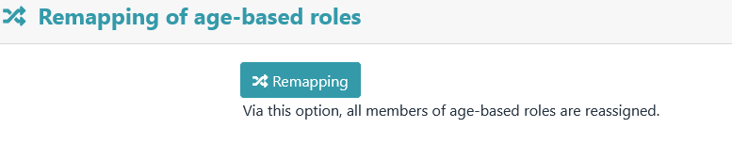

All members of age-based roles are reassigned via this menu item.

After clicking the "Remapping" button, a preview appears first.

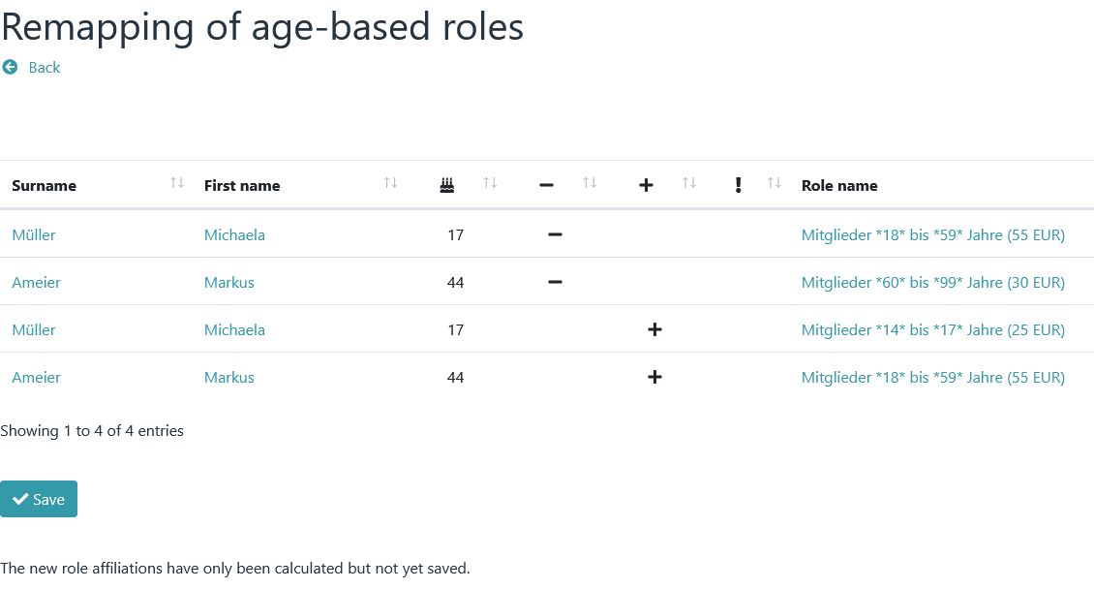

The new assignments are only saved after you click on "Save".

## Reference time/month offset

The reference time is always December 31st. (24 hours) of the past year.   
  
Example of the division into an age-based role:

A role with the following age restrictions should be given: **Members %1% to %2% years**

In this case, it is checked whether the member on 31.12. (midnight) of the past year still fit into the age struc­ture of 1 to 2 years (minimum was 1 year old and maximum was 2 years and 365 days old). If not, it will be moved to another role.

With a monthly offset, this reference time can be set full months in the future or in the past.

# Family roles

## Basics

Contributions defined for a family role apply to the entire family or group, not to each individual member. All members of a family role pay a joint contribution.

In order for the plugin to be able to distinguish family roles from other contribution roles, all family roles must begin with a clearly defined prefix, e.g. "Fam" or "Family" (*→ Preferences – Family Roles - Prefix*).

Any number of family roles can be defined (e.g. Fam100 with a contribution of EUR 100 or Fam200 with a contribution of EUR 200). However, it should be noted that all prefixes are different from one another. "Fam" cannot be used at the same time as "Family".

**Important NOTE**

*Even if family roles are not used, at least one family must be ­defined with a family role prefix, otherwise the plugin will classify all contribution roles as family roles and the contributions will be calculated incorrectly.*

Examples of role names:

- with the family role prefix "Family"

* Family Meier Hubert

* Family Huber

- with the family role prefix "Fam100"

* Fam100 Roller

* Fam100 Mueller Felix

## Usage

* + 1. First, one or more family roles (with prefix, contribution and contribution period) are defined via → *Prefer­ences – Family roles.*

Then the family roles are created and members are assigned to these roles.

Example:

role with the following data was defined via → *Preferences – Family roles:*

* Prefix: Fam100
* Contribution: 100
* Contribution Period: Monthly

The following roles could then be defined via “Groups & roles”:

* "Fam100 Meier Hubert" (with the members Meier Hubert, Meier Hildegard)
* "Fam100 Wildstetter" (with the members Wildstetter Anton, Wildstetter Hilde)

After all roles have been defined via "Groups & Roles", they must be updated. To do this, run *→ Options - Update family roles*. This will sync and update the Contribution, Contribution Period, and Description entries of family roles with the information in the settings.­

Finally you could run *→ Options - Tests* and correct any displayed errors.

## Payer

In the case of family roles, the plugin ­marks the first member who has account data as the party liable to pay. The calculated contributions are assigned to this payer.

If no account details are stored for any family member, the first member found in the database ­is designated as the payer. This could possibly also be a small child.

To prevent this special case, a leader can be appointed for a family. In this case, the leader is the ­person li­able to pay for the program, regardless of whether account details are stored with him or not.

***Important NOTE***

*A leader of a family cannot be the leader of another family at the same time.*

## Multiplier roles

A special form of family roles are multiplier roles (*→ Preferences - Multiplier roles*). In these types of roles, the contribution value of a role is not added, but serves as a multiplier.

Normally, a family role proceeds as follows:

All members of the family are traversed and checked to see if she is a member of another contributing ­role. If so, that role's contribution is added to the payer of the family role. Finally, the contribution of the family role is added to ­the payer's account.

If a family role is declared as a multiplier role, then the point "*Finally, the contribution of the family role is added to ­the payer's account*" has a different function. The contribution entered in the family role is now a percentage (70 means 70% of the contribution).

Example:   
  
There should be a family role with a contribution of 60 €. This role has 4 members. Each ­member is in an­other contribution role with a contribution of €50 each.

Normally, the payer of this family role would be charged €260 (50+50+50+50+60) ­.

However, if this family role is declared as a multiplier role, the following calculation applies (50+50+50+50) * 60% equals 120 €.

# Fixed Contribution Roles

## Basics

All other roles where a contribution and a contribution period are defined are declared as **fixed ­contribution roles**. The names of these roles and the categories they are in are not important ­. As soon as a member be­longs to one or more of these roles, the contribution of the role is included in the contribution calculation.

About fixed contribution roles can

* any number of divisional contributions
* contributions for young people
* contributions for students
* contributions for honorary members (fee 0 EUR)
* contribution reductions (negative contribution; minimum requirements: plugin version 4.3.2, Admidio version 3.3.8)
* contributions for seniors

be calculated.

## Usage

* 1. Create one or more roles via "Groups & roles" and define a contribution and a contribution period for each role. Then add any number of members to these roles.

After creating the roles, you should use *→ Options – Overview of roles* to check whether all roles are recog­nized.

# Individual contributions

## Basics

In addition to the contribution roles already presented, there are **individual ­contributions** that can be used to calculate individual contributions such as electricity or water consumption.

Individual contributions are divided into two categories:

* basic amount
  + A basic amount is calculated if the member is a member of a specific role.
* consumption amount
  + A consumption amount is calculated if the member is a member of a specific role
  + **and** a consumption value is specified in a profile field.

**Notice**

*No* ***contribution roles*** *(with contribution and contribution period) are required for the calculation of individual contributions ­. Only role affiliations are evaluated. All settings (amount, consumption, etc.) are defined via → Preferences – Individual contributions.*

## Usage

An individual water consumption with basic and consumption amount is to be calculated.

### Basic amount

In the first step, a new configuration for a basic amount is created under *→ Preferences - Individual contribu­tions (* **Description** eg "Water charges basic amount").

* A role is selected under **Role** for which this basic amount is to be calculated
* and enter an amount under **Basic or consumption amount**.

When calculating the individual contributions, it is checked whether a member is a member of this selected role. If so, the value of the **base or consumption** amount is added to an existing membership fee as a "base amount".

Example:

If 30 is specified as the **Basic or consumption amount**, the value 30 (as the basic amount) is added to an ­existing membership fee

### Consumption amount

A further configuration is then created under *→ Preferences – Individual contributions.* This time for the con­sumption amount (**Description** eg "Water charges consumption amount").

* Under **Role**, another role is selected for which this consumption amount is to be calculated
* Under **Basic or consumption amount**, an amount is to be specified,
* and under **Profile field**, select a profile field that contains a corresponding consumption value ­.

Example:

If 0.70 is entered as the **Basic or consumption amount** and the selected profile ­field contains 428 as the consumption information, this results in a consumption of 0.70×428 = 299.60. Thus the value 299.6 (as con­sumption) is added to an existing membership fee.

**Notice**

*If a consumption amount is to be defined, an associated profile field must also be selected. Mathematically, the value of "Basic or consumption ­amount" is multiplied by the value of the selected profile field. If no profile field is specified (for a basic amount), it is multiplied by 1.*

# Contribution calculation

## Contribution and contribution period

1. By default, a contribution and a contribution period can be assigned to a role in Admidio. The plugin evalu­ates these entries.
2. Only roles for which **a contribution and a contribution period** are defined are relevant for a contribution calculation (a contribution of ­0 € is also possible, eg for honorary members).
3. A member can belong to one or more roles. The contributions entered for these roles are added up. In which Admidio category these roles are located is not ­important.
4. The plugin always considers the contribution defined in a role (regardless of the "Contribution ­period" setting) **as an annual contribution**. The specification of a role's contribution period is used for the **"Prorated contri­bution calculation"** function.

## Prorated contribution calculation

1. If a member terminates their membership in a role during the year or joins a new role during the year, a pro­rated contribution calculation will be carried out.
2. The end of a role membership is used for the pro rata calculation when membership ends.  
      
   Depending on the configuration (*→ Preferences - Contribution settings – Calculation of proportional member­ship fee*), either the joining date or the start of a role membership is used for the pro rata calculation at the beginning of a membership.
3. **Contribution period Monthly** : Every month that has started is calculated
   1. Example:
   2. Joining in April -> April to December are calculated = 9 months = 9/12 of the annual fee
   3. Leaving in June -> January to June are calculated = 6 months = 6/12 of the annual fee
4. **Contribution period Quarterly** : In the joining/leaving year, each started quarter is calculated
   1. Example:
   2. Joining in the second quarter (Apr, May, Jun) -> 9 months are calculated = 9/12 of the annual fee
   3. Joining in the fourth quarter (Oct, Nov, Dec) -> 3 months are calculated = 3/12 of the annual fee
5. **Contribution period Half-yearly** : In the joining/leaving year, each started half-year is calculated
   1. Example:
   2. Joining in the first half of the year -> 12 months are calculated = 12/12 of the annual fee
   3. Joining in the second half of the year -> 6 months are calculated = 6/12 of the annual fee
   4. Leaving in the first half of the year -> 6 months are calculated = 6/12 of the annual fee
   5. Leaving in the second half of the year -> 12 months are calculated = 12/12 of the annual fee
6. **Contribution Period Annual and One time** : The full contribution of a role accrues in the entry/exit year.
7. **Notice**
8. *A contribution calculation (also a pro rata) is only carried out for active members. That is, a ­member must be an active member of the role on the day the calculation is performed. Future and former role memberships are not taken into account.*

### Prorated contribution calculation of family roles

1. The prorated contribution calculation of family roles works according to a similar principle.
2. Since it is not technically possible to assign an end date to a family role (in order to carry out calculations from - to), the data of the payer ­of the respective family role is used for the pro rata contribution calculation of family roles.
3. The end of a role membership is used for the pro rata calculation when membership ends.
4. Depending on the configuration, either the ­join date or the start of a role membership is used for the pro rata calculation at the start of a membership.

## Recalculation

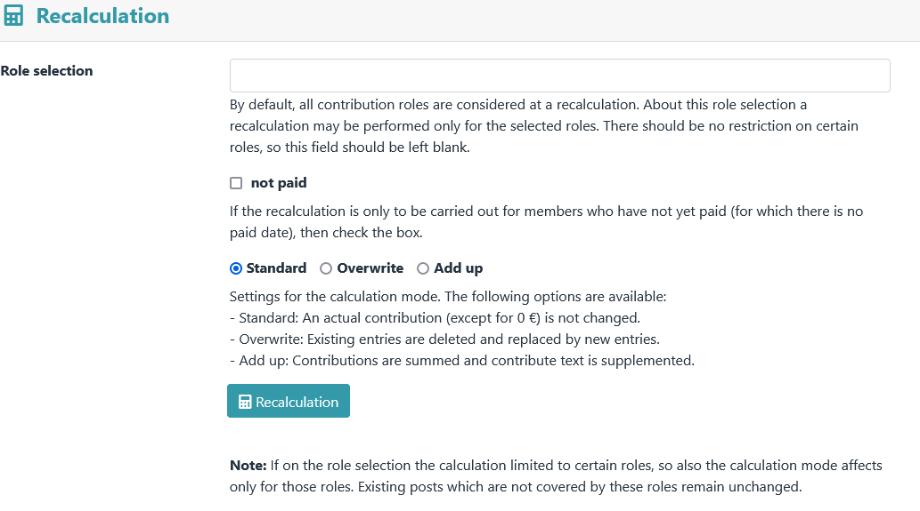

Membership fees are recalculated via **Recalculation**.

After clicking the "Recalculation" button, a preview appears first.

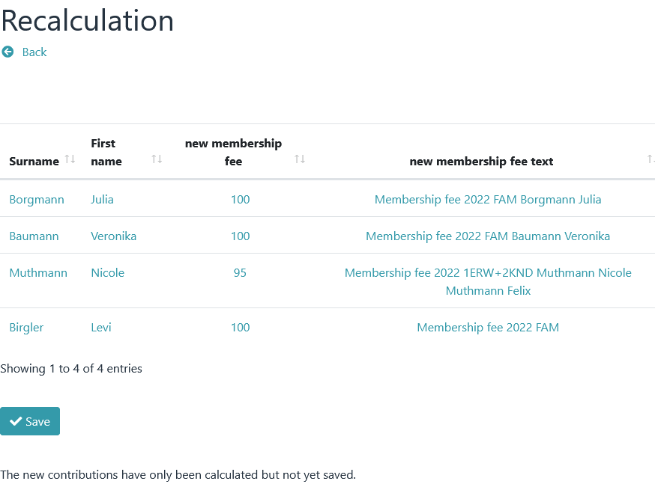

* + 1. The new amounts are only saved after you click on "Save".

## Individual contributions

1. 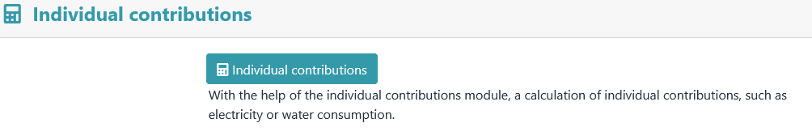
2. **Individual contributions** can be used to calculate individual contributions. This menu item is only available after activation ( *→ Preferences - Individual contributions* )
   * 1. After clicking on the “Individual Contributions” button, a preview appears first.

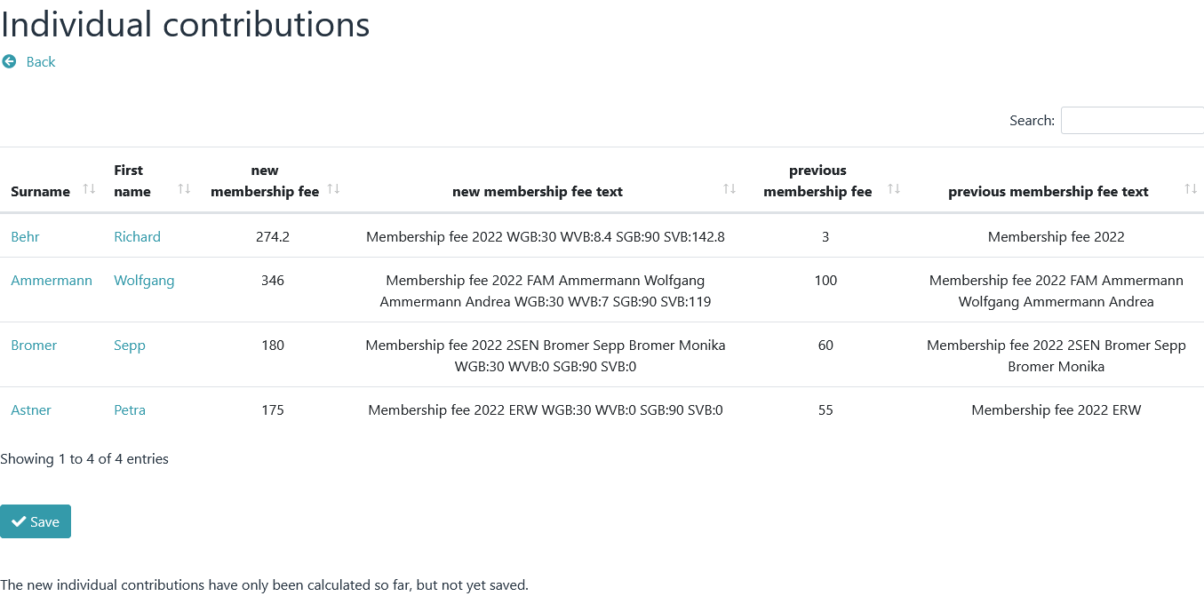

* + 1. The new amounts are only saved after you click on "Save".

**Notice**

*A calculation of individual contributions should always be carried out only after the contribution has been cal­culated, since a contribution text generated by the* ***Individual contributions*** *module is always appended to an existing text.*

Individual contributions are configured in *→ Preferences – Individual contributions.*

## Contribution payments

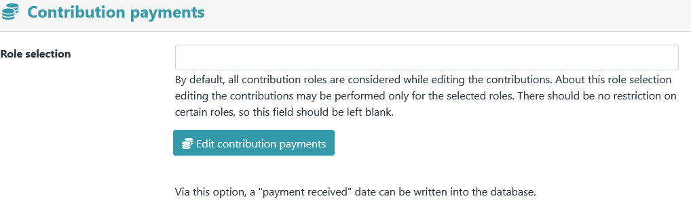

If the membership fee has been paid, this can be noted in the database. To do this, the date of the payday (paid date) is written to the database.

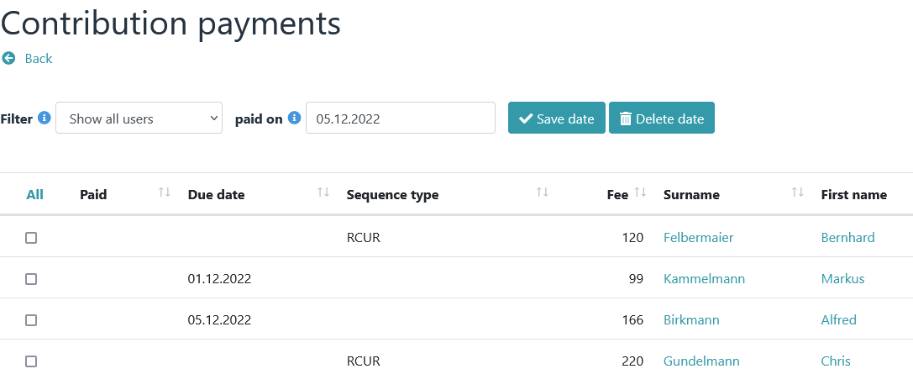

In the first step, the date is set (via "paid on") and those are marked for which a date should be entered.

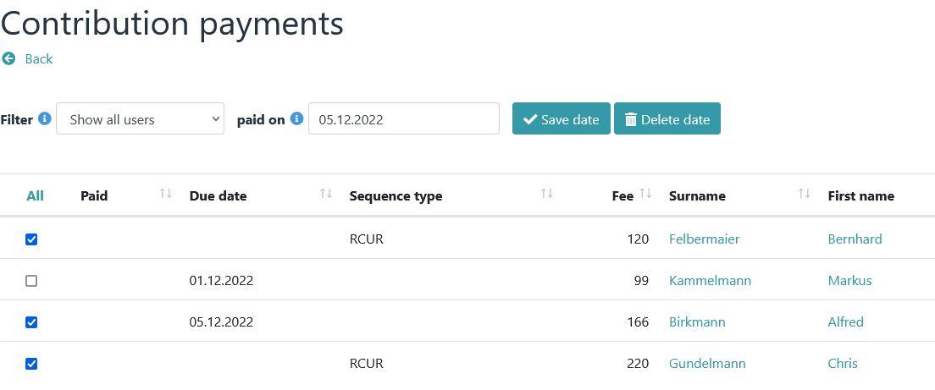

The new paid date is then set using the "Save date" button.

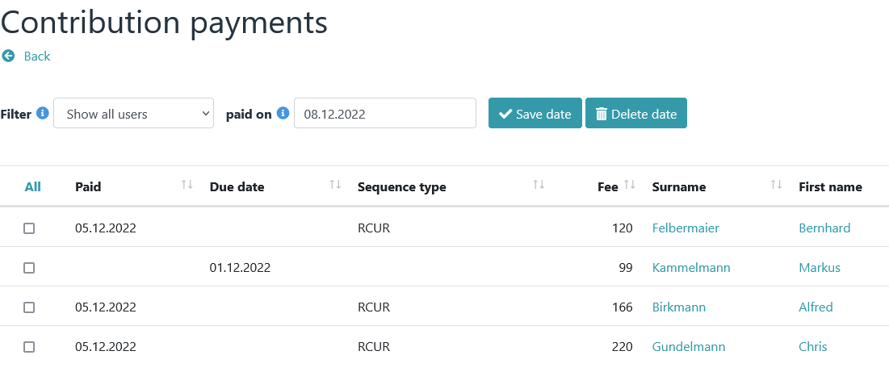

**Important NOTE**

*Setting a paid date also causes:*

* *the deletion of any existing due date*
* *the change of the SEPA sequence type FRST to RCUR*

**Notice**

*A global reset (deletion) of the paid date is possible via → Fees - Delete.*

### Payment reminder

* + 1. If a payment has not been made, an e-mail with a predefined text can be sent as a reminder (*→ Preferences – Email notifications – Contribution payments e-mail message*).

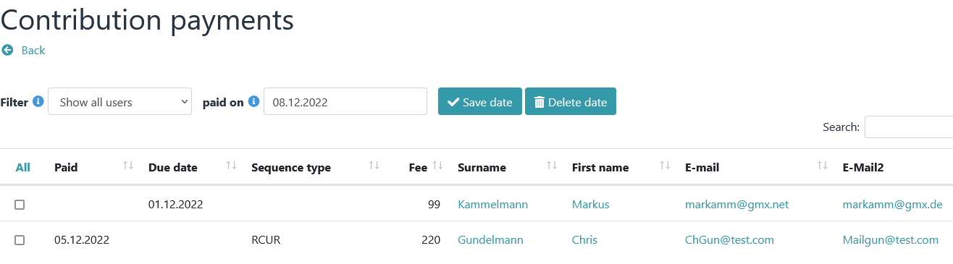

To do this, a profile field of the E-Mail type must be displayed in at least one column in the Contribution pay­ments module. When clicking on an e-mail address, the message module appears with the predefined text.

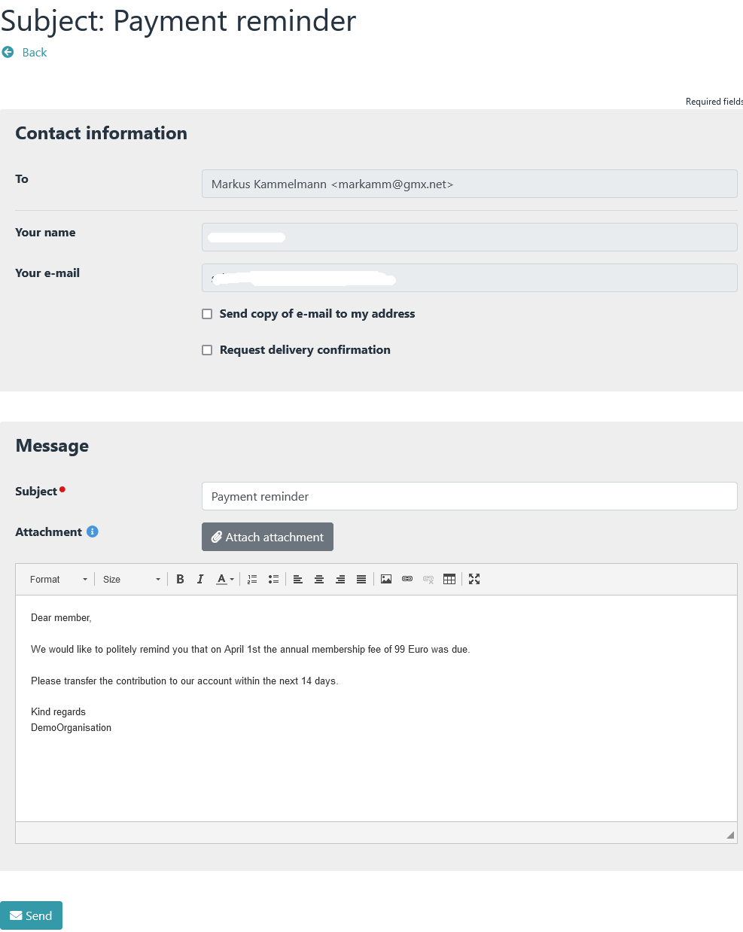

## Delete Amounts



Entries such as contribution, contribution text, paid date or due date can be deleted from the database via **Delete.**

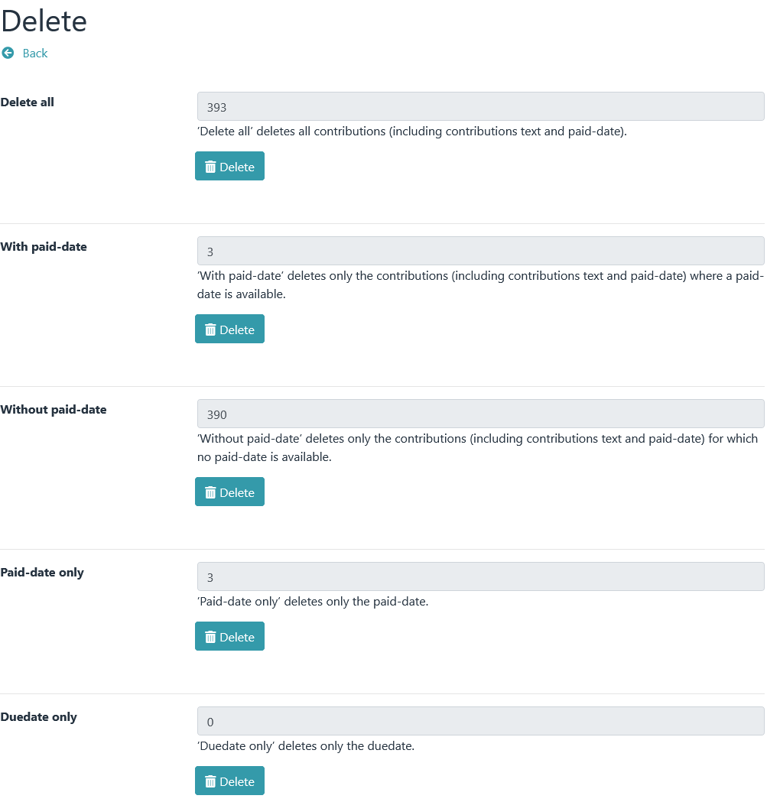

## Membership fee analysis

1. 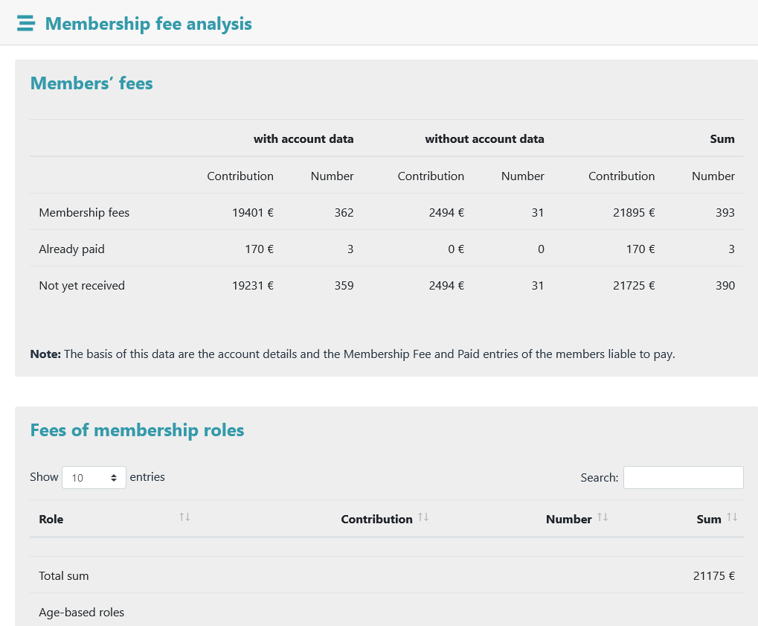
2. The membership fee analysis serves as a quick overview of the expected membership contributions.

## Contribution history

1. 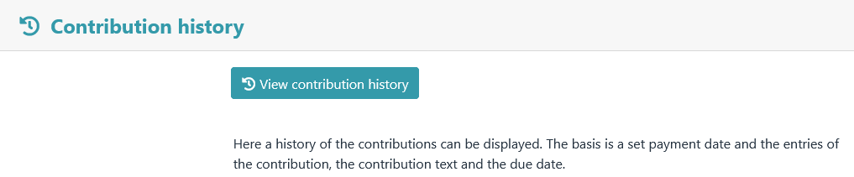
   * 1. A history of contribution payments can be viewed here.

# Export

## SEPA

1. All SEPA-specific export functions are summarized under the SEPA menu item. However, downloading ­a file or sending preliminary information is only possible if at least one due date has been set.

**Important NOTE**

*All SEPA functions require a previously performed and completed contribution calculation.*

All data generated via the SEPA functions such as mandate reference, mandate date, sequence type, etc. can be subsequently changed by editing a member's profile data. A manual change here should be carefully considered. Each SEPA function builds on another and requires the existence of certain data.

Example:

A due date can only be set via the "Due date" module if a ­mandate reference and a mandate date are avail­able. However, if a due date is entered via a member's profile without the mandate reference and mandate date being available, ­malfunctions can occur as the program continues to run.

The membership fee plugin can process the following mandate terms:

FRST first direct debit sequence

RCUR recurrent direct debit sequence

FNAL final direct debit sequence

OOFF one-off direct debit sequence

When setting a paid date for the first time, the direct debit type "FRST" is permanently changed to "RCUR".

The direct debit type "RCUR" can only be changed

* about a mandate change
* via the menu item *→ Export – SEPA - Due date*
* or by editing a member's profile



### Due date

1. 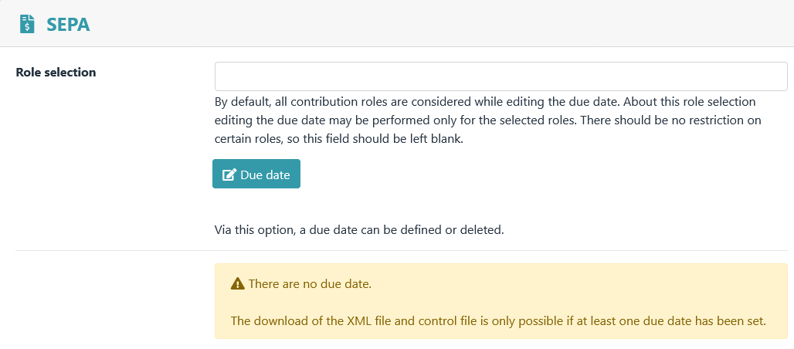
2. “Due date” view is accessed via the menu item **Due date .**
3. 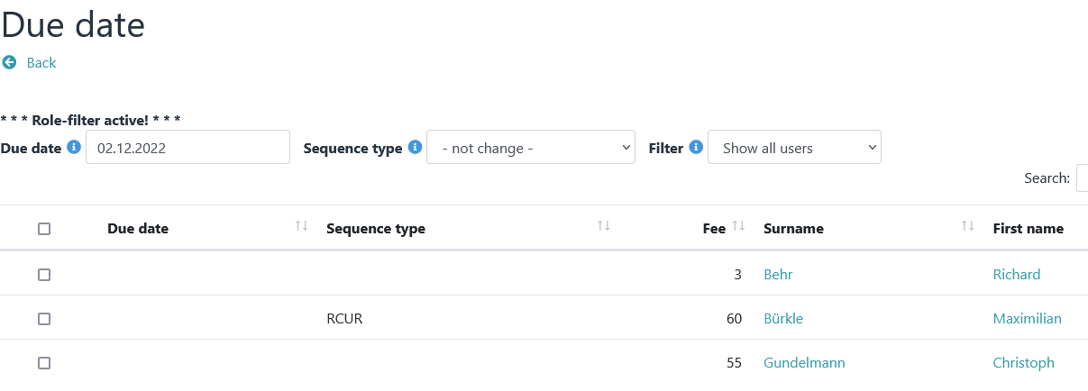
4. A due date can be set via this view.
5. 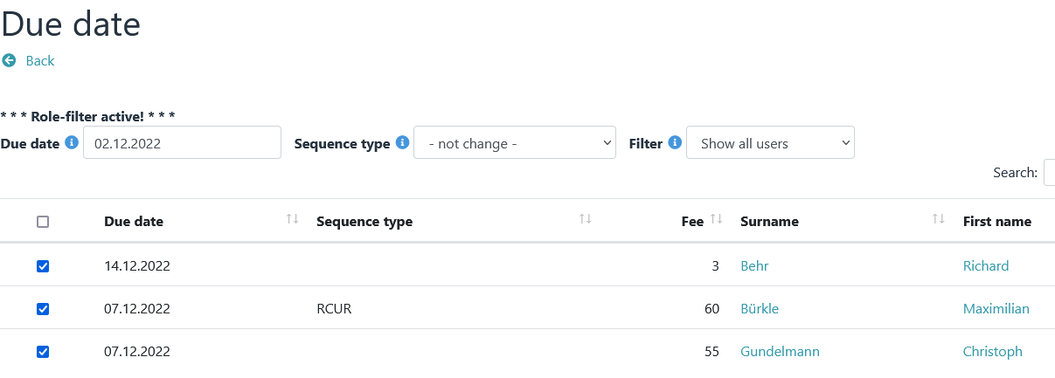
6. **Notice**
7. *A global reset (deletion) of the due date is possible via → Fees - Delete.*

### 

1. It is only possible to export data if at least one due date exist.

### XML file

1. **Notice**
2. *In the past, some savings banks and Jameica/Hibiscus could not read the XML files created by the plugin ac­cording to specification 3.1 of the DFU agreement. Problems were caused by the position ­and multiple pres­ence of the PmtTpInf block in the XML file. With version 4.3.2 of the plugin, the program code has therefore been revised and adapted accordingly.*
3. 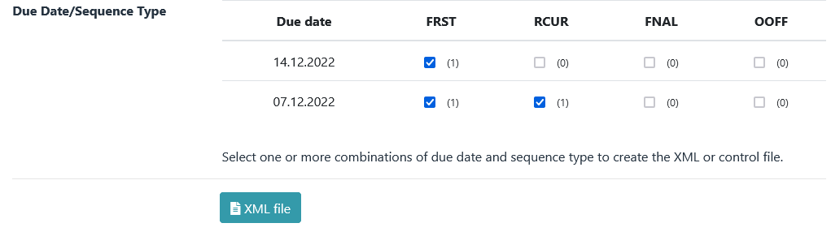
4. If you select several combinations of due date and sequence type under *→ Export - SEPA* , an XML file with several PmtTpInf blocks is generated. With the settings in the example above, a file with the following file name is created: sepa_2022-12-14-FRST_2022-12-07-FRST_2022-12-07-RCUR.xml.
5. 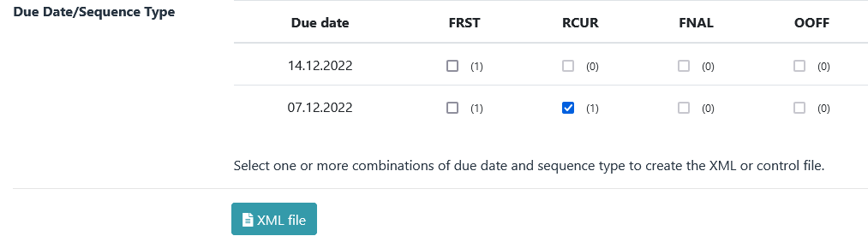
6. If only one combination of due date and sequence type is selected under *→ Export - SEPA* (only one box is checked), an XML file with exactly one PmtTpInf block is generated. This file should be able to be read by all savings banks, home banking programs, etc. With the settings in the example above, a file with the following file name is created: sepa_2022-12-07-RCUR.xml.

### Control file

1. 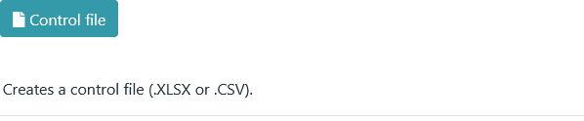
2. A control file contains the same data as an XML file. For better readability, they are just displayed differently.
3. The structure is fixed and cannot be changed.

### Pre-notification

1. 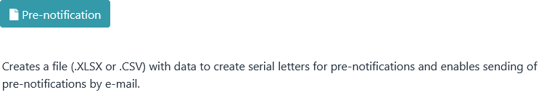
2. After clicking the "Pre-notification" button, the module view appears.
3. 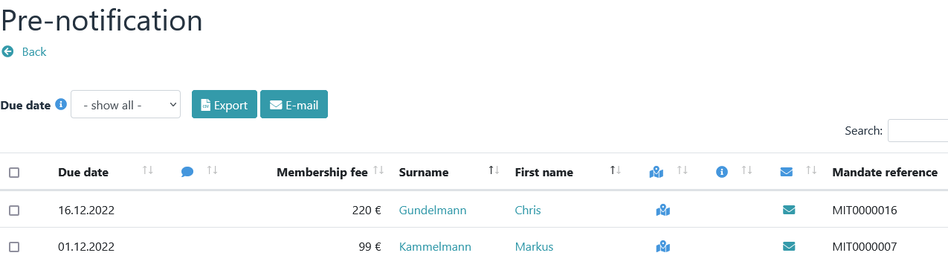
4. **Notice**
5. *Prior to a direct debit, the payee must inform the payer of the planned ­collection in writing by means of a pre-notification, at least 14 days before the debit ­. This can also be done by means of a contract or an invoice, which can also contain several due ­dates and the corresponding collection amounts.*
6. *A pre-notification must be created again if the amount of a recurrent direct debit sequence changes.*
7. *Pre-notifications must always be sent to the account holder. In exceptional cases (address of the account holder is not known), the member is to be informed as an alternative, with the request that this information be forwarded to the account holder. A* message text with placeholders can be defined ­under *→ Preferences – Email notifications* .

Example:

1. Email to a tagged member
2. 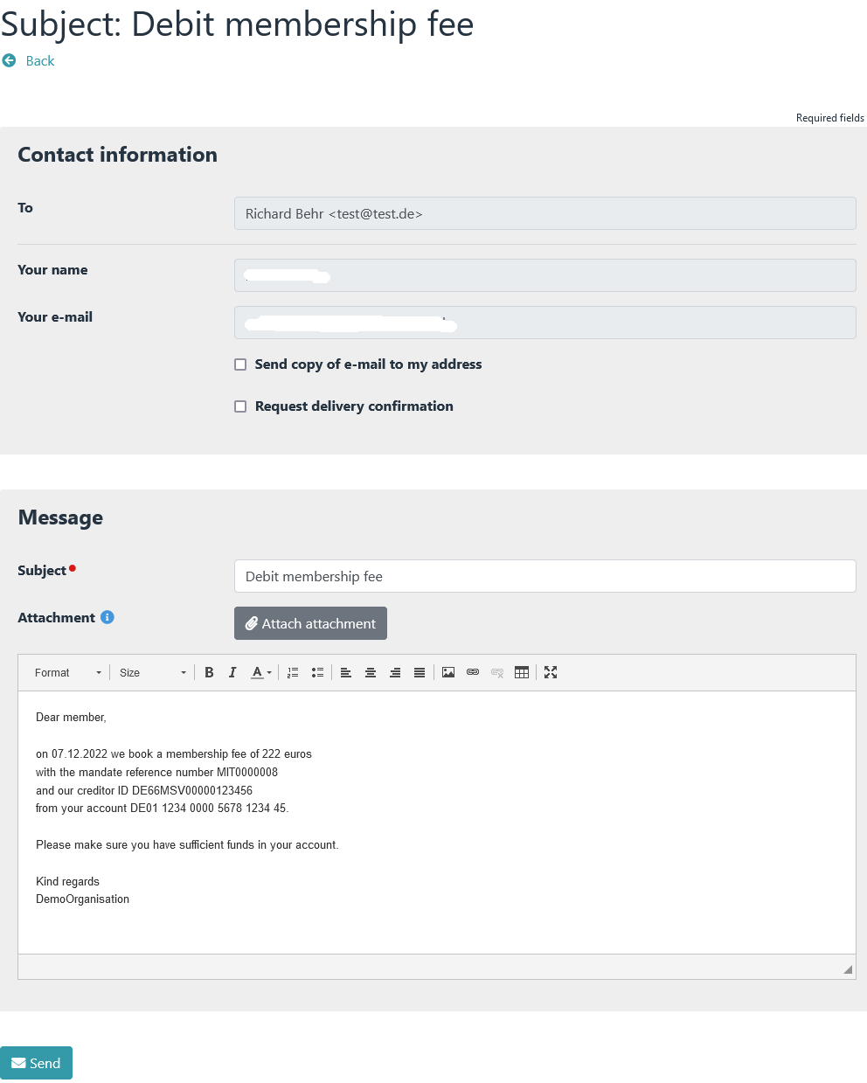
3. 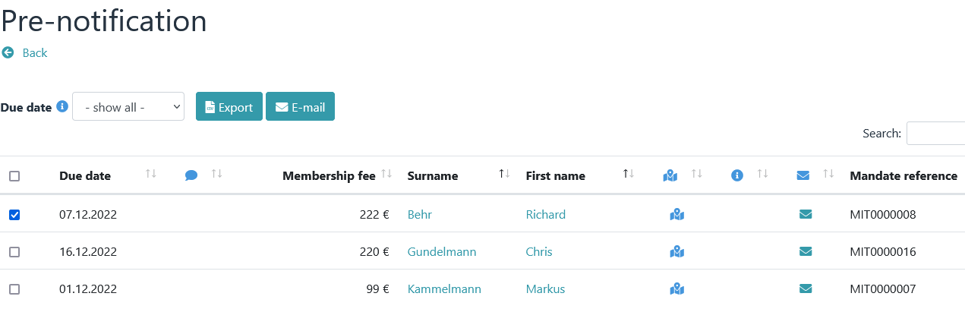
4. The body of the message contains unique information because the message is sent to only one person.
5. Example:
6. Email to multiple tagged members

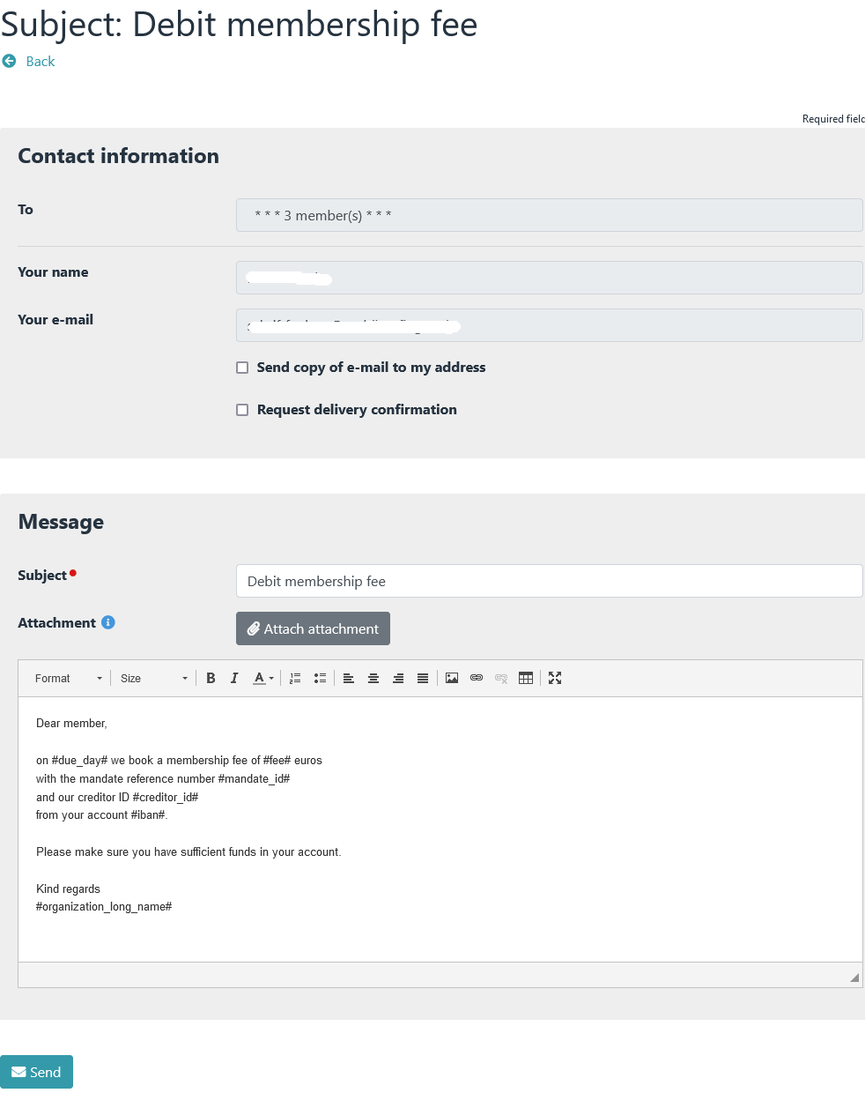

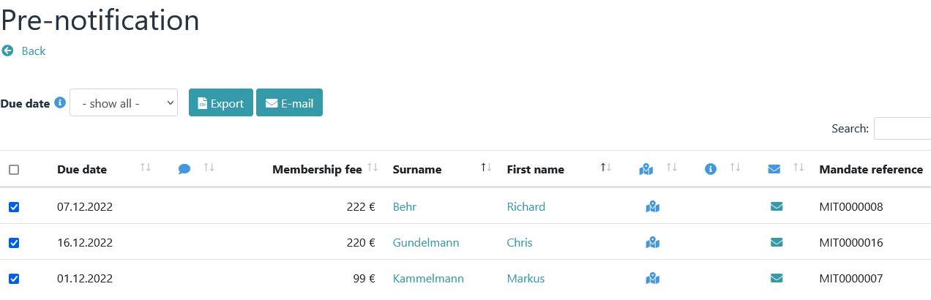

1. The message text contains placeholders. These will only be replaced after the "Send" button has been clicked.

## Invoice

1. Invoices can be created via the **Invoice** menu item . This menu ­item also offers the option of sending transfer requests by email.
2. 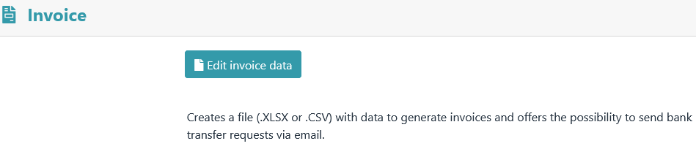
3. After clicking on the "Edit invoice data" button, the module view appears.
4. 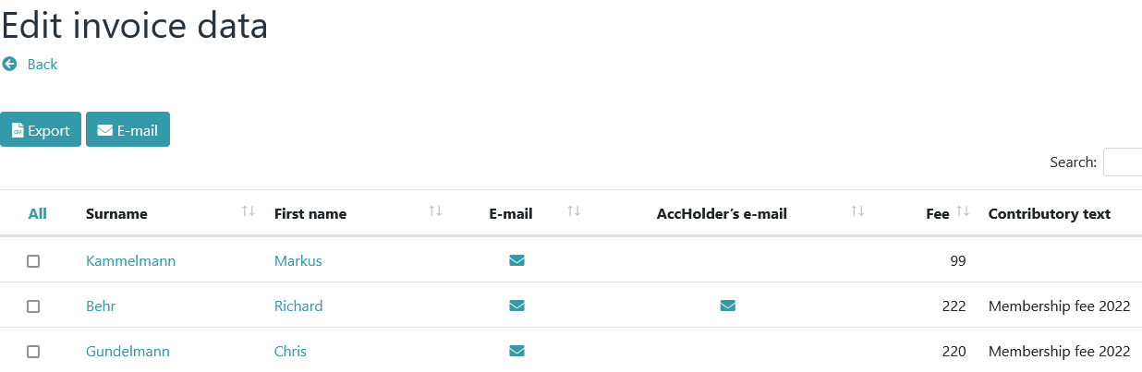
5. The displayed columns (profile fields) can be defined under *→ Preferences – View definitions.*
6. **Notice**
7. *This module only shows members who* ***do NOT have an*** *IBAN.*

### The Export button

1. The Export button creates a file with data for serial letters based on the selected members.
2. The structure of the file is hard-coded.

### The E-mail button

1. **Notice**
2. *Any number of email profile fields can be created in Admidio. If an e-mail is sent in this module ­via check­boxes and the e-mail button, the first step is to check whether an account holder e-mail address is available. If so, it will be sent to them. If this is empty, it is checked whether a standard e-mail address is available. If so, it will be sent to them.*
3. *Other e-mail addresses are not requested.*
4. *However, additional e-mail addresses can be displayed via → Settings – View definitions – Invoice­. Sending is then possible via the "letter symbol".*
5. Example:
6. Email to a tagged member
7. 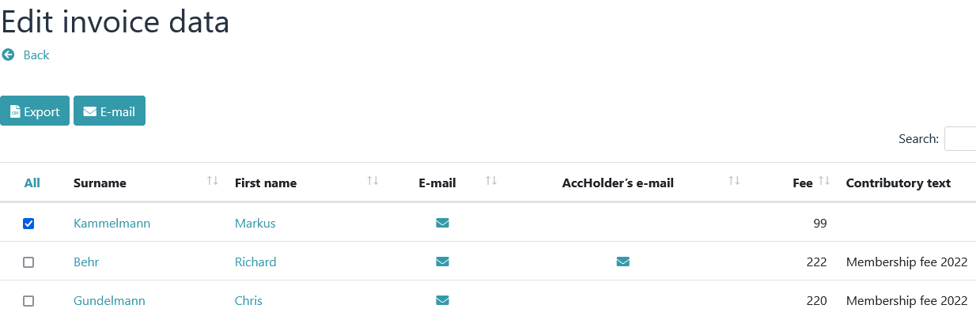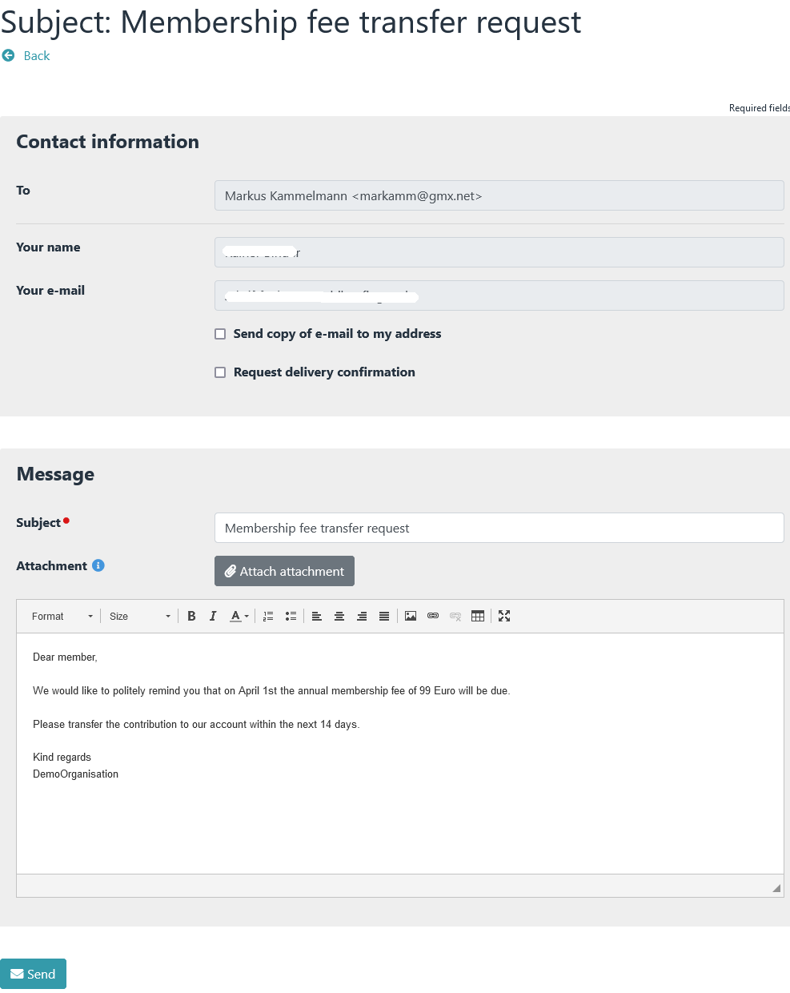
8. The body of the message contains unique information be­cause the message is sent to only one person.
9. Example:
10. 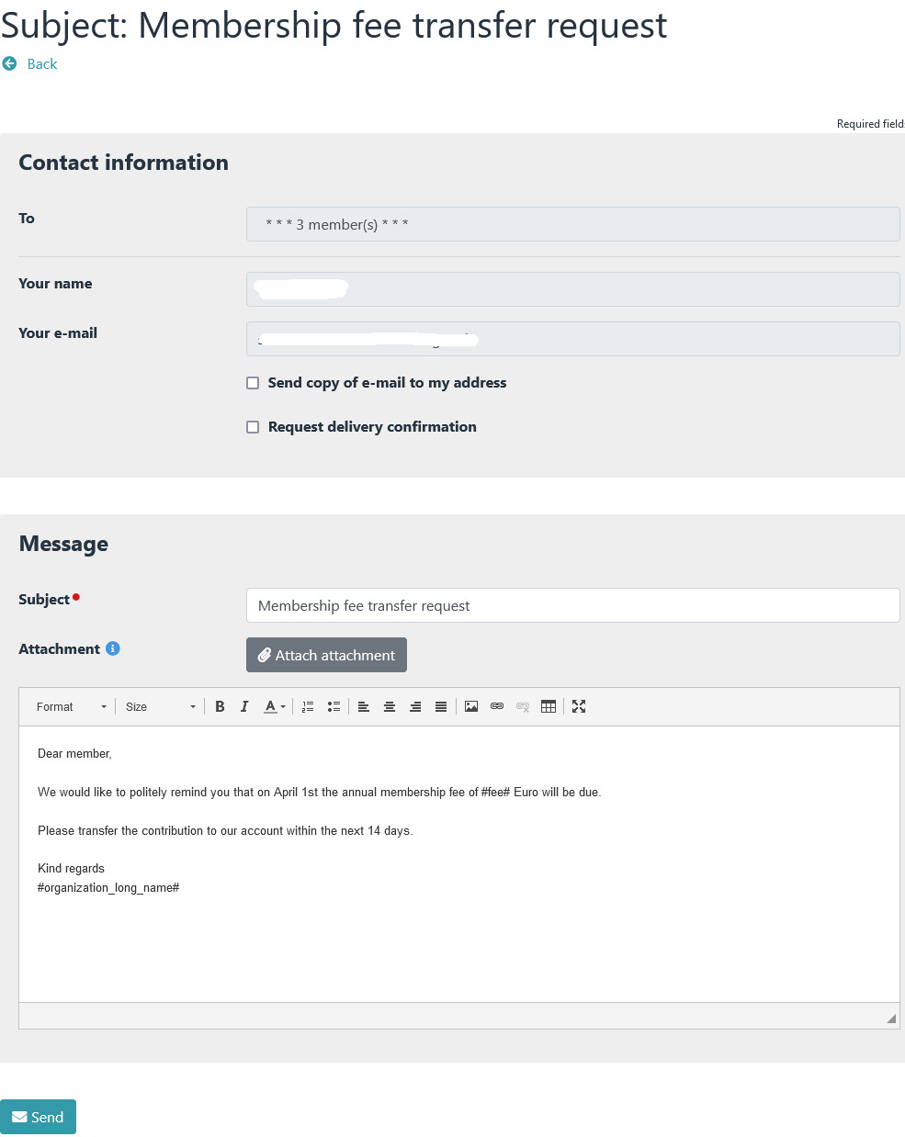Email to multiple tagged members
11. 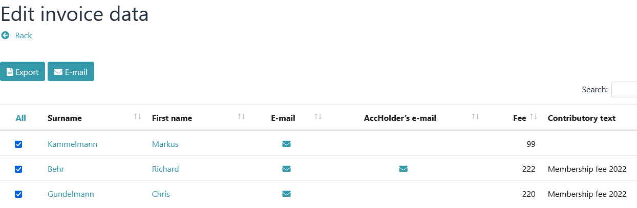
12. The message text contains placeholders. These will only be replaced after the "Send" button has been clicked.

# Mandate management

## Create mandate references

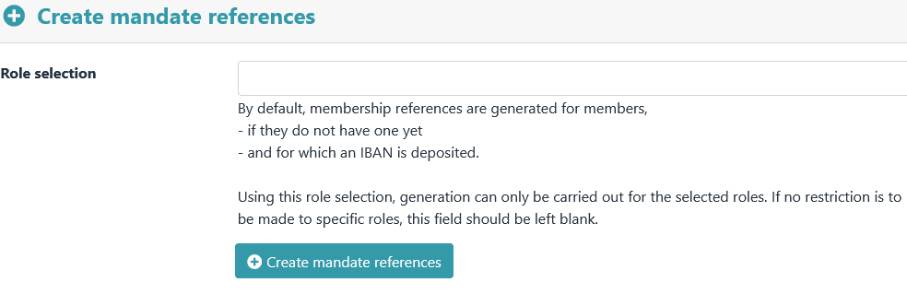

This allows mandate references to be generated depending on the specifications in *→ Preferences - Man­date Management* ­

After clicking the button "Create mandate references" a preview appears first.

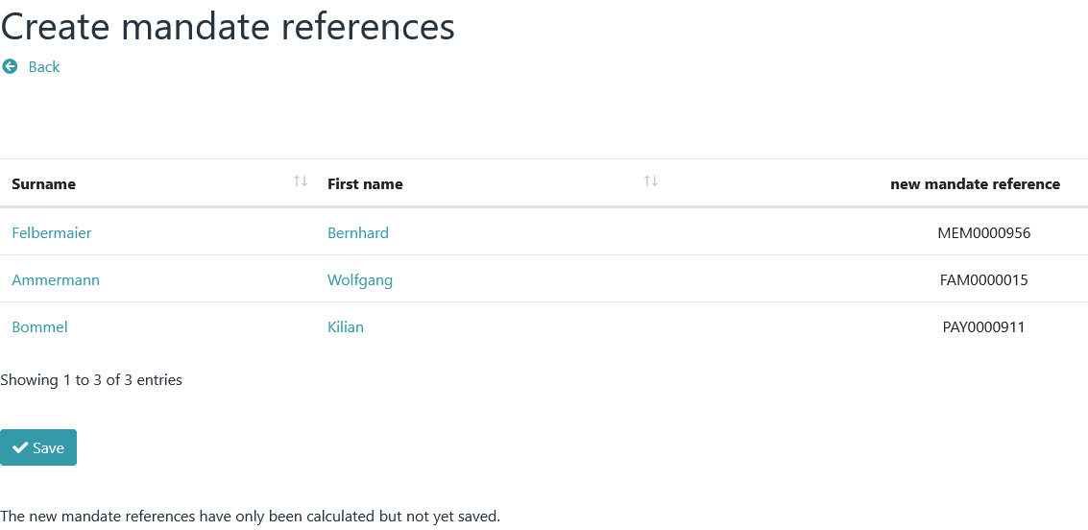

* + 1. The new mandate references are only saved after you click on "Save".

## Edit mandate

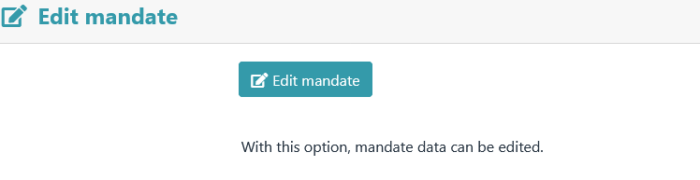

This menu item can be used to set a mandate date or change the mandate.

The Mandates view.

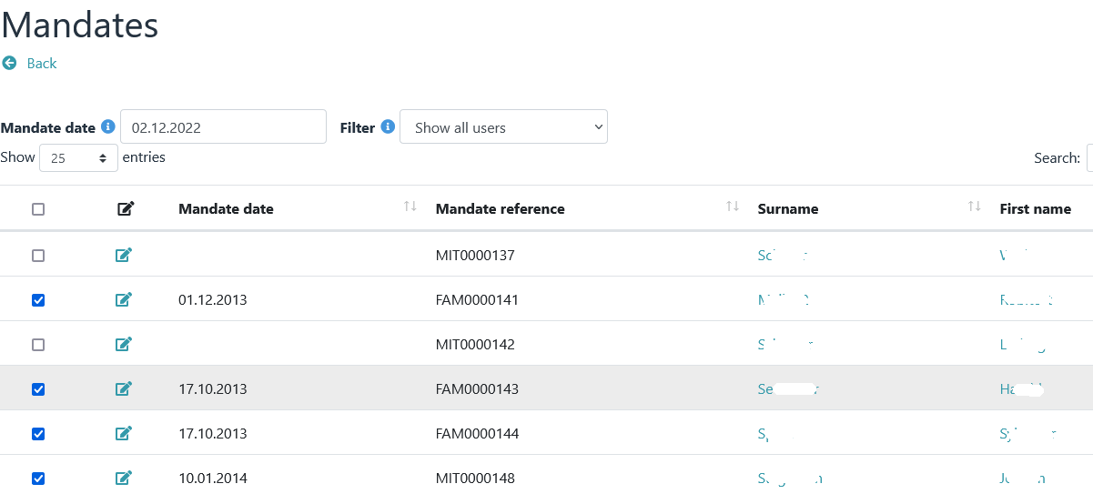

The change of mandate view is called up via the "Change of mandate" button.

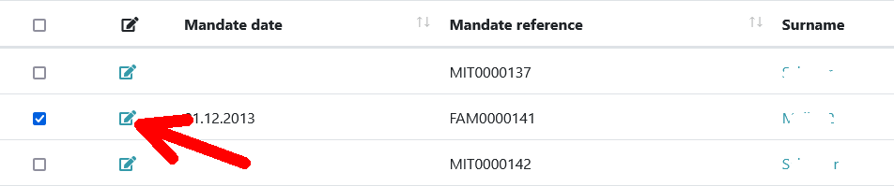

**a notice**

*Mandate changes are required if mandate data have changed since the last collection.*

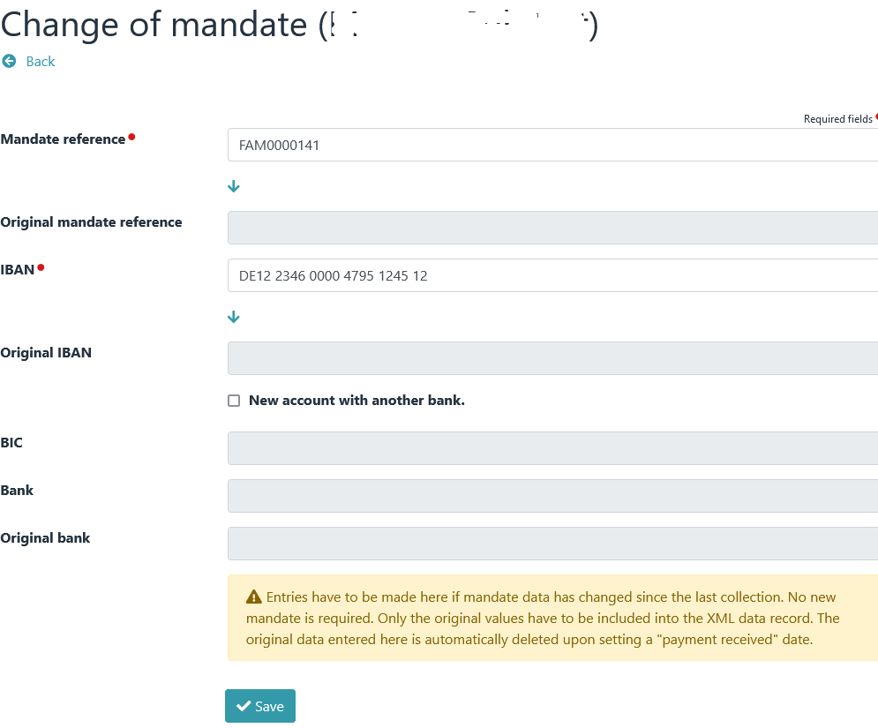

The mandate change for debtors.

# Options

## Generate membership number(s).

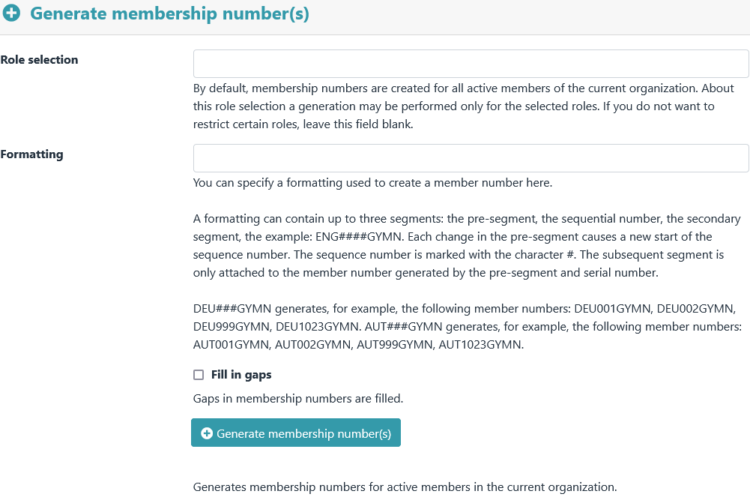

Member numbers for active members of the current organization can be created via this menu item.

After clicking the button "Generate membership number(s)" a preview appears first.

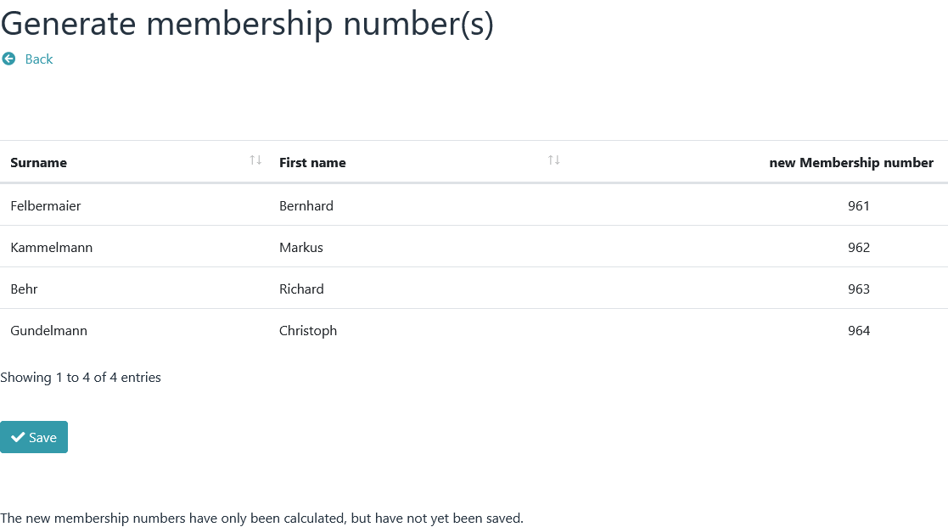

* + 1. The new membership numbers are only saved after you click on "Save".

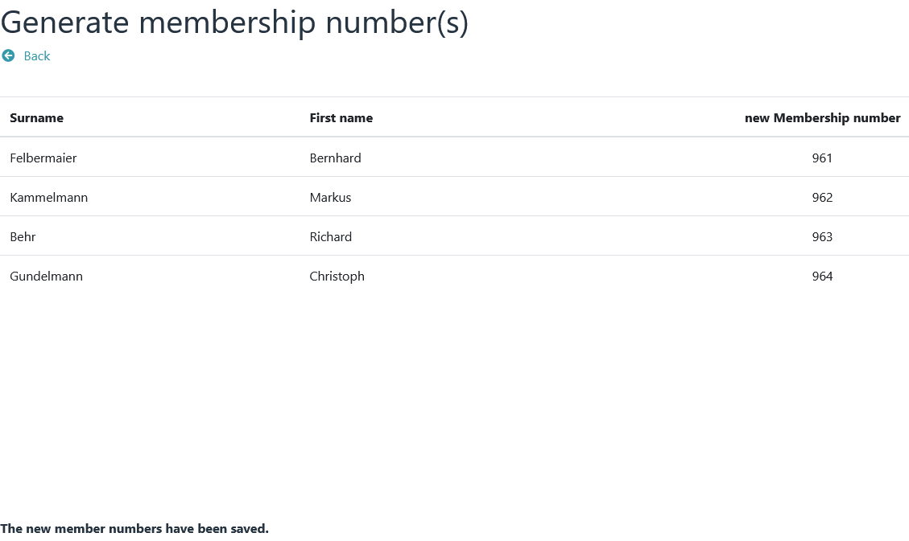

## Update family roles

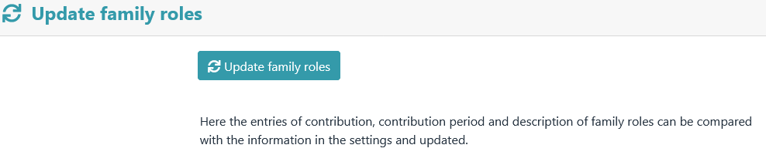

Here, the entries for contribution, contribution period and description of family roles can be compared with the information ­in the settings and updated.

After clicking the "Update family roles" button, a preview appears first. Differences ­in entries are highlighted in bold.

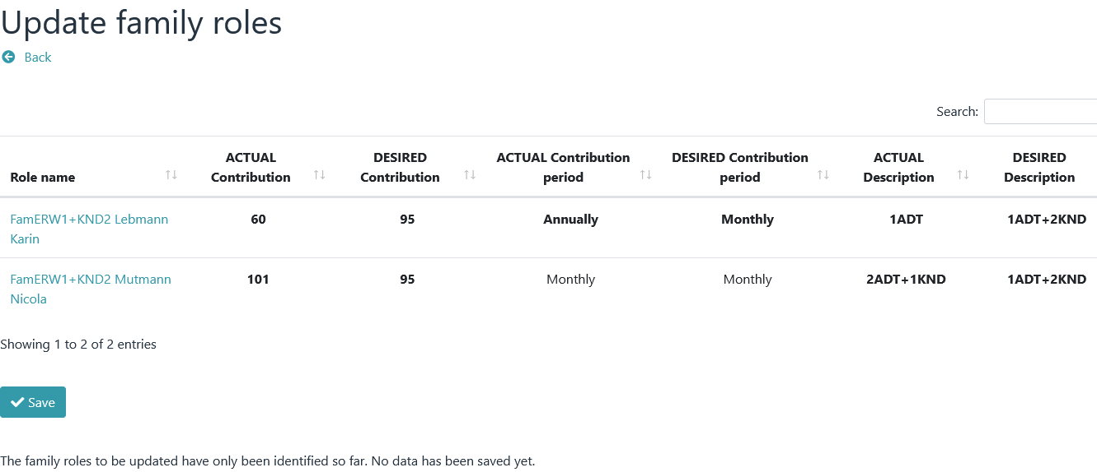

* + 1. The new data will not be saved until you click on "Save".

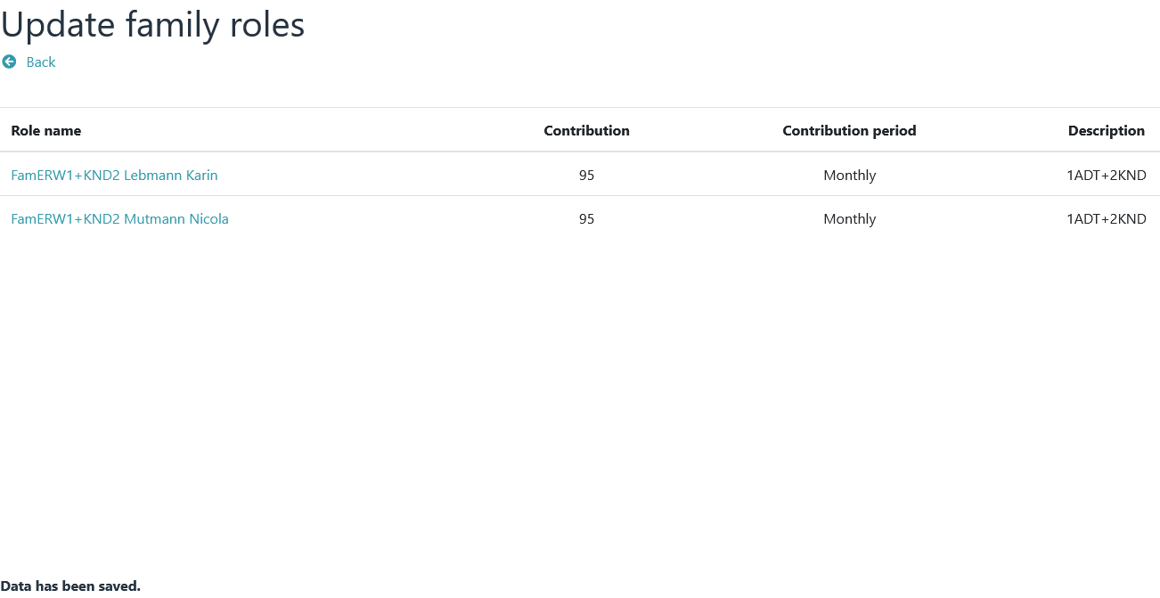

## Copy

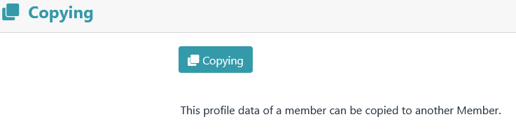

Using "Copy" the contents of profile fields can be copied from one member to another member.

The view of the "Copy" option.

First select source and target of the copy process.

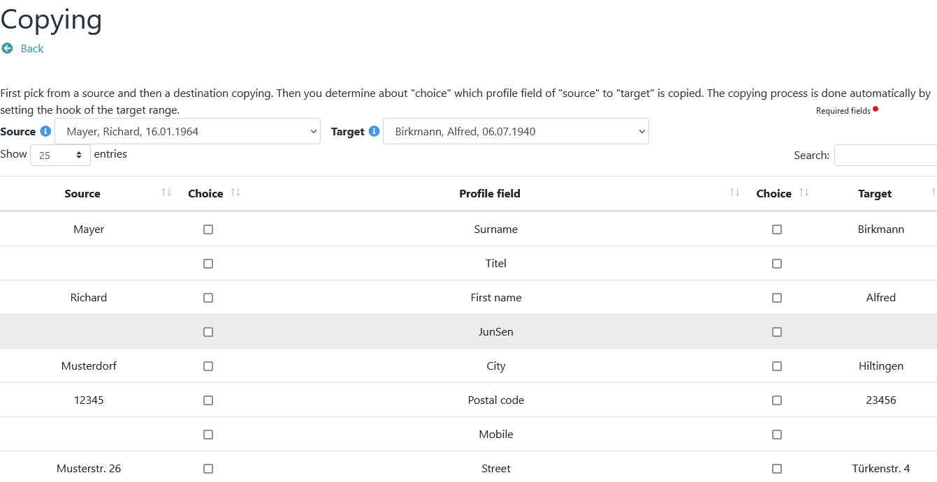

Then select the profile field that is to serve as the source and then the profile field that is to serve as the tar­get.

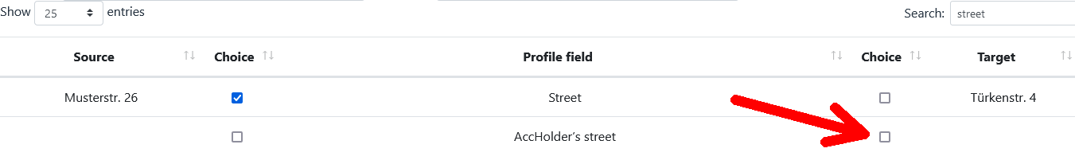

The finished result of a copy operation.

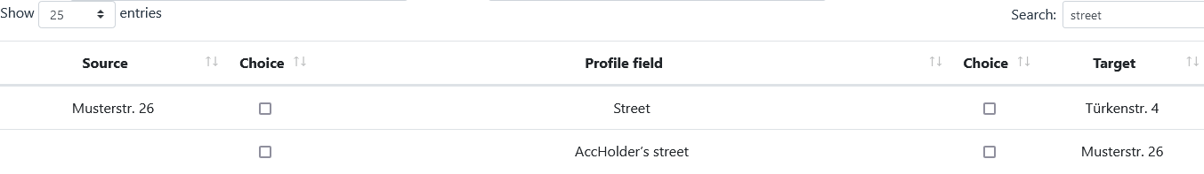

## Tests

Tests have no influence on the calculation of contributions. As the name suggests, they only serve to check certain data. Each check can be activated or deactivated via *→ Preferences – Tests .*

### Age-bases roles

Checks whether there are gaps or overlaps in the age-based roles, based on the age information.

### Role membership (age-based roles)

Checks whether a member is in several age-based roles (e.g. in grading ­% and in grading & at the same time)

### Role membership (mandatory)

Checks if a member is in at least one mandatory role membership.

### Role membership (exclusion)

Checks if a member is in mutually exclusive roles.

### Family roles

Checks whether there are members in family roles who should not be in this family role due to their age.

### Account details

Checks whether the account holder field is filled in the account data. If so, address data must also be filled out.

**Notice**

*If the member is also the account holder, the account holder field must contain **NO** content ­, it must be empty. In this case, only the IBAN field needs to be filled out*

*(BIC and bank can, but do not have to be filled out)*

*If the account holder/payer and member are not identical,*

*this data must also be given ­:*

*\* First and last name of the account holder*

*\* Street and house number*

*\* Postal code*

*\* Location*

### Mandate management

Checks whether mandate ID and mandate date are available (requirement: IBAN and membership fee must be ­filled out)

### IBAN test

Check for correct IBAN

### BIC test

Check for the existence of a BIC (for payments outside the EU/EEA, a BIC must still be specified ­)

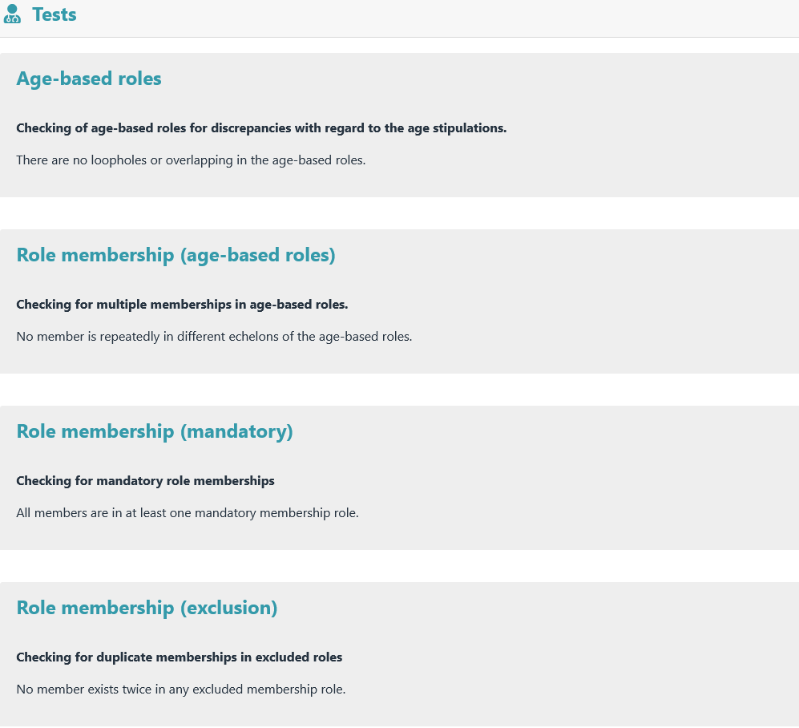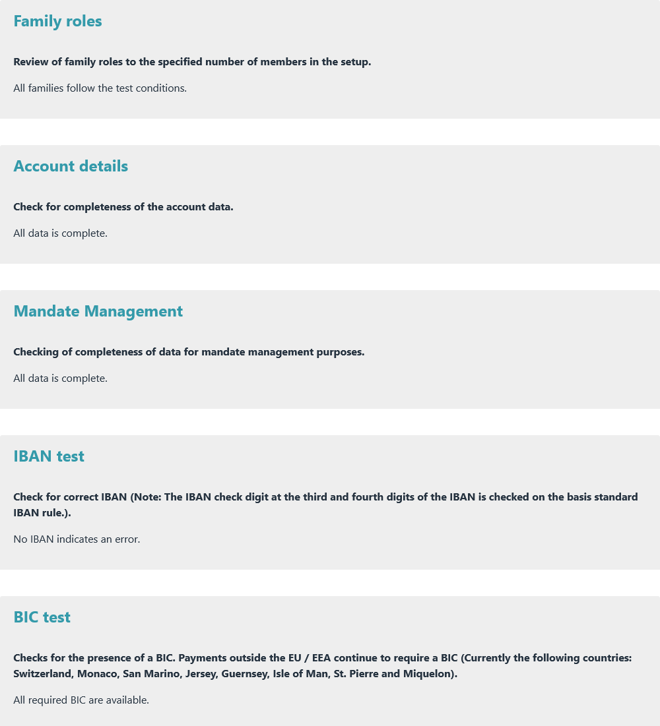Display when all test conditions are met.

Examples of unfulfilled test conditions.

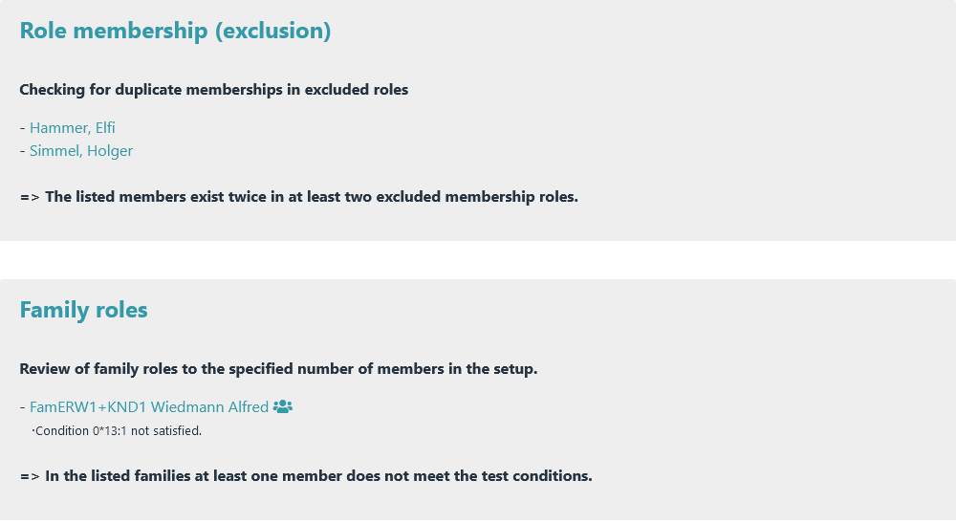

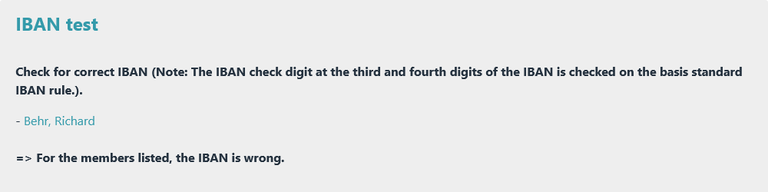

## Overview of roles

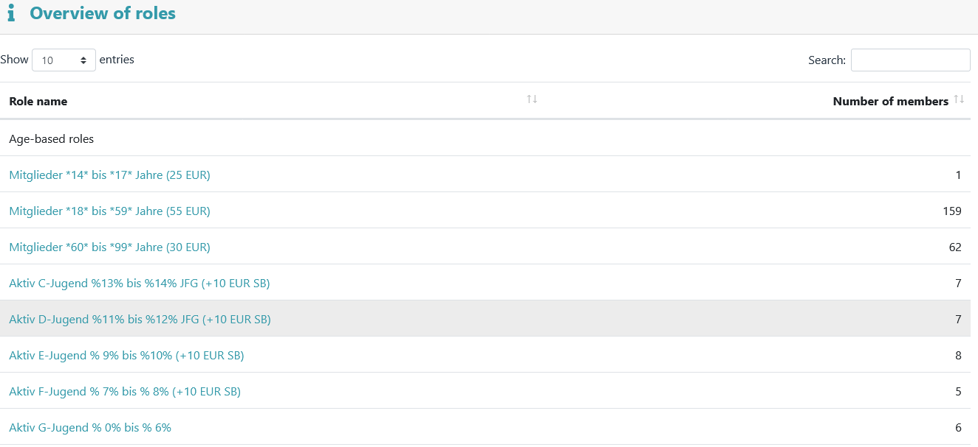

The role overview provides an overview of all contribution roles and their number of members.

## Plugin information

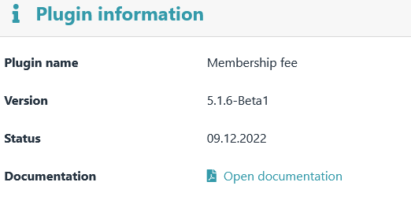

Information about the version and status of the plugin is displayed here.

# Preferences

## Contribution settings

1. 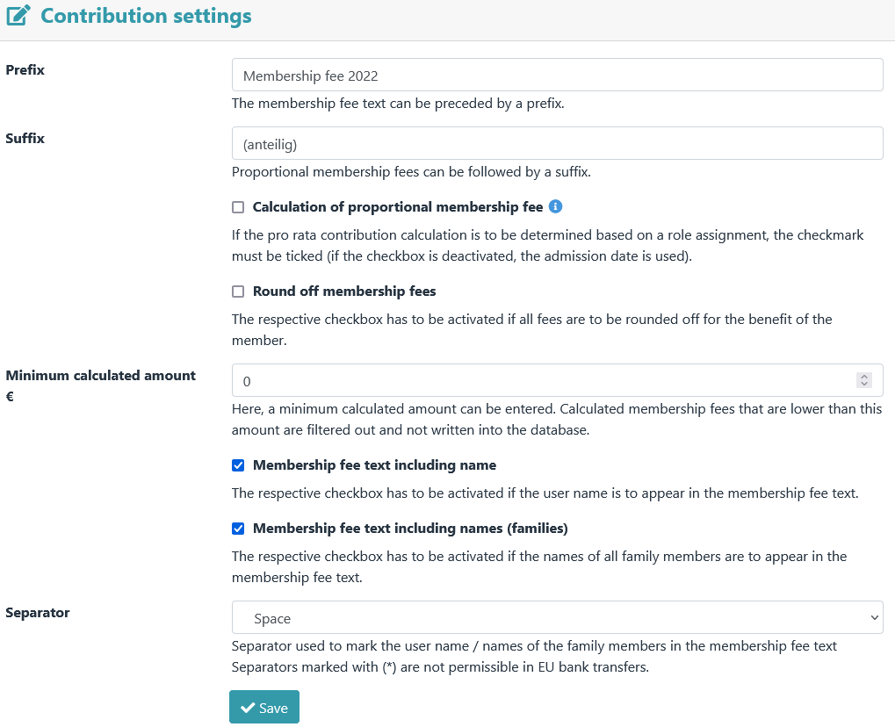
   1. General contribution settings.

## Age-based roles

1. 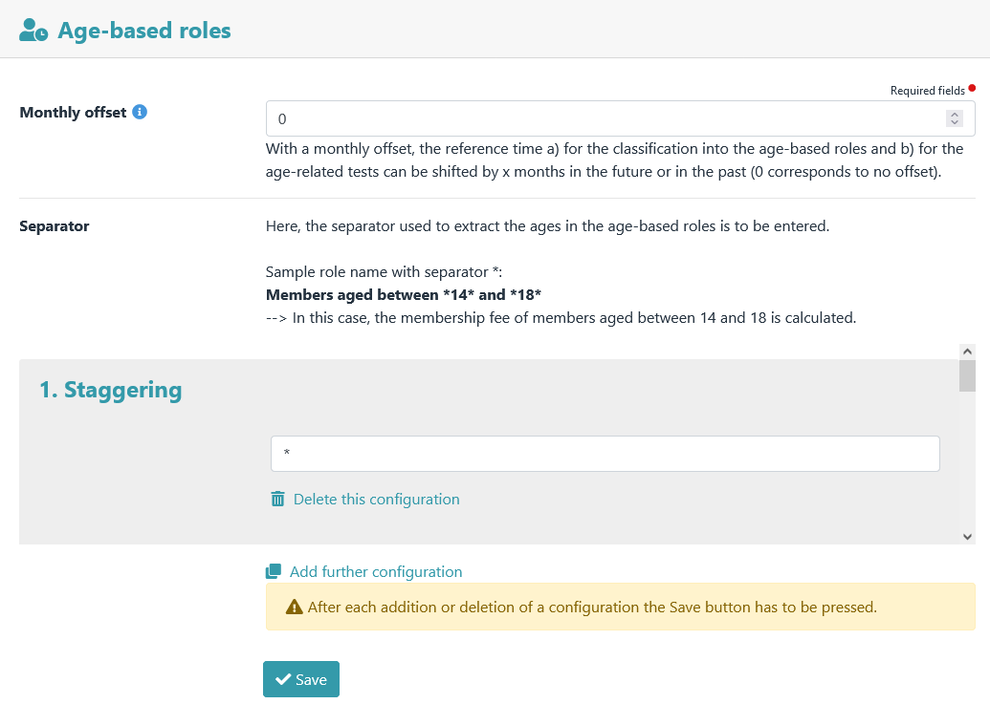
   1. Settings for the age-based roles.

## Family roles

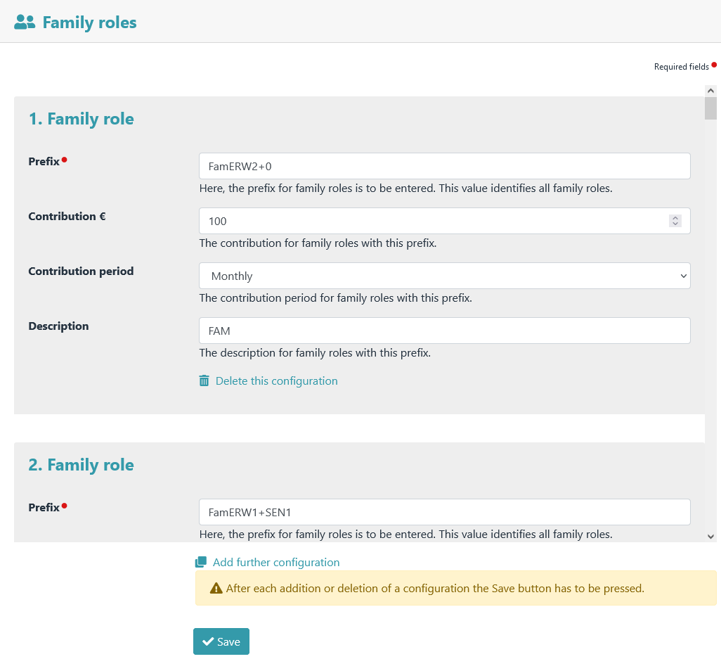

Family role settings.

## Multiplier roles

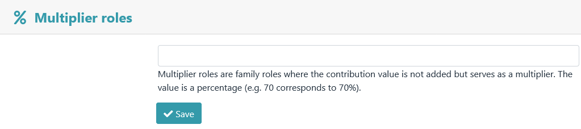Here one or more contribution roles can be defined as multiplier roles.

## Advanced role editing

### 

* + 1. Values of contribution, contribution period and description of contribution roles (except family roles) can be edited via the A**dvanced role editing.** It is only possible to enter a decimal value for the contribution of a role via this menu item (this is no longer possible via *→ Admidio – Groups & Roles – Edit Role ­) .*

## Individual contributions

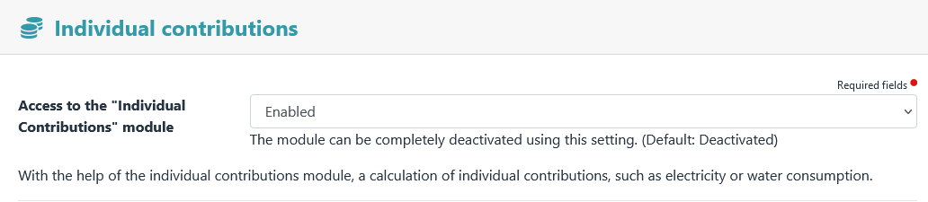**individual contributions** module can be activated or deactivated here.

Examples of configurations of basic and consumption amount of water and electricity.

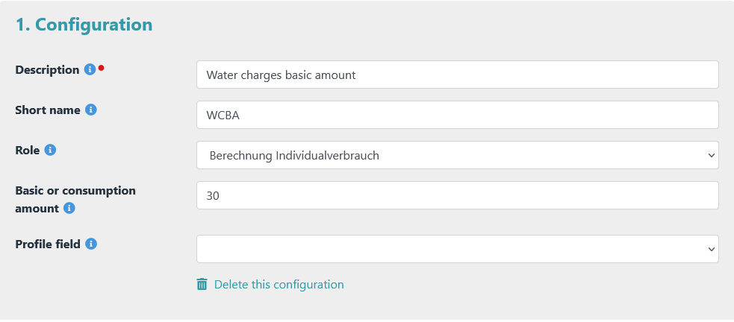Example basic amount of water charges

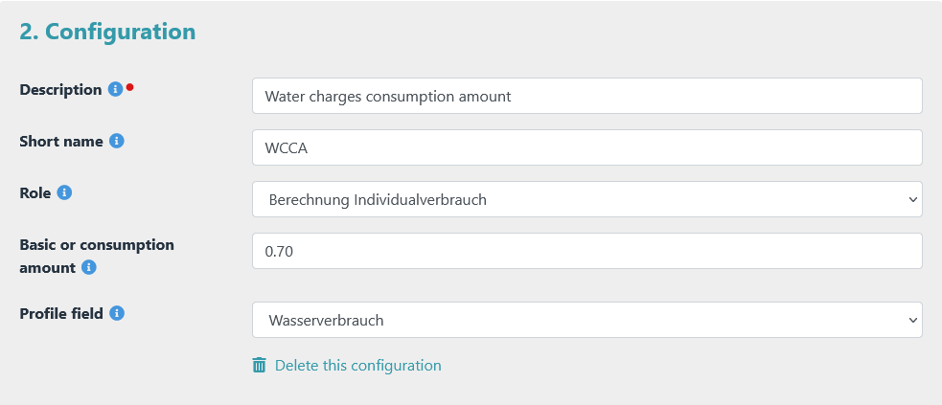Example consumption amount water charges

* + 1. 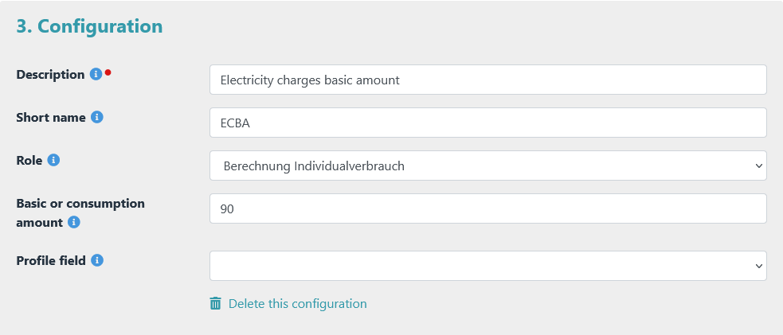Example basic amount of electricity charges

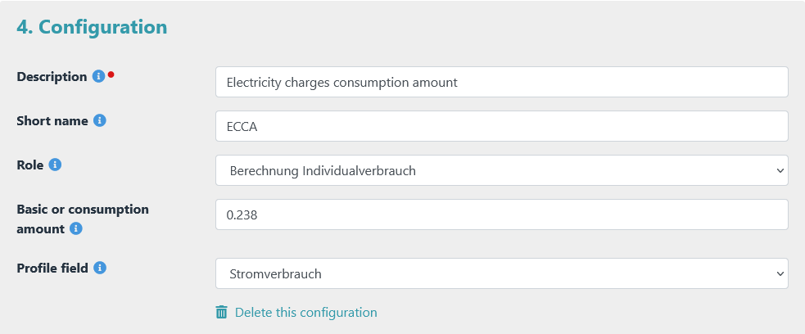Example consumption amount electricity charges

## Account details

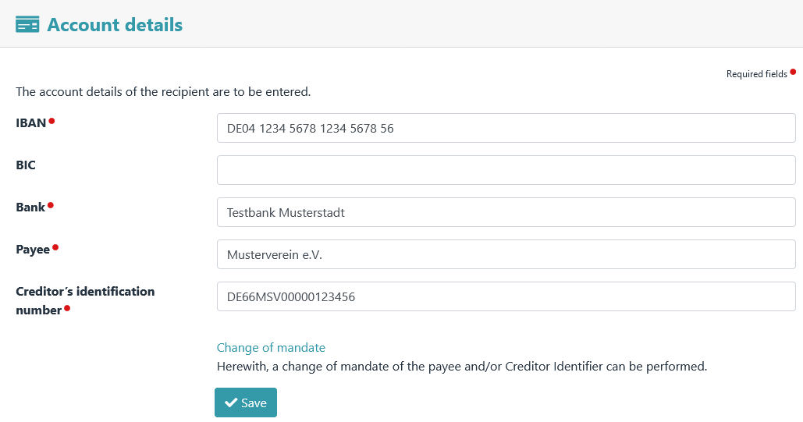

The payee's account details.

The Change of Mandate view is accessed via the "Change of Mandate" link.

**Notice**

*Mandate changes are required if mandate data have changed since the last collection.*

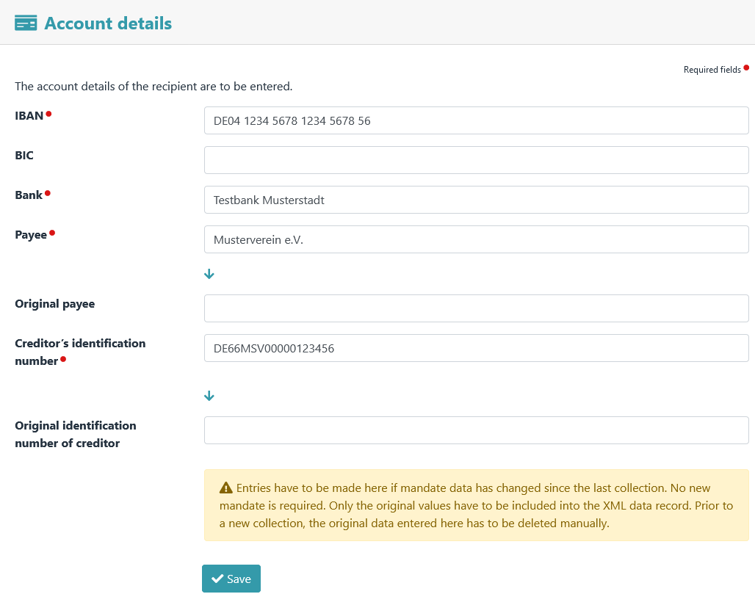

The change of mandate of the payee.

## Mandate management

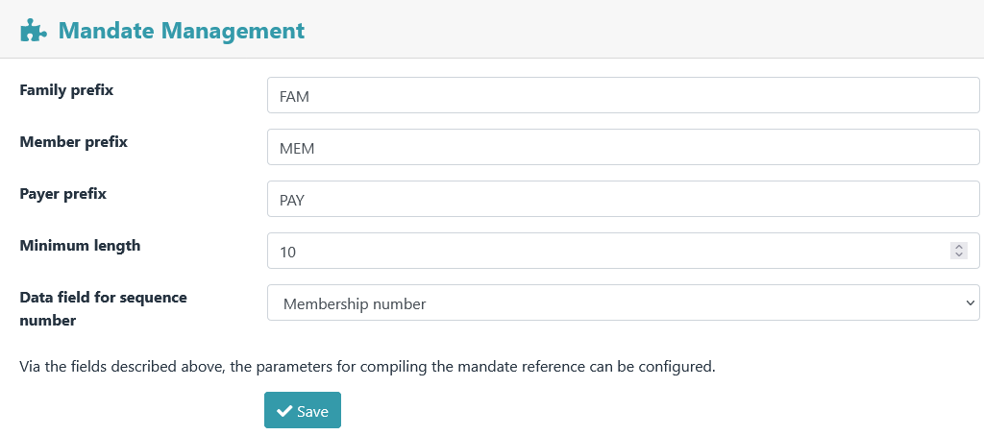

The parameters for the composition of the mandate reference are set here.

**Notice**

*Once a mandate reference has been created, it should not be changed. If it is changed, a ­change of man­date must be carried out.*

A mandate reference is divided into 3 sections. The number of characters (=minimum length) is specified in the menu.

|  |  |  |
| --- | --- | --- |
| **Section 1** | **Section 2** | **Section 3** |
| Digits 1 to x | Digits x+1 to y | Digits y+1 to z |
| prefix | zeros | sequential number |

### The prefix

The prefix in section 1 can be assigned individually. A distinction is made between:

* Families (e.g. FAM or FAMILY)
* Members who act as self-payers (e.g. SLF)
* Members who have a payer (e.g. PAY)

**Notice**

*A prefix can, but does not have to be entered. There is also no need to define different prefixes.*

### The zeros

Section 2 is filled with zeros (0) if the set minimum length has not yet been reached.

### The sequential number

Section 3 is a sequential number. To do this, a database field with clear content ( ­e.g. member number or user_id) is selected. The value from this database field is used as a sequential number.

|  |  |
| --- | --- |
| Example 1: | Example 2: |
| * Specified minimum length: 10 | * Specified minimum length: 5 |
| * Prefix: FAM | * Prefix: MEMBER |
| * Sequential number: 566 | * Sequential number: 723 |
| * => results in the following mandate reference: FAM0000566 | * => results in the following mandate reference: MEMBER723 |

## View definitions

This menu item can be used to define the columns (profile fields) to be displayed for the views

* Contribution payments,
* Mandate management,
* Due date and
* Invoice

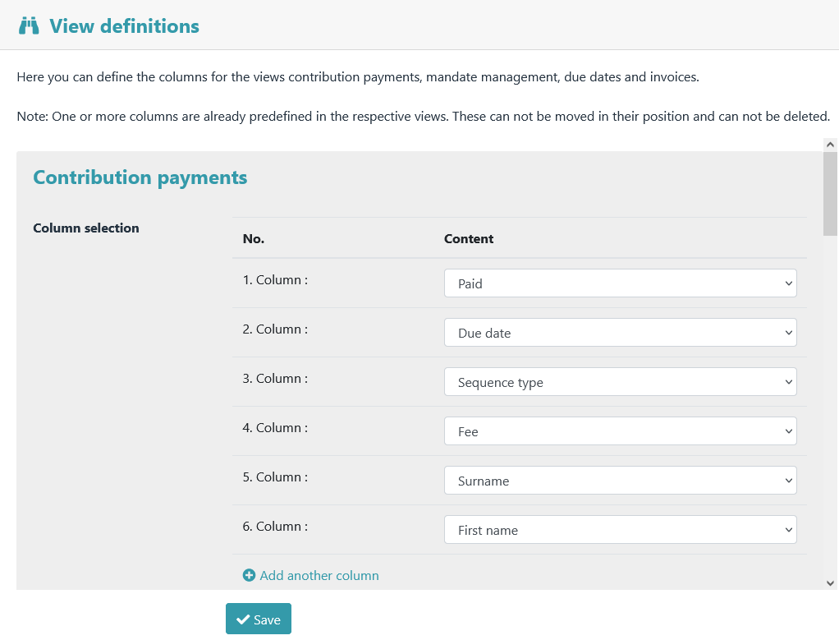

## Export

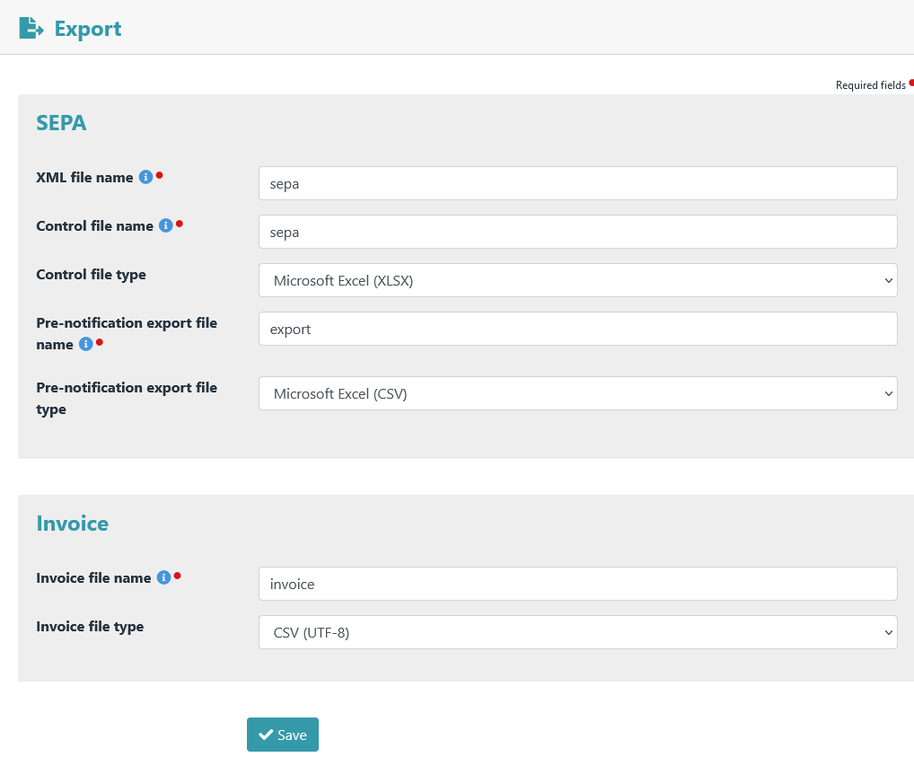

Settings for data export.

## Email notifications

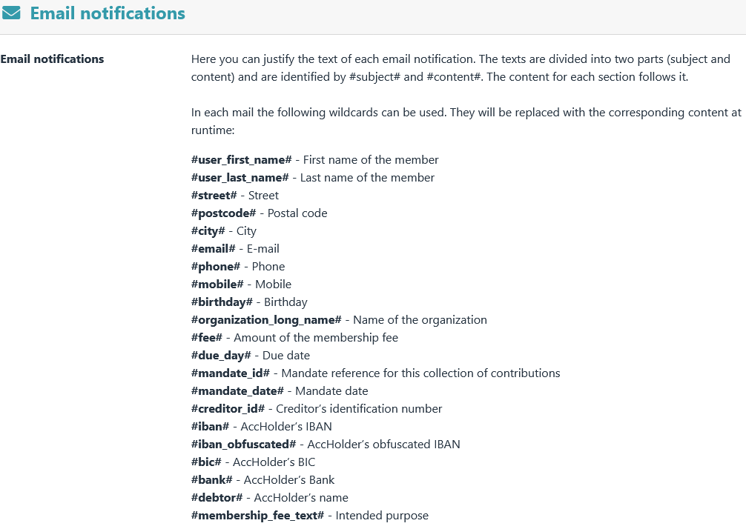

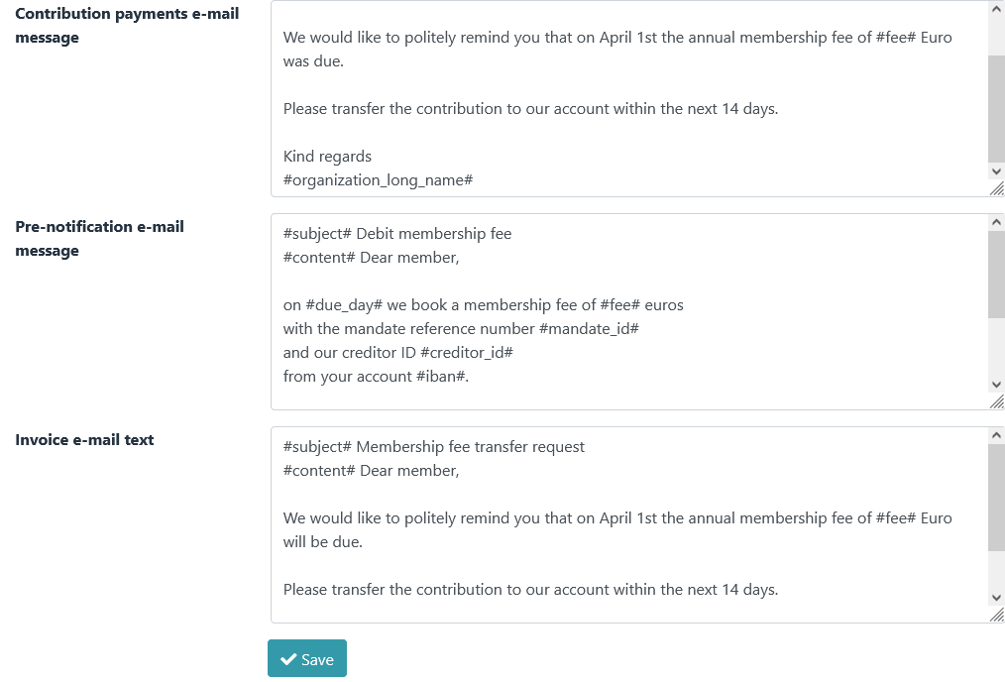

## Tests

Settings for the role checks

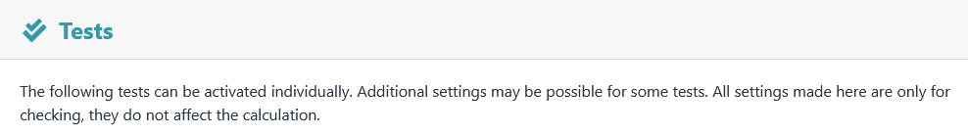

### Enable tests

All tests can be activated separately.

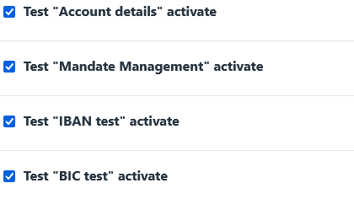

### Role membership (age-based roles)

#### 

* + - 1. Here you can select which scales should not be ­included in the "Role membership (age-based roles)" test.

### Role membership (mandatory) and Role membership (exclusion)

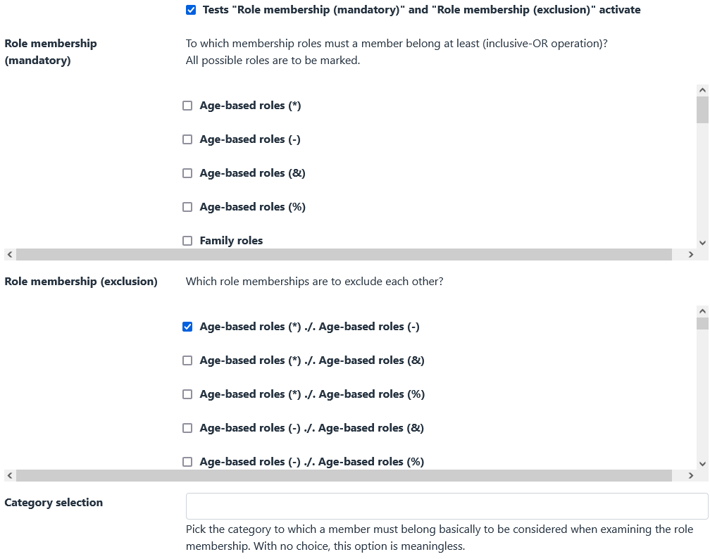

**Role membership (mandatory)**

All contribution roles to which a member should at least belong must be selected here. All possible roles are to be marked.

For example, a member should either be in

* an age-based role
* OR in a family role
* OR in an honorary members role

-> in this case tick the boxes: "Age-based roles", "Family roles" and "Honorary members"

**Role membership (exclusion)**

Here you have to select which contribution roles should be mutually exclusive.

For example, if a member is not allowed to be in an age-based role and a family role at the same time

(-> double contribution calculation), then "Age-based roles ./. Family roles" is to be marked.

### Family roles

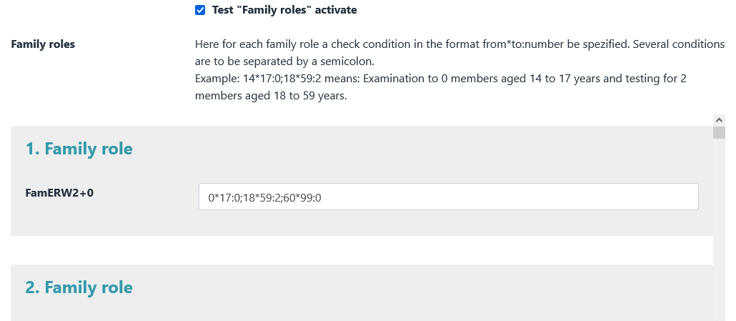

1. The test conditions for family roles are defined here. A separate test condition in the format "from*to:number" can be specified for each prefix of a family role. Multiple conditions must ­be separated by semicolons.
2. It is checked whether a member of a family role should not be in a family role with this prefix due to his age.
3. All checks of family roles refer to the reference time that was defined for the age-based roles.
4. Examples of test conditions for family roles:

|  |  |
| --- | --- |
| **exam on** | **test condition** |
| -0 people from 0 to 17  -2 people from 18 to 59  -0 people from 60 to 99 | 0*17:0;18*59:2;60*99:0 |
| -0 people from 0 to 13  -1 person from 14 to 17  -2 people from 18 to 59  -0 people from 60 to 99 | 0*13:0;14*17:1;18*59:2;60*99:0 |
| -0 people from 0 to 17  -1 person from 18 to 59  -1 people from 60 to 99 | 0*17:0;18*59:1;60*99:1 |
| -0 people from 0 to 17  -0 people from 18 to 59  -2 people from 60 to 99 | 0*17:0;*18:59::0*;60*99:2 |

The use of complex family role prefixes is also possible.

The author of the plugin currently uses the following family role prefixes:

With the following specifications:

* Child: 0 to 13 years
* Youth: 14 to 17 years
* Adult: 18 to 59 years old
* Senior: 60 to 99 years

|  |  |  |
| --- | --- | --- |
| **family role prefix** | **description** | **test condition** |
| FamERW1+JUG1+0 | 1 adult + 1 youth | 0*13:0;14*17:1;18*59:1;60*99:0 |
| FamERW1+JUG1+KND1 | 1 adult + 1 youth + 1 child | 0*13:1;14*17:1;18*59:1;60*99:0 |
| FamERW1+JUG1+KND2 | 1 adult + 1 teenager + 2 children | 0*13:2;14*17:1;18*59:1;60*99:0 |
| FamERW1+JUG1+SEN1 | 1 adult + 1 youth + 1 senior | 0*13:0;14*17:1;18*59:1;60*99:1 |
| FamERW1+KND1 | 1 adult + 1 child | 0*13:1;14*17:0;18*59:1;60*99:0 |
| FamERW1+KND2 | 1 adult + 2 children | 0*13:2;14*17:0;18*59:1;60*99:0 |
| FamERW1+KNDx | 1 adult + many children | 14*17:0;18*59:1;60*99:0 |
| FamERW1+SEN1 | 1 adult + 1 senior | 0*17:0;18*59:1;60*99:1 |
| FamERW1+STD1+SEN1 | 1 adult + 1 student + 1 senior | 0*13:0;14*24:1;25*59:1;60*99:1 |
| FamERW2+0 | 2 adults | 0*17:0;18*59:2;60*99:0 |
| FamERW2+ERW1+0 | 3 adults | 0*17:0;18*59:3;60*99:0 |
| FamERW2+ERW1+JUG1+0 | 3 adults + 1 teenager | 0*13:0;14*17:1;18*59:3;60*99:0 |
| FamERW2+ERW1+JUG1+KNDx | 3 adults + 1 teenager + many children | 14*17:1;18*59:3;60*99:0 |
| FamERW2+ERW1+JUG2 | 3 adults + 2 teenagers | 0*13:0;14*17:2;18*59:3;60*99:0 |
| FamERW2+ERW1+KNDx | 3 adults + many children | 14*17:0;18*59:3;60*99:0 |
| FamERW2+ERW2 | 4 adults | 0*17:0;18*59:4;60*99:0 |
| FamERW2+JUG1+0 | 2 adults + 1 teenager | 0*13:0;14*17:1;18*59:2;60*99:0 |
| FamERW2+JUG1+KNDx | 2 adults + 1 teenager + many children | 14*17:1;18*59:2;60*99:0 |
| FamERW2+JUG2+0 | 2 adults + 2 teenagers | 0*13:0;14*17:2;18*59:2;60*99:0 |
| FamERW2+JUG2+KNDx | 2 adults + 2 teenagers + many children | 14*17:2;18*59:2;60*99:0 |
| FamERW2+KNDx | 2 adults + many children | 14*17:0;18*59:2;60*99:0 |
| FamERW2+SEN1 | 2 adults + 1 senior | 0*17:0;18*59:2;60*99:1 |
| FamERW2+STD1 | 2 adults + 1 student | 0*13:0;14*24:1;25*59:2;60*99:0 |
| FamSEN2 | 2 seniors | 0*59:0;60*99:2 |

The initial configuration is certainly very time-consuming and requires extensive planning.

Example:

Max Mustermann joins the association with his wife and many children. A role with the name **FamERW2+KNDx Mustermann Max** is created for this purpose.

After a few years, one of the children becomes a teenager.

→ The name of the role is renamed to **FamERW2+JUG1+KNDx Mustermann Max.**

Again after a few years, a second child becomes a teenager.

→ The name of the role is renamed to **FamERW2+JUG2+KNDx Mustermann Max.**

Then one of the teenagers becomes an adult.

→ The name of the role is renamed to: **FamERW2+ERW1+JUG1+KNDx Mustermann Max** .

etc. etc.

Conclusion: A lot of work in the definition, but after that it's pretty much a sure-fire success.

1. **Extended test conditions**  
   From membership fee v5.3.0 onwards, extended test conditions can be used. The syntax for this is: <from>*<to>:<number_1>:<number_2>....:<number_n>. Example: **0*14:0:2:4** --> Checks whether there are 0, 2 or 4 members between the ages of 0 and 14 in this role.

## Access permission for preferences

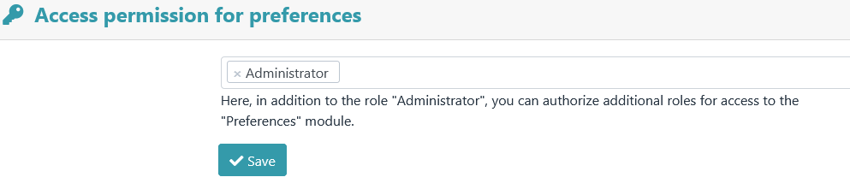

Authorize other roles to access the **Preferences** module**.**

## Uninstall

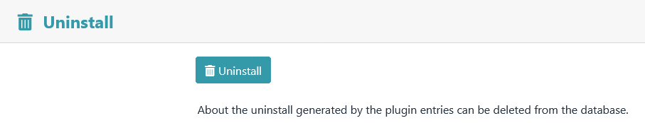

All data created by the plugin can be ­deleted again by uninstalling it.

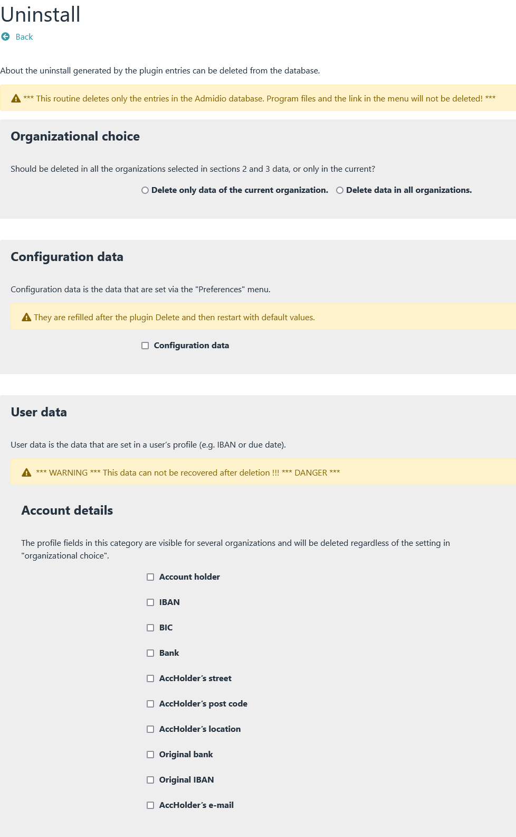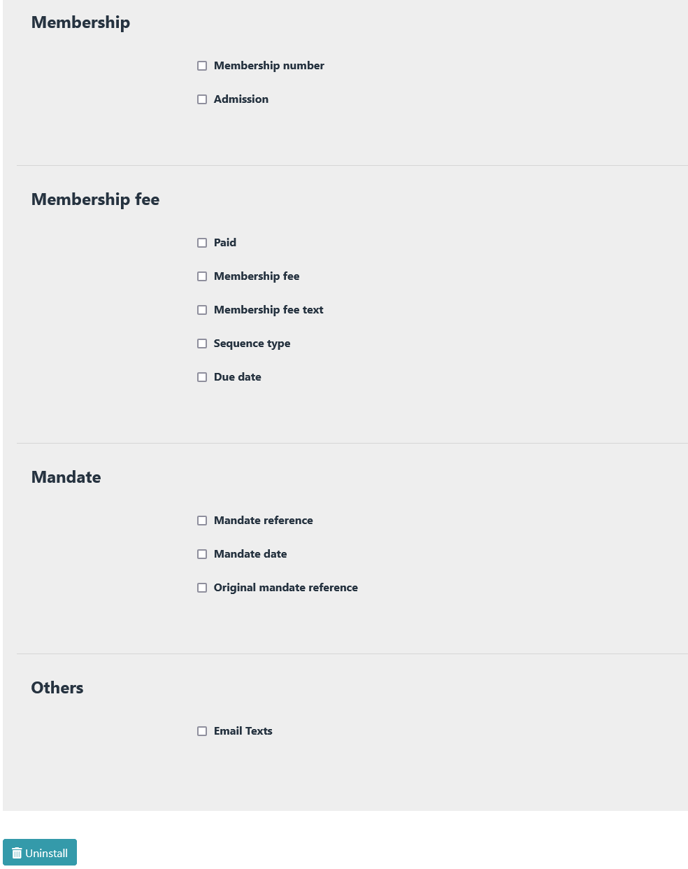

Here you can select whether only data in the current organization or in all organizations ­should be deleted.

Deleted configuration data is filled with default values after restarting the plugin.

Here you select which user data should be deleted.

**DANGER**

*Deleted user data (e.g. IBAN or membership number) cannot be restored!*

**Notice**

*In order to completely remove the membership fee plugin, all possible checkmarks must be set.*

Message after completed uninstallation.

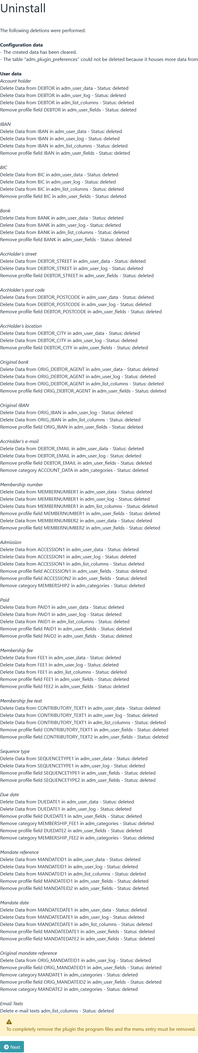

# Saving the configuration

All configuration data is stored in a table named adm_plugin_preferences in the Admidio database. If this ta­ble does not exist, it will be created.

The configurations of the following plugins are currently stored in this table:

* Mitgliedsbeitrag (membership fee)
* Geburtstagsliste
* FormFiller
* KeyManager

The table entries of the membership fee plugin all begin with the letters "PMB".

# Procedure for a contribution calculation

The following conditions must be met

* Basic settings are entered
* Basic functions have been tested
* Contribution roles are defined (and are also recognized by the plugin *→ Options – Overview of roles* )
* All test conditions should already be defined under *→ Preferences – Tests*

## Rough process

1. First, a contribution calculation is carried out. Then the due date is set, the XML file is generated and the contributions are collected.
2. When all contributions have been collected, the paid date is set. Setting this date is important as it triggers several follow-up actions (e.g. FRST becomes RCUR, mandate changes are rolled back, etc.). It is not important when this date is set. It only matters that it is set.
3. If more members join the association in the course of a year, the same procedure is repeated. So carry out the contribution calculation, set the due date, collect contributions, set the paid date.
4. At the end of a year (when all contributions have been collected) a "Delete" is performed. This will delete all contributions, contribution texts or due dates. Now you can start again in the new year with the first collection of contributions of the year, the total collection.

## Schedule

(a new member is added)

### Admission of the new member

The new member is added to Admidio. As part of the admission, it is already included in the various ­contribu­tion roles (e.g. in an age-based role or in a family role).

**Notice**

*The mandate date can also be included as part of the new inclusion.*

### Generate membership number

If you are working with membership numbers, create a membership number via ­*→ Options – Generate Mem­bership number(s)*.

### Create mandate reference

Via the menu item *→ Mandate management - Create mandate references*.

### Enter mandate date

If you have not already done so, enter a mandate date via *→ Mandate management - Edit mandate* (or by editing the member's profile).

### Perform remapping

If working with age-based roles, carry out a remapping now

### Contribution calculation

Via *→ Fees - Recalculation* .

### Due Date

Call up the Due date module ­via *→ Export – SEPA - Due date and assign a due date* .

### XML file

After a due date has been set, an XML file can also be generated via *→ Export – SEPA - XML ­file* .

### Pre-notification

A pre-notification can also only be created via *→ Export – SEPA - pre-notification* if a due date has been as­signed.

### Distribution of the XML file

After the XML file has been created, it can be sent to a bank via a home banking program (e.g. StarMoney or Jameica/Hibiscus).

### Completion of a contribution calculation

In order to complete the entire process, it is important that a paid date is set. Setting this date changes a se­quence type FRST to sequence type RCUR.