|  |  |
| --- | --- |
| **Fasset Learnerships: Professional Post-Graduate Qualification: Company Secretarial and Governance Practice** | **Fasset Logo** |

|  |  |
| --- | --- |
| Professional Body: | Chartered Secretaries Southern Africa |
| Learnership Title: | Professional Post-Graduate Qualification: Company Secretarial  and Governance Practice |
| Learnership Code: | 01Q010030001207 |
| NQF Level: | 8 |

The Chartered Secretary is a high-level professional Administrator, alert to change, strong on people skills and thoroughly disciplined. In addition, the Chartered Secretary has the ability to communicate clearly with a range of senior officials and other stakeholders – including Board Directors, Customers, Bankers, Brokers, Shareholders, Taxation and State officials. The effective Administrator will drive a team to attend to matters affecting accounting, purchasing, manufacturing, planning, finance, risk management, compliance, marketing, labour relations, and human resources.

Key personal attributes that a Chartered Secretary needs for success are summed up in the following diagram:

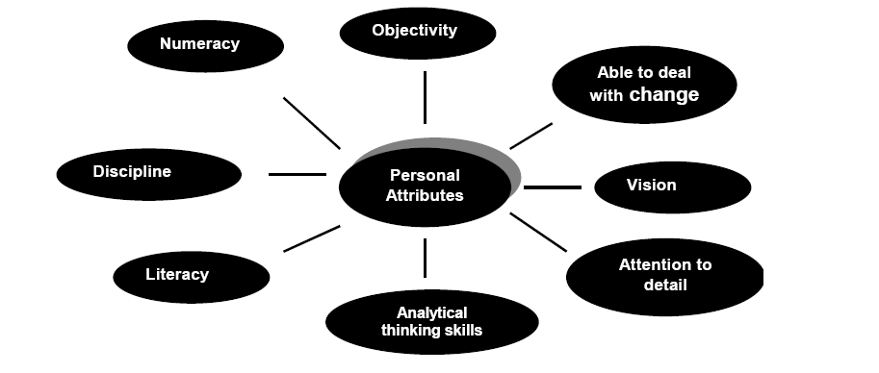

Career Prospects

Qualified and experienced Chartered Secretaries are in very short supply. They are in demand for their range of skills, knowledge, work experience and values (especially integrity, professional discipline and the willingness to maintain knowledge currency through continuing professional development – CPD).

Chartered Secretaries command excellent salaries, but the key to getting these top jobs is appropriate work experience and the maintenance of records of personal integrity and ability through **membership** of the Institute.

Membership is vital as it provides the proof of integrity and personal good standing that the modern employer demands – a portfolio of work evidence, supported by a record of unbroken membership, provides a job applicant with the edge that is needed in any competitive environment. Membership provides a record of accountability, which is priceless if they are working in the modern Corporate Governance environment. No other degree or academic qualification can perform the same accountability function as a professional relationship with an international, prestigious, and professional body such as Chartered Secretaries.

Membership is vital as it provides the proof of integrity and personal good standing that the modern employer demands – a portfolio of work evidence, supported by a record of unbroken membership, provides a job applicant with the edge that is needed in any competitive environment. Membership provides a record of accountability, which is priceless if they are working in the modern Corporate Governance environment. No other degree or academic qualification can perform the same accountability function as a professional relationship with an international, prestigious, and professional body such as Chartered Secretaries.

Membership of Chartered Secretaries Southern Africa comes together with an array of products and services, which include ongoing training to facilitate the necessary knowledge, competencies and functional skills members need to effectively execute their responsibilities in a manner that complies with local and international regulatory frameworks and standards.

Chartered Secretaries Southern Africa offers the following value-added benefits:

* Chartered Secretaries Southern Africa's qualifications are registered from Level 5 to Level Seven on the National Qualifications Framework (NQF) with the South African Qualifications Authority (SAQA).
* Chartered Secretaries Southern Africa has approximately 1000 students studying towards its range of professional qualifications, and runs a learnership which is registered with FASSET (the SETA for Finance, Accounting, Management Consulting and other Financial Services).
* Chartered Secretaries Southern Africa's Continuing Professional Development (CPD) department provides seminars to members and other interested parties, enabling them to keep up to date with developments in governance, administration and accounting.
* Chartered Secretaries Southern Africa is governed by a Constitution, Code of Conduct and By-laws and has detailed investigation and disciplinary procedures for defaulting members.
* Chartered Secretaries Southern Africa provides its members who are in public practice with mandatory Professional Indemnity (PI) insurance.
* Membership is reserved for persons who have complied with the academic, practical and professional evaluation requirements laid down by the Institute.

**Syllabus**

The registered Chartered Secretaries Southern Africa Learnership is based on academic studies as well as practical experience.

The aim of the learnership is to provide an opportunity to gain the practical experience required of candidates wishing to become members of this Institute. The learnership provides practical experience in Corporate Governance, Corporate Secretaryship and Corporate Administration. In addition, there is a Financial Management module which is assessed via examinations only.

In order to be accepted into the learnership you need to comply with two requirements, namely academic and employment with an Accredited Workplace Provider (AWP).

1. Academic requirement

You have completed your CSSA studies up to NQF Level 7 or you have a B. Comm or LLB from an accredited tertiary institution.

1. Employment

You need to contact an AWP close to where you are with regards to employment as a trainee company secretary. The AWP will register you on a Chartered Secretaries Southern Africa Learnership, usually after a trial period. You are expected to sign and forward a Learnership Agreement and all other Learnership application documents through to Chartered Secretaries Southern Africa, for further registration with FASSET.

**Duration of the Learnership**

The duration of the Learnership is one year. During this time a logbook must be kept and a portfolio of evidence must be assembled. At the end of the one year period, after the successful completion of the Board Examinations, learners will be issued with a FASSET certificate and registered on the National Learner Records Database. Please note that all learners are subject to a Professional Evaluation before full membership of this Institute will be considered.

**Contact Details:**

|  |  |
| --- | --- |
| Professional Body: | Chartered Secretaries Southern Africa |
| Contact Person: | Jacqui Baumgardt |
| Tel: | (031) 708 3971 |
| Fax: | 0866277756 |
| E-mail: | jacqui@icsa.co.za |
| Web: | www.icsa.co.za |