SCI – Users Manual

The SCI System
is Copyright 2000 Massachusetts Institute of Technology
All Rights Reserved

Requirements
SCI requires at least 8 MB of memory and a Pentium-class personal computer running either Windows 95, 98, 2000, or NT 4.0.

Installation
The SCI system is a front-end user interface to many different indoor airflow simulation programs. It comes as a single executable, stand-alone application. Once the application is unzipped, no further installation is necessary. However, the user must acquire the indoor airflow simulation programs themselves separately.
SCI also comes with two sample files to help you become acquainted with the system.

Registration
To use SCI, a valid registration code must be entered. A separate code is needed for each separate computer that runs SCI.
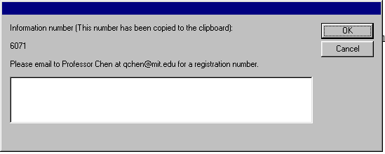
To obtain the valid code, please unzip and run the application. You will then be given a number which should be send via e-mail, phone, or post to the Massachusetts Institute of Technology’s Building Technology Program, c/o Qingyan Chen, Room 5-418, 77 Massachusetts Avenue, Cambridge MA, 02139. E-mail can be directed to qchen@mit.edu. You will shortly receive a valid response code that can be used to unlock the application for your use.

Please note that if your computer’s hard disk is reformatted, then a new registration code might be required. If Windows is re-installed, then your original registration code will still work, but you will need to enter it again.

What Is SCI?
SCI stands for the Simplified CFD Interface System. It is a user-interface for indoor airflow simulation, running on the Windows 95, 98, 2000, and NT platforms. With SCI you can:

- Create a computer model of a floor plan, single room, or group of buildings
- Solve for the temperature, pressure, air vectors, and other metrics, both inside and around your computer model, using several different solver algorithms
- Visualize your results using animations and 3-D rendering
- Import and export your models using the IFC data format
- Import computer models from AutoCAD and other popular CAD programs

The SCI system is three programs in one – a basic, easy to use CAD module, a simple interface to several CFD solver programs, and a visualization and post-calculation analysis tool.

SCI offers a range of computational solutions. Quick and dirty SCI models can be created and analyzed when fast results are needed, while more complex and accurate models can be construction when necessary. Best of all, no previous experience with computational fluid dynamics codes is required or expected.

How to Start SCI
To begin using SCI, install and register the application as stated above. Then, navigate to the folder containing SCI and launch the application by double-clicking on it. You should see the SCI splash-screen followed by a blank, white window with two additional, smaller windows to the right and bottom.
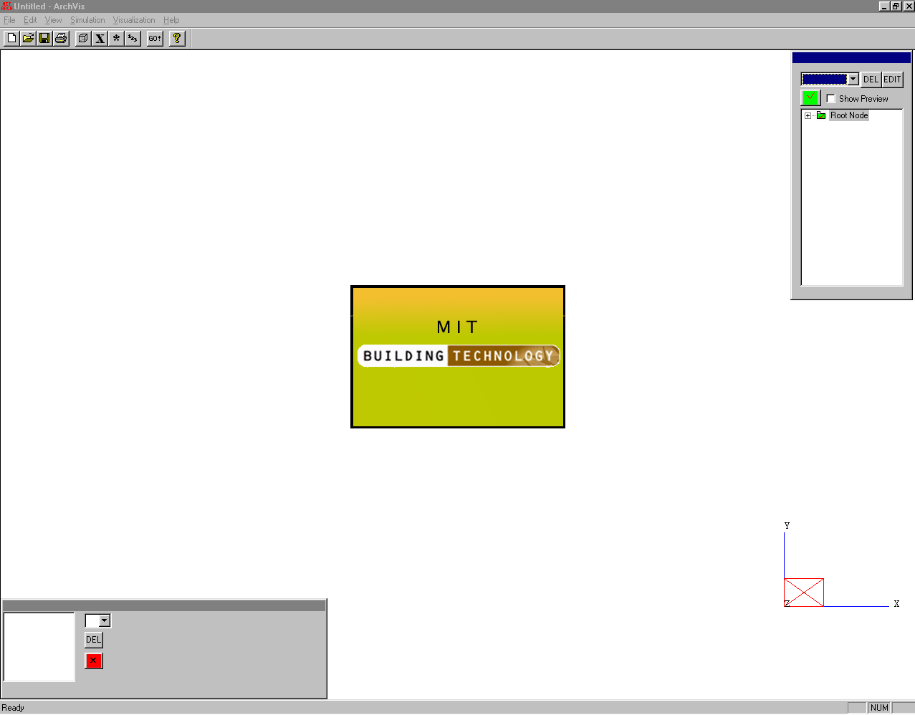
The most common way to use SCI is to enter a building environment, simulate it, and visualize the results. This manual will step you through each one of these steps.

How to Input A Building Environment
There are two components to a building environment model. The first component is the solid geometry of the building or room. Think of the geometry as the layout of chairs, tables, building walls, heat sources, windows, and any other physically existing objects. Each object’s size and location in the environment need to be specified. To enter this information, you can either use the built-in geometry editor that comes with SCI, or you can import this data from an outside application. The second component is the set of computational and environmental attributes associated with the building model. These attributes are sometimes given on a per-object basis and sometimes on a per-model basis, depending on the attribute. Per-object values can be entered through the geometry editor, and per-model values are entered using the dialog boxes under the “Simulation” menu.

Geometry
Entering the Geometry Using the Internal Editor

The narrow, rectangular window to the right of the main window is the internal geometry editor window. When starting with a fresh, new model, it should contain a single folder called “Root Node”. You will notice that the editor window lists folders and objects in a folder-like structure. Folders can contain object definitions (also known as boundary conditions, or boundaries) or other folders. To expand a folder, click on the plus sign to the left of the icon. To collapse a folder, click on the minus sign. For example, expanding the “Root Node” folder will reveal a second folder inside of it, called “Mesh Walls”.

To add an object to the model, highlight the folder you wish to place it in by clicking on the folder name once. Then, select “New Boundary” from the combo-box located to the left of the DEL button. You will notice that a new item has been placed inside the folder you selected, with a small green box for an icon named “Untitled.” To rename this object, click on it once to highlight it, then click again to activate the name editor. When a black box appears around the old name, you can type a new name and hit “enter” to save it.
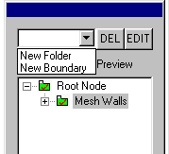
To specify the kind, location, and size of the new object, click it once to highlight and click the EDIT button, located next to the DEL button. This brings up the object editor. You will notice the object editor has four tabs. The first tab (Location) allows you to specify the size and location of the object. The other three (Contaminants, Airflow, Temp/Mass) are object-based attributes, and we will deal with them later.

When specifying the location and size of an object, keep in mind that all objects in SCI are rectangular. For convenience, there are several ways to specify the location of a cube and a square. The combo box next to the dimension name (X, Y, or Z) indicates the manner in which you will enter the information. The simplest way to enter this information is to give the start and end values for the object, in meters, along each dimension. To choose this method, select “Start (Value) → End (Value)” for each dimension’s combo-box. Then enter the start and end values in the edit boxes that appear below the method selection. For example, a one meter cubed object, whose bottom-left corner is situated on the floor, five feet from the origin in both the x and y directions, would be entered as 5, 6 under the X dimension, 5, 6 under the Y dimension, and 0, 1 under the Z dimension.
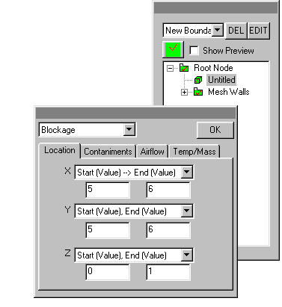
The second entry method, “Start (Value), Size (Value)” allows you to specify a start distance from the origin, followed by the length of the object along that dimension. If this method were used for each dimension, the previous box would be entered as 5, 1 under the X dimension, 5, 1 under Y, and 0, 1 under Z.

The third method, “West/South/Bottom → (Value)” allows you to specify dynamic object locations that vary based on where the computational mesh is defined. If you have defined the computational mesh as a box covering a 2 meter cubic area with its origin at (1,1,1), then choosing this method for each dimension, and specifying a value of 2 for each, would result in a cubic box offset by one meter from the origin. The fourth method, “West/South/Bottom → East/North/Top”, is also mesh-dependent. Choosing this option for each dimension would result in a box that encompasses the entire mesh box. Similarly, “West/South/Bottom/East/North/Top Boundary” are mesh-dependent options for specifying two-dimensional objects. This is helpful when defining a window that must lie along the mesh extrema. For example, a 2 meter by 3 meter window residing along the west wall, with its lower-left corner off the Z and X dimensions by one meter, would specify “West Boundary” for the X dimension method, “Start (Value), Size (Value)” for the Y dimension with the values 1 and 2, and “Start (Value), Size (Value)” for the Z dimension with values 1 and 3.

The final dimension method, “(Value)”, is useful for defining two-dimensional objects that are not dependent on the computational mesh. For example, if the window in the previous example had to be located along the X=0.5 meter plane and not along the western mesh boundary, we would change the X dimension method from “West Boundary” to “(Value)” and specify 0.5 in the edit box.

Selecting from the combo-box above the tab box allows you to choose the type of object represented by the size and location. There are six types of objects. The first, a blockage, is a physical impedance to air flow, such as a solid box. The second and third types are inlets and outlets. These types, almost always two-dimensional squares, represent air or contaminant flow into or out of the model.

The fourth type, a symmetric plane, allows your model to take advantage of any inherent axial symmetries. For example, if your building environment is the same on one side of the room as on the other, you need only specify the geometry for the one side together with a symmetric plane object, placed flush against the plane of symmetry. The simulator will complete the calculation as if the other half were included in the model, without the excessive computational expense of duplicating the calculation. For example, if you wished to model the globe at Epcot Center in Disneyworld (a spherical object), you could create the west side of the sphere out of a few rectangles, then place a symmetric plane with the location East Boundary for X, North → South Boundary for Y, and Bottom → Top Boundary for Z.

The fifth type of objects are walls, which are two-dimensional airflow impeding objects. The final type is a “User-Defined Source”. This object does not impede airflow, but can leak contaminants and heat into the space defined by the location tab.

When you have selected the type of object and have finished entering its location and size, click on the “OK” button to save the information.

Occasionally, you will want to group some objects together. For example, a desk set including a table, a person, and a computer, might all be considered under the group “Desk Set #1”. SCI provides for this desire through user-created folders. To create a folder, click on the comb-box located above the object list and select “New Folder”. The folder will appear in whichever folder was highlighted previously, and can be renamed by clicking once to highlight, and clicking again to edit. Then, to create the objects in the folder, highlight the folder and select “New Boundary” from the combo-box for as many objects as is required.

The internal geometry editor allows the user to activate or deactivate objects in the building environment. Deactivating a folder or object is the same as deleting it, only they can be brought back into the model without reentering the information by activating them again. For example, suppose you have defined two folders of objects named “Desk Set #1” and “Desk Set #2”, which contain two layouts for desks that you have been considering. You can deactivate “Desk Set #1” and activate “Desk Set #1”, run the simulator, view the results, the activate “Desk Set #1” and deactivate “Desk Set #2” and compare the differences.
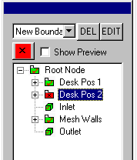
By default, all objects and folders are activated. Activated objects and folders are indicated by the green folder or green object icon next to their name in the object editor. To deactivate an object or folder, highlight the object by clicking it once, then click on the green checkmark box above the object list. You will notice the button, and the icon, have turned to a red X. This indicates the object has been deactivate. To reactivate, click on the red X button. Deactivation propagates downward – if a folder has been deactivated, then all folders and objects recursively contained within are considered deactivated, even if their icon is not red.

To delete a folder or an individual object, highlight it by clicking once on the name in the object editor, then click on the DEL button next to the EDIT button. Objects and folders cannot be undeleted, so be careful.

Entering the Geometry by Importing from AutoCad

Before exiting AutoCAD, save your blueprints in the STL (STereoLithography) format. This is the file SCI will use to extract the geometry data from. Launch SCI and select “Import STL File” from the File menu. Select the STL file you saved from AutoCAD.

You will notice that a folder has been created in the object editor called “From <filename>.stl”. The contents of this folder is a single object that shares the name of the STL filename. This object can be activated, deactivated, or deleted in the same manner as objects created using SCI’s internal editor. Objects cannot be removed, however. You must use the internal editor to add new objects (such as inflows and outflows) to the model, but any further changes to the STL file’s information must be made in AutoCAD and then re-imported.

Highlighting the STL object and clicking EDIT brings up a different location editor. The first item is a scale factor. If the STL file was exported from AutoCAD in feet and you wish to convert it to meters, or you wish to scale the size of the objects in the STL file by any factor, use this selector. If you wish to translate the origin of the STL file to a new point, you can enter the new origin’s coordinates into the origin offset boxes below the scale factor. For example, shrinking all the objects by half and moving the floor up to the Z=8.5 meter plane would entail setting the “Scale” combo-box to Custom, entering in 0.5, then setting the Z Origin Offset box to 8.5.
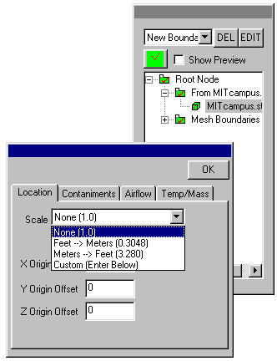
If you are going to use STL files, you MUST see the section below labeled “A Special Note Regarding Computational Meshes and STL Geometry”

Entering the Geometry by Importing from an IFC (Industry Foundation Class) File

Geometry data from IFC files can be imported into SCI. Launch SCI and select the “Import from IFC File” from the File menu. Select the IFC file you want to incorporate into SCI and click OK. You will notice that a folder named “From <filename>.ifc” has been added to the object editor list. Expanding this folder will result in a list of all the objects SCI was able to extract from the IFC file. By default, each of these objects are typed as a blockage and are converted into rectangles. Unlike an STL import, you can add additional objects, attach properties to, or delete the objects created by an IFC import by using the internal object editor.
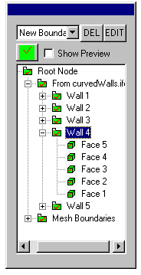
Final Geometry Notes

Sometimes it is hard to determine whether the user should use the internal geometry editor or a third-party application such as AutoCAD to enter the geometry into SCI. Generally, if your building environment has less than 40 objects, then your best bet is to use the internal editor, since this will give you the best control over naming and organizing the objects in your model. If, however, your model has a large number of objects, or already exists in an AutoCAD of IFC format, then using the file importing tools is a better option. You can always add or delete objects as you desire using the internal editor afterwards.

If you are using the internal editor, try to think about what kinds of folders and groupings you will want before you start creating objects, as there is no way to move objects between folders without deleting them and re-entering the information. This can be a pain.

SCI was designed to work with multiple computational simulators, so keep in mind that not all simulators support all types of objects. For example, some CFD back-ends that you might choose to execute your model may not support the symmetric plane type. Other back engines may not support STL files. SCI simply deactivates any objects that can not be used with the simulator chosen at simulation time.

Remember that all numbers should be given in meters.

Model Attributes and Computational Parameters
Specifying a Computational Mesh

CFD programs solve for the air flow, temperature, pressure, and other metrics at different points inside your building environment. You, the user, has control over where these points are physically located. Generally, more data points results in a slower computation. However, the additional points naturally result in a more accurate picture of the environment’s behavior. The locations of the data points are collectively known as the computational mesh.

SCI defines a computational mesh as a rectangular grid of crisscrossing horizontal and vertical lines. SCI places a data point in the middle of each small volume enclosed by the boundaries of the lines. At each of these points, the temperature, air flow, and pressure will be calculated. You can think of the mesh as a stack of differently shaped (rectangular) sugar cubes. In the center of each sugar cube is a data point. Each sugar cube is referred to as a “control volume”.

The mesh is defined by selecting the “Mesh Definition” command from the Simulation menu. A dialog box will appear containing a three-tabbed edit box, labeled “X Dim”, “Y Dim”, and “Z Dim”. Clicking on the different tabs allows you to edit the lengths of the control volumes dimension by dimension. Along each dimension, you can create a number of regions. A region is a length of constant or exponentially sized control volumes.
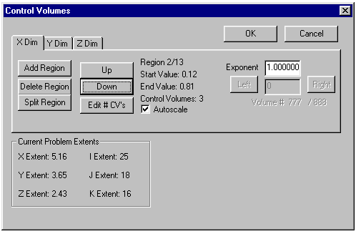
Starting with the X Dimension tab, click on “Add Region”. A new window will appear, with edit boxes for a start and end value and a number of control volumes. The start and end values define the beginning and the end, in meters, of the stretch of control volumes, and the last blank specifies how many volumes to create in this length. For example, a start value of 0.0 and an end value of 5.0, with 10 control volumes, creates ten control volumes of length 0.6 in the X dimension. If these values were repeated for all three dimensions, you would have created a mesh comprised of 1,000 square control volumes 0.6 meters cubed in size.
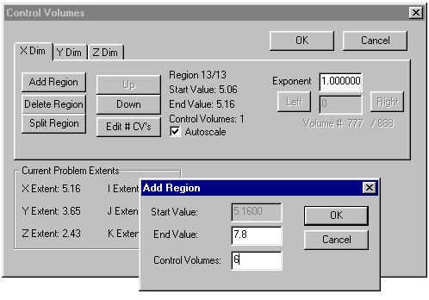
You can create more than one region per dimension. An additional region is always tacked right after the previous region, so you may only enter the new ending value and the number of control volumes for the new region. For example, if you had the cubic mesh above and added a second region in the Z dimension ending at 6 with 10 more control volumes, you would have the original cube of control volumes with an additional meter of 1,000 control volumes sized 0.6 x 0.6 x 0.1 in size.

You can delete or split in half any region along a dimension through the use of the buttons on the left, using the up and down buttons to navigate among a dimension’s regions. The box on the bottom left labeled “Current Problem Extents” identifies how large the current defined mesh is, both in meters and in the number of control points along each dimension (i, j, k is the control volume equivalent of x, y and z).

If you wish to increase the density of a particular region, you can navigate to that region using the up and down buttons and then press the “Edit # CV’s” button. This will bring up a window with a single edit box for the new number.

Sometimes, you want a region’s control volumes to be exponentially spaced instead of linearly spaced. This results in different sizes for each control volume inside a region. For example, if a region is 9 meters long with three control volumes, each volume normally has a size of 3 meters. However, if the exponent is moved from one to two (as set in the Exponent edit box in the right side of the window), then the three control volumes are sized 1, 3, and 5, respectively. An exponent of three results in sizes of 1/3, 2 1/3, and 6 and 1/3, and so on. Exponential sizing is a more advanced mesh technique to achieve a higher density of data points near an area of high interest; most problems do not require using it.

If you want to specify the sizes for each control volume yourself, you can set the start and end values and number of control volumes through the Add Region window, then unclick “autoscale”. The volume box to the right, beneath the exponent box, allows you to specify the lengths of each individual control volume. The only constraint is that all control volumes must sum up to the length between the start and end values.
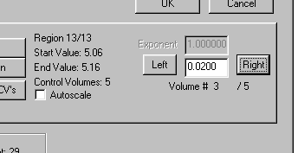
The locations of the walls of the final mesh are sent to the object editor so that mesh-dependent objects (objects that used any of the East/West/North/South/Bottom/Top location definition methods) have a physical location.

A Special Note About Computational Meshes and STL Geometry

As you may have noticed, geometry from STL files is handled differently than geometry entered solely with the geometry editor.

STL files are essentially lists of triangles that, when arranged together, form the blueprints to your buildings. SCI has to turn these triangles into rectangles so that CFD engines can process them. This process is called “3D pixellation”.

The way SCI chooses to pixelize STL triangles is to use the computational mesh. If you want to use STL files, you must define your computational mesh in a specific way, or it will not work.

For a proper STL mesh, each dimension must have exactly three regions.

Also, the middle region for each dimension must have autoscale on and an exponent of one.

The mesh formed from the intersection of each dimension’s middle region is used to pixellate the STL lines. Any triangle that enters one of this inner mesh’s control volumes will turn that control volume into a solid blockage. In this way, the STL triangles choose which control volumes are blockages and which ones will allow air to flow through. Taken together, all the solid control volumes form a rough approximation of the STL lines. Of course, the finer the inner mesh is, the more approximate the representation becomes.

To view which control volumes have been turned into solid blocks, view the boundary plot with the STL object highlighted. See the boundary plot section below if you need help with the plot editor.

The first and third regions only need to have one control volume in them, but it is usually a good idea to make these side regions large enough so the CFD engines can arrive at a solution faster.
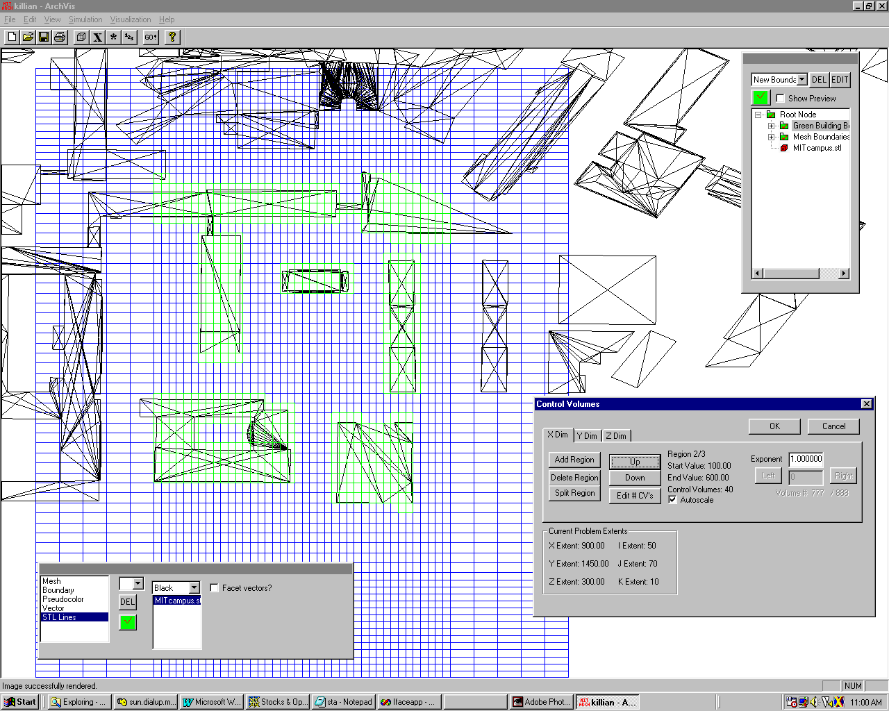
Setting Problem Specifics

SCI needs to know which data metrics you want solved for your building environment, and how you want them solved. Click on the “Problem Description” item under the Simulation menu. A window will appear. On the bottom of this window is a collection of different variables with two check boxes next to them, labeled Solve and Output. Check the variables you wish to solve for. A variable that is solved but not output is calculated but never sent back to SCI for visualization. This is (rarely) useful to decrease the size of the results file.
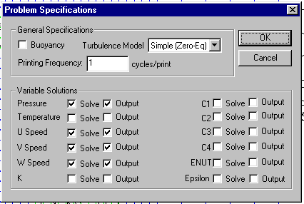
On the top of this window are a few general problem parameters. Buoyancy indicates whether or not the buoyancy equations should be used in the calculation. Cycles/print helps the user determine early if the problem is converging well or not. Finally, this window allows you to set which turbulence model you would like the CFD solver to use.

Now, click on the “Simulation Properties” command under the Simulation menu. Here, you can enter the altitude of the building site, as well as the direction gravity is acting. Different altitudes change the ambient air properties fed to the CFD application. Varying the direction of gravity is useful in two-dimensional cases where the X-Y plane is used to model a X-Z or Y-Z plane.
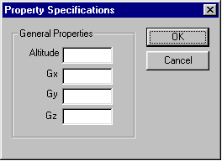
Click on the “Iteration Control” command, again under the Simulation menu. This window allows you to change specific parameters relating to the computational solution of your model. The most important values are in the top right corner, labeled “Convergence” and “Max Iteration”. These two numbers indicate when the CFD solver should consider the results accurate enough to return to SCI. The convergence criterion indicates what level of error is acceptable for success (convergence on the solution). The smaller the criterion, the longer the computation time, and the more accurate the returned results. The maximum iteration is a time limiting value, meant to specify an upper limit on the total time spent attempting to achieve the convergence criterion. The larger the maximum iterations, the longer the CFD program will spend.
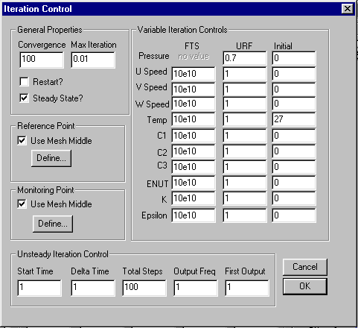
The two boxes on the left identify the reference and monitoring points to be used. The array of numbers in the center allow the alteration of special parameters for each variable type. These three variables are FTS, or False Time Step, URF, or Universal Relaxation Factor, and Initial Value. The default values given should be sufficient to run most models, however they are present for your convenience.

The properties for the objects in the room need to be set. Each of the six object types has a different parameterization. Click on the inflow object once to highlight it in the object editor window, then click on EDIT. The last three tabs (Contaminants, Airflow, and Temp/Mass) control that particular object’s parameters. Most important for an inlet and outlet is the air flow. Click on the airflow tab. You will see three edit boxes, U, V, and W, representing the air flow along the X, Y, and Z dimensions. Enter the air flow rate in each dimension. Now, click on the contaminant tab. You can specify up to four concentration amounts to be emitted from each object, in each of the four contaminant edit boxes.
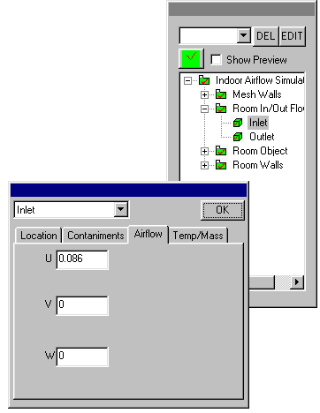
Finally, click on Temp/Mass. For an inlet, you can specify the amount of air mass entering through the plane. For an outlet, you can specify the pressure. You can also specify a temperature for the object. The symmetric plane, blockage, and wall objects alternatively allow you to specify a heat flux instead of a temperature. Temperatures are specified in Celsius. Blockages also have a constant inner temperature that can be set. The following table indicates which object types have which parameterizations.

 | Air Flow | Contaminants | Temperature | Heat Flux | Inner Temp. | Mass | Pressure
Inlet | Yes | Yes | Yes | No | No | Yes | No
Outlet | Yes | Yes | Yes | No | No | No | Yes
Sym. Plane | No | No | Yes | Yes | No | No | No
Wall | No | No | Yes | Yes | No | No | No
Blockage | Yes | Yes | Yes | Yes | Yes | No | No
User Source | No | Yes | Yes | No | No | No | No

Once you have entered all the information for your model, be sure to save a copy to disk. This can be done by selecting Save under the File menu. To export the current geometry to an IFC file, select “Export to IFC File” under the File menu.

How to Simulate the Building Environment

To get the results, you need to run one of the CFD engines. To do this, click on the “GO!” button on the toolbar, or choose “Run Simulation” from the Simulation menu. At this point, you will be provided with a list of the different CFD engines SCI is currently programmed to work with.

Choose whichever CFD engine you know suits your particular environment best. Keep in mind, however, that some engines do not support all the options available in SCI. For example, not all simulators support all the turbulence models.

After you choose which simulator program you want to use, you will need to locate its executable for the engine on the local hard disk. Engines are not provided with the distribution and must be obtained. Navigate to the executable, highlight it in the file browser, and click OK. At this point, SCI will suspend itself and launch the CFD engine in a new window. When the engine is finished solving your model, SCI will import the results and resume.

Each engine is developed outside of SCI, so an error is encountered at this stage is beyond the scope of this user’s manual.

How to Visualize the CFD Results
The visualization component of SCI helps you understand your model and the results returned by the CFD simulator. All plots are presented on the main window. Plots are controlled by the separate rectangular window on the lower part of this window, called the plot editor. There are five basic types of plots: mesh, boundary, pseudocolor, vector, and contour.

The Plot Editor
The plot editor is a convenient tool to manage visualizations of your data. On the left side of the window is a white box called the plot list. This list contains all the plots you have created. Next to the plot list are three buttons. The top-most button is a combo-box. Clicking on the combo-box drops the six-entry list V, PC, C, B, M, S. Each letter group corresponds to a different type of plot: V for vector, PC for pseudocolor, C for contour, B for boundary, M for mesh, and S for STL lines. Selecting one of these six entries creates a new plot of its type and inserts it into the plot list. The middle button marked DEL will delete any plot that has been selected in the plot list. The lowest button is an activation button, much like the one used in the geometry editor. Clicking it will activate or deactivate the plot selected in the plot list. A deactivated plot is not displayed on the main viewing window, and an activated plot is.
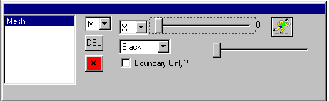
To the right of the three buttons are user-interface controls unique to each plot type. A different group of controls will appear depending on the type of the plot currently selected in the plot list. Editing the controls for a plot changes the behavior of the selected plot only. The following sections discuss the various controls for the different plot types.

Mesh Plot

A mesh plot will display the computational mesh you defined using the mesh generation tool. When a mesh plot is highlighted in the plot list, the mesh controls appear on the right hand side of the plot editor. The top-left control is a combo-box with the entries X, Y, Z, and ALL, and to the right of that is a long slider bar. These two controls work together to create a 2-D slicing tool. For example, pretend you wanted to see the mesh at the X=4 plane. To do this, you would set the combo-box to X and move the slider until the number to the right of the slider reads 4. To view the mesh at the Z=2 plane, you would set the combo-box to Z and move the slider to 2. Keep in mind that the numbers 4 and 2 are not in meters, but rather refer to the 2nd and 4th control volume in the X and Z direction, and their actual location in the model will vary depending on the mesh definition. Setting the comb-box to ALL displays the entire mesh.

The “running man” icon appears next to the slider whenever X, Y, or Z has been selected. Clicking on the running man will animate the slider bar, allowing you to view the mesh at each logical plane along the dimension you chose. Click the running man again to halt the animation.

The combo-box beneath the slicing tool sets the color of the mesh lines. The slider bar to the right of the color selector varies the thickness of the mesh lines. The checkbox labeled “Boundary Only?” toggles between only plotting the mesh bounding box lines and plotting the entire mesh.
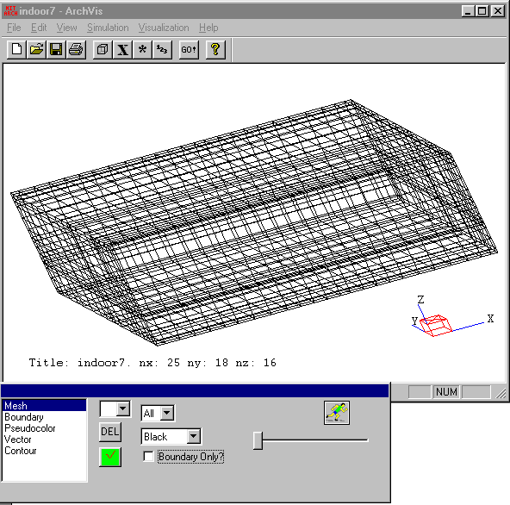

STL Lines Plot

An STL plot allows you to view the geometry imported from an STL file. The top most control for the STL lines plot is a color box. Changing the color alters the color of the lines. The checkbox next to the color box, labeled “Facet vectors?”, toggles on or off the vector normal lines that are included with the STL file. Vector normal lines are arrows that point in a direction normal to the particular face they are located on. The large white box beneath the color box is the STL selection box. If you have imported more than one STL file, this box lets you choose which one you wish to view. To view more than one, create more than one STL lines plot.
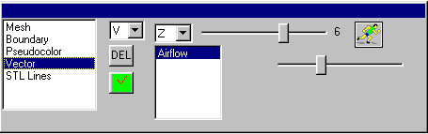
Boundary Plot

Boundary plots visualize the objects you created with the geometry editor. The combo-box in the top-left is a color selector, and it changes the color of the lines used to draw the object. The checkbox to the right of the color box, labeled “Filled?”, switches between filled squares or wireframe squares.

The tree box beneath the color box is a mini-replica of the geometry editor box. Click on the object you wish to visualize, or, click on an folder to visualize all the objects it contains. Changes made in the geometry editor are automatically reflected in the boundary plot.

The slider to the right of the object selector box controls the thickness of the lines used to represent the object.
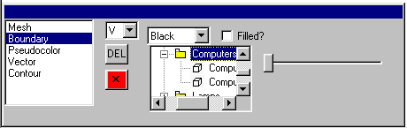
Pseudocolor Plot

A pseudocolor (also known as a false coloring) is a method of visualizing a 2D field of scalar values. Once a pseudocolor plot is selected in the plot list, the pseudocolor-specific controls appear to the right. On the top is the combination slider and combo-box used to select a 2D slice. This operates in the same manner as it did in the mesh plot, only there is no ALL selection. The data on the slice selected with this tool will be visualized by color shading.

Think of the pseudocolor plot as similar to a weather map, where the coldest temperatures are colored blue and the hottest temperatures are colored red, and all temperatures in between are shaded.

The white box beneath the slice selector allows you to select which scalar variable to plot. Only the scalar variables solved by the CFD engine will be present in this list. Click on the variable to select it.

To the right of the variable list is a checkbox labeled “Plot Full Range?” If it is checked, then the lowest value over the entire variable will be shaded blue, and the highest variable will be shaded red. It is important to note the phrase “over the entire variable,” for while the highest and lowest values might not be present in the 2D slice you have chosen, they still influence the color shadings. If the box is unchecked, then you may enter the lowest and highest values, and these will become the lowest blue and the highest red, respectively. Any value outside of this range will be transparent.

Clicking on the running man will animate which slice is chosen by stepping through every possible 2D plane along the selected dimension.

Contour Plot

A contour plot draws contour lines on 2D slices of a scalar field. This is similar to weather maps that draw contour lines tracing the areas of a constant temperature, and terrain maps that draw contour lines along mountain ridges of the same altitude.

The contour plot’s controls look and operate in the same fashion as the pseudocolor plot’s, except for the addition of a slider above the “Plot Full Range?” checkbox. This slider controls how many contour lines to draw. The lower the slider, the less contour lines are drawn. Adjust the slider until you feel the right number of contours is drawn.
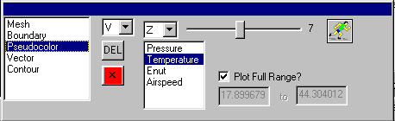
Vector Plot

A vector plot draws arrows representing vector data at a particular point. The vector plot’s controls contain the slice selection tool, the running man, and the variable list. Also included is a slider beneath the running man icon. This slider controls the relative length of the average vector arrow. The farther the slider is pushed to the right, the longer the arrows become.
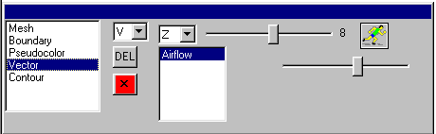

Main Window

The visualizations in the main window are controlled by the mouse. Hold down the left button and move the mouse to rotate the image in the three dimensional plane. To zoom in, click the right button at the place you wish to zoom in on. To zoom out, hold down control and click the right button. To translate the image, hold the control button and the left mouse button while moving the mouse.

